**Cariboo Lake Results Draft**

Section 3: Temporal Sedimentary Record

January 9, 2022

Revision 1

Four glaciolacustrine sediment cores, which range from 2 – 4 m in length, were retrieved from the deepest basins of Cariboo Lake (Fig. 1). Cores V1 and V2 were selected for detailed analysis as these two cores had sufficient organic material for AMS radiocarbon chronology, and their sedimentary record was well preserved. Records of grain size, varve thickness, and organic content from these two cores demonstrate patterns in sediment delivery to Cariboo Lake over the past 1500 years.

*Chronology*

AMS radiocarbon dates obtained for cores V1 and V2 (Table 1) provide temporal control and evidence of sediment accumulation rates. A small twig from V1 at 347 cm yielded a date of 1899-1819 cal BP. Two separate samples were analyzed from V2, one comprised of a large twig at 222 cm yielding a date of 490-316 cal BP (V2a), and a combination of two separate organic pieces which were combined into one sample, a twig at 286 cm and a pine needle at 294 cm and provided a date of 2045-1895 cal BP (V2b). Figure 2, shows the dating calibration curves derived for the three AMS radiocarbon dates. The date provided for sample V2a, yields a sedimentation rate of 5.51 mm/yr, which is much higher, relative to the rates of 1.87 and 1.45 mm/yr provided for V1 and V2b respectively. Additional sedimentation rates derived from the Ekman surficial cores 13-15 are shown in Fig. 3, which are proximal to the V2 core (see Fig. 1), and exhibit sedimentation rates of 2.24, 2.52, and 2.31 mm/yr respectively. The consistency of the EK13-15 sedimentation rates with the V1 and V2b AMS sedimentation rate, suggests that the V2a sample may have been pulled down during the coring process due the large twig size of 4 cm resulting in a erroneously high sedimentation rate for V2a. Since no additional evidence was found to support the V2a sedimentation rate of 5.51 mm/yr, it was not included in subsequent analysis. The AMS radiocarbon dates from samples V1 and V2b, which were consisent with sedimentation rates provided by proximal ekman surficial cores, provide an important temporal control when interpreting the following sediment analyses.

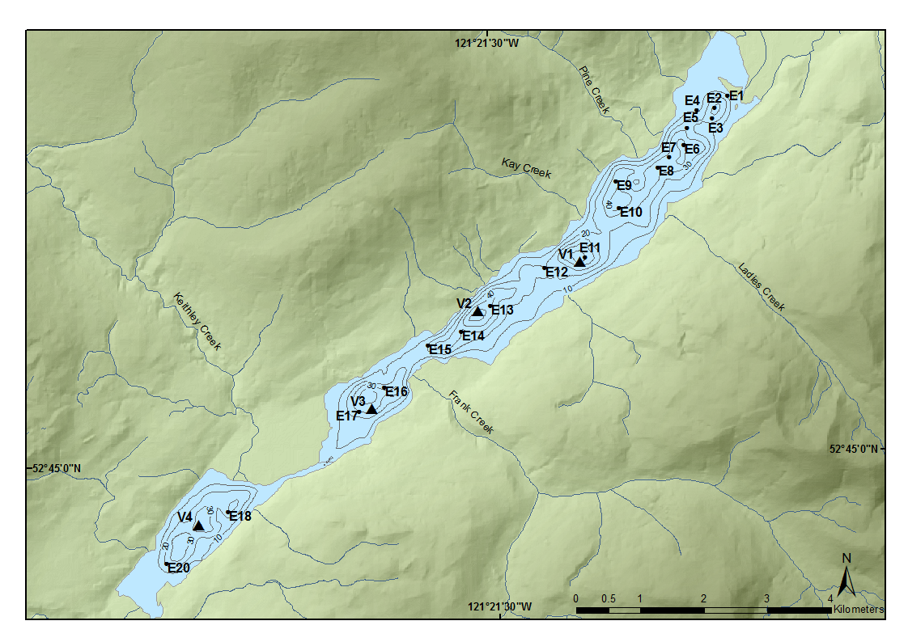

Figure 1: Likely Shown in Earlier Section But attached here for reference.

Figure 2: Sediment accumulation rates derived from the three C14 dates for Cores V1 (Red), and V2 (Green and Blue. The black line is the line of best fit through all three ams radio carbon dates.

Figure 3: Sedimentation rates for Ekman surficial cores proximal to core V2.

Figure 1: Cumulative sedimentation rates for cores V1 and V2 and Ekman surficial cores EK13, 14, and 15 proximal to V2

Laminae couplets were counted within V1 and V2 with the hypothesis that the couplets were annually deposited. To determine if couplets were annually deposited the sedimentation rate derrived from couplet counting was compared to the rates derived from the AMS radio carbon dates. Prior to this comparison event-based laminae, with thicknesses greater than three standard deviations above the mean were removed from the varve chronology. The degree of surface disturbance was much larger than expected, due to the vibra coring process. This led to sections of the cores without visible laminae couples, primarily near the tops of the cores. At V1 127 cm of the core were considered disturbed and at V2 75 cm were disturbed. In the absence of laminae couplets in the disturbed sections, time was interpolated using an average sediment rate.

In core V1, laminae couplets were counted down to the core depth of 347 cm, where the AMS radiocarbon organic material was retrieved, which resulted in an estimated date of 1451 BP. In core V2 a date of 1866 cal BP was estimated by laminae couplet counting down to a core depth of 290 cm which matches up closely with the second AMS radiocarbon date of 2045-1895 cal BP of provided for V2. Based on this relatively close agreement between the AMS radiocarbon dated organic material and the varve chronology, laminae couplets at V1 and V2 are considered to be deposited annually. However, some error in this assumption is expected due to overcounting of discrete turbidite deposits events or undercounting varves that were not visible during years of low sediment flux. Since the AMS radiocarbon dates are older than the varve chronology estimated dates, undercounting was likely the dominant source of error and is also more likely as the turbidite events contain coarse gained sediment and were easy to observe compared to faint varves.

The basal age for each core for was estimated using both the varve chronology and extrapolating the average AMS radiocarbon date for each core. The basal age at V1 is 1580 BP based on the varve chronology and 2057 cal BP when extrapolating the AMS radiocarbon date. The basal age at V2 is 1872 BP based on the varve chronology and 2057 cal BP by extrapolating. The basal dates for these cores are only an approximation but given the relatively close agreement between the varve chronology and radiocarbon dates they are a reasonable estimate.

## Sediment yield statistics

The sedimentation rate for V1 and V2 was calculated using mean couplet thickness from the varve chronology. Varves that had a thickness greater than 3 standard deviations above the mean were removed for this calculation as they were classified as discrete localized turbidite deposits rather than suspended sediment deposits from the main Cariboo River. The mean sedimentation rate for V1 is 2.4 mm/yr and for V2 it is 1.52 mm/yr. These findings are consistent with the surficial sediment core results where a higher sediment flux was found closer to the Cariboo River delta. The suspended sediment yield (SSY) was also calculated which illustrates the volume of sediment moving through the watershed per year. The SSY at V1 is 9.1 Mg·km-2·a-1 and 1.75 km further down lake at V2 is 5.8 Mg·km-2·a-1. The average SSY between the two cores is 7.45 Mg·km-2·a-1.

Suspended Sediment Yield

The thickness of laminae couplets (varves) measured in core V1 and V2 demonstrate trends in suspended sediment delivery to Cariboo Lake over the Late Holocene period from AD 440-2017 at V1 and AD 150-2017 at V2. In the bottom portion of the record, the strongest signal of increased sediment flux to Cariboo Lake is observed. Varve thickness is 0.53 standard deviations above the mean at V1 (p < 0.05, n=230) and 0.29 standard deviations above the mean at V2 (p < 0.05, n=479). Grain size also exhibits an increase in sediment flux during this time. At V1 D50 grain size is 0.45 standard deviations above the mean from (n.s., n=10). At V2 D50 grain size is 0.48 standard deviations above the mean (n.s., n = 13). Percent loss on ignition does not exhibit a systematic trend between V1 and V2 This time period also coincides with the First Millennial Advance (AD 200-700), where there is evidence of increased glacier activity in the Cariboo Lake watershed (e.g. Maurer et al., 2009). After this, varve thickness and grain size begin a declining trend and remain mostly below average from AD 750 – 1500 at both V1 and V2. Core V2 reaches a minimum varve thickness at around AD 1250 and is overall at -0.33 standard deviations below the mean and grain size at -0.84 standard deviations below the mean between 751-1250 AD with

During the Medieval Warm Period (AD 750-1100) the sediment record at V1 and V2 provide evidence of decreased sediment flux during this time. A decline in both varve thickness and D50 grain size is observed from AD 750 – 850. This coincides with a period of above average temperature and decreased glacier extent in the region.

Grain Size

.