Cariboo Lake Results Draft: Core Record

Alex Cebulski

Feb 13, 2022

Four glaciolacustrine sediment cores, which range from 2 – 4 m in length, were retrieved from the deepest basins of Cariboo Lake (Figure 1). Cores V1 and V2 were selected for detailed analysis as these two cores had sufficient organic material for AMS radiocarbon dating, and their sedimentary record was well preserved. The chronology of the two cores is provided by AMS radiocarbon dating and varve counting. No evidence of volcanic tephra was found within either of the two cores. @Westgate1977 reports the most recent major volcanic ash event to reach central BC occurred 2100 yr BP. This combined with the dark colour of the clastic core sediments prevented finding smaller volcanic ash events within the cores. Records of grain size, varve thickness, and organic content from these two cores demonstrate patterns in sediment delivery to Cariboo Lake over the past 2000 years.

*Chronology*

AMS radiocarbon dates obtained for cores V1 and V2 provide temporal control and evidence of sediment accumulation rates. A small twig from V1 at 347 cm yielded a date of 1899-1819 cal BP. Two separate samples were analyzed from V2, one comprised of a large twig at 222 cm yielding a date of 490-316 cal BP (V2a), and a combination of two separate organic pieces which were combined into one sample, a twig at 286 cm and a pine needle at 294 cm and provided a date of 2045-1895 cal BP (V2b). Figure 2, shows the dating calibration curves derived for the three AMS radiocarbon dates. The dates from samples V1 and V2b yield consistent accumulation rates of of 1.87 +/- 0.04 mm/yr and 1.47 +/- 0.11 mm/yr respectively. Sample V2a, yields a sedimentation rate of 5.51 mm/yr, inconsistent with the rates provided for V1 and V2b. Accumulation rates derived from Ekman surficial cores 13-15 are shown in Figure 3. These short cores are proximal to the V2 long core (see Figure 1), and exhibit accumulation rates of 2.24, 2.52, and 2.31 mm/yr respectively. Higher accumulation rates are expected for the Ekman samples are they are not subjected to the same level of compaction as the long cores. Still, the consistency of the E13-15 accumulation rates compared with the V1 and V2b cores (Figure 4) suggests that the V2a is suspect. In viewing sample orientation and position along the outer core it is speculated that the sample may have been pulled down during the coring process due the large twig size at about 4 cm. This probably results in an erroneously high accumulation rate for V2a. Accumulation rates in areas proximal to river inputs in nearby Quesnel Lake were measured to be as high as 0.72 mm/a (see Figure 9 in Gilbert and Desloges, 2012). While this is lower than Cariboo Lake, inputs are expected to be lower from this more arid and less glaciated portion of the Quesnel Lake watershed. Accumulation rates of 1.47 to 1.87 are consistent for a smaller and more glaciated Cariboo Lake watershed. Since the laminae thickness in Ekmans and vibra cores do not support the V2a accumulation rate of 5.51 mm/yr, it was not included in subsequent analysis. The AMS radiocarbon dates from samples V1 and V2b provide an important control when interpreting the inferred temporal pattern of sediment inputs to Cariboo Lake. The top section of cores V1 and V2 were disturbed - 110 mm for V1 and 70 mm at V2. While the Ekman cores were too short to overlap with the undisturbed sections of the vibra cores, laminae thickness similarities allow anchoring the top of core dates and 0/0 (depth/date) (Fig. 3 and Fig. 4).

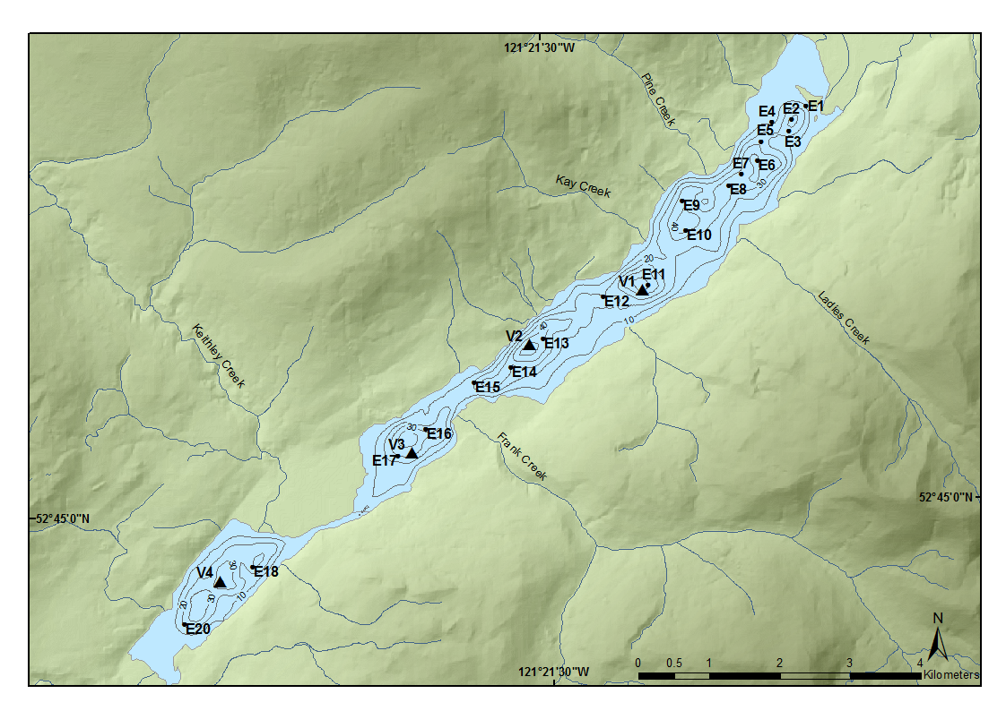

Figure 1: Location of long vibra cores (V) and Ekman surficial cores (E).

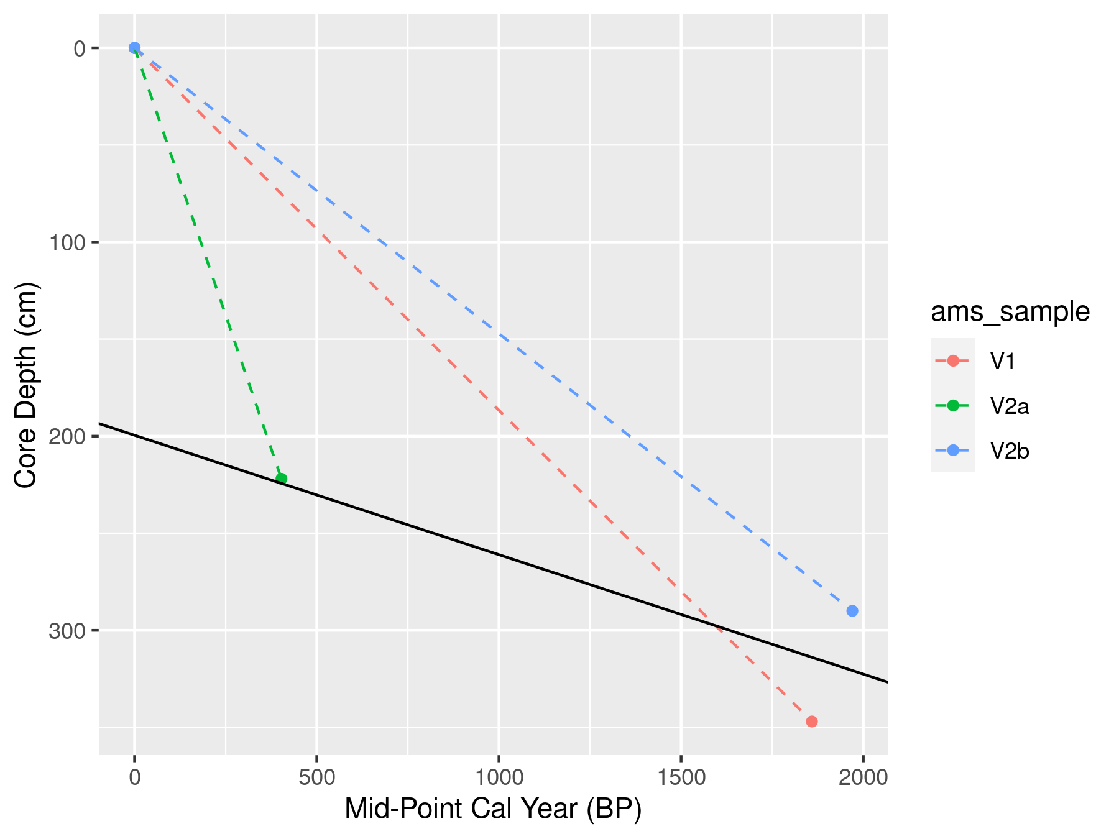

Figure 2: Sediment accumulation rates derived from the three C14 dates for Cores V1 (Red), and V2 (Green and Blue. Get rid of the black line. It is based on one date that you argue is suspect.

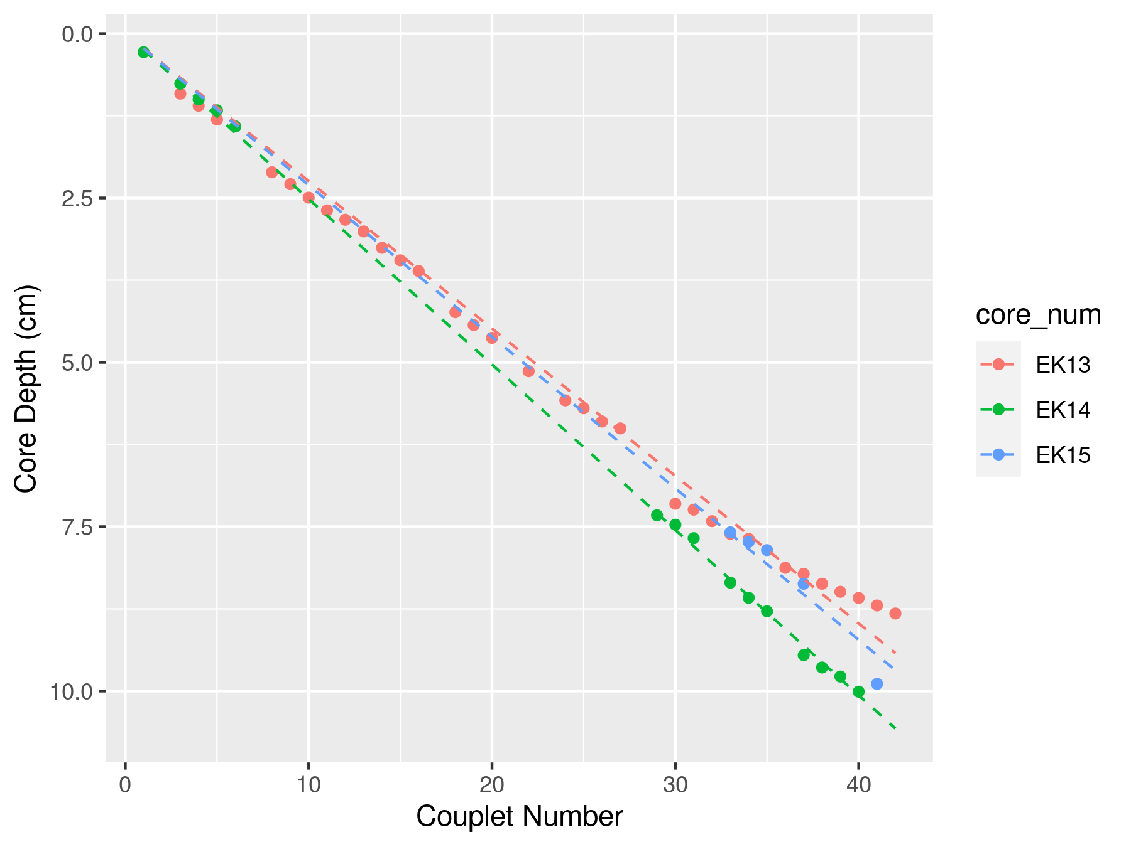

Figure 3: Sedimentation rates for Ekman (E) surficial cores proximal to core V2.

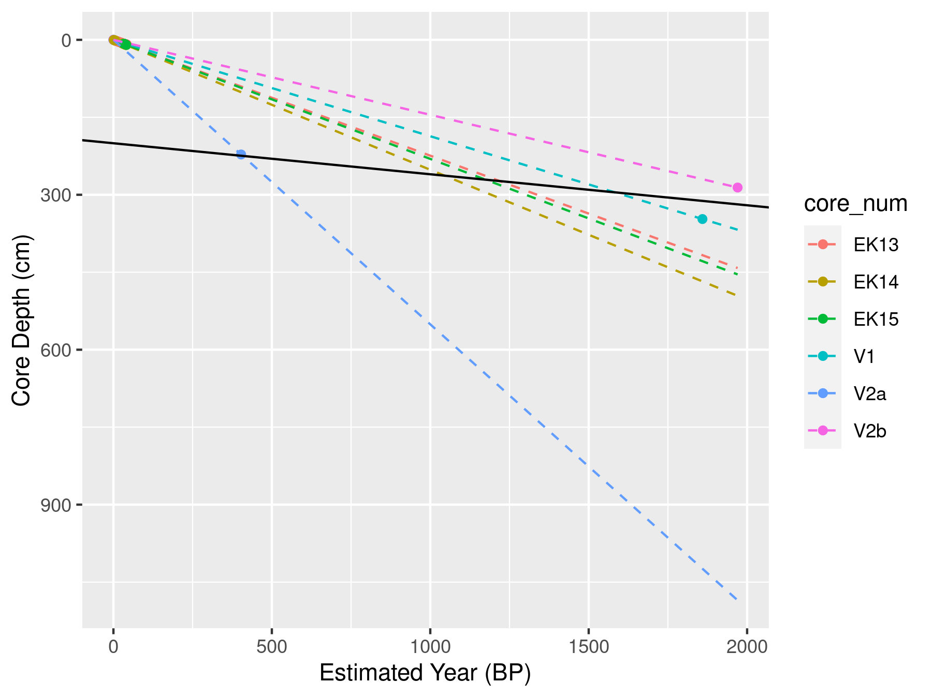

Figure 4: Cumulative accumulation rates for cores V1 and V2 and Ekman surficial cores E13, 14, and 15 proximal to V2.

The sediment laminae chronology from cores V1 and V2 are interpreted as annual couplets or varves. This interpretation is supported by the AMS radiocarbon dated samples from cores V1 and V2 which corresponded reasonably well with the age of the varve at the same depth. However, some error is present in the varve chronology due to the presence of disturbed sections of core, core compaction, undercounting, and subjectivity in classifying thicker graded and massive laminae/beds that interpreted as flood events. In the absence of laminae couplets, the time elapsed over disturbed sections, was interpolated using a 30-year moving average sediment rate following methods described in Menounos et al., 2008.

Laminae couplets with thicknesses greater than 3 standard deviations from the mean were classified as event-based turbidite beds. Table 1, shows the eight turbidites observed in V1 and nine turbidites observed in V2, and their corresponding laminae thickness and estimated year using the 14C-derived accumulation rates. Figure 5, shows the timing of the turbidite beds are not correlated between V1 and V2. It is likely the turbidite beds are formed by more isolated events proximal to the core locations such as adjacent hillslope failures, subaqueous side-wall slumps and/or very local tributary stream floods. For the purpose of establishing an accumulation rate chronology based on the varve only couplets, the turbidite beds were removed from the varve counting chronology.

Table 1: Timing and thickness of turbidite laminae for V1 and V2. Est. Year (CE) is the estimated year using linear interpolation of the accumulation rate curve.

| Core | Depth (mm) | Est. Year (CE) | Laminae Thickness (mm) |
| --- | --- | --- | --- |
| V1 | 790.0 | 1593.77 | 13.3 |
| V1 | 1373.0 | 1281.44 | 15.9 |
| V1 | 1609.0 | 1155.00 | 5.3 |
| V1 | 1678.0 | 1118.04 | 3.4 |
| V1 | 1681.0 | 1116.43 | 2.7 |
| V1 | 1757.0 | 1075.71 | 2.7 |
| V1 | 1760.0 | 1074.11 | 3.6 |
| V1 | 2235.0 | 819.63 | 3.9 |
| V2 | 298.8 | 1811.18 | 2.3 |
| V2 | 587.7 | 1612.19 | 4.0 |
| V2 | 768.4 | 1487.72 | 2.3 |
| V2 | 1090.3 | 1265.99 | 8.8 |
| V2 | 1139.7 | 1231.96 | 3.0 |
| V2 | 1800.1 | 777.07 | 5.1 |
| V2 | 2305.7 | 428.81 | 47.0 |
| V2 | 2314.8 | 422.54 | 4.7 |
| V2 | 2504.4 | 291.94 | 3.5 |

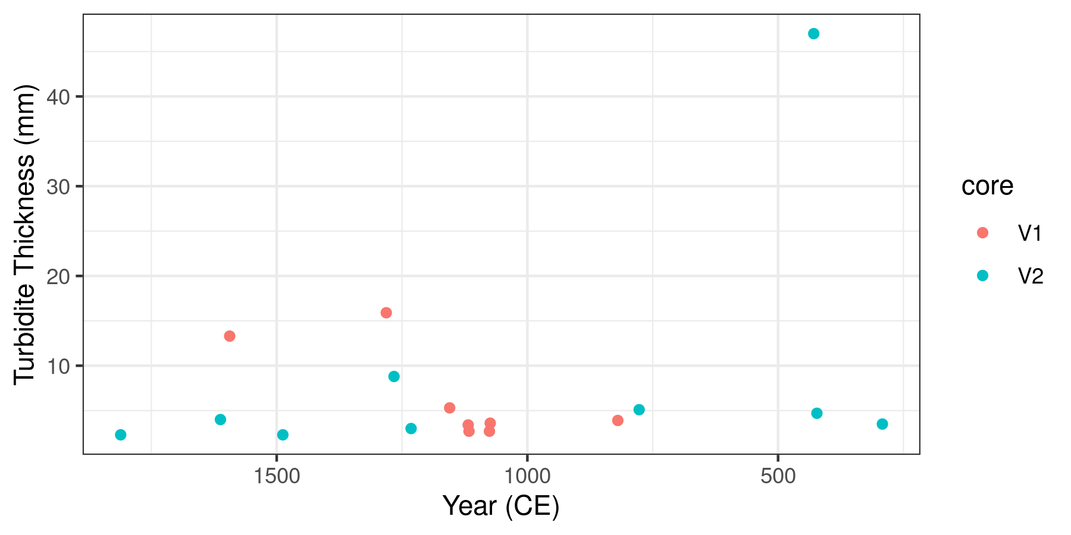

Figure 5: Timing and thickness of turbidite laminae in V1 and V2. Year (CE) is the estimated year using linear interpolation from the AMS radiocarbon dates.

For core V1, laminae couplets were counted down to a core depth of 347 cm, where the AMS radiocarbon organic material was retrieved. This resulted in a couplet-derived age estimated of 1450 BP compared to the AMS radiocarbon estimate of 1899 - 1819 cal BP. For core V2 a date of 1886 BP was estimated by couplet couplet counting down to a core depth of 294 cm which matches closely with the V2b AMS radiocarbon date of 2045-1895 cal BP. The better alignment between the couplet counting age and the AMS derived age in V2 can be attributed to the higher degree of core disturbance in V1 compared to V2. Disturbed sections may have resulted in undercounting of some couplets. Based on the relatively close agreement between the AMS radiocarbon dated organic material and couplet counting, laminae couplets in V1 and V2 are considered to be deposited annually. Close alignment was not expected due to the aforementioned error present in the couplet counting methodology and the limited 14C dates available.

The basal age for each core is estimated using both the varve chronology and the AMS radiocarbon accumulation rate. The basal age of V1 at a depth of 382 cm is 1622 BP based on the varve chronology and 2046 cal BP, or about a 400 year difference from the extrapolated 14C date. The basal age of V2 at a depth of 291 cm is 1913 BP based on the varve chronology and 2007 cal BP by extrapolating the 14C. Accumulation rates estimated using varve chronology and AMS radiocarbon dates had a larger difference at V1 with 2.4 mm/yr and 1.87 +/- 0.04 mm/yr respectively. Closer agreement was observed at V2 with 1.52 mm/yr estimated by the varve chronology and 1.47 +/- 0.11 mm/yr from the AMS radiocarbon date. While V2 is likely the better predictor of changes in accumulation rates over the last 2000 years, both cores are considered below.

*Sediment Yield Statistics*

Figure 6 shows the time series of varve thickness measured from V1 and V2 and illustrates trends in suspended sediment delivery to Cariboo Lake. The measured couplet thicknesses in the two cores are plotted as standardized departures to facilitate comparison between the two cores. In each plot a 30-year moving average with a 1-year time step is plotted in black to emphasize decadal to centennial patterns in accumulation rate departures. Chronologies in Figure 6 assume a linear interpolation from the single AMS radiocarbon dates.

[[[At V1, the 30-year average varve thickness remains above average from CE 0-600, 850-950, 1000-1100, 1150-1200 and below average between CE 800-850, 950-1000, 1100-1150, and 1200-1850. At V2, varve thickness is above average between CE 0-250, 350-450, 550-600, 1500-1600, 1700-1800, and 1900-1950 and below average between CE 250-350, 450-550, 1950-1500, 1450-1500, 1800-1900.]]] Above average varve thickness is consistent between V1 and V2 between 0-500 CE, with a stronger signal observed for V1 which is closer to the main Cariboo River outlet. Below average varve thickness is observed at both V1 and V2 between 1000-1500 CE, with a stronger signal at V2. After this, trends in varve thickness between the two cores are not consistent, but generally remain below average for V1 and above average for V2. Sub-centennial trends are not reported due to the coarse temporal control for both V1 and V2.

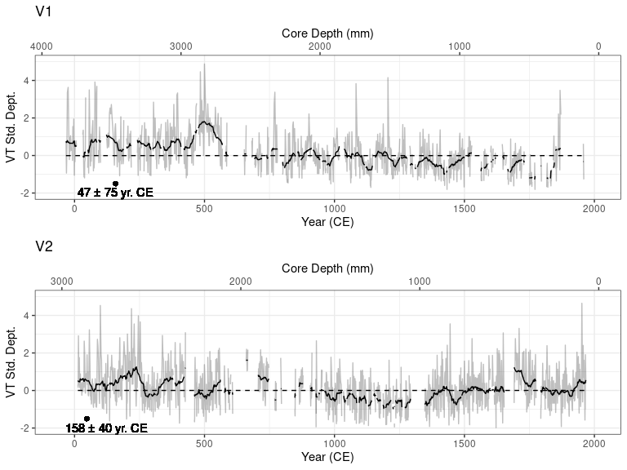

Figure 6: OPTION A - Standardized departure from the mean varve thickness for cores V1 and V2. The gray lines represent measured varve thickness, the black line is a 30-year moving average, gaps correspond to portions of the core that did not have discernible varves. The top axes, labelelled Year (CE), was estimated using linear interpolation from the AMS radiocarbon dates. The black points on the bottom of each plot denote the AMS radiocarbon age (± dating error) and depth of the respective sample.

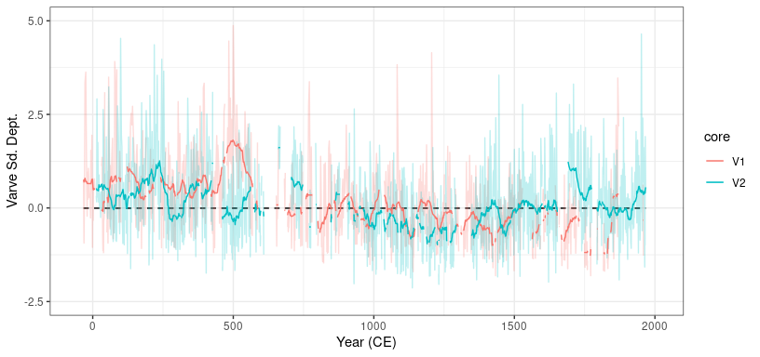

Figure 7: OPTION B - Standardized departure from the mean varve thickness for cores V1 and V2. The gray lines represent measured varve thickness, the black line is a 30-year moving average, gaps correspond to portions of the core that did not have discernible varves. The top axes, labelelled Year (CE), was estimated using linear interpolation from the AMS radiocarbon dates. The black points on the bottom graph of V1 and V2 denote the AMS radiocarbon age (± dating error) and depth of the respective sample.

*Grain Size*

Although based on a limited number of measurements, the temporal pattern in grain size (standardized departures of the D50??? Other??) between the two cores shows a consistent pattern (Figure 8).Both V1 and V2 have above average grain size between 0 and 500 to 700 CE and below average from 700 to 1500 CE. After 1500 CE grain size follows an increasing trend with average to above average grain size. V1 shows the more dramatic increase in grain size compared to V2.Overall, grain size fluctuations at the coarse resolution of about 100-years shows good correspondence between the two cores over the last 2000 years.

Event-based layers identified in the varve thickness chronology were removed from the grain size analysis presented here. The composition of sediment grains within the event-based layers were all characterized by a single mode with less than 0.01% clay, over 98% silt and less than 1% sand. The D50 of event based is? The average D50 particle size of couplet sediment is 7.6 µm and 6.4 µm for V1 and V2 respectively. The particle size distribution for couplet sediment is characterized by a bi-modal distribution with an average composition of 13% clay, 86% silt, and 0.8% sand sized particles at V1 and 81% silt, 18% clay, and 0.5% sand sized at V2.

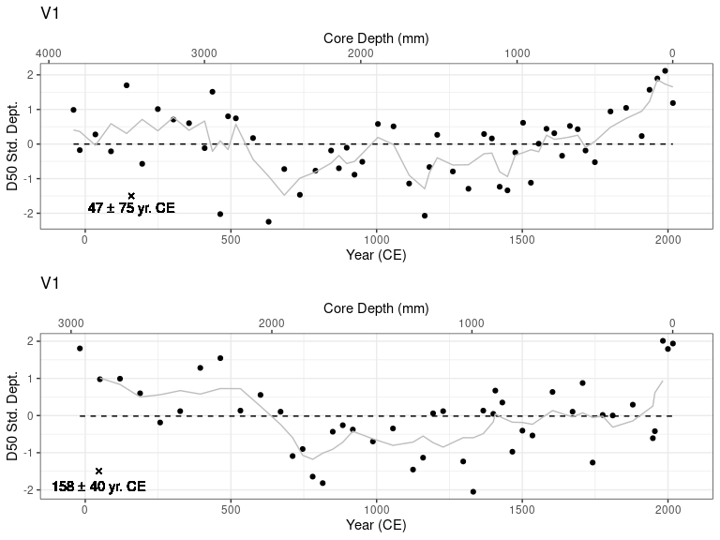

Figure 8: OPTION A - Standardized departure from the mean D50 grain size for cores V1 and V2. The black points represent D50 particle size at 5 - 10 cm intervals and the gray line is the 3 sample (~125 year) moving average. The top axes, labelelled Year (CE), are calculated as per Figure X. The black X’s on the bottom graph of V1 and V2 denote the AMS radiocarbon age (± dating error) and depth of the respective sample.Chart

Thicker, coarser varves due to colder wetter climate. Explain why more LOI

Thinner, finer varves due to warmer dryer climate. Explain why LOI stays high

Thicker, coarser varves due to colder wetter climate. Explain why less LOI

Grain size and LOI show the dramatic post LIA trends. Thickness not so much.

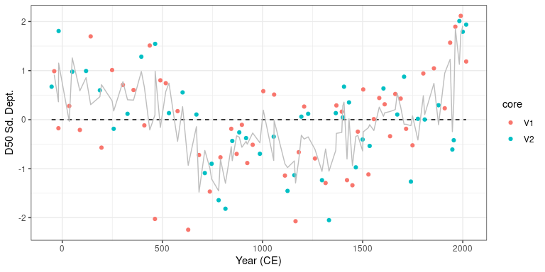

Figure 9: OPTION B - Standardized departure from the mean D50 grain size for cores V1 and V2. The black points represent D50 particle size at 5 - 10 cm intervals and the gray line is the 3 sample (~125 year) moving average. The top axes, labelelled Year (CE), are calculated as per Figure X. The black X’s on the bottom graph of V1 and V2 denote the AMS radiocarbon age (± dating error) and depth of the respective sample.

*Loss on Ignition*

Figure 10 shows the losson ignition (LOI) for both V1 and V2. Higher levels of organic content are shown in V1 and V2 from from 0-1000 CE and mostly below average from 1000-2000 CE. Specific periods of above average LOI for V1 occur around CE 0-500, 650-1100, 1150, 1300, 1750-1850 and below average between 50 BCE - 50 CE, CE 550-650, 1150-1300, 1350-1750, 1850-2000. LOI is above between at V2 around CE 0-100, 250-500, 650-900, 1800-1950, and below average between 1000-1050, 1300-1600, 1950-2000. The average LOI at V1 and V2 is similar at 4.76% and 4.80% respectively suggesting that the flux of allochthonous organic material to the core locations is not dependent on distance from the main Cariboo River as it is easily transported through the lake due to the low density.

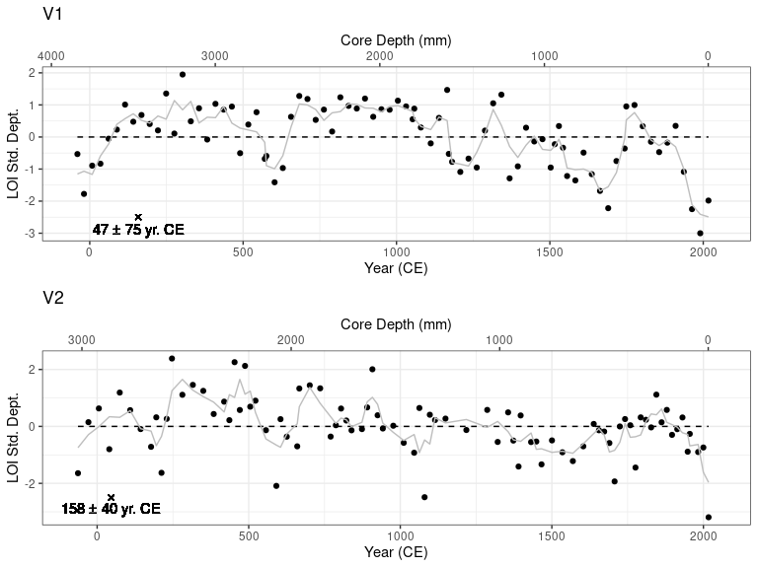

Figure 10: Standardized departure from the mean percent LOI for cores V1 and V2. The black points represent percent LOI at 2.5 - 5 cm intervals and the gray line is the 3 sample (~75 year) moving average. The top axes, labelelled Year (CE), are calculated as per Figure X. The black X’s on the bottom graph of V1 and V2 denote the AMS radiocarbon age (± dating error) and depth of the respective sample.

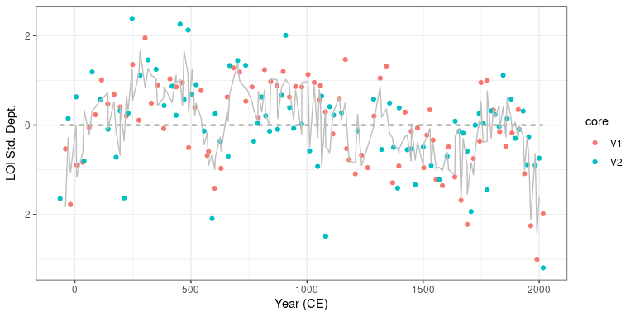

Figure 11: Standardized departure from the mean percent LOI for cores V1 and V2. The black points represent percent LOI at 2.5 - 5 cm intervals and the gray line is the 3 sample (~75 year) moving average. The top axes, labelelled Year (CE), are calculated as per Figure X. The black X’s on the bottom graph of V1 and V2 denote the AMS radiocarbon age (± dating error) and depth of the respective sample.