The Influence of Climate Variability and Canopy Structure on Snow Interception Losses in Needleleaf Forests

Alex Cebulski

January 25, 2022

# Research Problem:

* Improve estimates of sub-canopy snow accumulation. Figure 1

# Objectives

1. (option 1) Develop a process-based understanding of sublimation, wind redistribution, unloading, and drip of intercepted snow to inform the improvement of subcanopy snow accumulation algorithms for a sparse canopy in the Rocky Mountains.
2. (option 2) Determine how fine scale snow-canopy interactions influence snow water equivalent variability for a sparse subalpine canopy in the Canadian Rockies to inform the improvement of subcanopy snow accumulation algorithms for a sparse canopy in the Rocky Mountains
3. Test the performance of snow interception and ablation algorithms developed in the Rockies at research basins located in coastal temperate and sub-arctic climates; and determine if each basin has different sensitivity to sublimation, wind redistribution, unloading, and drip processes requiring site specific algorithms.
4. Mobilize findings by applying the updated algorithms in an existing regional-scale hydrological model to determine the sensitivity of snow interception losses to future climate change in the Canadian Cordillera.

These objectives will be addressed utilizing data collected from three mountain basins: a sub-arctic basin (Wolf Creek Research Basin (WCRB), YT ~ 61 ◦ N), a continental headwater basin (Fortress Mountain Research Basin (FMRB), AB ~ 51 ◦ N), and a coastal temperate basin (Russell Creek watershed (RCW), BC ~ 50 ◦ N). Historical data from each field site will be utilized along with additional data collected over the next three field seasons.

## Objective 1

For Objective 1, a detailed investigation of snow redistribution processes will be conducted at FMRB, located on the east side of the Rocky Mountains, 80 km from Canmore, AB. FMRB was selected for detailed investigation because of its good accessibility, dynamic winter weather systems, and has an extensive hydrometeorological sensor network with long term data records dating back several decades. Located adjacent to a cat skiing operation, FMRB has a maintained forest service road allowing mid-winter access to 2100 m above sea level. While winters at FMRB are generally characterized by cold and wet conditions, Chinook events are common at this site which also bring warm and dry conditions. As a result of the winter weather variability at FMRB, it is likely that several snow redistribution processes will be frequently observed at FMRB, including wind transport by saltation and suspension; and vegetation interactions such as interception, unloading, sublimation, and drip. At RCW and WCRB the occurrence of some snow redistribution processes has been shown to be limited. For example, in coastal environments research by Storck et al. (2002) has shown unloading and melt to be the primary snow redistribution processes. In cold and dry climates Essery & Pomeroy (2001) have shown sublimation of intercepted snow to contribute to up to a 25-45% loss in winter snowpack, and in windy environments J. W. Pomeroy & Gray (1995) have shown blowing snow sublimation and redistribution to be of importance.

The instrumentation at FMRB will include hydrometeorological sensors to measure snow interception, ablation and redistribution, following studies by Hedstrom & Pomeroy (1998), Broxton et al. (2015), and Sexstone et al. (2018). Stations at FMRB are set up to measure air temperature, humidity, wind speed, precipitation, snow depth, snow water equivalent (SWE), net radiation, surface temperature of the snow, and eddy covariance (EC) systems. Seven stations are located in open canopy and one station is located in sparse forest which has a 100 ft tower set up to measure above and below canopy meteorological data. Regular field visits to the FMRB stations will involve snow surveys to determine the spatial variability of snow depth and SWE. At one of the open forest stations a snow particle detector and upward facing radar will provide additional insights to incoming precipitation. At the forested station, a weighed suspended tree will measure snow interception and subsequent sublimation, unloading and melt, following methods in Hedstrom & Pomeroy (1998). The canopy and trunk surface temperature of the weighed tree will be measured to assist in modelling the canopy energy balance. Three sub-canopy lysimeters will also be installed at the FMRB forested station to measure unloading of intercepted snow as in MacDonald (2010). Four EC systems are operational at FMRB, two are located within closed canopy; one installed in 2014 above the canopy, and one installed in fall of 2021 below canopy 2 m above the ground; and two are located in open canopy. EC systems are known to be the best method available to continuously measure evaporation (e.g. Wang & Dickinson, 2012) or sublimation (e.g. J. W. Pomeroy et al., 1998). However, while widely used, Helgason & Pomeroy (2012) notes that EC systems are not perfect and can have considerable error when used in mountainous terrain with complex topography, variable land cover and high wind speeds. To control for this, additional estimates of sublimation will be provided by the weighed tree experiment and snow survey comparisons in open and closed canopy. For the weighed tree experiment, a live needleleaf tree will be cut and suspended from a load cell which will record the weight of the tree over time. To account for mass lost due to transpiration and loss of foliage, the initial weight and the weight of the tree during snow free periods will be used to track the mass change and provide a dynamic tare value. The bottom of the tree will also be sealed to limit some transpiration. To prevent prevent spinning and abrupt impacts of the free hanging tree, the base of the tree will be attached to a support system that allows for vertical movement but limits abrupt horizontal movements. Digital cameras will be set up to monitor the interception and ablation of snow on the weighed tree and to ensure it is representative of the surrounding forest. Additional estimates of snow interception losses will be provided by comparing the difference between snow water equivalent observed in the open and in the sub-canopy (at the end of winter once all snow has ablated from the forest canopy) a method used in Hedstrom & Pomeroy (1998).

More detailed observations of snow depth spatial variability will be provided by aerial-borne LiDAR surveys. Data from the LiDAR survey will provide millions of point measurements of snow depth data across FMRB, by subtracting the snow-on ground elevation from the summer snow-off elevation. Harder et al. (2020) have demonstrated that reliable UAV-LiDAR derived snow depth measurements can be provided sub-canopy, especially in sparse forests. UAV-LiDAR flights will be conducted following significant snowfall of 20 cm or greater and then again several days after to observe the redistribution storm snow. The snow-free UAV-LiDAR point cloud will also be used to describe the forest canopy structure of the FMRB forest canopy. Additional measurements of SWE will be provided by a novel instrument called the CHIONE, described in Kinar & Pomeroy (2015), which is a portable handheld device which provides a nondestructive method to measure SWE using acoustic sound waves. This device will be useful for measuring SWE in a more efficient manner compared to the Federal Snow Sampler which is traditionally used for snow surveys. The portability of the CHIONE will allow for sampling in confined places such as in tree-wells which are typically difficult or not possible to measure. Data collected using the methods described above will be used to determine the primary ablative processes that remove snow from the forest canopy and controls sub-canopy snow accumulation. Existing snow interception and subsequent ablation algorithms (Hedstrom & Pomeroy (1998); J. Pomeroy et al. (1998); Ellis et al. (2013); Andreadis et al. (2009); Moeser et al. (2015)) will be tested against measured snow interception and subsequent losses at FMRB. Several processes that may be important for controlling snow redistribution at FMRB, are either not included in these algorithms or are empirically based such as wind redistribution, unloading and melt. The inclusion of additional physically based processes in the snow interception loss algorithms will be evaluated for their ability to reduce error in predicted sub-canopy SWE.

## Objective 2

For objective 2, snow accumulation will be modelled at RCW and WCRB using the updated algorithms developed in Objective 1 and assessed using measured snow depth and SWE at each site. The WCRB site is well instrumented, with hydrometeorological stations located in the open and forest instrumented with sensors similar to those at FMRB, excluding the following sensors: sub-canopy lysimeter, upward facing radar, and snow particle detector. A weighed tree experiment has also been conducted at WCRB for several years and will continue into the next 2 field seasons. The extensive sensor network at WCRB and field observations will allow for some process investigation in addition to algorithm testing. The RCW has ten hydrometeorological stations located in open canopy and instrumented with the following sensors: air temperature, relative humidity, wind speed, cumulative precipitation, snow depth, and net solar radiation. A weighed tree experiment is not possible at RCW due to the size of the old growth trees at this site. However, the weighed tree experiment is not as crucial at RCW as Storck et al. (2002) has shown sublimation to be less important in coastal environments due to the high humidity. Several remote cameras have been installed at RCW located in closed canopy to monitor the ablation of intercepted snow. A meteorological station will be set up at one of the forested camera sites to monitor temperature and relative humidity for the 2022/2023 winter season. Still, since RCW is not as well instrumented as FMRB and WCRB process investigation will be limited, and algorithm testing will be the primary objective at this site. Snow depth and SWE will be measured at WCRB and RCW by monthly snow surveys and aerial borne LiDAR flights by local technicians and compared to SWE predicted by the algorithms. If model performance is satisfactory, snow interception and ablation algorithms will be modified to be site specific, by not including insensitive ablative processes or adjusting parameter values to attempt to minimize model error.

## Objective 3

Algorithm developments from Objective 1 and 2 will be mobilized in Objective 3 by applying the updated algorithms to a regional scale model to predict snow accumulation outside of the algorithm development zones. A hydrological model, still to be selected, such as the Cold Regions Hydrological Model (CRHM) (Ellis et al., 2013) or the Canadian Hydrological Model (CHM) (Marsh et al., 2020) will be used to apply the developed snow interception and ablation algorithms in several basins across the Western Cordillera to predict SWE. First, the model will be validated by running it on historical climate forcing data and comparing the snow depth and SWE predictions to measured values collected across the Canadian Cordillera. After validation, the model will be run using future climate change forcing data on basins outside of the development zone to determine the sensitivity of intercepted snow ablation processes to climate change.

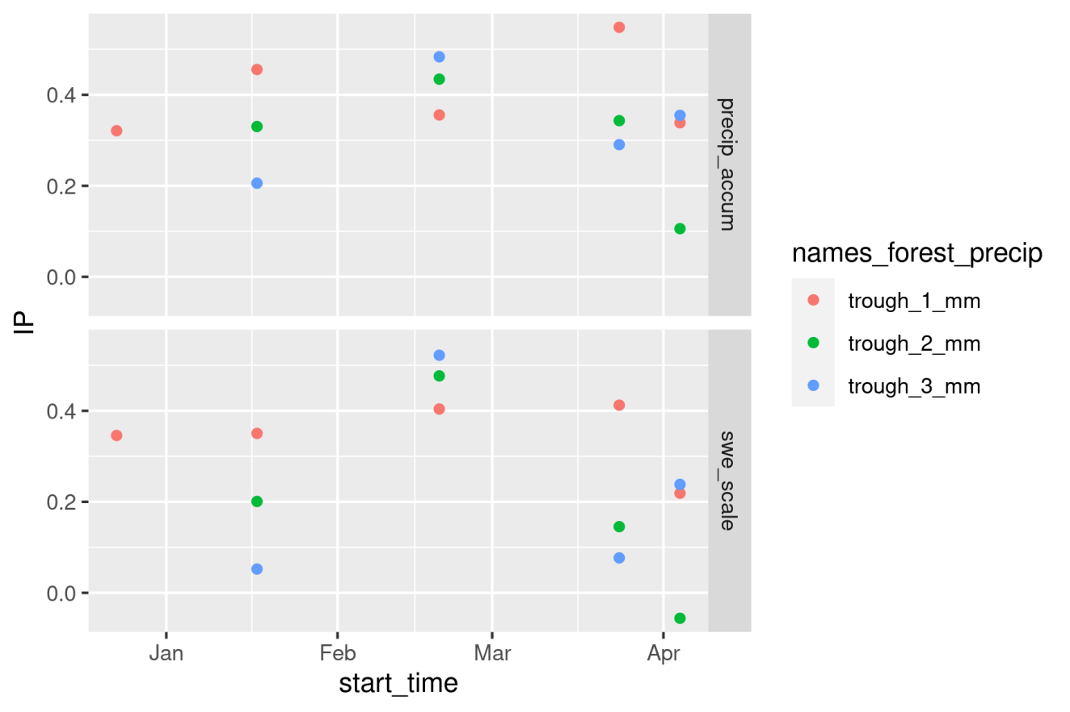

Figure 10.1: Interception efficiency (IP, %) calculated over five storm periods using three different sub-canopy lysimeters (SCLs) located in varying canopy density. trough_1_mm is a SCL located in medium density forest, trough_2_mm is a SCL located in sparse forest, trough_3_mm is a SCL located in dense forest.

Table 1.1: This is a test

| start_time | end_time | Air Temp. (°C) | RH (%) | Net Rad. (W/m2) | Max Wind Speed (m/s) | Needle Temp. (°C) | Snow Temp. (°C) | Trunk Temp. (°C) |
| --- | --- | --- | --- | --- | --- | --- | --- | --- |
| 2021-12-23 00:00:00 | 2021-12-27 00:00:00 | -23.98 | 80.77 | 10.44 | 7.08 | -24.50 | -24.07 | -24.32 |
| 2022-01-17 10:00:00 | 2022-01-18 10:00:00 | -5.06 | 84.15 | -2.48 | 5.31 | -6.37 | -7.75 | -5.77 |
| 2022-02-19 10:00:00 | 2022-02-20 10:00:00 | -7.12 | 96.52 | 6.39 | 2.61 | -8.19 | -8.66 | -7.45 |
| 2022-03-24 00:00:00 | 2022-03-24 09:45:00 | -4.93 | 90.78 | -6.12 | 5.74 | -5.33 | -5.84 | -2.28 |
| 2022-04-04 00:00:00 | 2022-04-04 18:00:00 | -3.08 | 78.91 | 48.19 | 4.46 | -3.57 | -4.39 | -2.33 |

$ρ_{s}=m⋅d_{s}+b\left(8\right)$

# References

Andreadis, K. M., Storck, P., & Lettenmaier, D. P. (2009). Modeling snow accumulation and ablation processes in forested environments. *Water Resources Research*, *45*(5), 1–33.

Broxton, P. D., Harpold, A. A., Biederman, J. A., Troch, P. A., Molotch, N. P., & Brooks, P. D. (2015). Quantifying the effects of vegetation structure on snow accumulation and ablation in mixed-conifer forests. *Ecohydrology*, *8*(6), 1073–1094. <https://doi.org/10.1002/eco.1565>

Ellis, C. R., Pomeroy, J. W., & Link, T. E. (2013). Modeling increases in snowmelt yield and desynchronization resulting from forest gap-thinning treatments in a northern mountain headwater basin. *Water Resources Research*, *49*(2), 936–949. <https://doi.org/10.1002/wrcr.20089>

Essery, R., & Pomeroy, J. W. (2001). Sublimation of snow intercepted by coniferous forest canopies in a climate model. *IAHS-AISH Publication*, *270*, 343–348.

Harder, P., Pomeroy, J. W., & Helgason, W. D. (2020). Improving sub-canopy snow depth mapping with unmanned aerial vehicles: Lidar versus structure-from-motion techniques. *Cryosphere*, *14*(6), 1919–1935. <https://doi.org/10.5194/tc-14-1919-2020>

Hedstrom, N. R., & Pomeroy, J. W. (1998). Measurements and modelling of snow interception in the boreal forest. *Hydrological Processes*, *12*(10-11), 1611–1625. <https://doi.org/10.1002/(SICI)1099-1085(199808/09)12:10/11<1611::AID-HYP684>3.0.CO;2-4>

Helgason, W., & Pomeroy, J. W. (2012). Characteristics of the near-surface boundary layer within a mountain valley during winter. *Journal of Applied Meteorology and Climatology*, *51*(3), 583–597. <https://doi.org/10.1175/JAMC-D-11-058.1>

Kinar, N. J., & Pomeroy, J. W. (2015). Measurement of the physical properties of the snowpack. *Reviews of Geophysics*, *53*(2), 481–544. <https://doi.org/10.1002/2015RG000481>

MacDonald, J. (2010). *Unloading on intercepted snow in conifer forests* (PhD Thesis August, University of Saskatchewan; pp. 0–93). [http://scholar.google.com/scholar?hl=en&btnG=Search&q=intitle:UNLOADING+OF+INTERCEPTED+SNOW+IN+CONIFER+FORESTS#0](http://scholar.google.com/scholar?hl=en&btnG=Search&q=intitle:UNLOADING+OF+INTERCEPTED+SNOW+IN+CONIFER+FORESTS" \l "0)

Marsh, C. B., Pomeroy, J. W., & Wheater, H. S. (2020). The Canadian Hydrological Model (CHM) v1.0: a multi-scale, multi-extent, variable-complexity hydrological model-design and overview. *Geosci. Model Dev*, *13*, 225–247. <https://doi.org/10.5194/gmd-13-225-2020>

Moeser, D., Stähli, M., & Jonas, T. (2015). Improved snow interception modeling using canopy parameters derived from airborne LiDAR data. *Water Resources Research*, *51*(7), 5041–5059.

Pomeroy, J. W., & Gray, D. M. (1995). *Snowcover Accumulation, Relocation and Management* (NHRI Scien). National Hydrology Research Institute.

Pomeroy, J. W., Gray, D. M., Shook, K. R., Toth, B., Essery, R. L. H., Pietroniro, A., & Hedstrom, N. (1998). An evaluation of snow accumulation and ablation processes for land surface modelling. *Hydrological Processes*, *12*(15), 2339–2367. <https://doi.org/10.1002/(SICI)1099-1085(199812)12:15<2339::AID-HYP800>3.0.CO;2-L>

Pomeroy, J., Hedstrom, N., & Gray, D. (1998). *55TH E4SERN SNOW CONFERENCE Coupled Modelling of Forest Snow Interception and Sublimation PAR VIA IN EN^*.

Sexstone, G. A., Clow, D. W., Fassnacht, S. R., Liston, G. E., Hiemstra, C. A., Knowles, J. F., & Penn, C. A. (2018). Snow Sublimation in Mountain Environments and Its Sensitivity to Forest Disturbance and Climate Warming. *Water Resources Research*, *54*(2), 1191–1211.

Storck, P., Lettenmaier, D. P., & Bolton, S. M. (2002). Measurement of snow interception and canopy effects on snow accumulation and melt in a mountainous maritime climate, Oregon, United States. *Water Resources Research*, *38*(11), 1–16. <https://doi.org/10.1029/2002wr001281>

Wang, K., & Dickinson, R. E. (2012). A review of global terrestrial evapotranspiration: Observation, modeling, climatology, and climatic variability. *Reviews of Geophysics (1985)*, *50*(2), n/a.