Fault Condition Twelve Report

Fault condition Twelve of ASHRAE Guideline 36 is an AHU economizer + mechanical cooling mode and AHU mechanical cooling mode only with an attempt at flagging conditions when the AHU mixing air temperature is warmer than the supply air temperature. Fault condition Twelve equation as defined by ASHRAE:

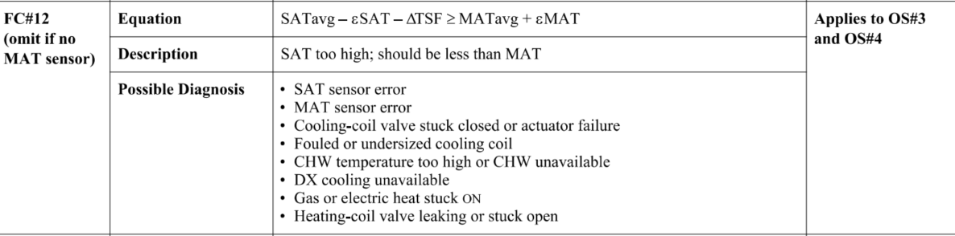

## Dataset Plot

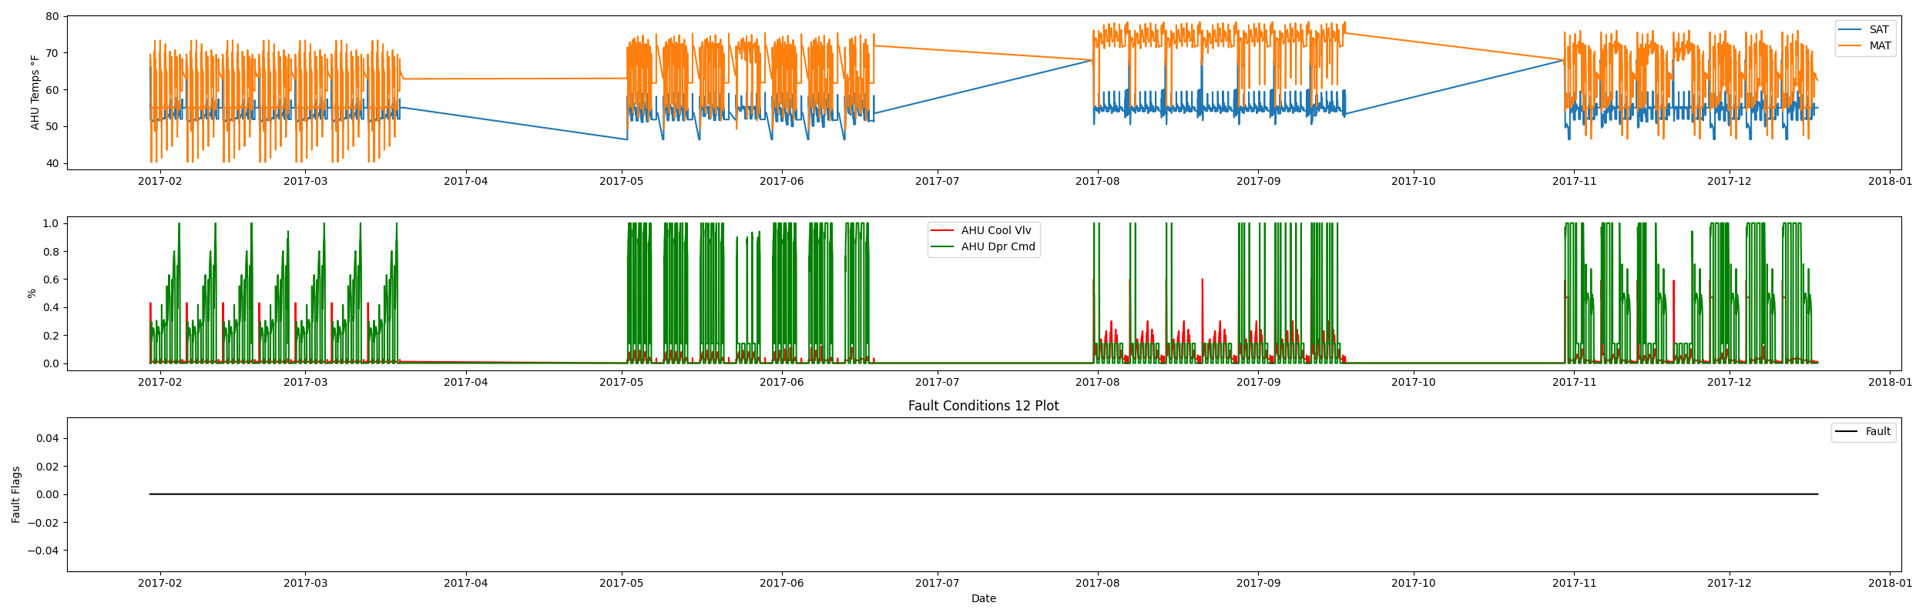

## Dataset Statistics

* Total time in days calculated in dataset: 322.0
* Total time in hours calculated in dataset: 7727.983333333334
* Total time in hours for when fault flag is True: 0.0
* Percent of time in the dataset when the fault flag is True: 0.0%
* Percent of time in the dataset when the fault flag is False: 100.0%
* Calculated motor runtime in hours based off of VFD signal > zero: 3061.08
* No faults were found in this given dataset for the equation defined by ASHRAE.

# Summary Statistics filtered for when the AHU is running

### Supply Air Temp

* count 183665.000000  
  mean 54.113744  
  std 1.730771  
  min 48.578000  
  25% 52.740000  
  50% 54.928000  
  75% 55.046000  
  max 70.310000  
  Name: AHU: Supply Air Temperature, dtype: float64

### Mix Air Temp

* count 183665.000000  
  mean 64.303172  
  std 7.987304  
  min 40.262000  
  25% 55.090000  
  50% 64.300000  
  75% 72.220000  
  max 78.320000  
  Name: AHU: Mixed Air Temperature, dtype: float64

## Suggestions based on data analysis

* The percent True metric that represents the amount of time for when the fault flag is True is low inidicating the AHU components are within calibration for this fault equation Ok.

Report generated: Sat Apr 1 14:00:39 2023