Fault Condition One Report

Fault condition one of ASHRAE Guideline 36 is related to flagging poor performance of a AHU variable supply fan attempting to control to a duct pressure setpoint. Fault condition equation as defined by ASHRAE:

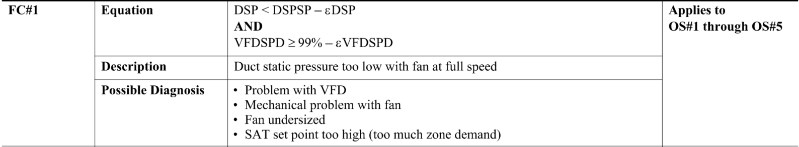

## Dataset Plot

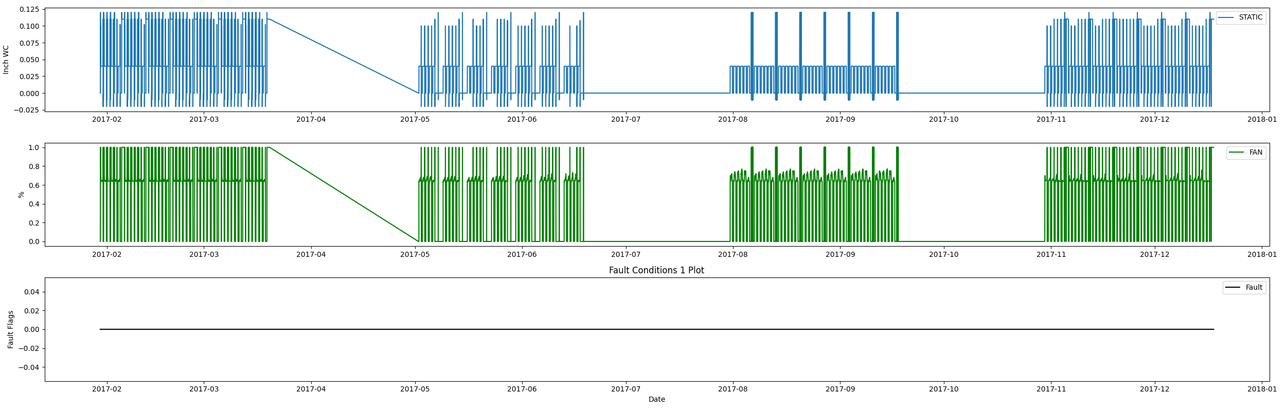

## Dataset Statistics

* Total time in days calculated in dataset: 322.0
* Total time in hours calculated in dataset: 7727.983333333334
* Total time in hours for when fault flag is True: 0.0
* Percent of time in the dataset when the fault flag is True: 0.0%
* Percent of time in the dataset when the fault flag is False: 100.0%
* Calculated motor runtime in hours based off of VFD signal > zero: 3061.08
* No faults were found in this given dataset for the equation defined by ASHRAE.

# Summary Statistics filtered for when the AHU is running

### VFD Speed

* count 183665.000000  
  mean 0.711763  
  std 0.133541  
  min 0.126000  
  25% 0.640000  
  50% 0.650000  
  75% 0.710000  
  max 1.000000  
  Name: AHU: Supply Air Fan Speed Control Signal, dtype: float64

### Duct Pressure

* count 183665.000000  
  mean 0.051242  
  std 0.026002  
  min -0.012000  
  25% 0.040000  
  50% 0.040000  
  75% 0.040000  
  max 0.120000  
  Name: AHU: Supply Air Duct Static Pressure, dtype: float64

### Duct Pressure Setpoint

* count 1.836650e+05  
  mean 4.000000e-02  
  std 1.387783e-17  
  min 4.000000e-02  
  25% 4.000000e-02  
  50% 4.000000e-02  
  75% 4.000000e-02  
  max 4.000000e-02  
  Name: AHU: Supply Air Duct Static Pressure Set Point, dtype: float64

## Suggestions based on data analysis

* The percent True metric that represents the amount of time for when the fault flag is True is low inidicating the fan appears to generate good duct static pressure
* No duct static pressure setpoint reset detected consider implementing a reset strategy to save AHU fan energy

Report generated: Thu Apr 27 09:28:41 2023