Fault Condition Three Report

Fault condition two and three of ASHRAE Guideline 36 is related to flagging mixing air temperatures of the AHU that are out of acceptable ranges. Fault condition 2 flags mixing air temperatures that are too low and fault condition 3 flags mixing temperatures that are too high when in comparision to return and outside air data. The mixing air temperatures in theory should always be in between the return and outside air temperatures ranges. Fault condition three equation as defined by ASHRAE:

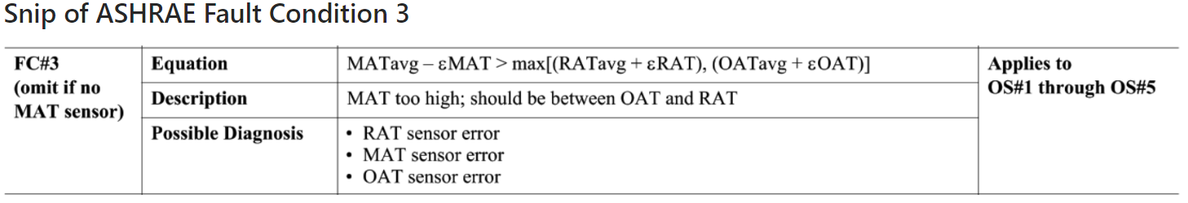

## Dataset Plot

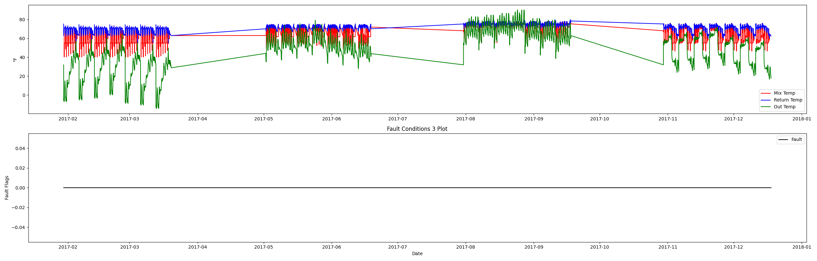

## Dataset Statistics

* Total time in days calculated in dataset: 322.0
* Total time in hours calculated in dataset: 7727.983333333334
* Total time in hours for when fault flag is True: 0.0
* Percent of time in the dataset when the fault flag is True: 0.0%
* Percent of time in the dataset when the fault flag is False: 100.0%
* Calculated motor runtime in hours based off of VFD signal > zero: 3061.08
* No faults were found in this given dataset for the equation defined by ASHRAE.

# Summary Statistics filtered for when the AHU is running

### Mix Temp

* count 183665.000000  
  mean 64.303172  
  std 7.987304  
  min 40.262000  
  25% 55.090000  
  50% 64.300000  
  75% 72.220000  
  max 78.320000  
  Name: AHU: Mixed Air Temperature, dtype: float64

### Return Temp

* count 183665.000000  
  mean 71.173949  
  std 3.476898  
  min 55.262000  
  25% 70.102000  
  50% 71.834000  
  75% 73.898000  
  max 79.366000  
  Name: AHU: Return Air Temperature, dtype: float64

### Outside Temp

* count 183665.000000  
  mean 47.087935  
  std 22.141181  
  min -14.236000  
  25% 32.720000  
  50% 51.700000  
  75% 63.536000  
  max 90.140000  
  Name: AHU: Outdoor Air Temperature, dtype: float64

## Suggestions based on data analysis

* The percent True of time is low inidicating the AHU temperature sensors are within calibration

Report generated: Sat Apr 1 13:45:59 2023