Fault Condition Five Report

Fault condition five of ASHRAE Guideline 36 is (an AHU heating mode or winter time conditions only fault equation) related to flagging supply air temperatures that are out of acceptable ranges based on the mix air temperature and an assumption for heat created by the AHU supply fan in the air stream. Fault condition five equation as defined by ASHRAE:

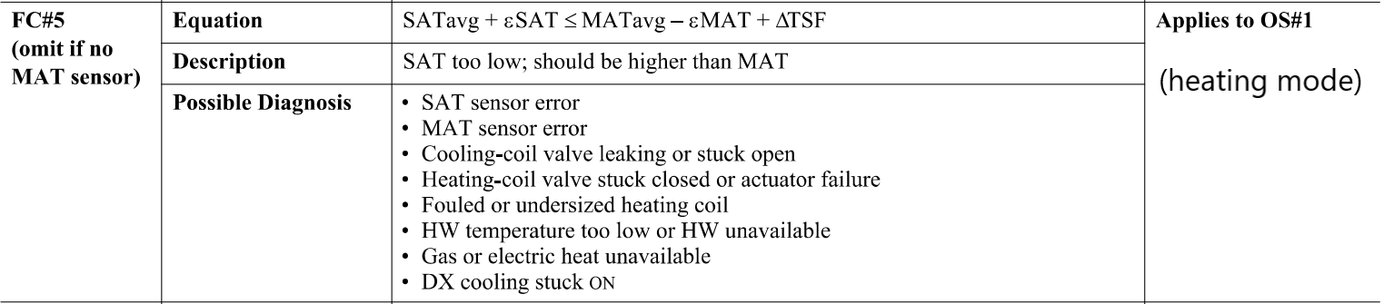

## Dataset Plot

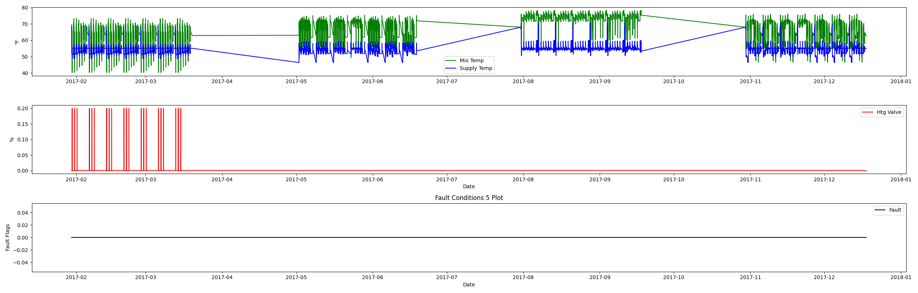

## Dataset Statistics

* Total time in days calculated in dataset: 322.0
* Total time in hours calculated in dataset: 7727.983333333334
* Total time in hours for when fault flag is True: 0.0
* Percent of time in the dataset when the fault flag is True: 0.0%
* Percent of time in the dataset when the fault flag is False: 100.0%
* Calculated motor runtime in hours based off of VFD signal > zero: 3061.08
* No faults were found in this given dataset for the equation defined by ASHRAE.

# Summary Statistics filtered for when the AHU is running

### Mix Temp

* count 183665.000000  
  mean 64.303172  
  std 7.987304  
  min 40.262000  
  25% 55.090000  
  50% 64.300000  
  75% 72.220000  
  max 78.320000  
  Name: AHU: Mixed Air Temperature, dtype: float64

### Supply Temp

* count 183665.000000  
  mean 54.113744  
  std 1.730771  
  min 48.578000  
  25% 52.740000  
  50% 54.928000  
  75% 55.046000  
  max 70.310000  
  Name: AHU: Supply Air Temperature, dtype: float64

## Suggestions based on data analysis

* The percent True metric that represents the amount of time for when the fault flag is True is low inidicating the AHU temperature sensors are within calibration

Report generated: Sat Apr 1 13:56:38 2023