Fault Condition Ten Report

Fault condition ten of ASHRAE Guideline 36 is an AHU economizer + mechanical cooling mode only with an attempt at flagging conditions where the outside air temperature and mixing air temperatures are not approximetely equal when the AHU is in a 100% outside air mode. Fault condition ten equation as defined by ASHRAE:

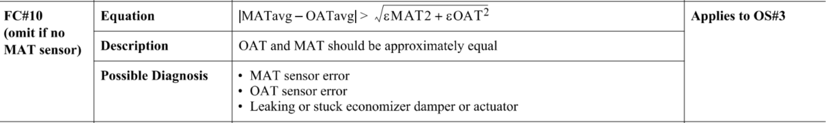

## Dataset Plot

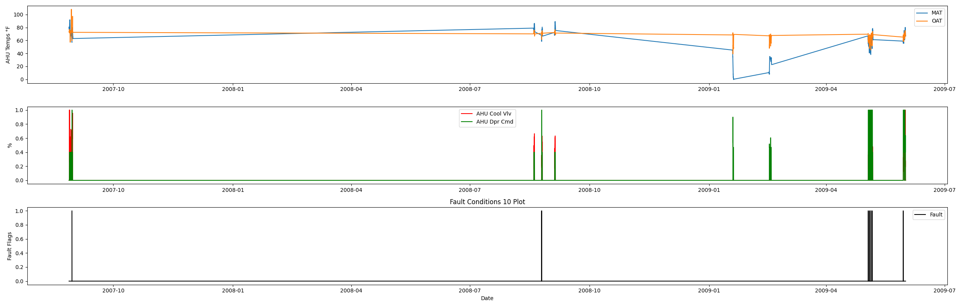

## Dataset Statistics

* Total time in days calculated in dataset: 643.0
* Total time in hours calculated in dataset: 15431.983333333334
* Total time in hours for when fault flag is True: 0.48333333333333334
* Percent of time in the dataset when the fault flag is True: 0.13%
* Percent of time in the dataset when the fault flag is False: 99.87%
* Calculated motor runtime in hours based off of VFD signal > zero: 15431.98
* This fan system appears to run 24/7 consider implementing occupancy schedules to reduce building fuel use through HVAC

## Time-of-day Histogram Plots

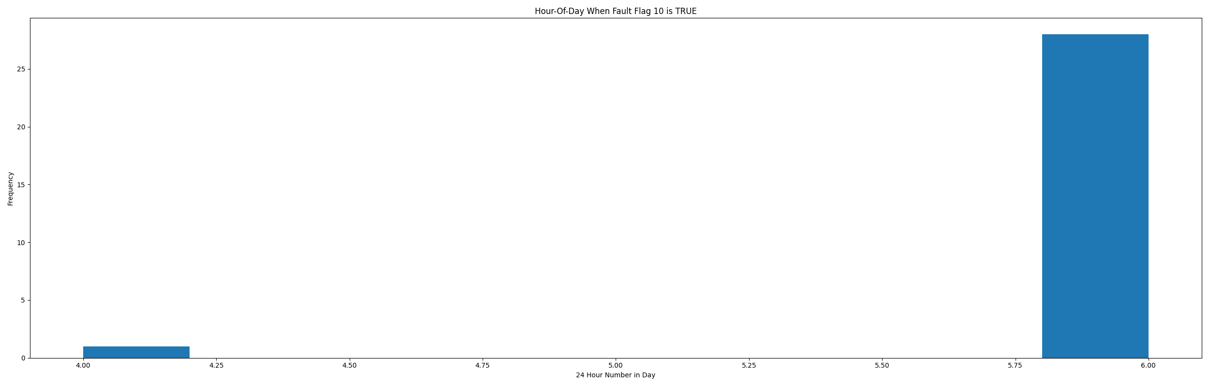

* When fault condition 9 is True the average outside air is 53.29 in °F and the mixing air temperature is 43.58 in °F.

# Summary Statistics filtered for when the AHU is running

### Mixing Air Temp

* count 21600.000000  
  mean 58.224958  
  std 21.454548  
  min -0.456000  
  25% 44.965500  
  50% 63.643000  
  75% 74.556500  
  max 91.776000  
  Name: AHU: Outdoor Air Temperature, dtype: float64

### Outside Air Temp

* count 21600.000000  
  mean 67.488601  
  std 7.859105  
  min 39.212000  
  25% 64.080000  
  50% 68.684000  
  75% 72.590000  
  max 108.130000  
  Name: AHU: Mixed Air Temperature, dtype: float64

## Suggestions based on data analysis

* The percent True metric that represents the amount of time for when the fault flag is True is low inidicating the AHU components are within calibration for this fault equation Ok.

Report generated: Sat Apr 1 13:59:16 2023