Fault Condition Eleven Report

Fault condition eleven of ASHRAE Guideline 36 is an AHU economizer + mechanical cooling mode only with an attempt at flagging conditions where the outside air temperature is too low for 100% outside air AHU operating mode. Fault condition Eleven equation as defined by ASHRAE:

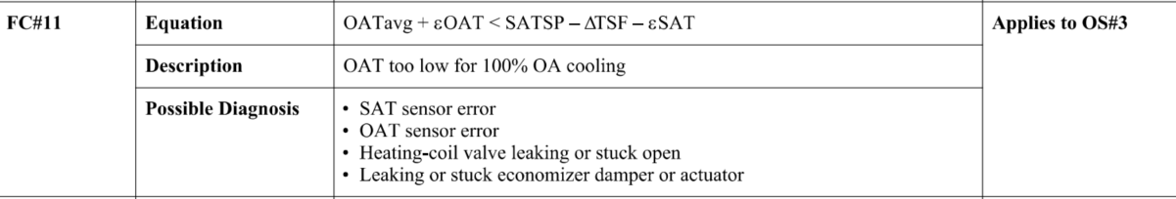

## Dataset Plot

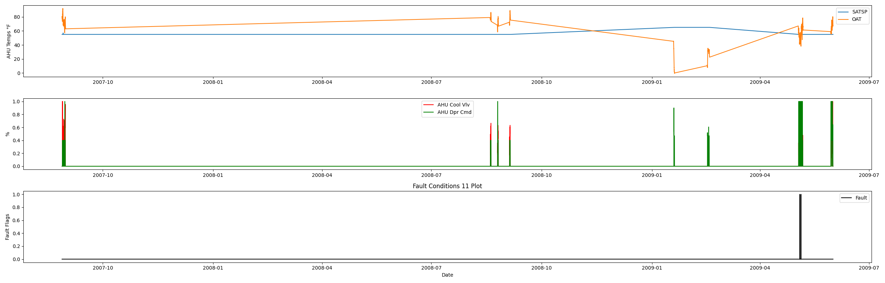

## Dataset Statistics

* Total time in days calculated in dataset: 643.0
* Total time in hours calculated in dataset: 15431.983333333334
* Total time in hours for when fault flag is True: 0.55
* Percent of time in the dataset when the fault flag is True: 0.15%
* Percent of time in the dataset when the fault flag is False: 99.85%
* Calculated motor runtime in hours based off of VFD signal > zero: 15431.98
* This fan system appears to run 24/7 consider implementing occupancy schedules to reduce building fuel use through HVAC

## Time-of-day Histogram Plots

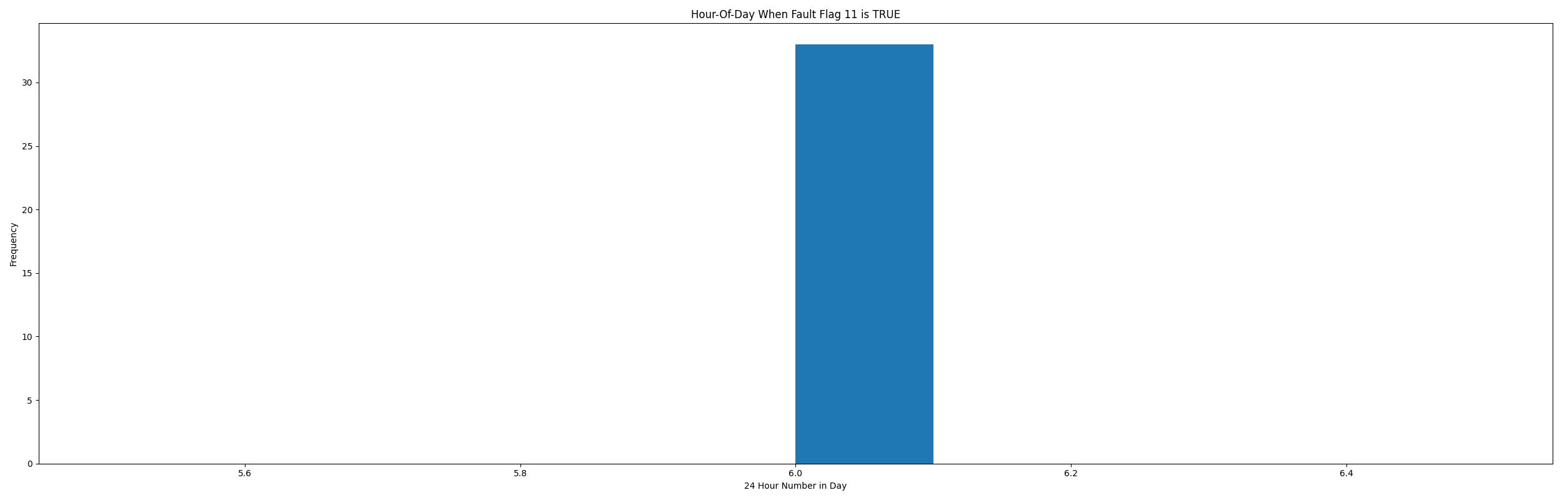

* When fault condition 11 is True the average AHU mix air is 40.49 in °F and the supply air temperature is 55.0 in °F.

# Summary Statistics filtered for when the AHU is running

### Supply Air Temp Setpoint

* count 21600.000000  
  mean 57.000463  
  std 3.999977  
  min 55.000000  
  25% 55.000000  
  50% 55.000000  
  75% 55.000000  
  max 65.000000  
  Name: AHU: Supply Air Temperature Set Point, dtype: float64

### Outside Air Temp

* count 21600.000000  
  mean 58.224958  
  std 21.454548  
  min -0.456000  
  25% 44.965500  
  50% 63.643000  
  75% 74.556500  
  max 91.776000  
  Name: AHU: Outdoor Air Temperature, dtype: float64

## Suggestions based on data analysis

* The percent True metric that represents the amount of time for when the fault flag is True is low inidicating the AHU components are within calibration for this fault equation Ok.

Report generated: Sat Apr 1 13:59:59 2023