Fault Condition One Report

Fault condition one of ASHRAE Guideline 36 is related to flagging poor performance of a AHU variable supply fan attempting to control to a duct pressure setpoint. Fault condition equation as defined by ASHRAE:

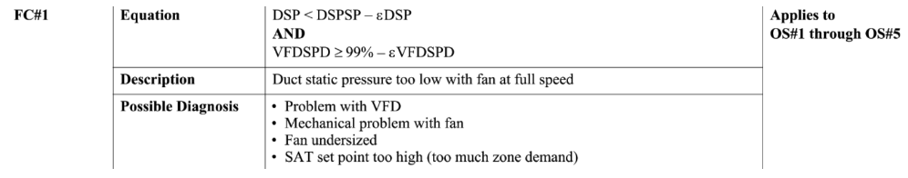

## Dataset Plot

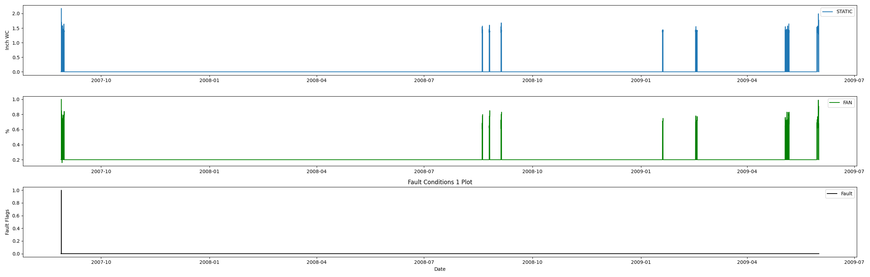

## Dataset Statistics

* Total time in days calculated in dataset: 643.0
* Total time in hours calculated in dataset: 15431.983333333334
* Total time in hours for when fault flag is True: 0.38333333333333336
* Percent of time in the dataset when the fault flag is True: 0.11%
* Percent of time in the dataset when the fault flag is False: 99.89%
* Calculated motor runtime in hours based off of VFD signal > zero: 15431.98
* This fan system appears to run 24/7 consider implementing occupancy schedules to reduce building fuel use through HVAC

## Time-of-day Histogram Plots

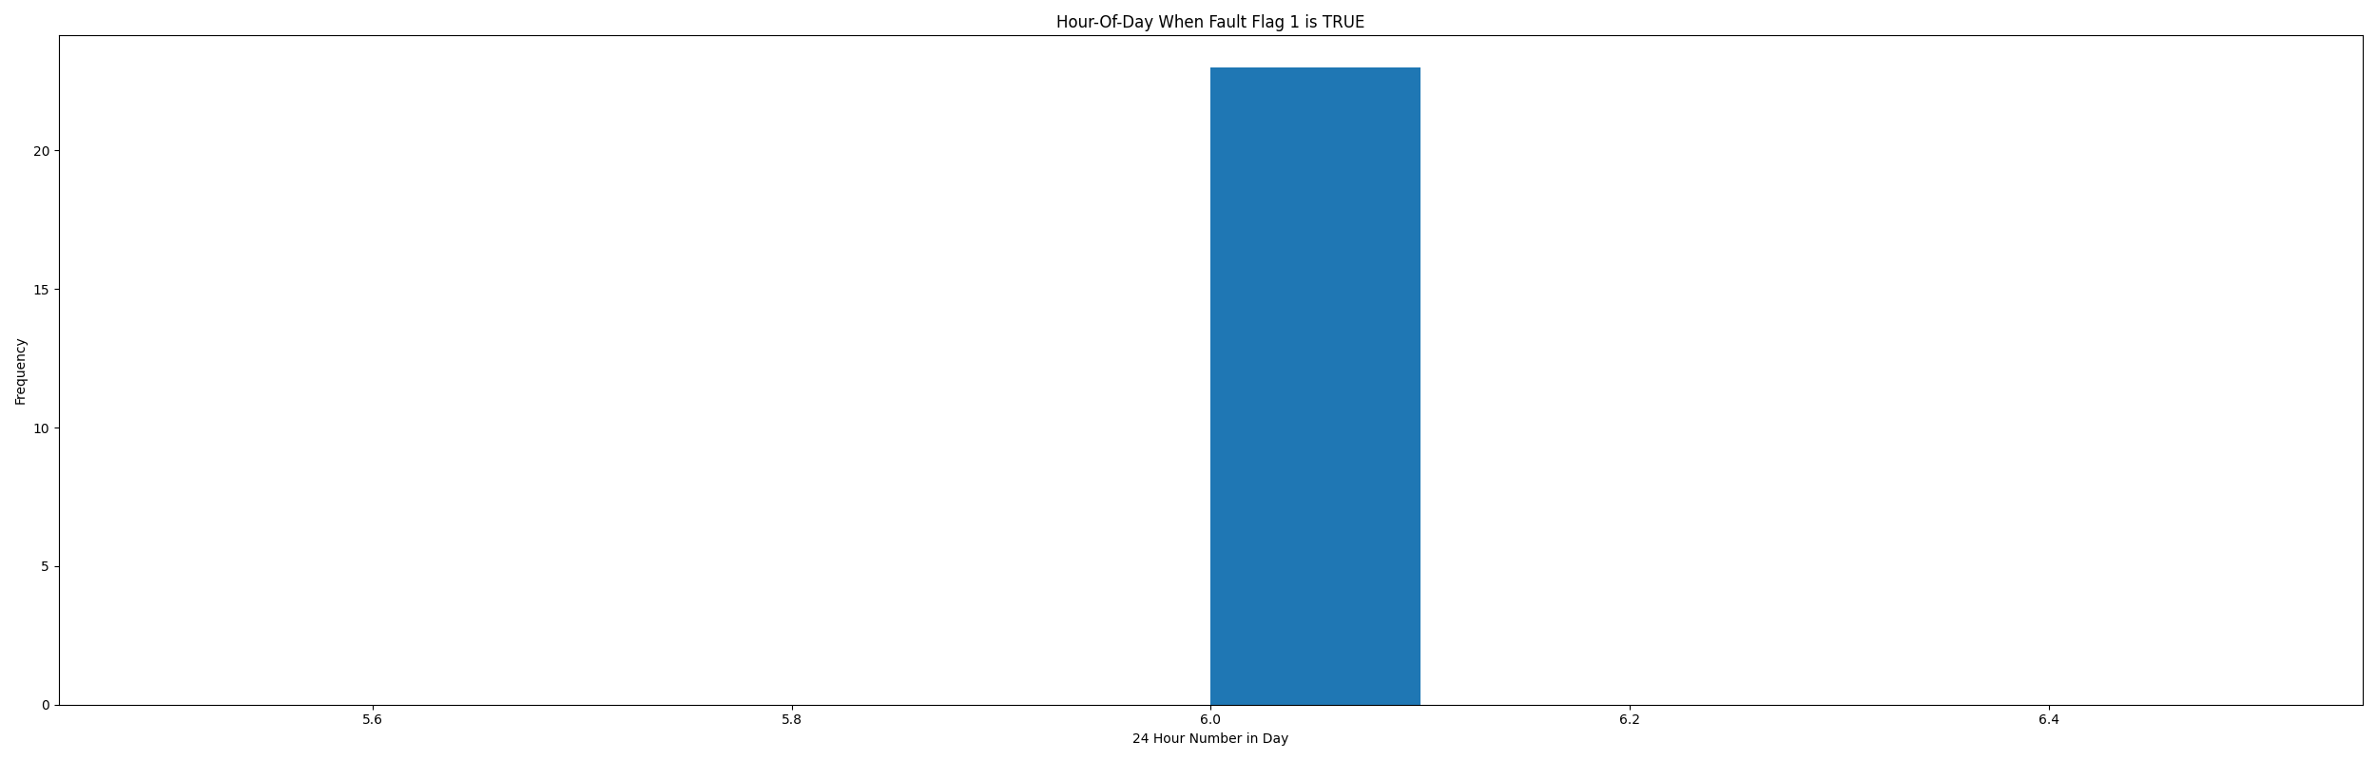

* Average duct system pressure for when in fault condition (fan VFD speed > 95%): 1.21"WC

# Summary Statistics filtered for when the AHU is running

### VFD Speed

* count 21600.000000  
  mean 0.474657  
  std 0.260736  
  min 0.160000  
  25% 0.200000  
  50% 0.620000  
  75% 0.718000  
  max 1.000000  
  Name: AHU: Supply Air Fan Speed Control Signal, dtype: float64

### Duct Pressure

* count 21600.000000  
  mean 0.738494  
  std 0.694503  
  min 0.000000  
  25% 0.000000  
  50% 1.354000  
  75% 1.396000  
  max 2.176000  
  Name: AHU: Supply Air Duct Static Pressure, dtype: float64

### Duct Pressure Setpoint

* count 21600.0  
  mean 1.4  
  std 0.0  
  min 1.4  
  25% 1.4  
  50% 1.4  
  75% 1.4  
  max 1.4  
  Name: AHU: Supply Air Duct Static Pressure Set Point, dtype: float64

## Suggestions based on data analysis

* The percent True metric that represents the amount of time for when the fault flag is True is low inidicating the fan appears to generate good duct static pressure
* No duct static pressure setpoint reset detected consider implementing a reset strategy to save AHU fan energy

Report generated: Sat Apr 1 13:44:23 2023