Fault Condition Five Report

Fault condition five of ASHRAE Guideline 36 is (an AHU heating mode or winter time conditions only fault equation) related to flagging supply air temperatures that are out of acceptable ranges based on the mix air temperature and an assumption for heat created by the AHU supply fan in the air stream. Fault condition five equation as defined by ASHRAE:

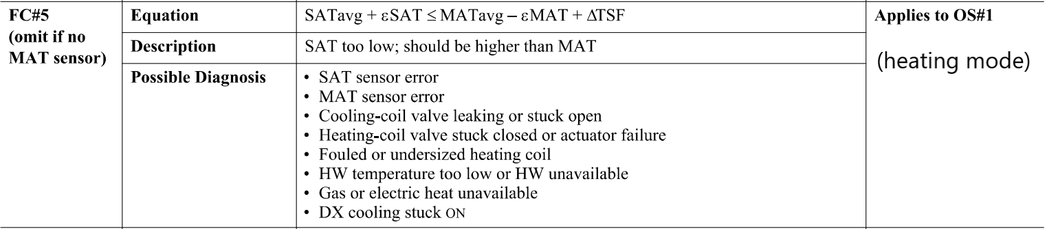

## Dataset Plot

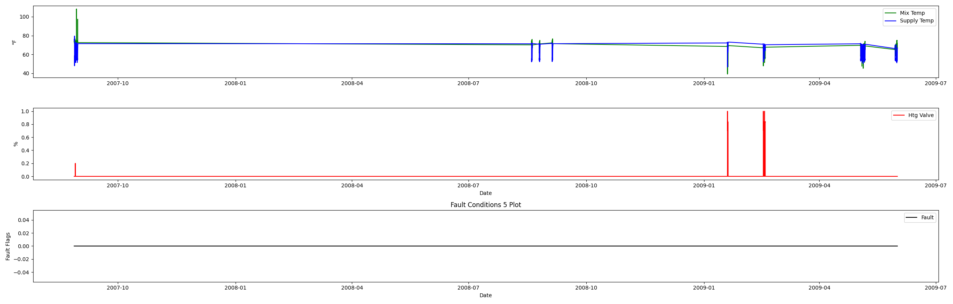

## Dataset Statistics

* Total time in days calculated in dataset: 643.0
* Total time in hours calculated in dataset: 15431.983333333334
* Total time in hours for when fault flag is True: 0.0
* Percent of time in the dataset when the fault flag is True: 0.0%
* Percent of time in the dataset when the fault flag is False: 100.0%
* Calculated motor runtime in hours based off of VFD signal > zero: 15431.98
* This fan system appears to run 24/7 consider implementing occupancy schedules to reduce building fuel use through HVAC
* No faults were found in this given dataset for the equation defined by ASHRAE.

# Summary Statistics filtered for when the AHU is running

### Mix Temp

* count 21600.000000  
  mean 67.488601  
  std 7.859105  
  min 39.212000  
  25% 64.080000  
  50% 68.684000  
  75% 72.590000  
  max 108.130000  
  Name: AHU: Mixed Air Temperature, dtype: float64

### Supply Temp

* count 21600.000000  
  mean 62.996892  
  std 7.352721  
  min 46.624000  
  25% 55.150000  
  50% 64.792000  
  75% 70.430000  
  max 79.474000  
  Name: AHU: Supply Air Temperature, dtype: float64

## Suggestions based on data analysis

* The percent True metric that represents the amount of time for when the fault flag is True is low inidicating the AHU temperature sensors are within calibration

Report generated: Tue Apr 11 11:58:11 2023