Fault Condition Seven Report

Fault condition seven of ASHRAE Guideline 36 is an AHU heating mode only with an attempt at verifying an AHU heating or cooling valve is not stuck or leaking by verifying AHU supply temperature to supply temperature setpoint. Fault condition seven equation as defined by ASHRAE:

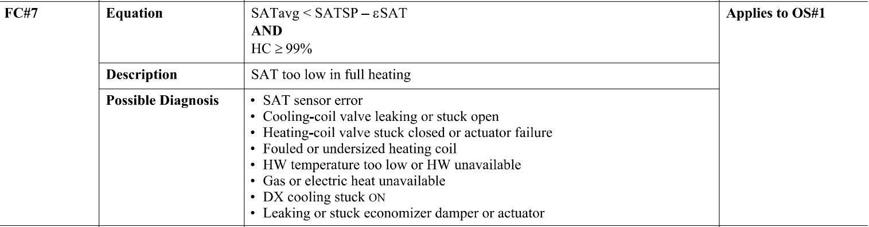

## Dataset Plot

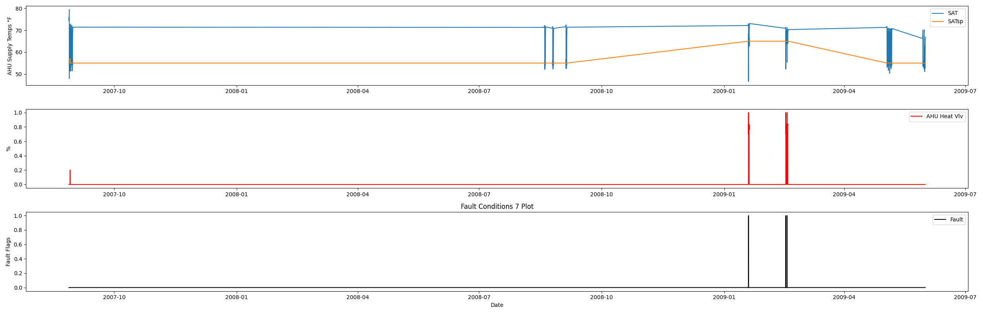

## Dataset Statistics

* Total time in days calculated in dataset: 643.0
* Total time in hours calculated in dataset: 15431.983333333334
* Total time in hours for when fault flag is True: 0.8
* Percent of time in the dataset when the fault flag is True: 0.22%
* Percent of time in the dataset when the fault flag is False: 99.78%
* Calculated motor runtime in hours based off of VFD signal > zero: 15431.98
* This fan system appears to run 24/7 consider implementing occupancy schedules to reduce building fuel use through HVAC

## Time-of-day Histogram Plots

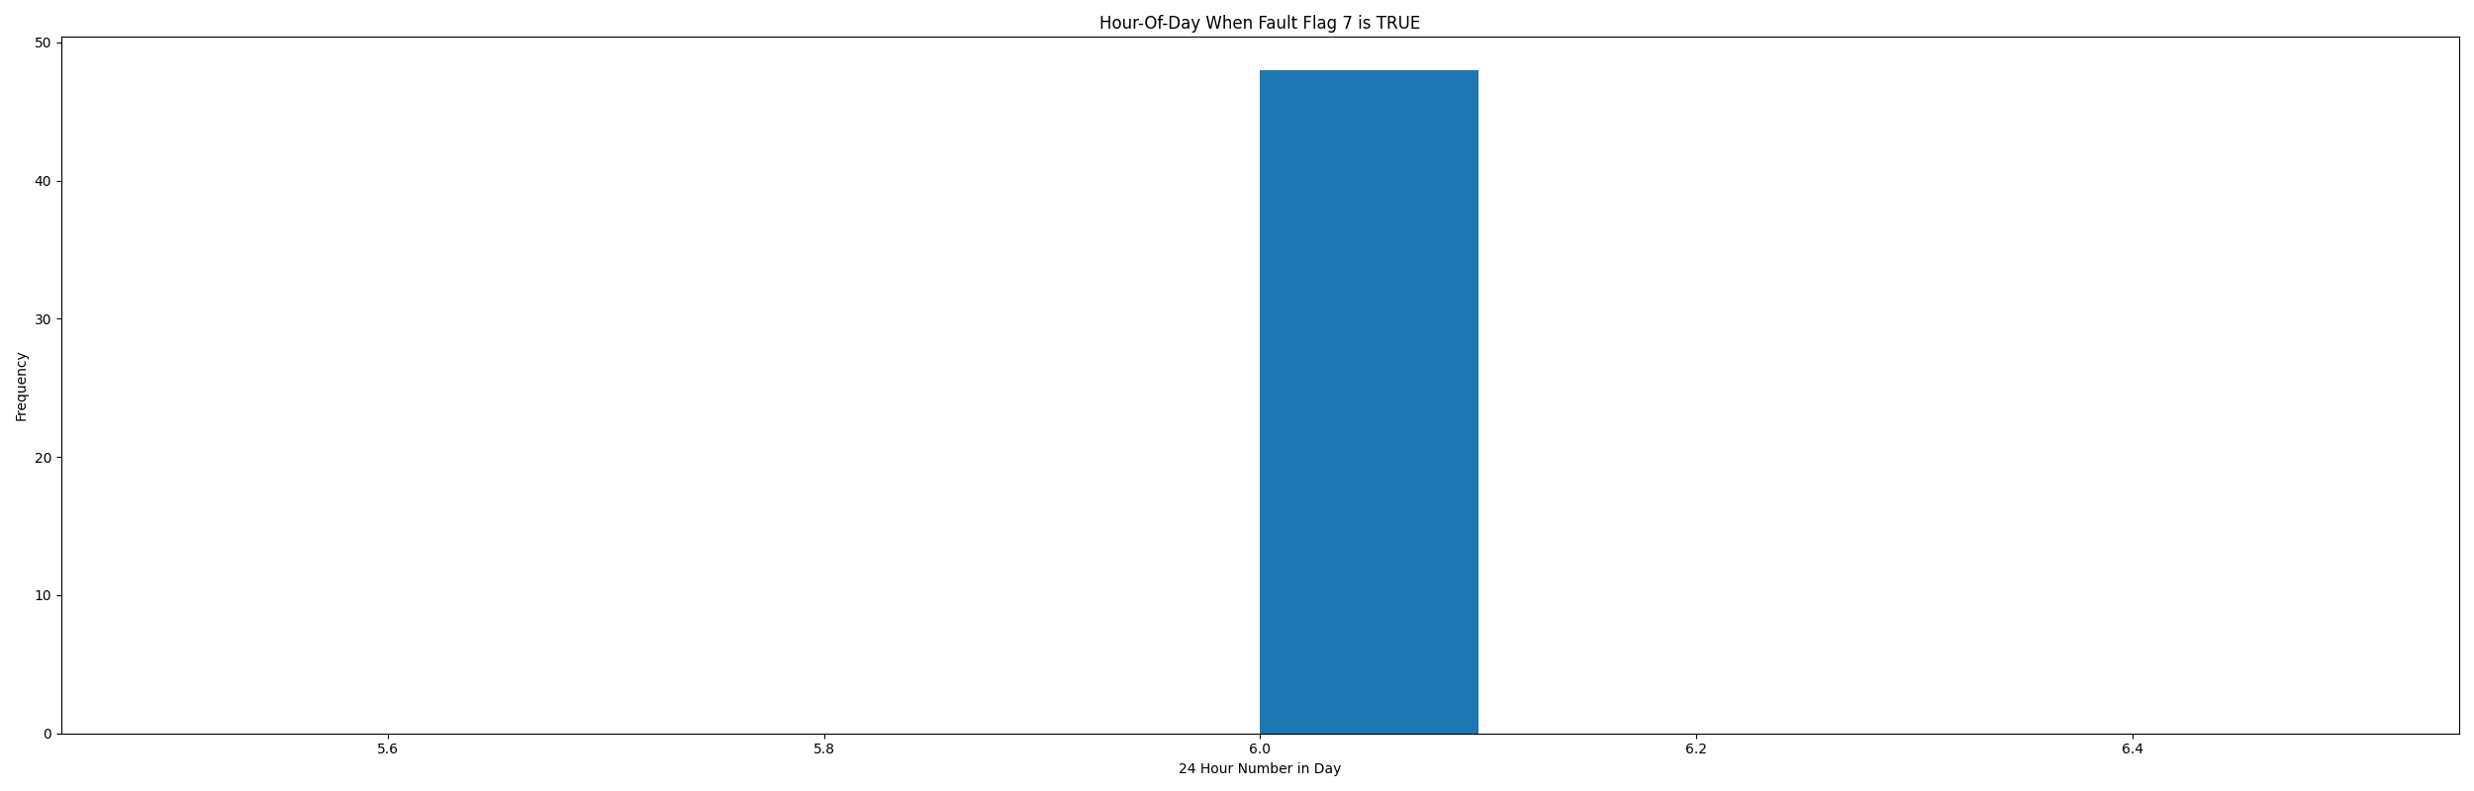

* When fault condition 7 is True the average AHU supply air setpoint is 55.93 in °F and the supply air temperature is 65.0 in °F.

# Summary Statistics filtered for when the AHU is running

### Supply Air Temp

* count 21600.000000  
  mean 62.996892  
  std 7.352721  
  min 46.624000  
  25% 55.150000  
  50% 64.792000  
  75% 70.430000  
  max 79.474000  
  Name: AHU: Supply Air Temperature, dtype: float64

### Supply Air Temp Setpoint

* count 21600.000000  
  mean 57.000463  
  std 3.999977  
  min 55.000000  
  25% 55.000000  
  50% 55.000000  
  75% 55.000000  
  max 65.000000  
  Name: AHU: Supply Air Temperature Set Point, dtype: float64

### Heating Coil Valve

* count 21600.000000  
  mean 0.083330  
  std 0.249507  
  min 0.000000  
  25% 0.000000  
  50% 0.000000  
  75% 0.000000  
  max 1.000000  
  Name: AHU: Heating Coil Valve Control Signal, dtype: float64

## Suggestions based on data analysis

* The percent True metric that represents the amount of time for when the fault flag is True is low inidicating the AHU heating valve operates Ok.

Report generated: Tue Apr 11 11:59:09 2023