Fault Condition Eight Report

Fault condition Eight of ASHRAE Guideline 36 is an AHU economizer free cooling mode only with an attempt at flagging conditions when the AHU mixing air temperature the supply air temperature are not approximately equal. Fault condition eight equation as defined by ASHRAE:

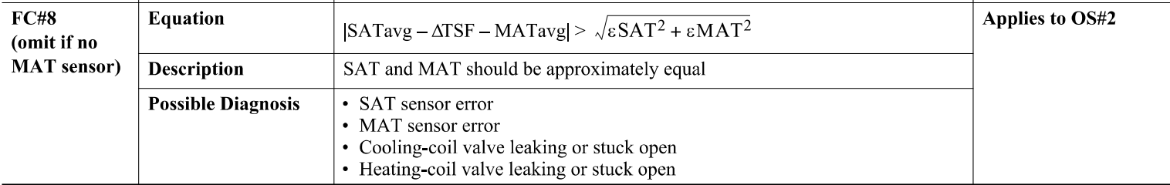

## Dataset Plot

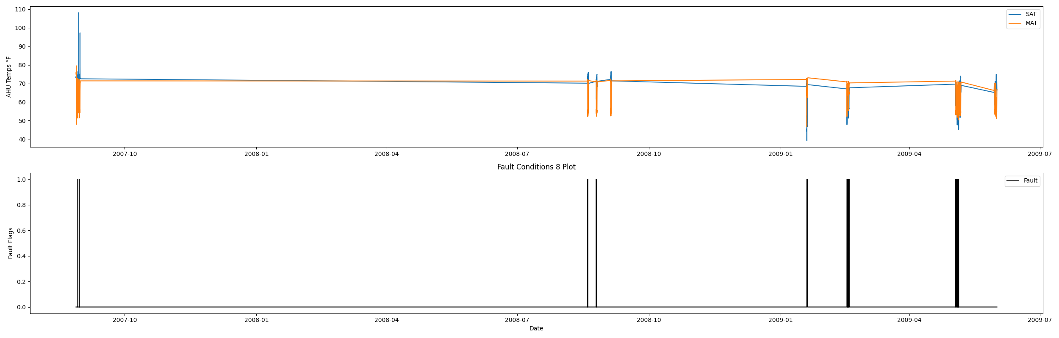

## Dataset Statistics

* Total time in days calculated in dataset: 643.0
* Total time in hours calculated in dataset: 15431.983333333334
* Total time in hours for when fault flag is True: 31.733333333333334
* Percent of time in the dataset when the fault flag is True: 8.81%
* Percent of time in the dataset when the fault flag is False: 91.19%
* Calculated motor runtime in hours based off of VFD signal > zero: 15431.98
* This fan system appears to run 24/7 consider implementing occupancy schedules to reduce building fuel use through HVAC

## Time-of-day Histogram Plots

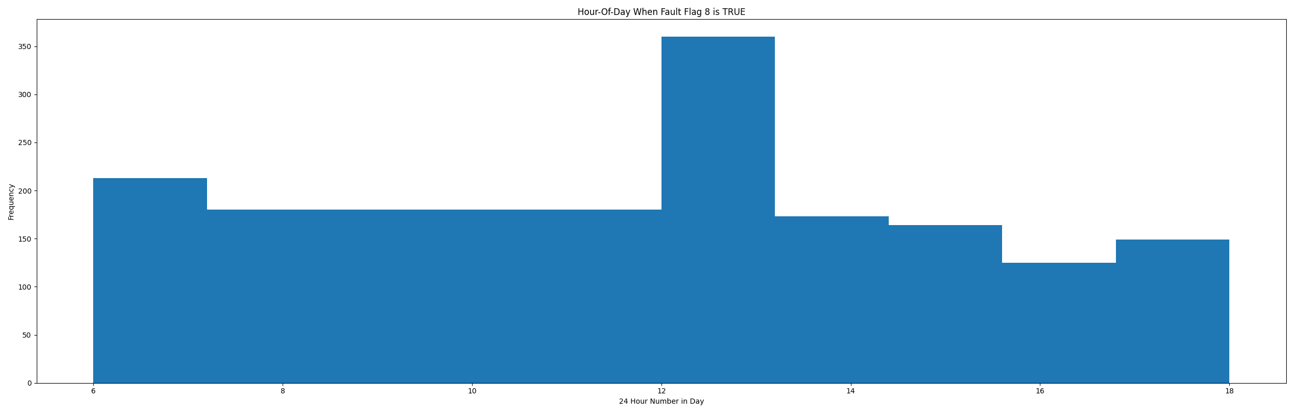

* When fault condition 8 is True the average AHU mix air is 65.0 in °F and the supply air temperature is 52.92 in °F.

# Summary Statistics filtered for when the AHU is running

### Supply Air Temp

* count 21600.000000  
  mean 67.488601  
  std 7.859105  
  min 39.212000  
  25% 64.080000  
  50% 68.684000  
  75% 72.590000  
  max 108.130000  
  Name: AHU: Mixed Air Temperature, dtype: float64

### Mix Air Temp

* count 21600.000000  
  mean 62.996892  
  std 7.352721  
  min 46.624000  
  25% 55.150000  
  50% 64.792000  
  75% 70.430000  
  max 79.474000  
  Name: AHU: Supply Air Temperature, dtype: float64

## Suggestions based on data analysis

* The percent True metric that represents the amount of time for when the fault flag is True is high indicating temperature sensor error or the heating/cooling coils are leaking potentially creating simultenious heating/cooling which can be an energy penalty for running the AHU in this fashion. Verify AHU mix/supply temperature sensor calibration in addition to a potential mechanical issue of a leaking valve. A leaking valve can be troubleshot by isolating the valve closed by manual shut off valves where piping lines enter the AHU coil and then verifying any changes in the AHU discharge air temperature.

Report generated: Tue Apr 11 11:59:51 2023