Fault Condition Ten Report

Fault condition ten of ASHRAE Guideline 36 is an AHU economizer + mechanical cooling mode only with an attempt at flagging conditions where the outside air temperature and mixing air temperatures are not approximetely equal when the AHU is in a 100% outside air mode. Fault condition ten equation as defined by ASHRAE:

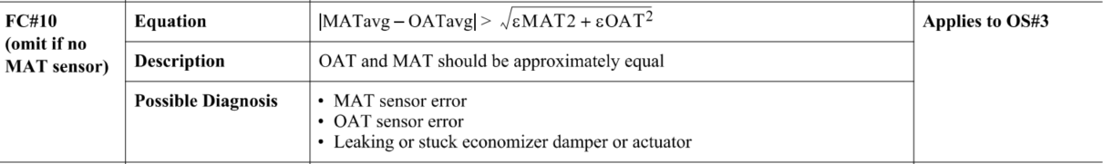

## Dataset Plot

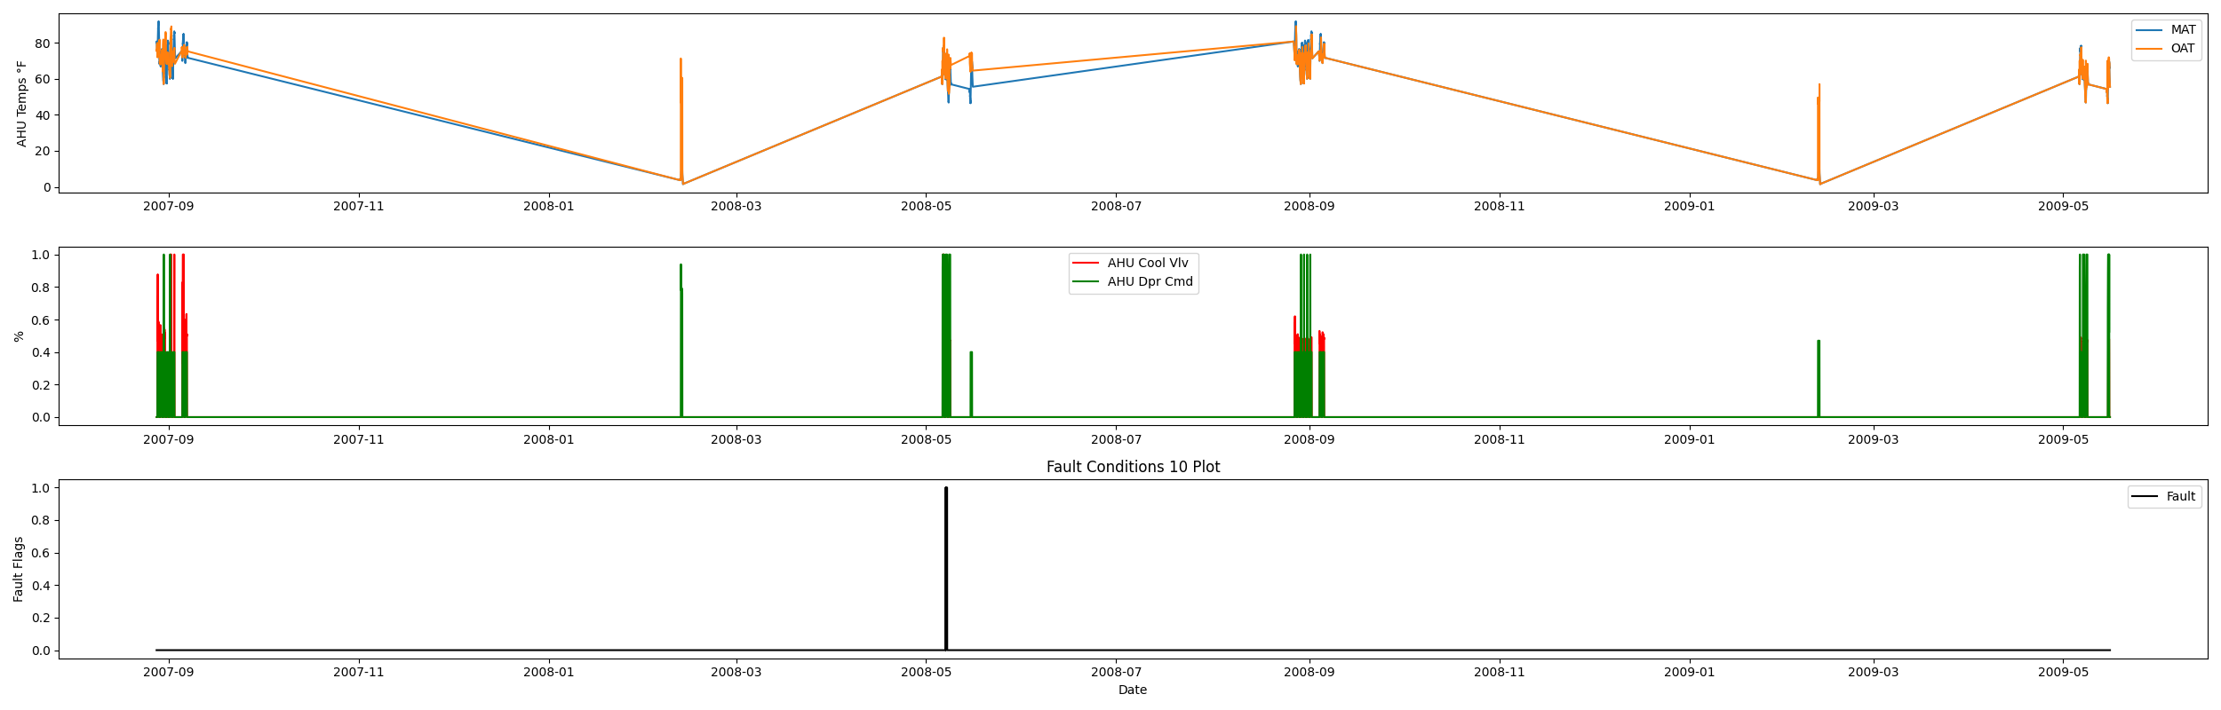

## Dataset Statistics

* Total time in days calculated in dataset: 627.0
* Total time in hours calculated in dataset: 15047.983333333334
* Total time in hours for when fault flag is True: 11.4
* Percent of time in the dataset when the fault flag is True: 1.83%
* Percent of time in the dataset when the fault flag is False: 98.17%
* Calculated motor runtime in hours based off of VFD signal > zero: 601.32

## Time-of-day Histogram Plots

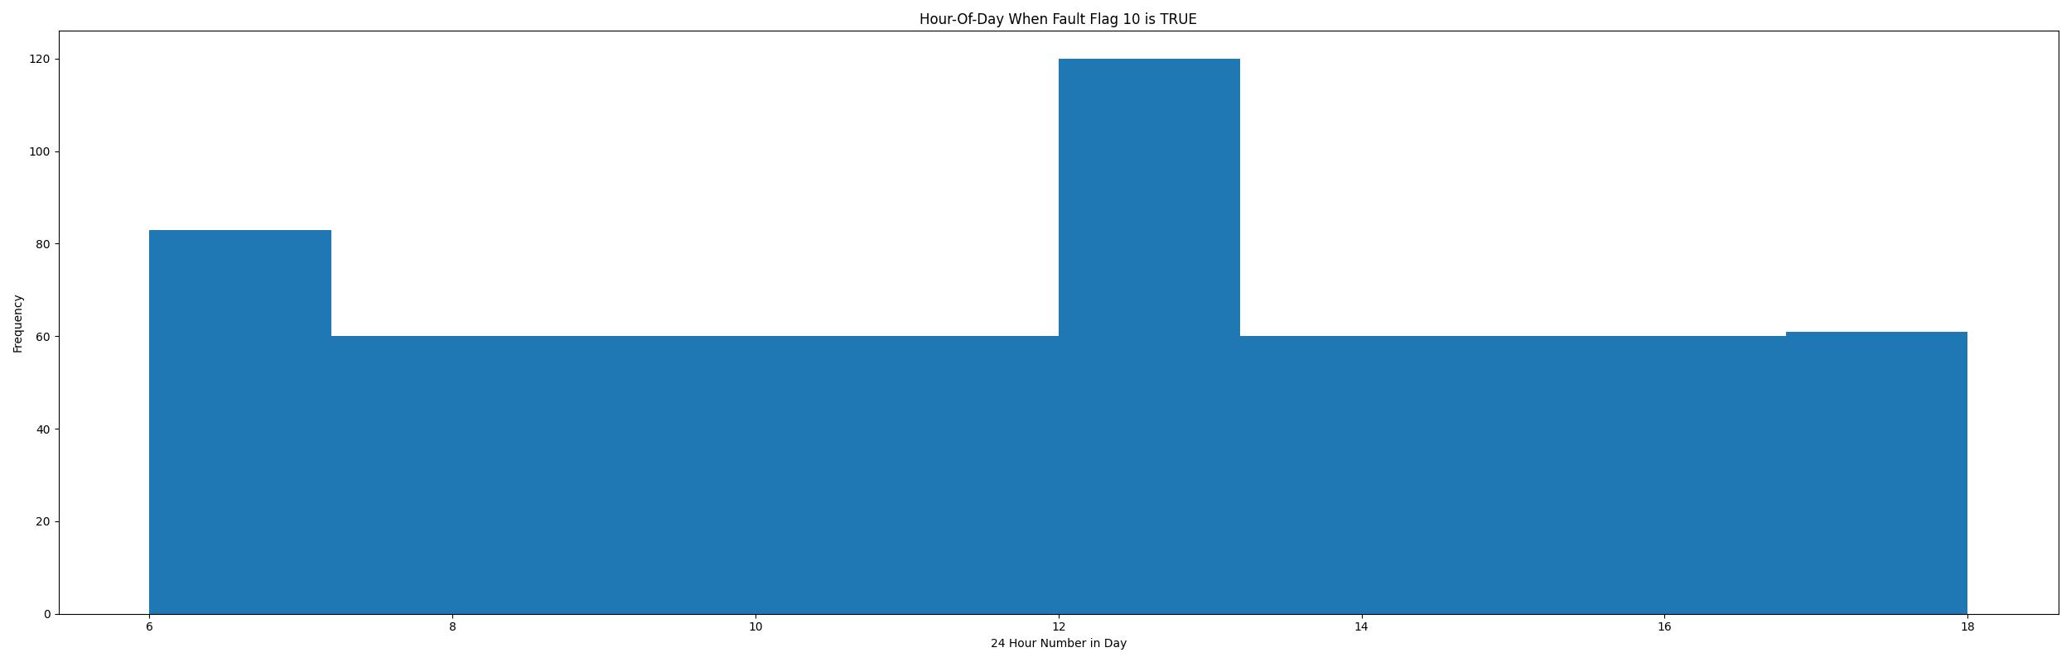

* When fault condition 9 is True the average outside air is 72.05 in °F and the mixing air temperature is 62.35 in °F.

# Summary Statistics filtered for when the AHU is running

### Mixing Air Temp

* count 24560.000000  
  mean 67.099021  
  std 17.318396  
  min 3.856000  
  25% 62.128000  
  50% 70.887000  
  75% 77.378000  
  max 91.776000  
  Name: AHU: Outdoor Air Temperature, dtype: float64

### Outside Air Temp

* count 24560.000000  
  mean 70.859680  
  std 7.275293  
  min 15.946000  
  25% 67.696000  
  50% 72.976000  
  75% 74.614500  
  max 89.022000  
  Name: AHU: Mixed Air Temperature, dtype: float64

## Suggestions based on data analysis

* The percent True metric that represents the amount of time for when the fault flag is True is low inidicating the AHU components are within calibration for this fault equation Ok.

Report generated: Sat Apr 1 13:59:23 2023