Fault Condition Twelve Report

Fault condition Twelve of ASHRAE Guideline 36 is an AHU economizer + mechanical cooling mode and AHU mechanical cooling mode only with an attempt at flagging conditions when the AHU mixing air temperature is warmer than the supply air temperature. Fault condition Twelve equation as defined by ASHRAE:

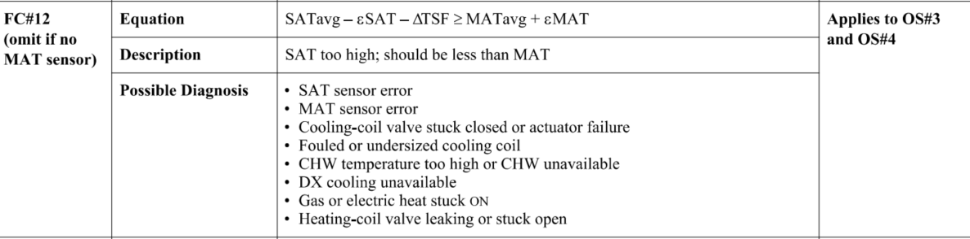

## Dataset Plot

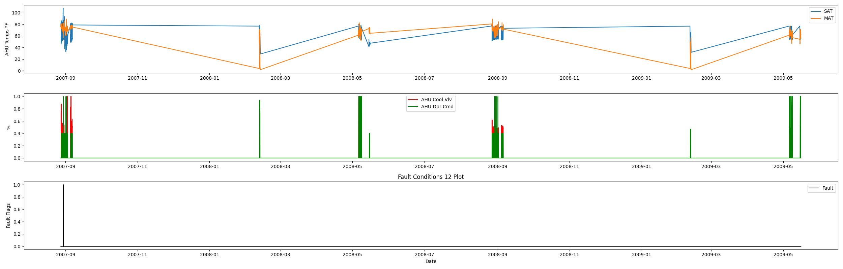

## Dataset Statistics

* Total time in days calculated in dataset: 627.0
* Total time in hours calculated in dataset: 15047.983333333334
* Total time in hours for when fault flag is True: 0.16666666666666666
* Percent of time in the dataset when the fault flag is True: 0.03%
* Percent of time in the dataset when the fault flag is False: 99.97%
* Calculated motor runtime in hours based off of VFD signal > zero: 601.32

## Time-of-day Histogram Plots

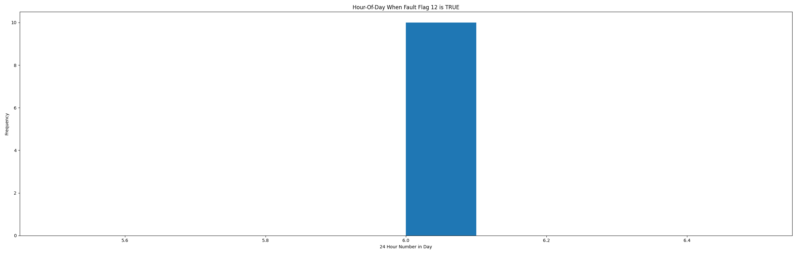

* When fault condition 12 is True the average AHU mix air is 57.21 in °F and the supply air temperature is 68.76 in °F.

# Summary Statistics filtered for when the AHU is running

### Supply Air Temp

* count 24560.000000  
  mean 60.927629  
  std 11.208602  
  min 23.950000  
  25% 54.938000  
  50% 55.270000  
  75% 65.034000  
  max 101.630000  
  Name: AHU: Supply Air Temperature, dtype: float64

### Mix Air Temp

* count 24560.000000  
  mean 70.859680  
  std 7.275293  
  min 15.946000  
  25% 67.696000  
  50% 72.976000  
  75% 74.614500  
  max 89.022000  
  Name: AHU: Mixed Air Temperature, dtype: float64

## Suggestions based on data analysis

* The percent True metric that represents the amount of time for when the fault flag is True is low inidicating the AHU components are within calibration for this fault equation Ok.

Report generated: Sat Apr 1 14:00:50 2023