Fault Condition One Report

Fault condition one of ASHRAE Guideline 36 is related to flagging poor performance of a AHU variable supply fan attempting to control to a duct pressure setpoint. Fault condition equation as defined by ASHRAE:

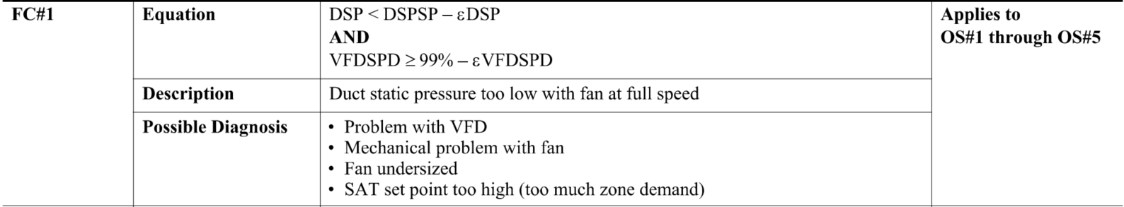

## Dataset Plot

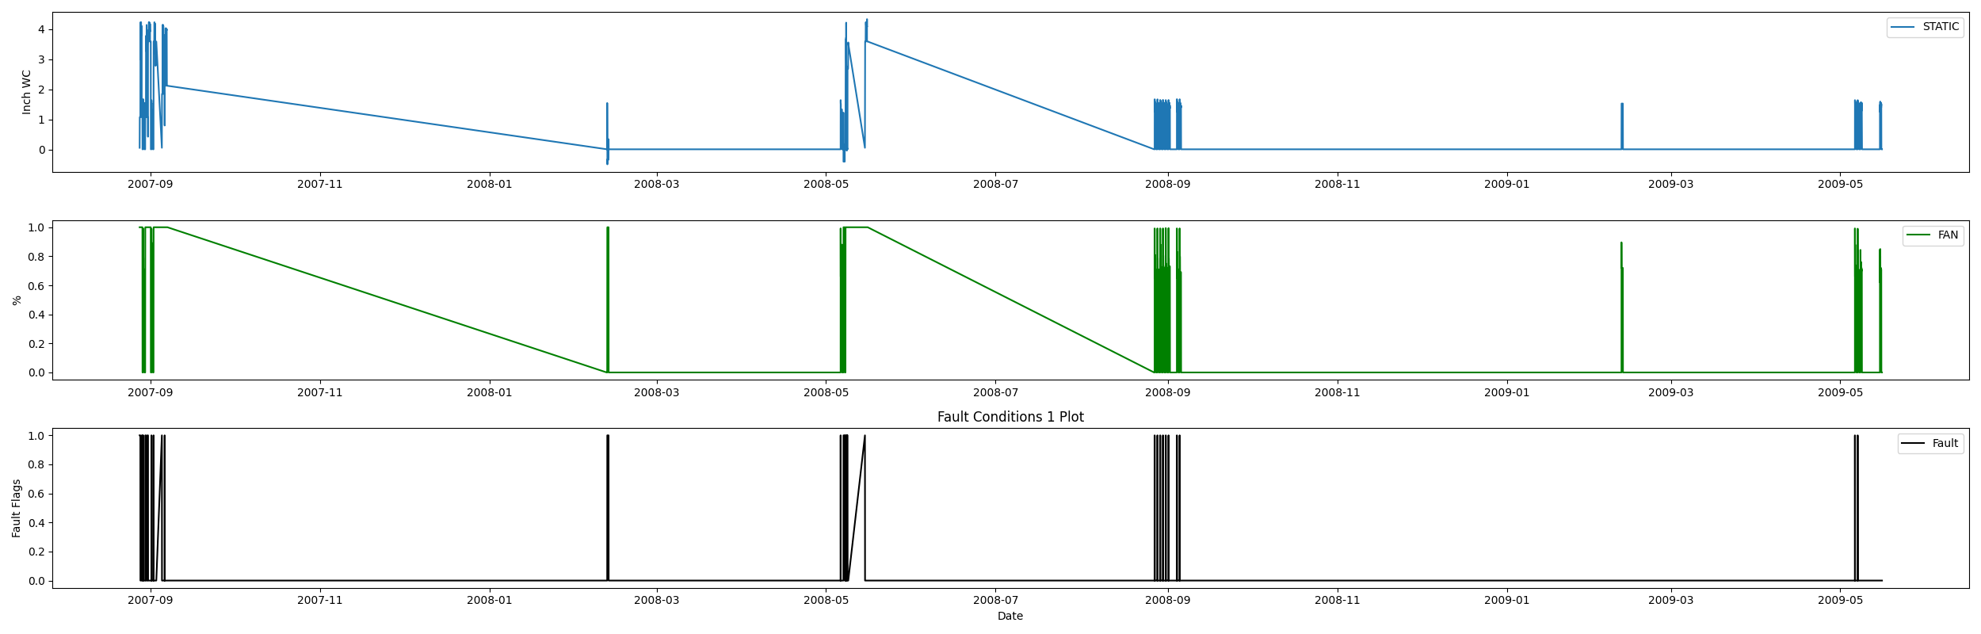

## Dataset Statistics

* Total time in days calculated in dataset: 627.0
* Total time in hours calculated in dataset: 15047.983333333334
* Total time in hours for when fault flag is True: 249.61666666666667
* Percent of time in the dataset when the fault flag is True: 9.24%
* Percent of time in the dataset when the fault flag is False: 90.76%
* Calculated motor runtime in hours based off of VFD signal > zero: 601.32

## Time-of-day Histogram Plots

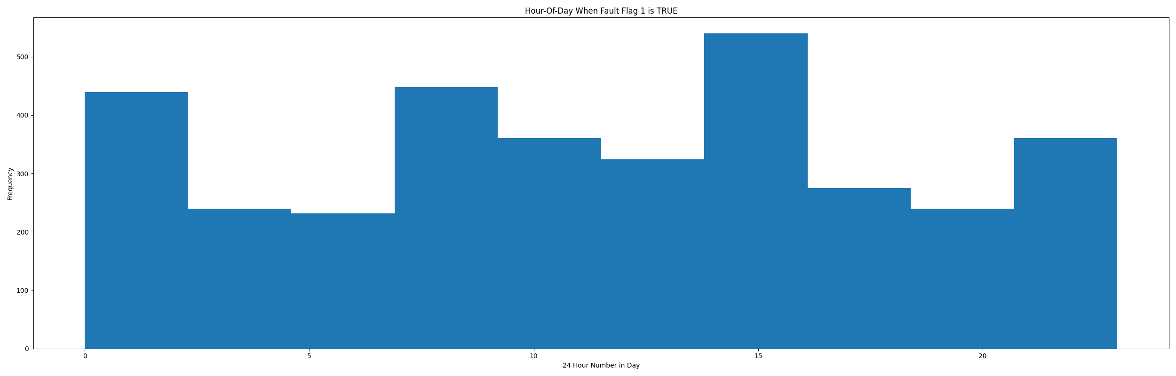

* Average duct system pressure for when in fault condition (fan VFD speed > 95%): 0.34"WC

# Summary Statistics filtered for when the AHU is running

### VFD Speed

* count 24560.000000  
  mean 0.867059  
  std 0.151767  
  min 0.138000  
  25% 0.710000  
  50% 1.000000  
  75% 1.000000  
  max 1.000000  
  Name: AHU: Supply Air Fan Speed Control Signal, dtype: float64

### Duct Pressure

* count 24560.000000  
  mean 2.041544  
  std 1.267347  
  min -0.490000  
  25% 1.372000  
  50% 1.530000  
  75% 3.590000  
  max 4.334000  
  Name: AHU: Supply Air Duct Static Pressure, dtype: float64

### Duct Pressure Setpoint

* count 2.456000e+04  
  mean 1.400000e+00  
  std 2.220491e-16  
  min 1.400000e+00  
  25% 1.400000e+00  
  50% 1.400000e+00  
  75% 1.400000e+00  
  max 1.400000e+00  
  Name: AHU: Supply Air Duct Static Pressure Set Point, dtype: float64

## Suggestions based on data analysis

* The percent True metric that represents the amount of time for when the fault flag is True is high indicating the fan is running at high speeds and appearing to not generate good duct static pressure
* No duct static pressure setpoint reset detected consider implementing a reset strategy to save AHU fan energy

Report generated: Thu Apr 27 09:28:51 2023