Fault Condition Two Report

Fault condition two and three of ASHRAE Guideline 36 is related to flagging mixing air temperatures of the AHU that are out of acceptable ranges. Fault condition 2 flags mixing air temperatures that are too low and fault condition 3 flags mixing temperatures that are too high when in comparision to return and outside air data. The mixing air temperatures in theory should always be in between the return and outside air temperatures ranges. Fault condition two equation as defined by ASHRAE:

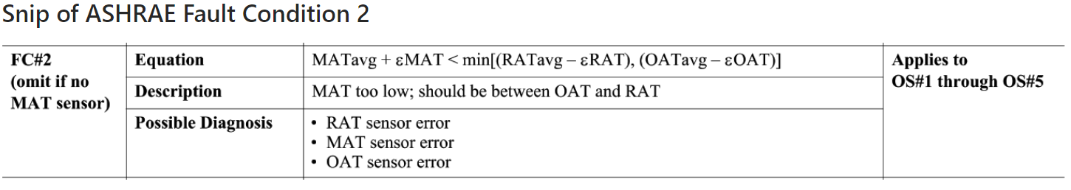

## Dataset Plot

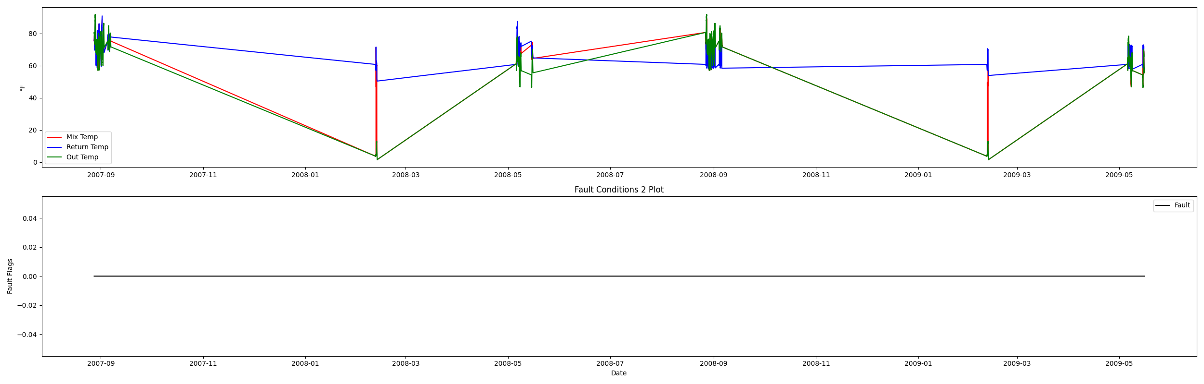

## Dataset Statistics

* Total time in days calculated in dataset: 627.0
* Total time in hours calculated in dataset: 15047.983333333334
* Total time in hours for when fault flag is True: 0.0
* Percent of time in the dataset when the fault flag is True: 0.0%
* Percent of time in the dataset when the fault flag is False: 100.0%
* Calculated motor runtime in hours based off of VFD signal > zero: 601.32
* No faults were found in this given dataset for the equation defined by ASHRAE.

# Summary Statistics filtered for when the AHU is running

### Mix Temp

* count 24560.000000  
  mean 70.859680  
  std 7.275293  
  min 15.946000  
  25% 67.696000  
  50% 72.976000  
  75% 74.614500  
  max 89.022000  
  Name: AHU: Mixed Air Temperature, dtype: float64

### Return Temp

* count 24560.000000  
  mean 72.828872  
  std 4.455810  
  min 59.386000  
  25% 71.328000  
  50% 72.000000  
  75% 72.534000  
  max 90.854000  
  Name: AHU: Return Air Temperature, dtype: float64

### Outside Temp

* count 24560.000000  
  mean 67.099021  
  std 17.318396  
  min 3.856000  
  25% 62.128000  
  50% 70.887000  
  75% 77.378000  
  max 91.776000  
  Name: AHU: Outdoor Air Temperature, dtype: float64

## Suggestions based on data analysis

* The percent True of time is low inidicating the AHU temperature sensors are within calibration

Report generated: Sat Apr 1 13:45:24 2023