Fault Condition Four Report

Fault condition four of ASHRAE Guideline 36 is related to flagging AHU control programming that is hunting between heating, economizing, economizing plus mechanical cooling, and mechanical cooling operating states. This fault diagnostic does NOT flag simultaneous heating and cooling, just excessive cycling between the states or operating modes the AHU maybe going in and out of. Fault condition four equation as defined by ASHRAE:



## Dataset Plot

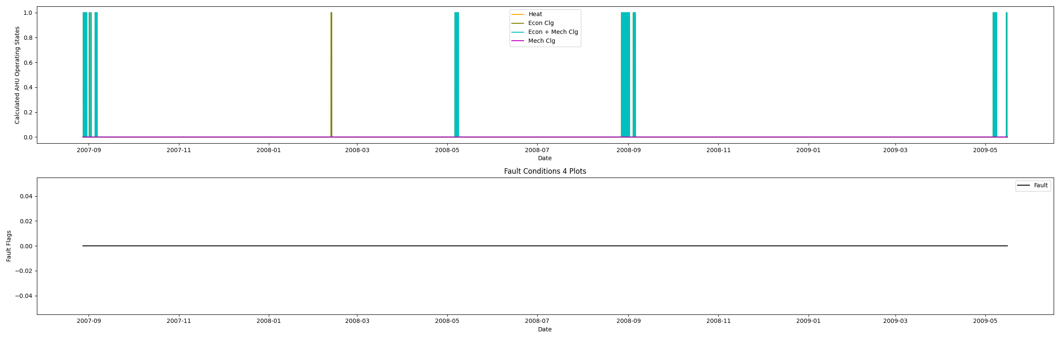

## Dataset Statistics

* Total time in days calculated in dataset: 626.96
* Total time in hours calculated in dataset: 15047.0
* Total time in hours for when fault flag is True: 0.0
* Percent of time in the dataset when the fault flag is True: 0.0%
* Percent of time in the dataset when the fault flag is False: 100.0%

## Calculated AHU Mode Statistics

* Total time in hours while AHU is in a heating mode: 0.0
* Total percent time in while AHU is in a heating mode: 0.0%
* Total time in hours while AHU is in a economizing mode: 47.0
* Total percent time in while AHU is in a economizing mode: 0.31%
* Total time in hours while AHU is in a economizing plus mechanical cooling mode: 269.0
* Total percent time in while AHU is in a economizing plus mechanical cooling mode: 1.79%
* Total time in hours while AHU is in a mechanical cooling mode: 0.0
* Total percent time in while AHU is in a mechanical cooling mode: 0.0%
* No faults were found in this given dataset for the equation defined by ASHRAE.

## Suggestions based on data analysis

* No control system tuning appears to be needed for the operating conditions of this AHU.

Report generated: Thu Apr 27 09:36:45 2023