Fault Condition Five Report

Fault condition five of ASHRAE Guideline 36 is (an AHU heating mode or winter time conditions only fault equation) related to flagging supply air temperatures that are out of acceptable ranges based on the mix air temperature and an assumption for heat created by the AHU supply fan in the air stream. Fault condition five equation as defined by ASHRAE:

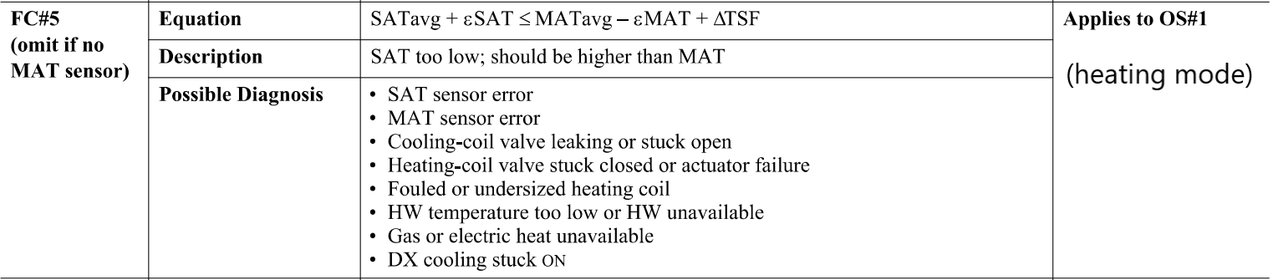

## Dataset Plot

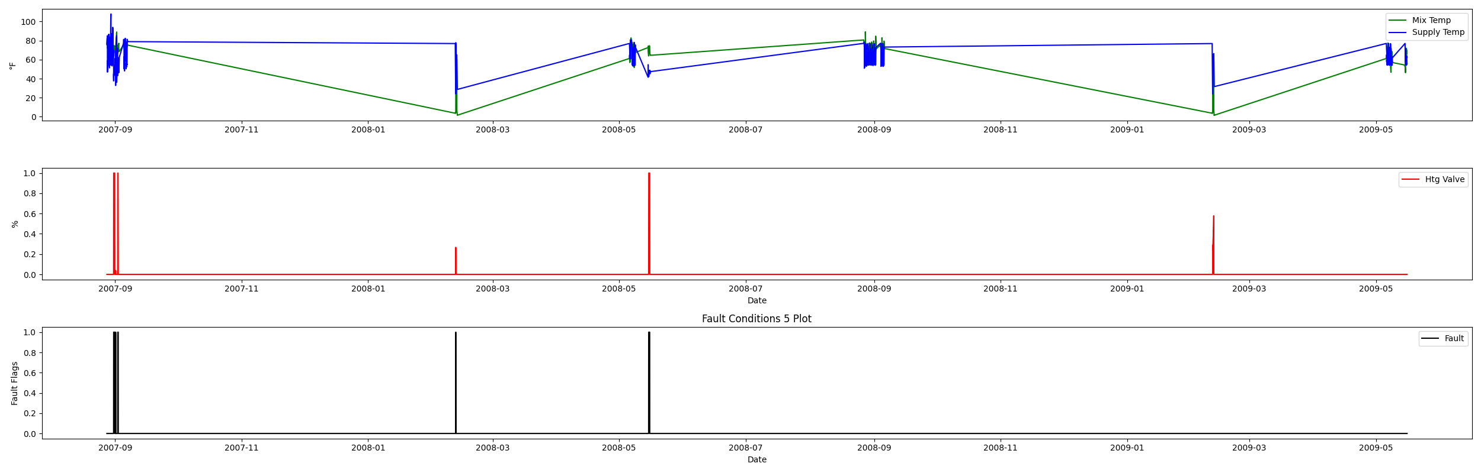

## Dataset Statistics

* Total time in days calculated in dataset: 627.0
* Total time in hours calculated in dataset: 15047.983333333334
* Total time in hours for when fault flag is True: 29.416666666666668
* Percent of time in the dataset when the fault flag is True: 4.71%
* Percent of time in the dataset when the fault flag is False: 95.29%
* Calculated motor runtime in hours based off of VFD signal > zero: 601.32

## Time-of-day Histogram Plots

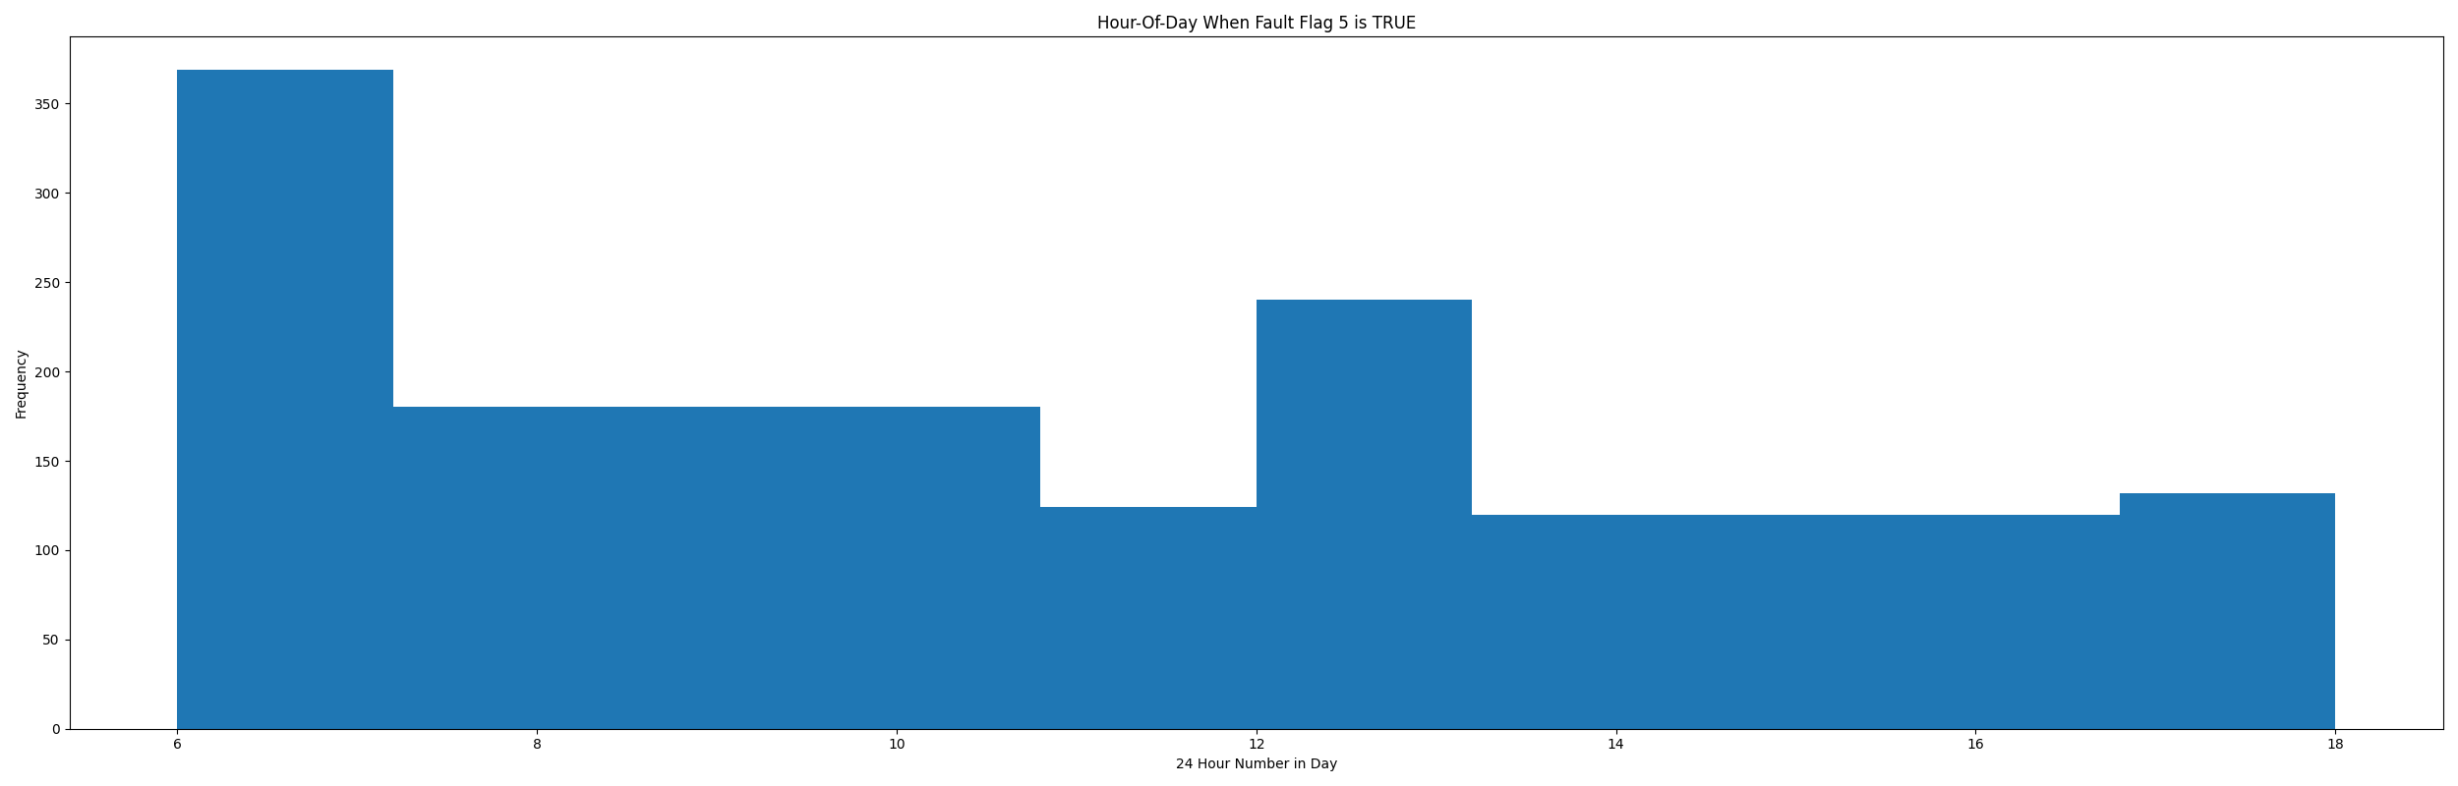

* When fault condition 5 is True the average mix air temp is 73.22°F and the outside air temp is 48.25°F. This could possibly help with pin pointing AHU operating conditions for when this fault is True.

# Summary Statistics filtered for when the AHU is running

### Mix Temp

* count 24560.000000  
  mean 70.859680  
  std 7.275293  
  min 15.946000  
  25% 67.696000  
  50% 72.976000  
  75% 74.614500  
  max 89.022000  
  Name: AHU: Mixed Air Temperature, dtype: float64

### Supply Temp

* count 24560.000000  
  mean 60.927629  
  std 11.208602  
  min 23.950000  
  25% 54.938000  
  50% 55.270000  
  75% 65.034000  
  max 101.630000  
  Name: AHU: Supply Air Temperature, dtype: float64

## Suggestions based on data analysis

* The percent True metric that represents the amount of time for when the fault flag is True is low inidicating the AHU temperature sensors are within calibration

Report generated: Thu Apr 27 09:37:17 2023