Fault Condition Seven Report

Fault condition seven of ASHRAE Guideline 36 is an AHU heating mode only with an attempt at verifying an AHU heating or cooling valve is not stuck or leaking by verifying AHU supply temperature to supply temperature setpoint. Fault condition seven equation as defined by ASHRAE:

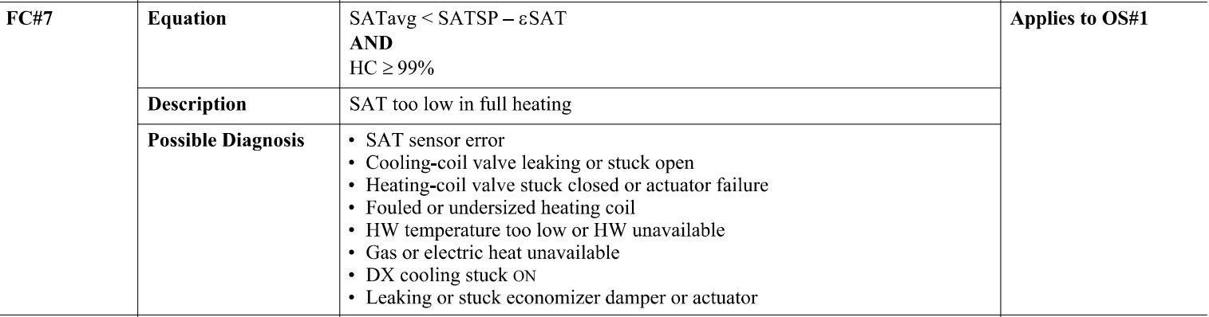

## Dataset Plot

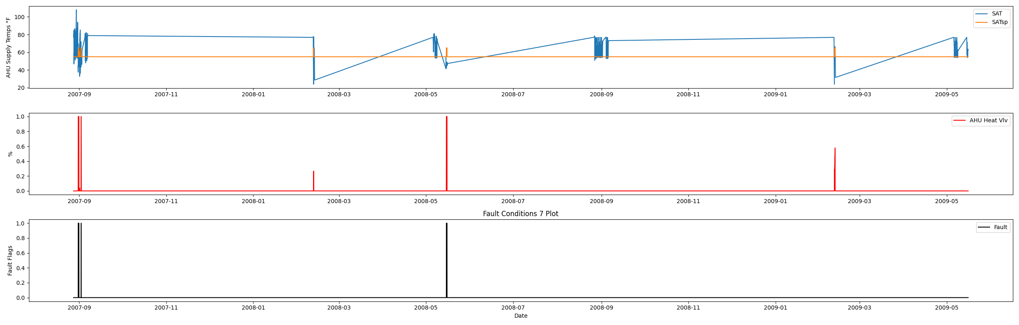

## Dataset Statistics

* Total time in days calculated in dataset: 627.0
* Total time in hours calculated in dataset: 15047.983333333334
* Total time in hours for when fault flag is True: 25.116666666666667
* Percent of time in the dataset when the fault flag is True: 4.03%
* Percent of time in the dataset when the fault flag is False: 95.97%
* Calculated motor runtime in hours based off of VFD signal > zero: 601.32

## Time-of-day Histogram Plots

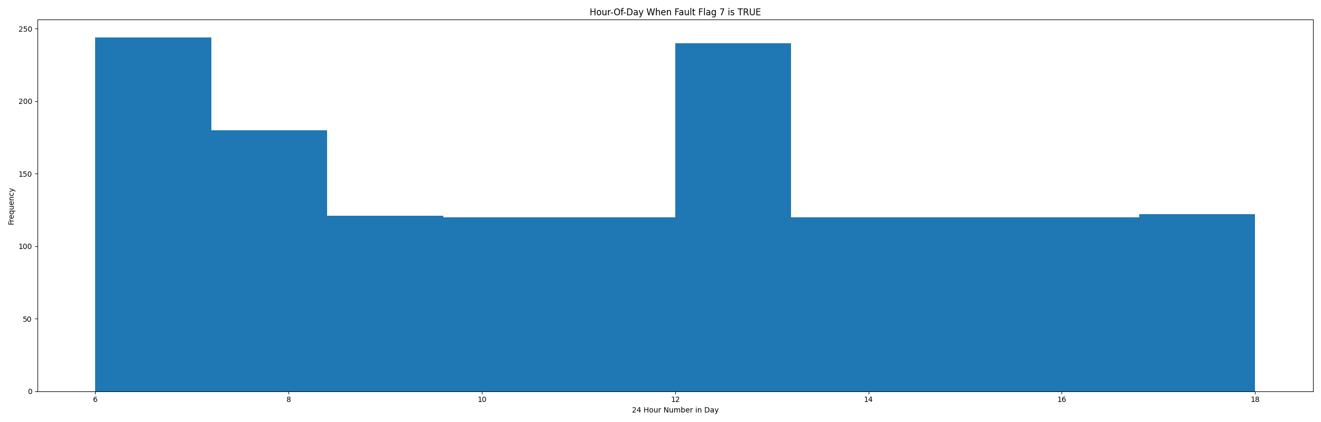

* When fault condition 7 is True the average AHU supply air setpoint is 47.73 in °F and the supply air temperature is 65.0 in °F.

# Summary Statistics filtered for when the AHU is running

### Supply Air Temp

* count 24560.000000  
  mean 60.927629  
  std 11.208602  
  min 23.950000  
  25% 54.938000  
  50% 55.270000  
  75% 65.034000  
  max 101.630000  
  Name: AHU: Supply Air Temperature, dtype: float64

### Supply Air Temp Setpoint

* count 24560.000000  
  mean 56.009283  
  std 3.006067  
  min 55.000000  
  25% 55.000000  
  50% 55.000000  
  75% 55.000000  
  max 65.000000  
  Name: AHU: Supply Air Temperature Set Point, dtype: float64

### Heating Coil Valve

* count 24560.000000  
  mean 0.077419  
  std 0.250572  
  min 0.000000  
  25% 0.000000  
  50% 0.000000  
  75% 0.000000  
  max 1.000000  
  Name: AHU: Heating Coil Valve Control Signal, dtype: float64

## Suggestions based on data analysis

* The percent True metric that represents the amount of time for when the fault flag is True is low inidicating the AHU heating valve operates Ok.

Report generated: Sat Apr 1 13:57:24 2023