Fault Condition Nine Report

Fault condition nine of ASHRAE Guideline 36 is an AHU economizer free cooling mode only with an attempt at flagging conditions where the outside air temperature is too warm for cooling without additional mechanical cooling. Fault condition nine equation as defined by ASHRAE:

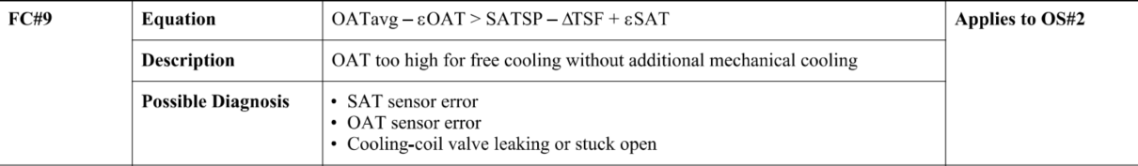

## Dataset Plot

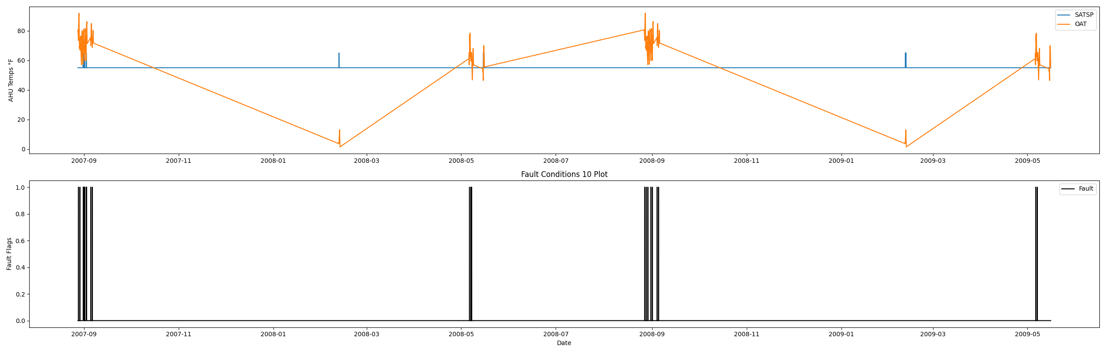

## Dataset Statistics

* Total time in days calculated in dataset: 627.0
* Total time in hours calculated in dataset: 15047.983333333334
* Total time in hours for when fault flag is True: 20.5
* Percent of time in the dataset when the fault flag is True: 3.29%
* Percent of time in the dataset when the fault flag is False: 96.71%
* Calculated motor runtime in hours based off of VFD signal > zero: 601.32

## Time-of-day Histogram Plots

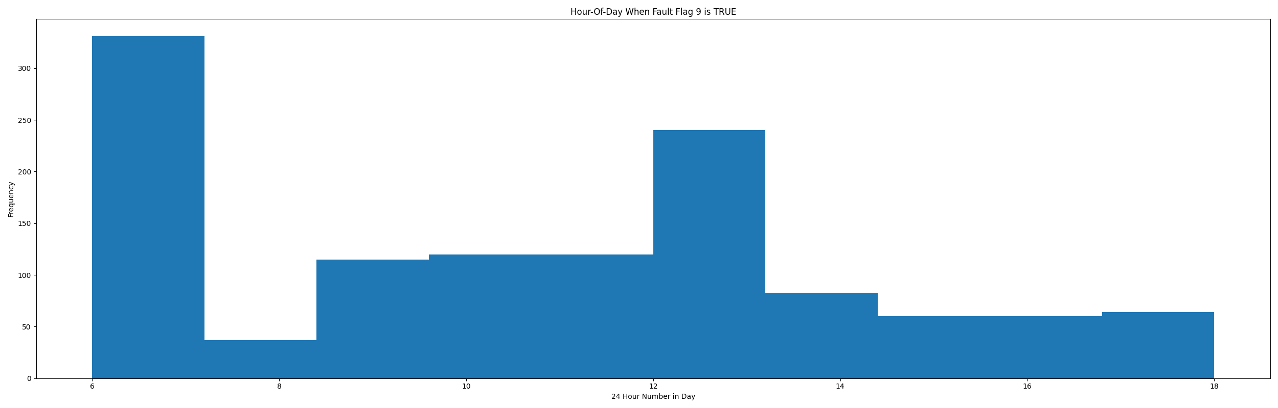

* When fault condition 9 is True the average outside air is 73.85 in °F and the supply air temperature setpoinht is 60.68 in °F.

# Summary Statistics filtered for when the AHU is running

### Supply Air Temp Setpoint

* count 24560.000000  
  mean 56.009283  
  std 3.006067  
  min 55.000000  
  25% 55.000000  
  50% 55.000000  
  75% 55.000000  
  max 65.000000  
  Name: AHU: Supply Air Temperature Set Point, dtype: float64

### Outside Air Temp

* count 24560.000000  
  mean 67.099021  
  std 17.318396  
  min 3.856000  
  25% 62.128000  
  50% 70.887000  
  75% 77.378000  
  max 91.776000  
  Name: AHU: Outdoor Air Temperature, dtype: float64

## Suggestions based on data analysis

* The percent True metric that represents the amount of time for when the fault flag is True is low inidicating the AHU components are within calibration for this fault equation Ok.

Report generated: Thu Apr 27 09:38:55 2023