Fault Condition One Report

**Duct static pressure too low with fan at full speed.**



* DSP: Duct Static Pressure
* DPSP: Duct Static Pressure Setpoint
* VFDSPD: VFD Speed Reference in Percent
* eVFDSPD: VFD Speed Reference Error Threshold

## Dataset Plot

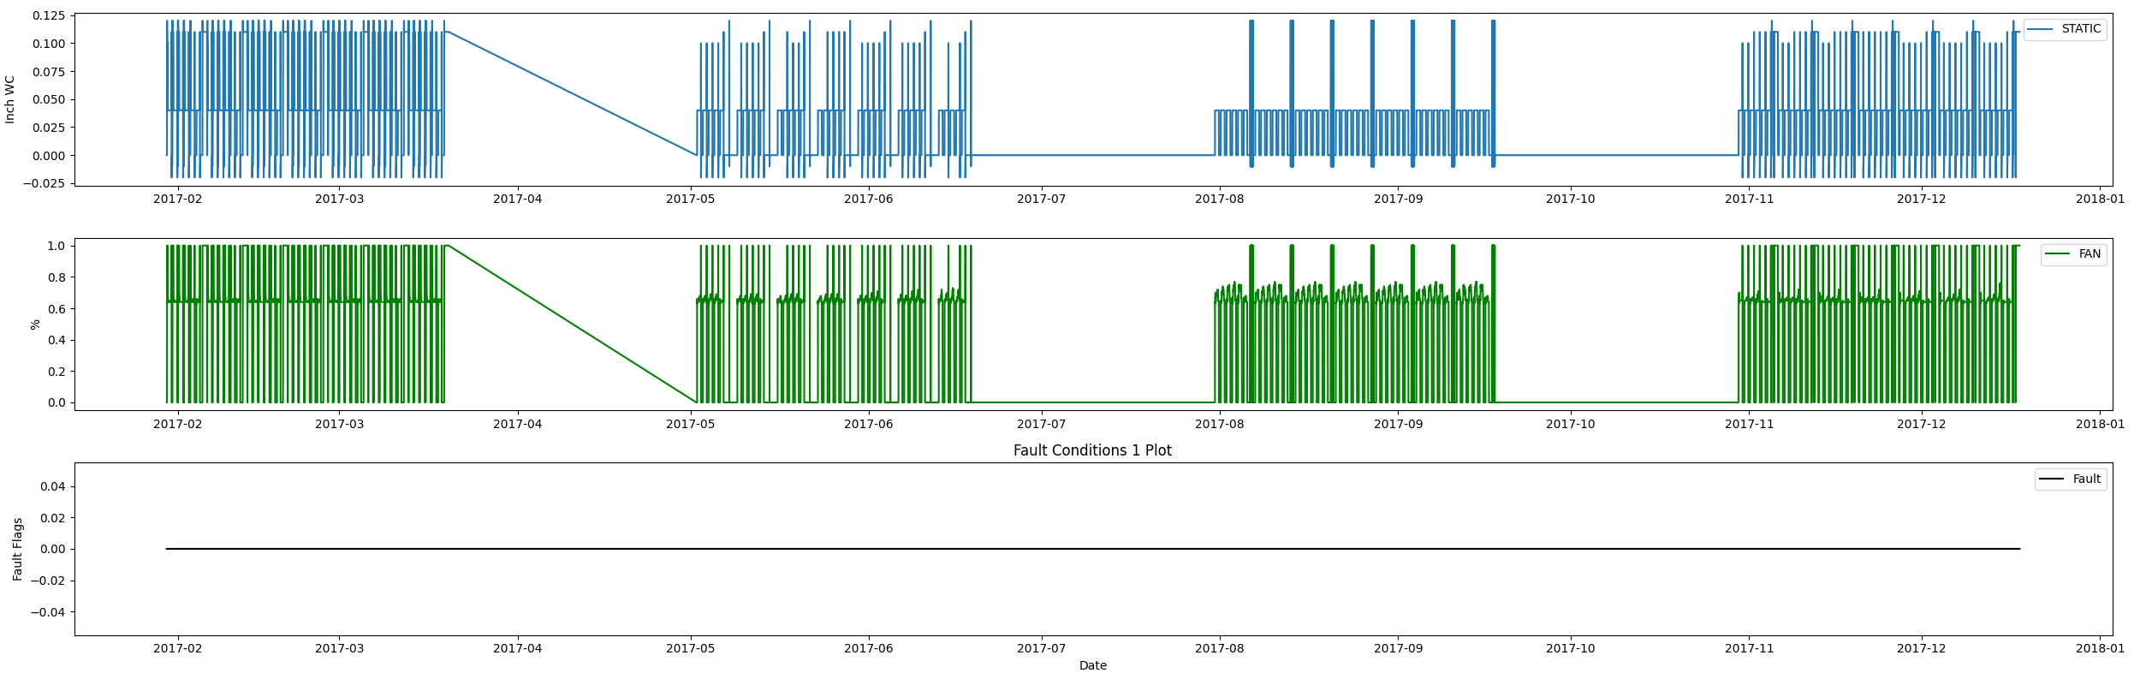

## Dataset Statistics

* Total time in days calculated in dataset: 322.0
* Total time in hours calculated in dataset: 7727.983333333334
* Total time in hours for when fault flag is True: 0.0
* Percent of time in the dataset when the fault flag is True: 0.0%
* Percent of time in the dataset when the fault flag is False: 100.0%
* Calculated motor runtime in hours based off of VFD signal > zero: 3040.22
* No faults were found in this given dataset.

# Summary Statistics filtered for when the AHU is running

### VFD Speed

* count 182413.000000  
  mean 0.716670  
  std 0.129755  
  min 0.620000  
  25% 0.640000  
  50% 0.650000  
  75% 0.710000  
  max 1.000000  
  Name: AHU: Supply Air Fan Speed Control Signal, dtype: float64

### Duct Pressure

* count 182413.000000  
  mean 0.051622  
  std 0.026240  
  min -0.010000  
  25% 0.040000  
  50% 0.040000  
  75% 0.040000  
  max 0.120000  
  Name: AHU: Supply Air Duct Static Pressure, dtype: float64

### Duct Pressure Setpoint

* count 1.824130e+05  
  mean 4.000000e-02  
  std 1.387783e-17  
  min 4.000000e-02  
  25% 4.000000e-02  
  50% 4.000000e-02  
  75% 4.000000e-02  
  max 4.000000e-02  
  Name: AHU: Supply Air Duct Static Pressure Set Point, dtype: float64

## Suggestions based on data analysis

* an AI-powered HVAC specialist, I have analyzed the data provided on the air handling unit (AHU) supply fan and duct static pressure. The AHU operates by controlling the speed of the supply fan to maintain a set duct static pressure. The dataset shows that the AHU has been operating for a total of 322 days, with a total of 7727.98 hours of data. The fault detection dataset shows that the fault occurs when the fan is running near 100 percent speed and the duct static pressure in the duct system is not meeting setpoint.   
    
  The summary statistics of the fan speed in percent data show that the fan speed ranges from 62% to 100%, with an average of 71.67%. The summary statistics of the duct static pressure in engineering units show that the duct static pressure ranges from -0.01 to 0.12, with an average of 0.05. The summary statistics of the duct static pressure setpoint in engineering units show that the setpoint is constant at 0.04.  
    
  Based on the data, if the faults are high, it may indicate that the AHU has mechanical issues and is not meeting the duct static pressure setpoint. On the other hand, if the faults are low, it suggests that the AHU is operating fine and meeting the duct static pressure requirements. If the total hours of operation are approximately equal to the hours of motor runtime, it may be recommended to schedule the AHU fan to save electrical energy consumption. Additionally, if the duct static setpoint is not changing, it may be recommended to reset the duct static pressure to save electrical energy from the fan motor consumption. Overall, analyzing the data allows us to identify usage patterns in how the AHU operates over time and any potential mechanical issues.

Report generated: Wed Jun 21 13:59:51 2023