10 Closest Weather Days Summary

**Test Case 10A_4 on 08-05-2022**

## Data used to calculate an averaged load profile

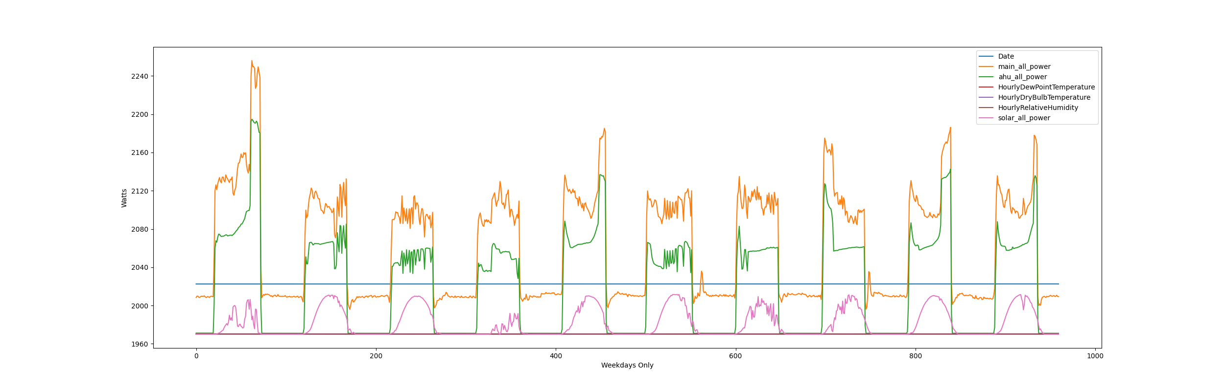

## Main meter test day plot event from hour 12 to hour 16

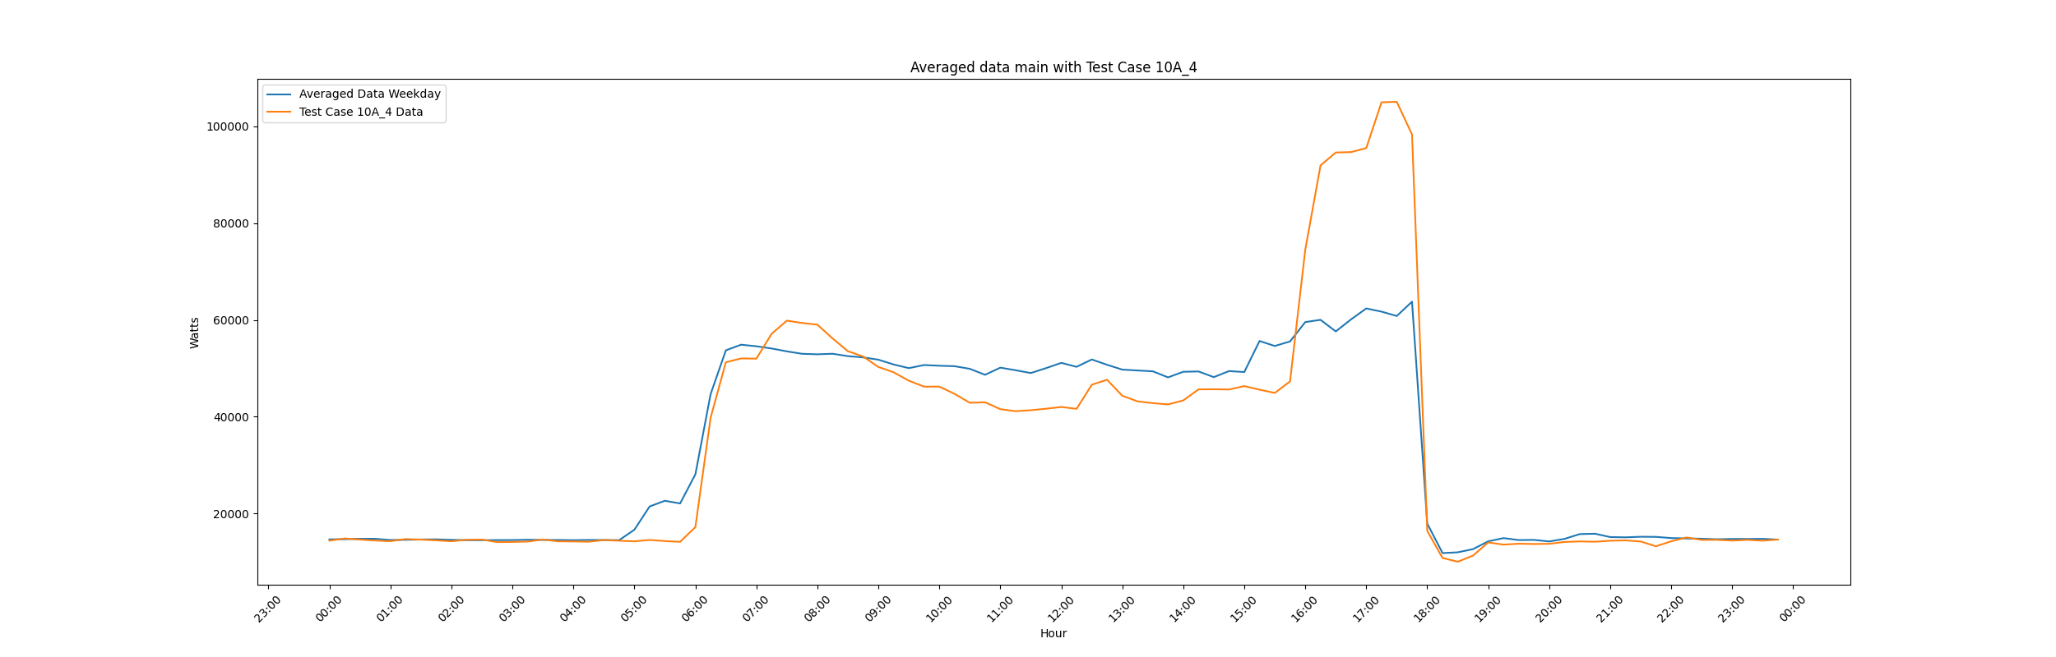

## Main Meter Statistics

* Main meter net change power during event: 1076.88 Watts
* Main meter percent change in power during event: 1 %
* Averaged data main meter max power: 63768 Watts
* Test day main meter max power: 105080 Watts
* Averaged data main meter calculated energy: 807731 Watt-Hr
* Test day main meter calculated energy: 824082 Watt-Hr

## AHU meter test day plot event from hour 12 to hour 16

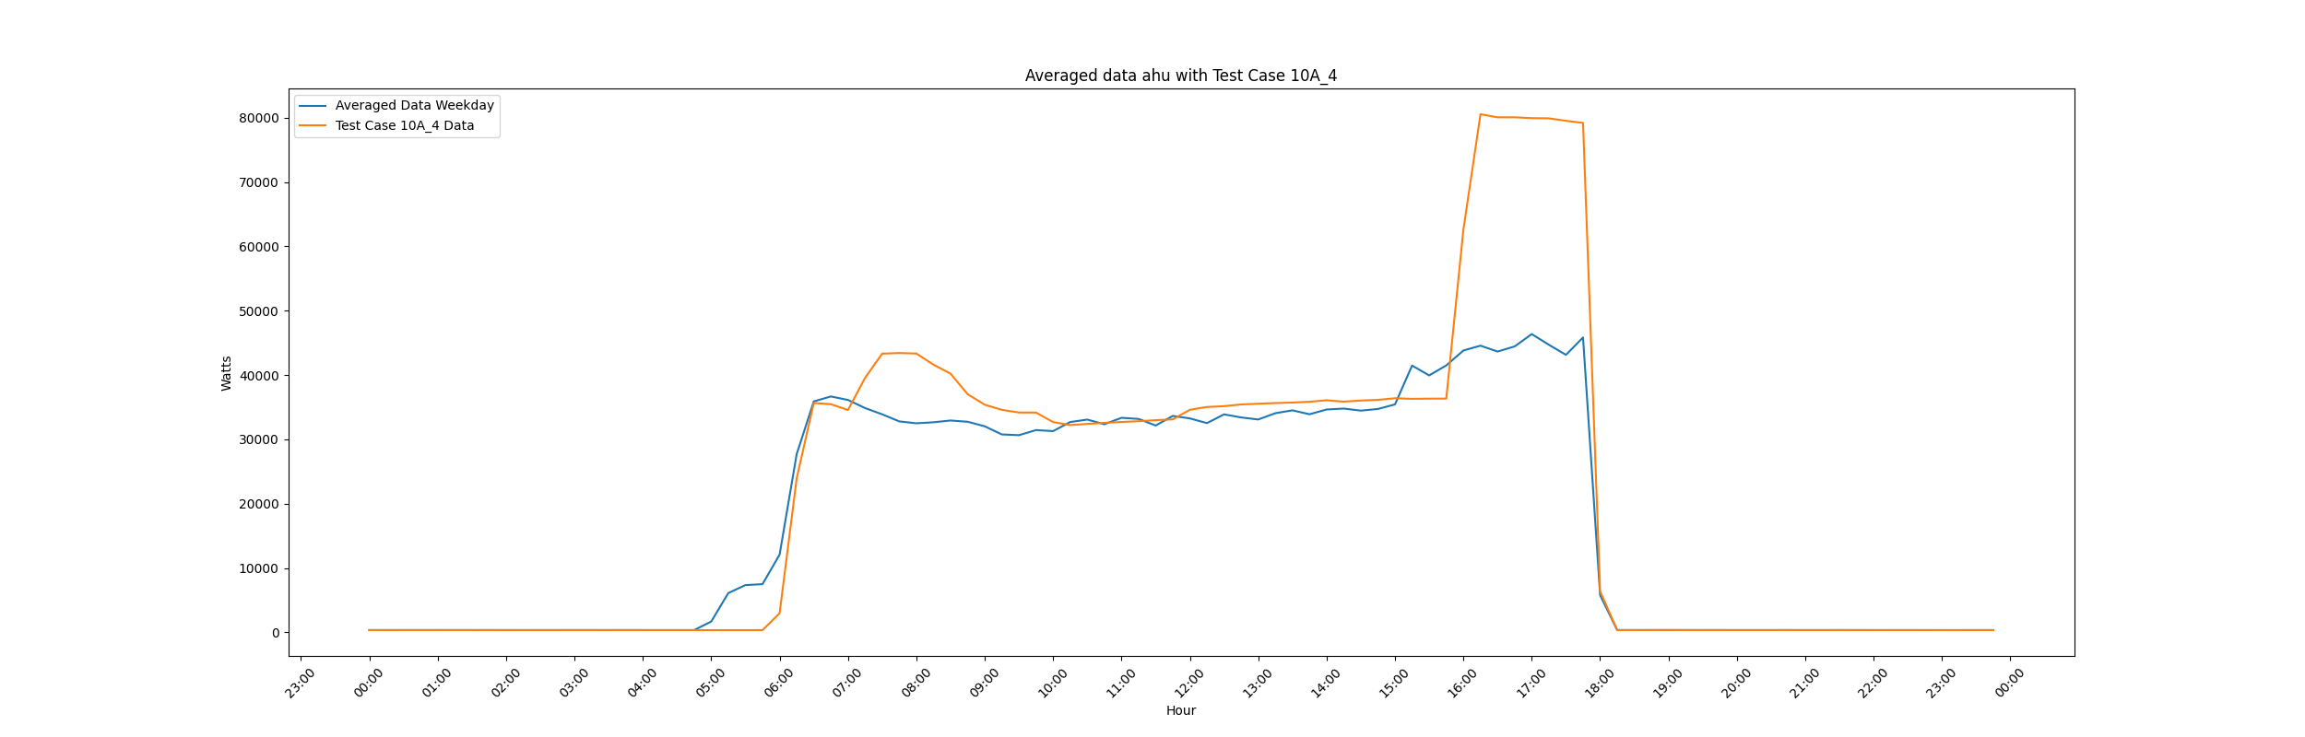

## AHU Meter Statistics

* AHU meter net change power during event: 6678.24 Watts
* AHU meter percent change in power during event: 16 %
* Averaged data ahu meter max power: 46367 Watts
* Test day ahu meter max power: 80537 Watts
* Averaged data ahu meter calculated energy: 433517 Watt-Hr
* Test day ahu meter calculated energy: 509699 Watt-Hr

Report generated: Sat Jul 1 11:09:56 2023