Fault Condition Six Report

Fault condition six of ASHRAE Guideline 36 is an attempt at verifying that AHU design minimum outside air is close to the calculated outside air fraction through the outside, mix, and return air temperature sensors. A fault will get flagged in an AHU heating or mechanical cooling mode only if the calculated OA fraction is too low or too high as to compared to percent Min calculation which is the AHU total air flow divided by the design minimum outdoor air expressed as a percent. Fault condition six equation as defined by ASHRAE:

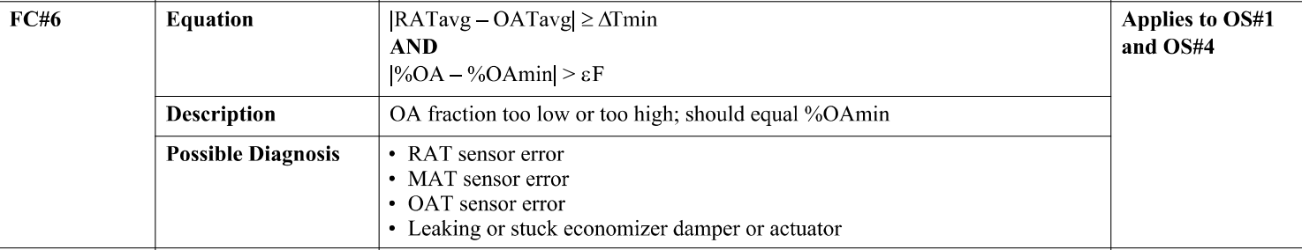

## Dataset Plot

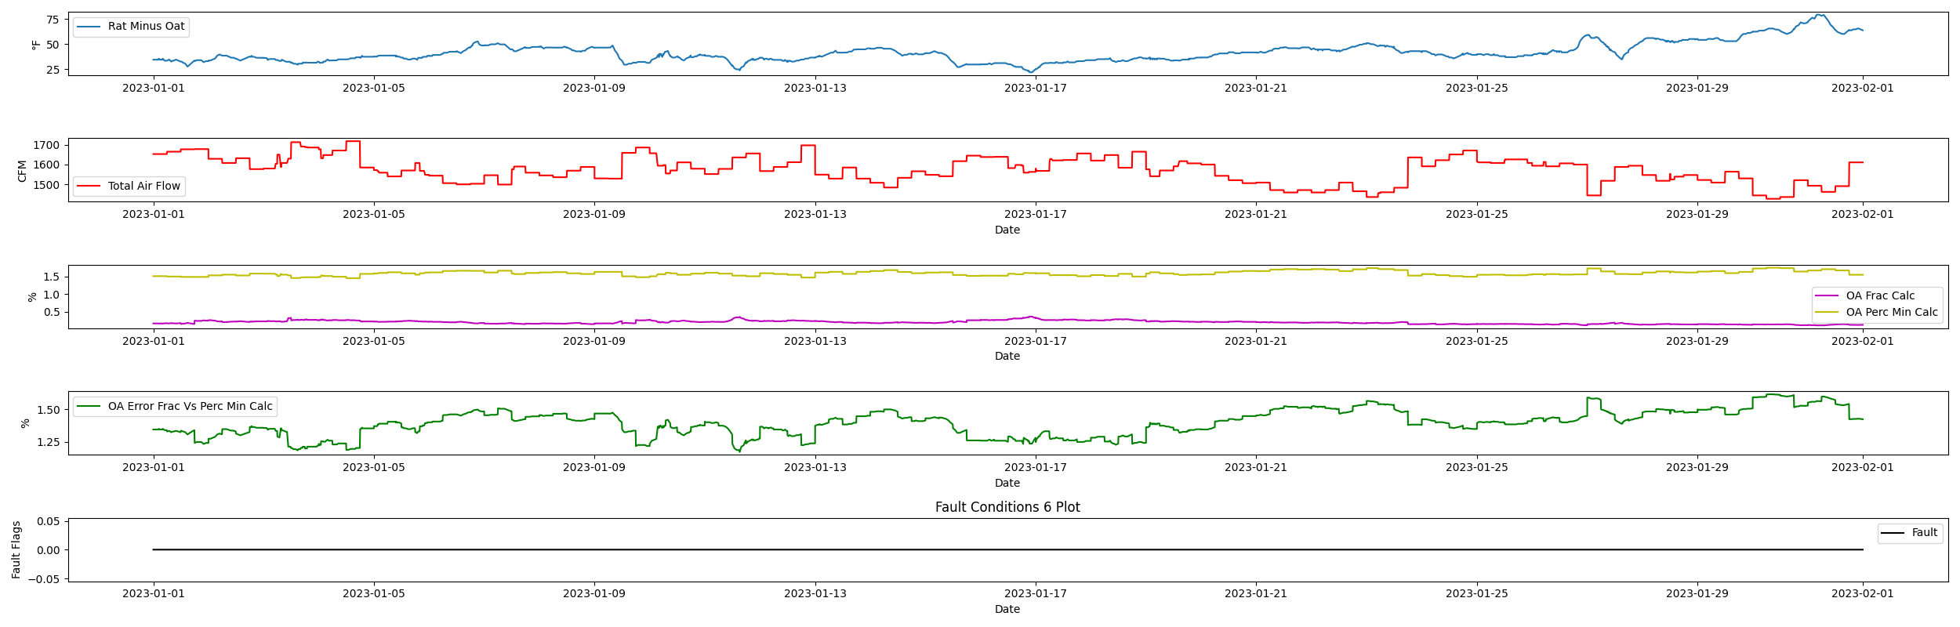

## Dataset Statistics

* Total time in days calculated in dataset: 31.0
* Total time in hours calculated in dataset: 743.8833333333333
* Total time in hours for when fault flag is True: 0.0
* Percent of time in the dataset when the fault flag is True: 0.0%
* Percent of time in the dataset when the fault flag is False: 100.0%
* Calculated motor runtime in hours based off of VFD signal > zero: 743.88
* This fan system appears to run 24/7 consider implementing occupancy schedules to reduce building fuel use through HVAC
* No faults were found in this given dataset for the equation defined by ASHRAE.

# Summary Statistics filtered for when the AHU is running

### Mix Temp

* count 1369.000000  
  mean 60.848868  
  std 1.102967  
  min 58.100000  
  25% 60.100000  
  50% 60.500000  
  75% 61.300000  
  max 63.600000  
  Name: AHU4_MATemp, dtype: float64

### Outside Temp

* count 1369.000000  
  mean 27.661432  
  std 8.729501  
  min -10.000000  
  25% 23.000000  
  50% 30.000000  
  75% 34.000000  
  max 46.000000  
  Name: HourlyDryBulbTemp, dtype: float64

### Return Temp

* count 1369.000000  
  mean 68.739445  
  std 0.347348  
  min 67.800000  
  25% 68.500000  
  50% 68.700000  
  75% 69.000000  
  max 69.600000  
  Name: AHU4_RATemp_value, dtype: float64

### Total Air Flow

* count 1369.000000  
  mean 1574.639153  
  std 63.777252  
  min 1427.000000  
  25% 1530.000000  
  50% 1579.000000  
  75% 1617.000000  
  max 1718.000000  
  Name: AHU4_SaFanFlow_value, dtype: float64

## Suggestions based on data analysis

* The percent True metric that represents the amount of time for when the fault flag is True is low inidicating the sensors are within calibration

Report generated: Mon Feb 27 13:15:40 2023