COMP 3123 – Assignment 1
Testing Evidence: Secure Employee Management REST API
Item | Details
Student ID | 101549617
GitHub repository | https://github.com/aceeejlrz/101549617_COMP3123_Assignment1
Date | October 18, 2026
Stack | Node.js 22, Express 5, MongoDB 9.0 with Mongoose 8, JWT, bcryptjs, Helmet, express-rate-limit, express-validator, winston
Test environment | API at http://localhost:3000 (npm start), local MongoDB database comp3123_assignment1, Postman 12, MongoDB Compass 1.53
Postman collection | postman/COMP3123_Assignment1.postman_collection.json (54 requests with test scripts)
Deployed API | Not deployed (runs locally)
Sample credentials for marking
Non-sensitive demo accounts created by npm run seed (local testing only). The Postman run also creates fresh users (user_a_<runId>, user_b_<runId>) on every run.
User | Username | Email | Password
User A | demo_user_a | demo.user.a@example.com | DemoUserA@2026
User B | demo_user_b | demo.user.b@example.com | DemoUserB@2026

Evidence Index
Where each item from the submission checklist is shown.
Section | Figures | Checklist item
Full Postman Collection Run | 1 | Postman testing (all endpoints)
Health Check and Helmet Security Headers | 2–3 | Health-check screenshot; Helmet/security evidence
User Signup (POST /api/v1/user/signup) | 4–11 | Signup screenshots; validation/error screenshots
User Login and JWT (POST /api/v1/user/login) | 12–15 | Login/JWT screenshots
JWT Authentication on Protected Employee Routes | 16–19 | Login/JWT screenshots; validation/error screenshots
Employee CRUD and Validation (User A) | 20–33 | Employee CRUD screenshots; validation/error screenshots
Per-User Visibility (User B) | 34–36 | Two-user authorization/ownership test
Two-User Ownership Test (Cross-User Access Must Be Rejected) | 37–43 | Two-user authorization/ownership test
Delete Employee and Error Handling | 44–47 | Employee CRUD screenshots; validation/error screenshots
Rate Limiting | 48–50 | Rate-limiting screenshot
MongoDB Evidence (MongoDB Compass) | 51–56 | MongoDB screenshots (database, collections, relationship, hashed passwords, ownership)
Local Logging | 57–58 | Local logging evidence

1. Full Postman Collection Run
Figure 1: Collection Runner summary: 183 of 183 tests passed
The whole Postman collection run in order with the Collection Runner: 183 assertions passed, 0 failed, 0 errors. The run covers signup, login, JWT errors, employee CRUD, validation, two-user ownership checks, deletion and rate limiting.
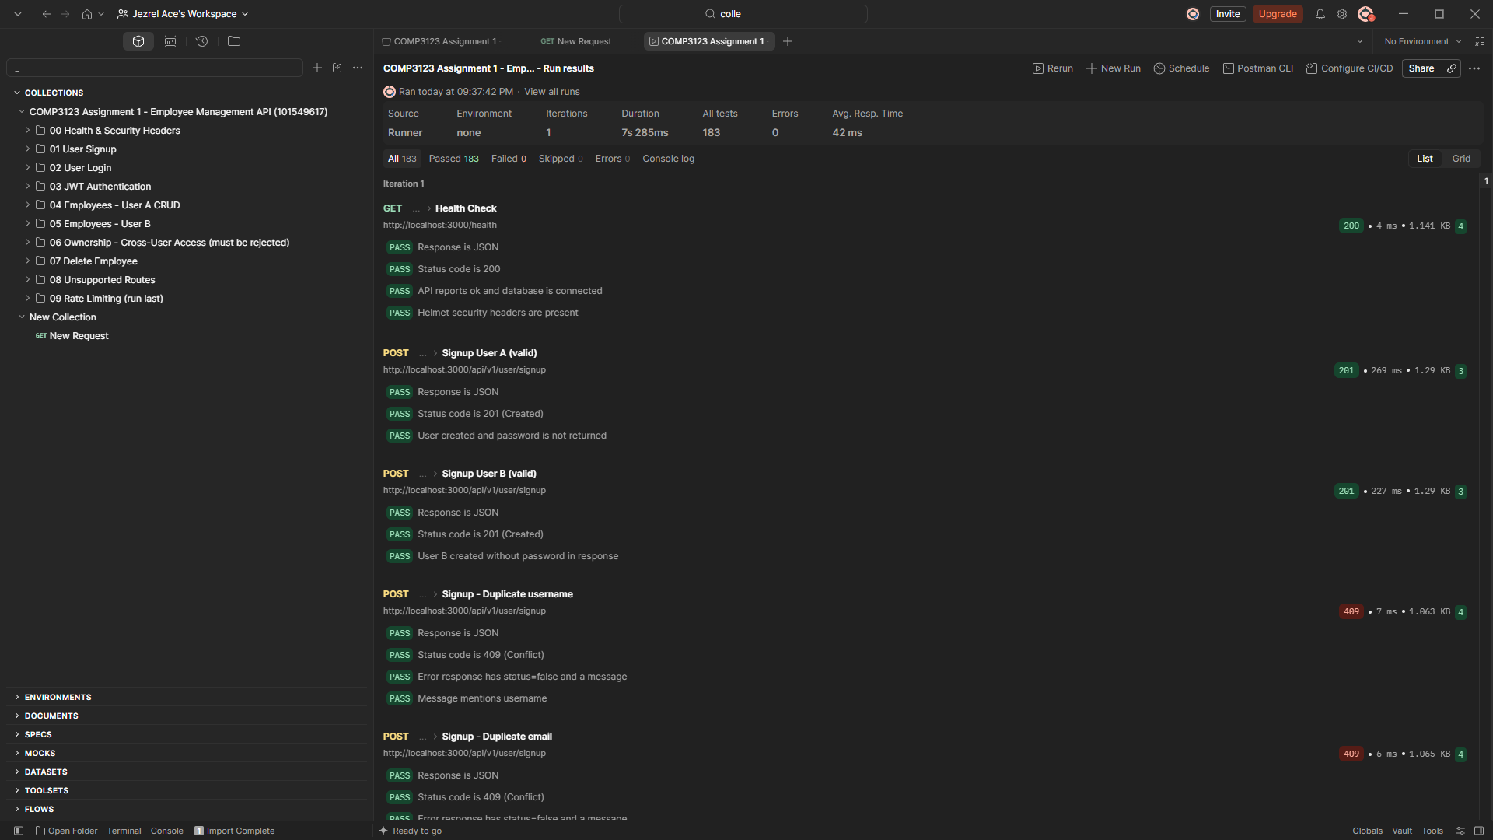
00-collection-runner-183-tests-passed.png

2. Health Check and Helmet Security Headers
Figure 2: GET /health returns 200 OK
The health check reports status "ok", the API version, uptime and the database status "connected" for comp3123_assignment1.
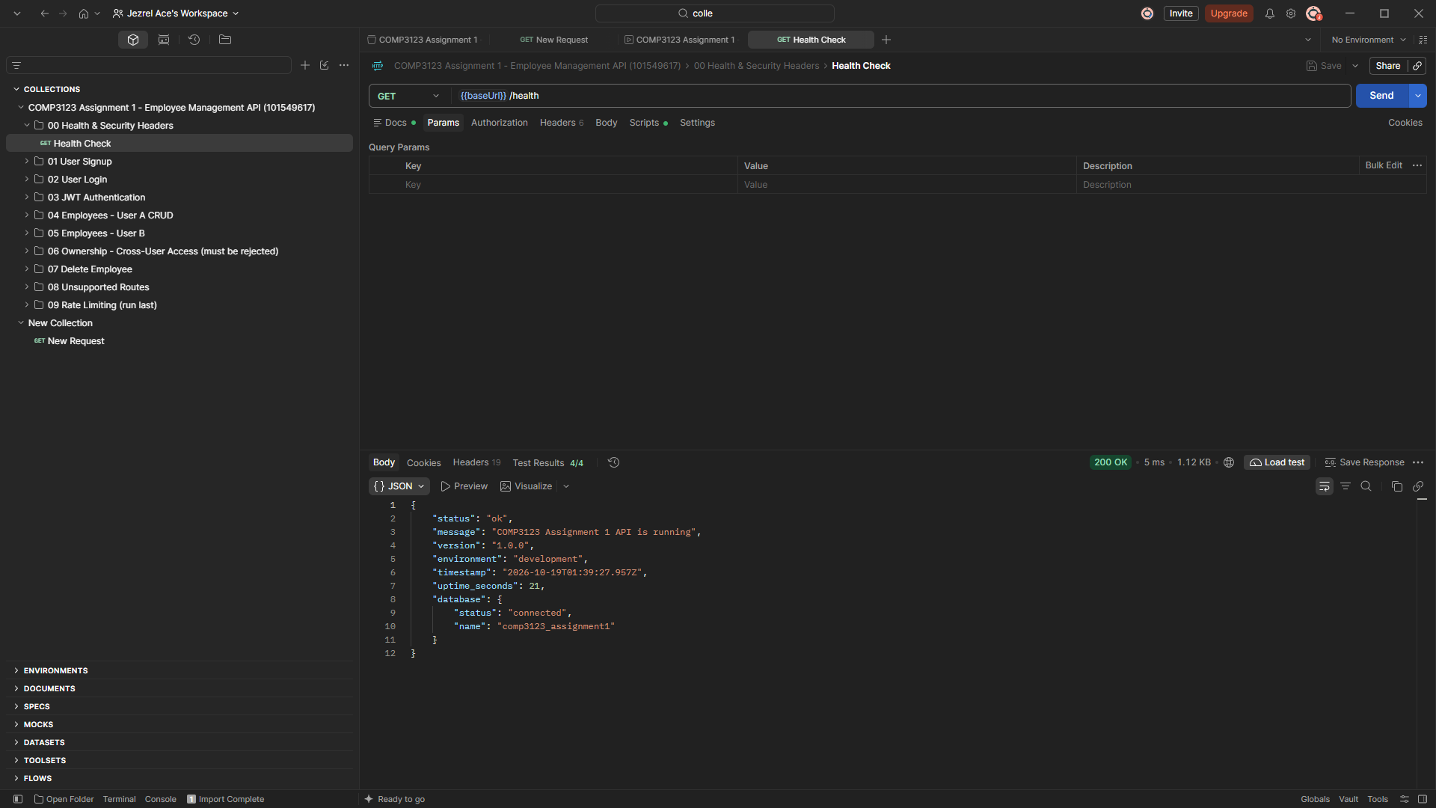
01-health-check.png
Figure 3: Helmet security headers on every response
Response headers added by Helmet: Content-Security-Policy, Strict-Transport-Security, X-Content-Type-Options: nosniff, X-Frame-Options: SAMEORIGIN, Referrer-Policy and the Cross-Origin policies. X-Powered-By is removed.
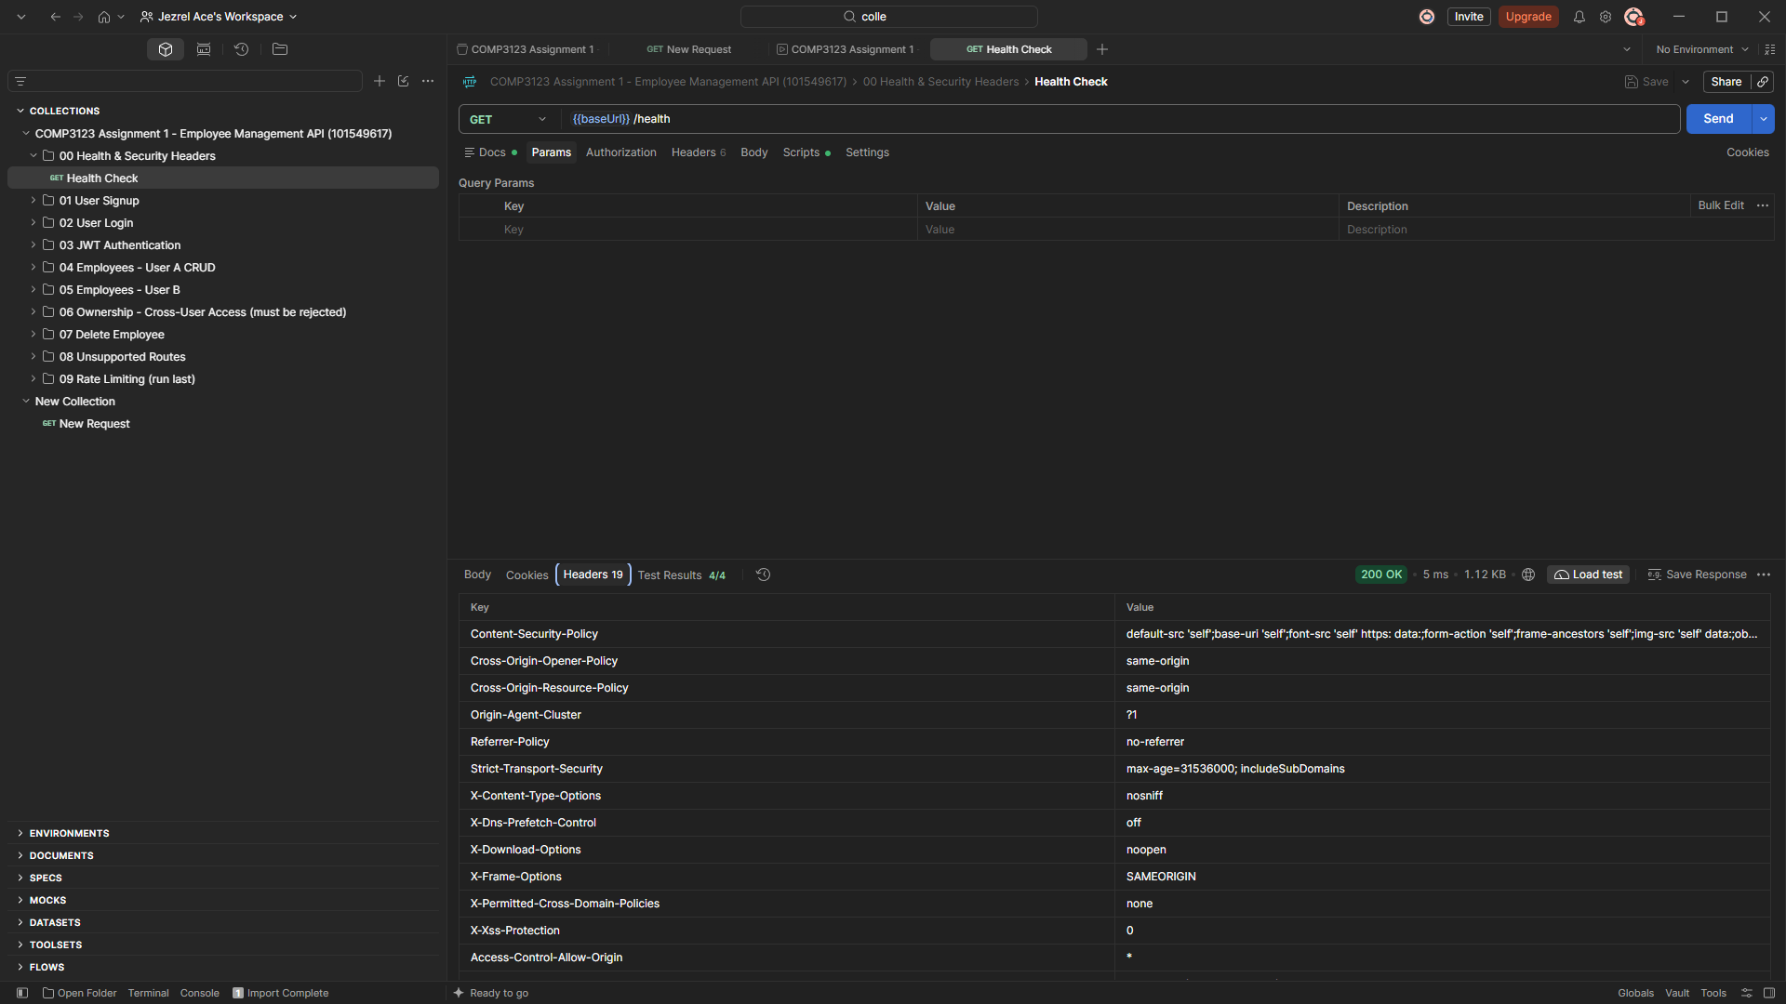
02-helmet-security-headers.png

3. User Signup (POST /api/v1/user/signup)
Figure 4: Signup User A returns 201 Created
A valid signup creates the user and returns user_id and the user object. The password is never returned.
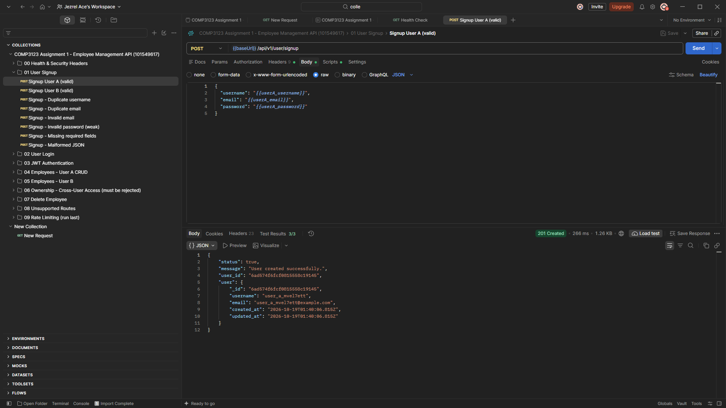
03-signup-user-a-201.png
Figure 5: Signup User B returns 201 Created
A second user is created for the two-user ownership test.
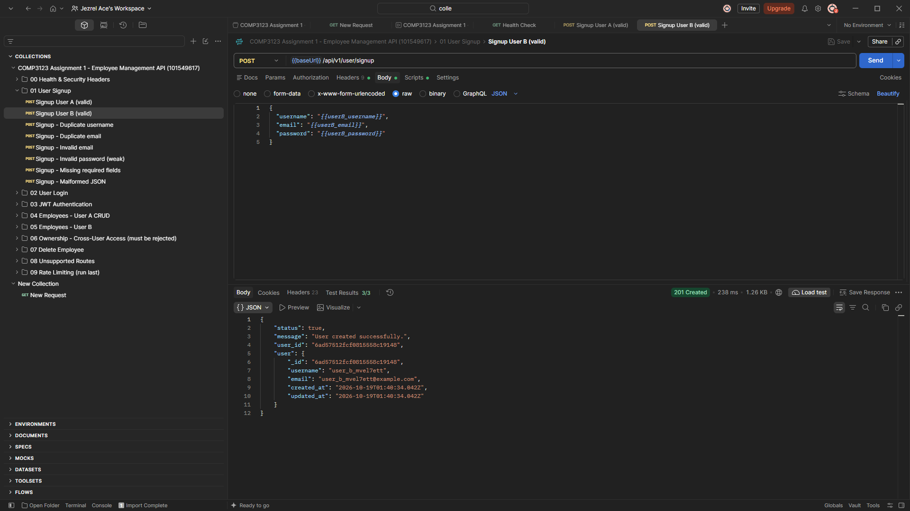
04-signup-user-b-201.png
Figure 6: Duplicate username returns 409 Conflict
Signing up with an existing username is rejected: "Username is already taken".
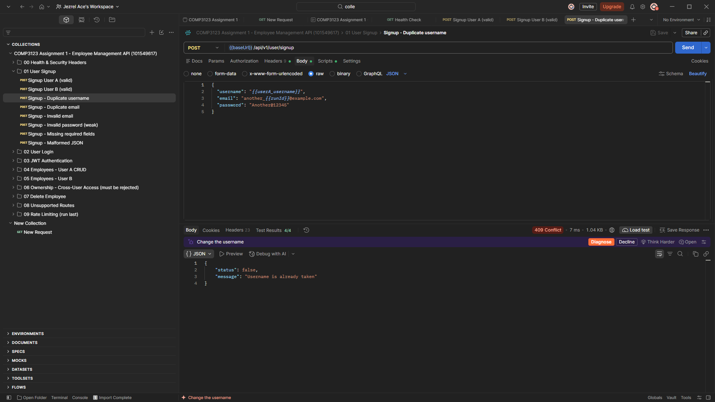
05-signup-duplicate-username-409.png
Figure 7: Duplicate email returns 409 Conflict
Signing up with an existing email is rejected: "Email is already registered".
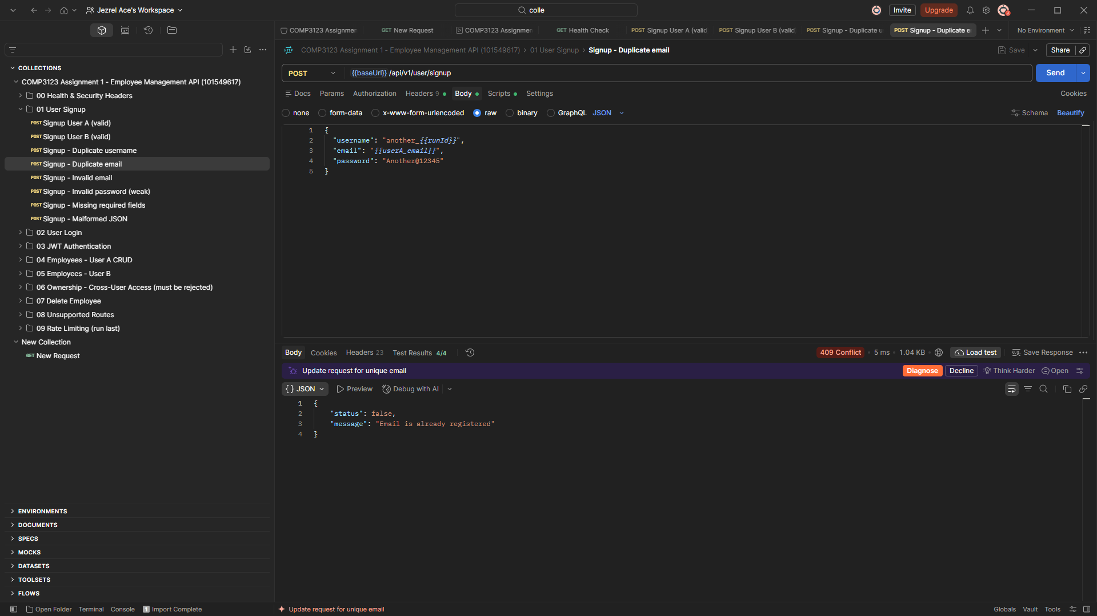
06-signup-duplicate-email-409.png
Figure 8: Invalid email returns 400 Bad Request
express-validator rejects "not-an-email" with a field-level error for email.
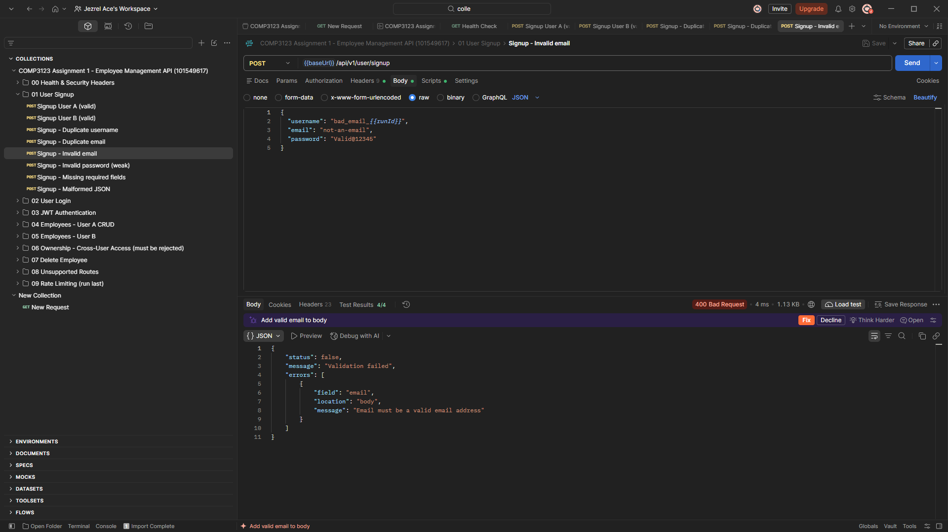
07-signup-invalid-email-400.png
Figure 9: Weak password returns 400 Bad Request
Passwords must be 8+ characters with an uppercase letter, a lowercase letter, a number and a special character.
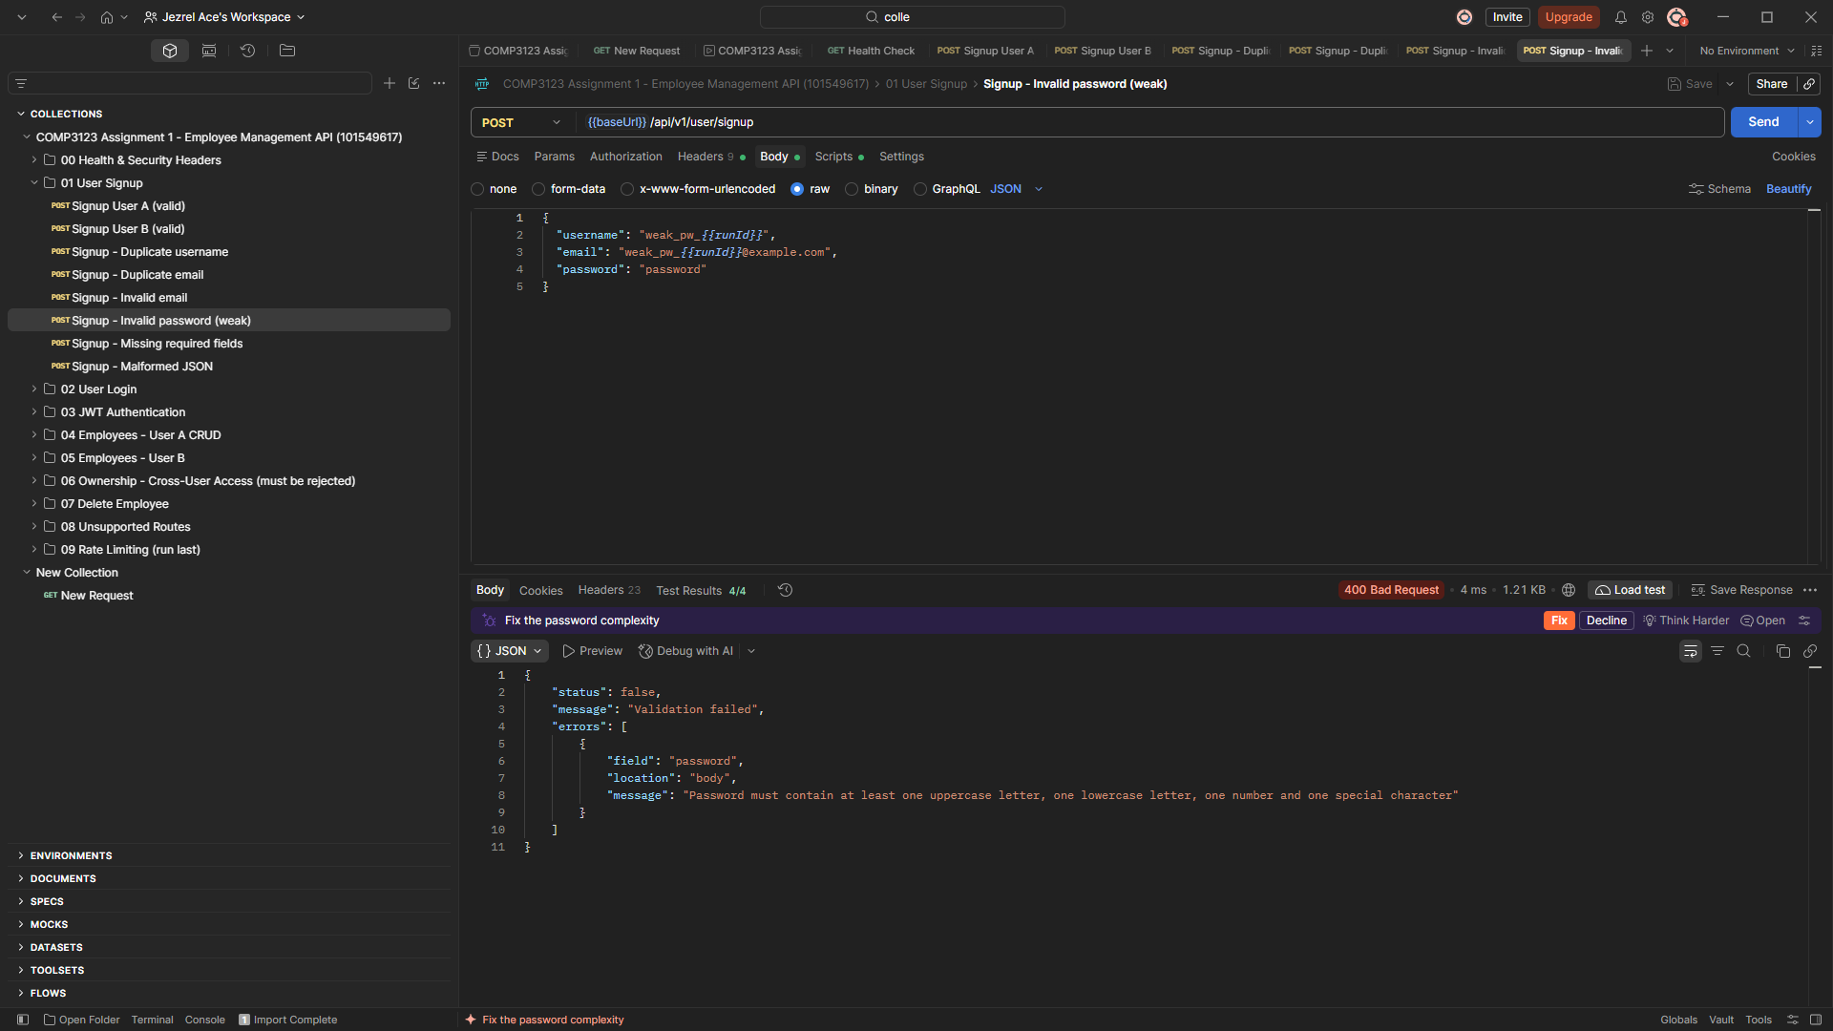
08-signup-weak-password-400.png
Figure 10: Missing required fields return 400 Bad Request
An empty body returns one error each for username, email and password.
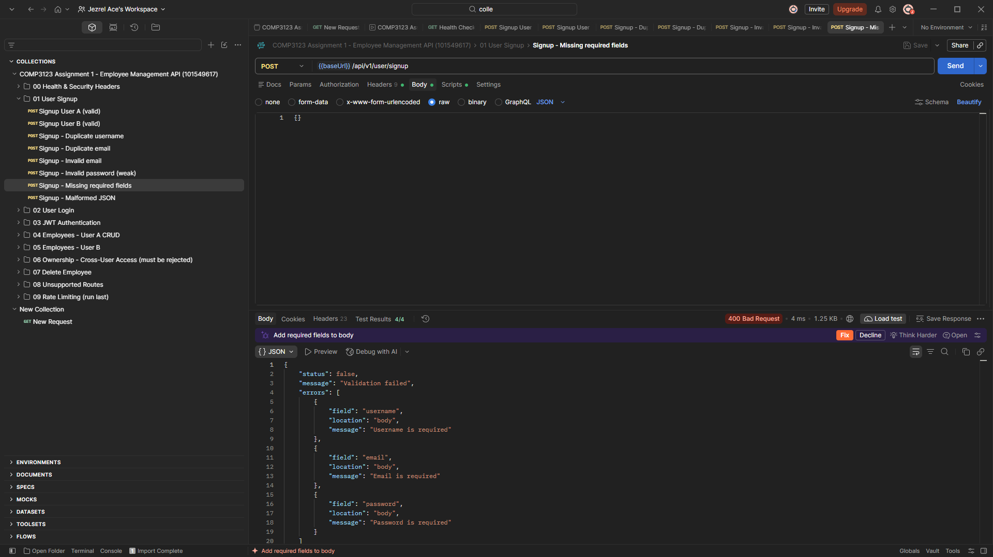
09-signup-missing-fields-400.png
Figure 11: Malformed JSON returns 400 Bad Request
Broken JSON is caught by the central error handler: "Malformed JSON in request body".
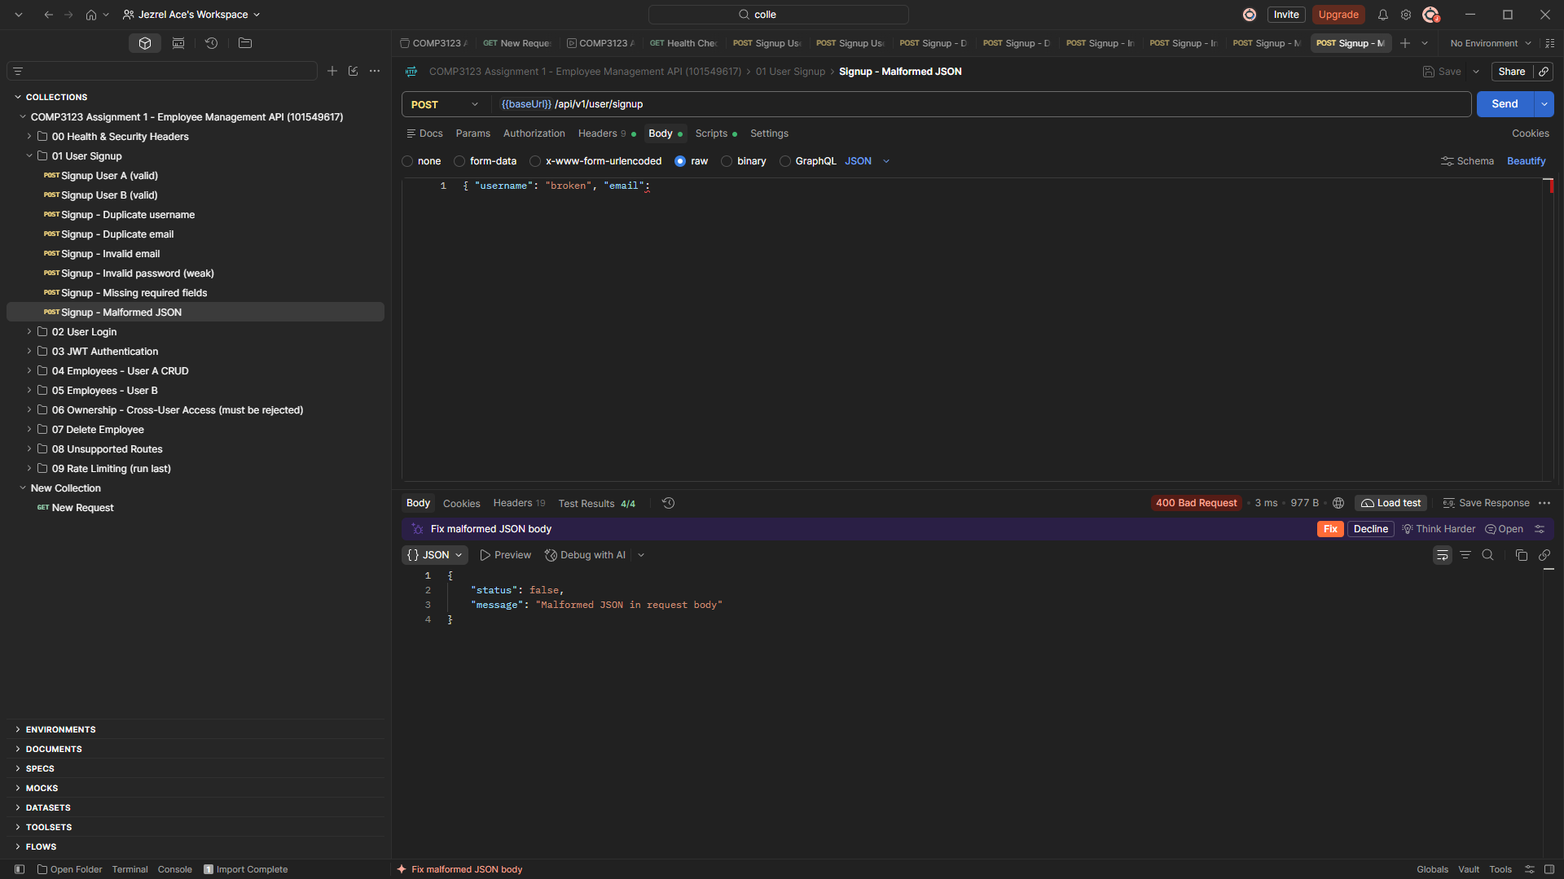
10-signup-malformed-json-400.png

4. User Login and JWT (POST /api/v1/user/login)
Figure 12: Login with username + password returns 200 OK and a JWT
The response contains jwt_token, token_type "Bearer", expires_in "1h" and the user object without the password.
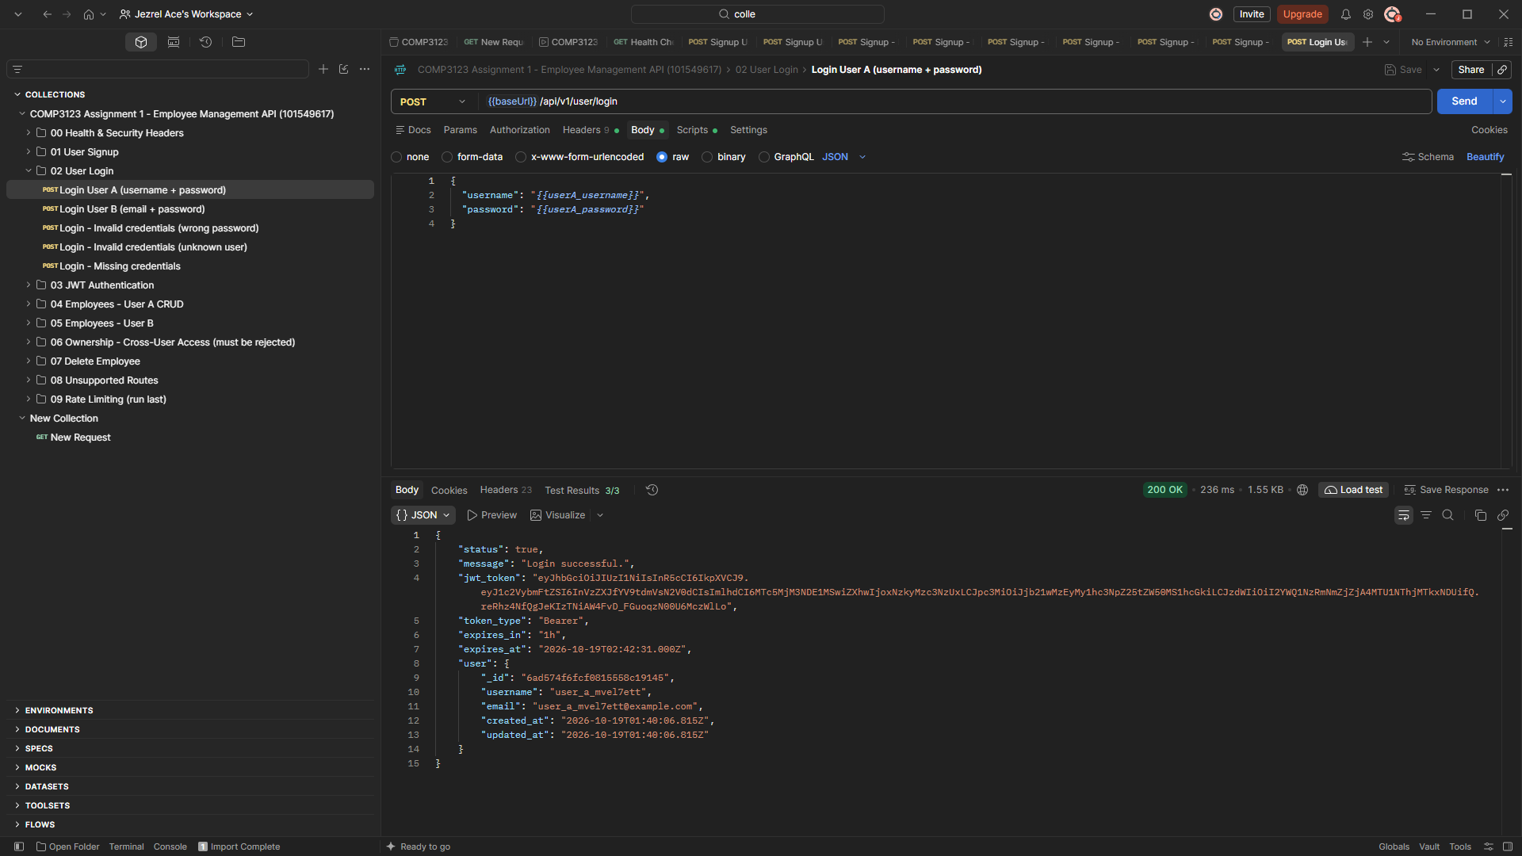
11-login-username-200-jwt.png
Figure 13: Login with email + password returns 200 OK and a JWT
Login also works with email instead of username.
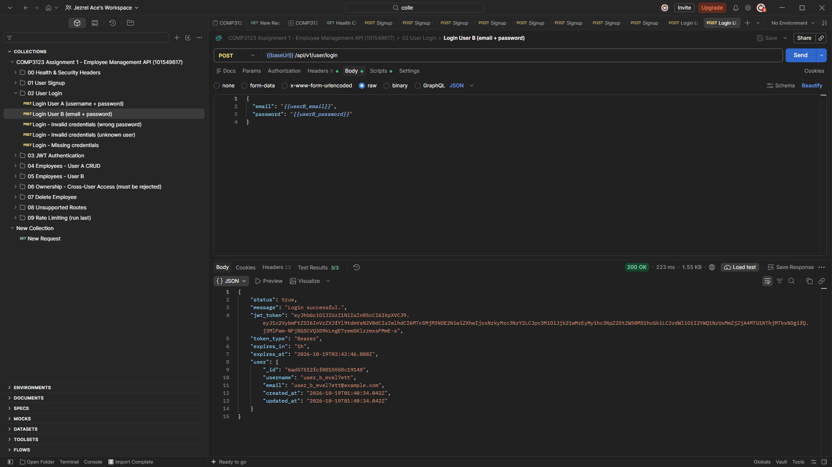
12-login-email-200-jwt.png
Figure 14: Wrong password returns 401 Unauthorized
Invalid credentials return the same generic message whether or not the user exists.
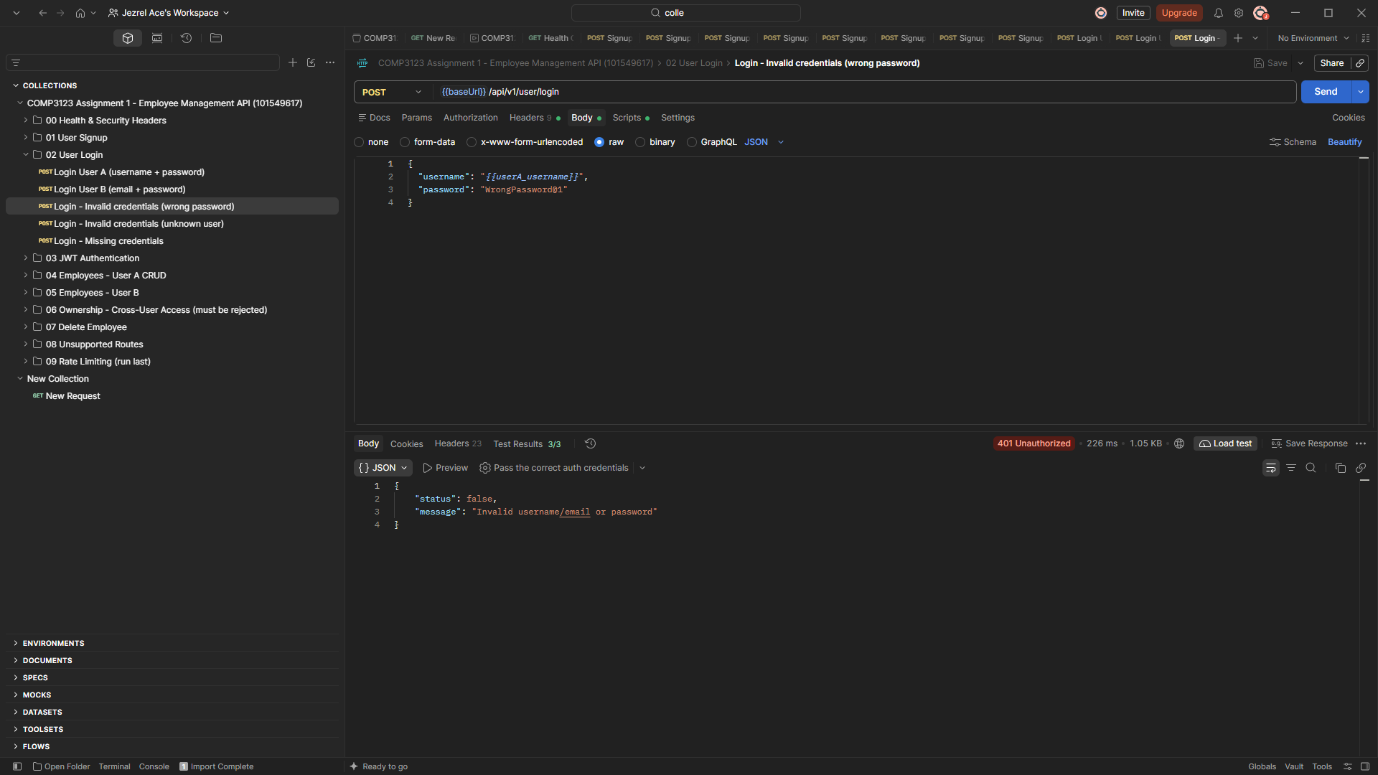
13-login-invalid-credentials-401.png
Figure 15: Missing credentials return 400 Bad Request
An empty body reports "Username or email is required" and "Password is required".
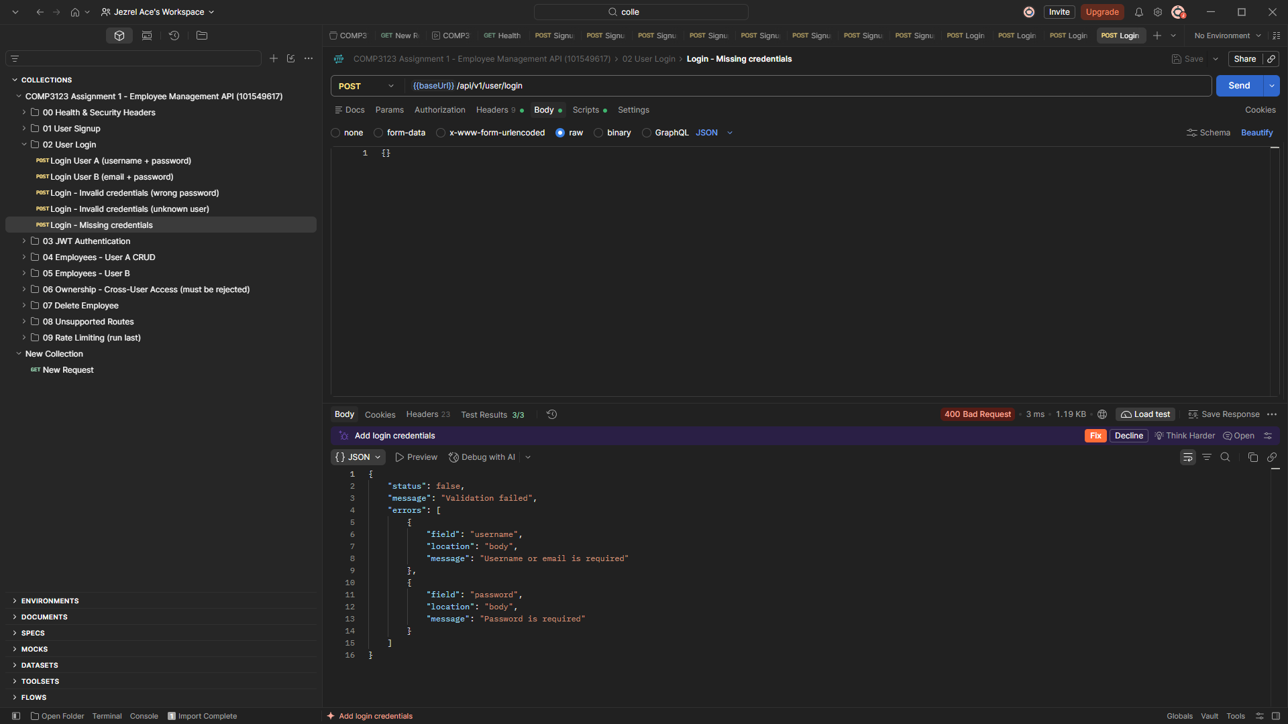
14-login-missing-credentials-400.png

5. JWT Authentication on Protected Employee Routes
Figure 16: Missing JWT returns 401 Unauthorized
GET /api/v1/emp/employees with no Authorization header: "Access denied. No token provided."
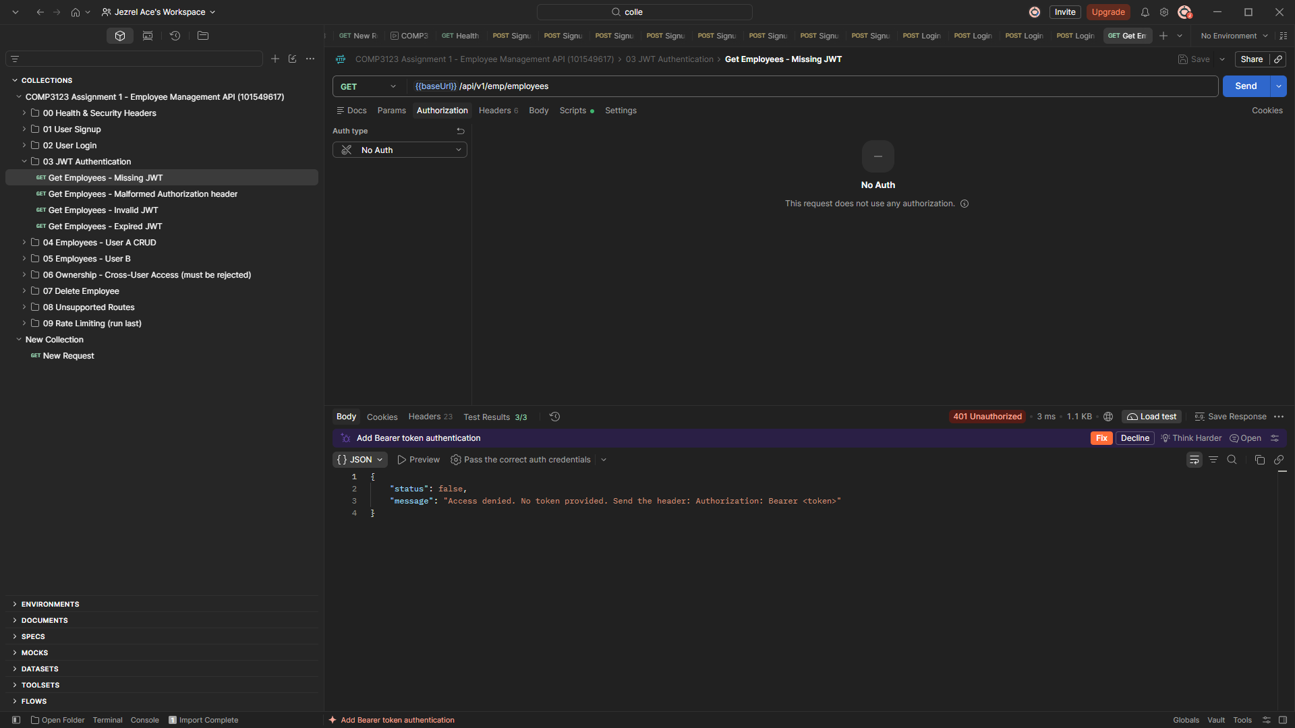
15-jwt-missing-401.png
Figure 17: Malformed Authorization header returns 401 Unauthorized
The header "Token <jwt>" is rejected because the expected format is "Bearer <token>".
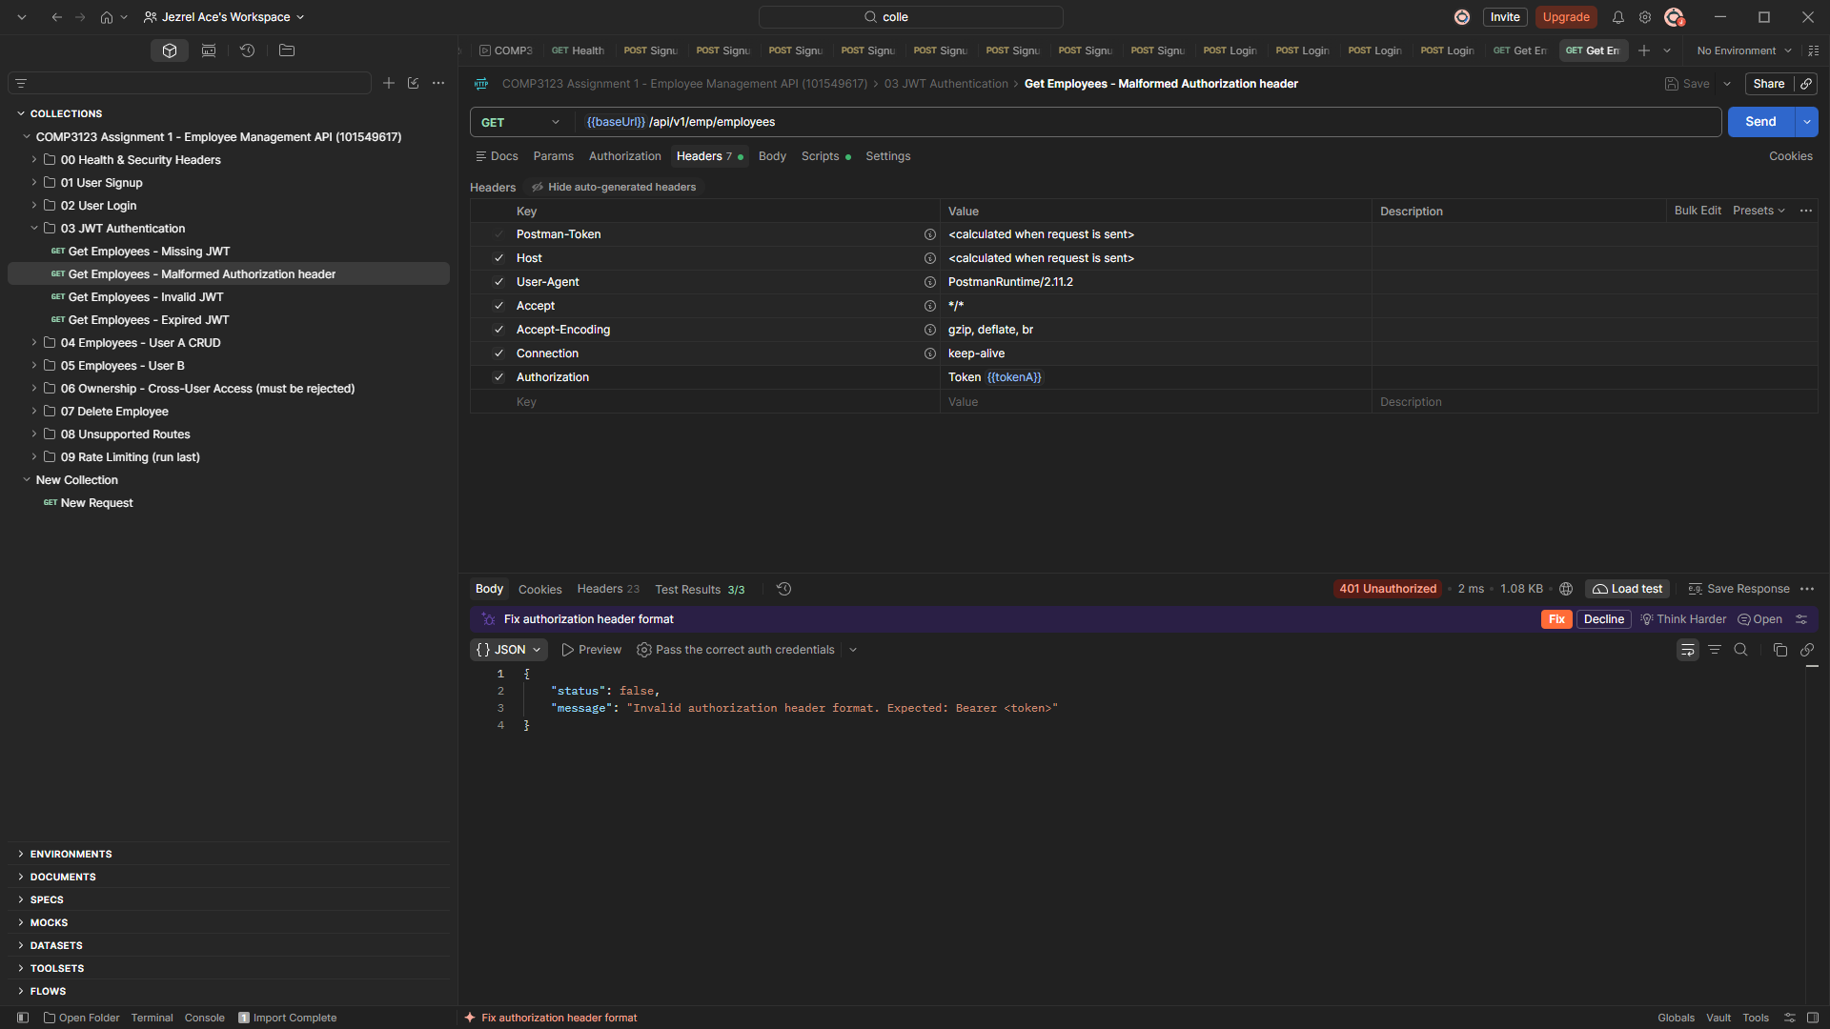
16-jwt-malformed-header-401.png
Figure 18: Invalid JWT returns 401 Unauthorized
A token that is not a valid signed JWT is rejected: "Invalid token".
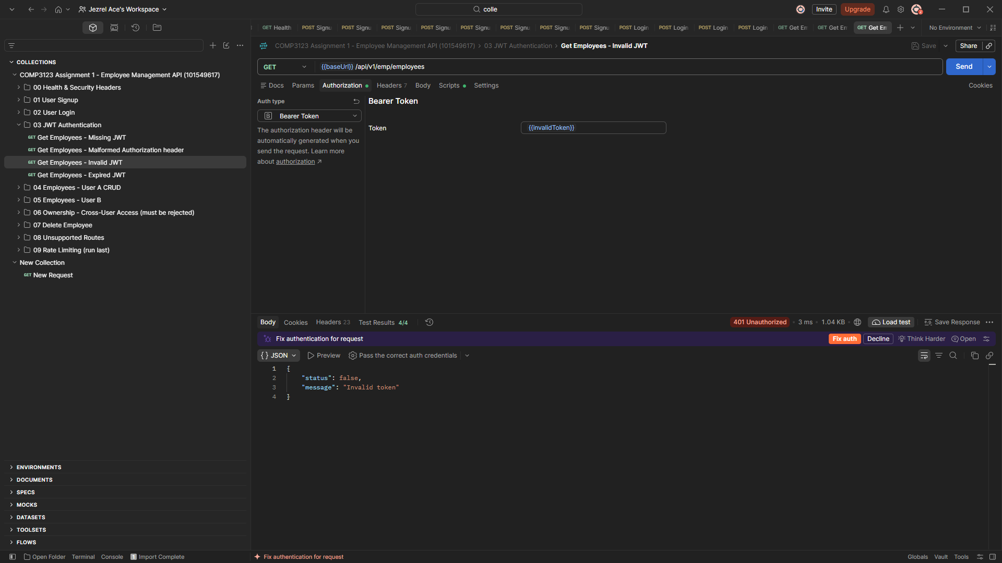
17-jwt-invalid-401.png
Figure 19: Expired JWT returns 401 Unauthorized
A token signed with the real secret but already expired (from npm run token:expired): "Token has expired. Please log in again."
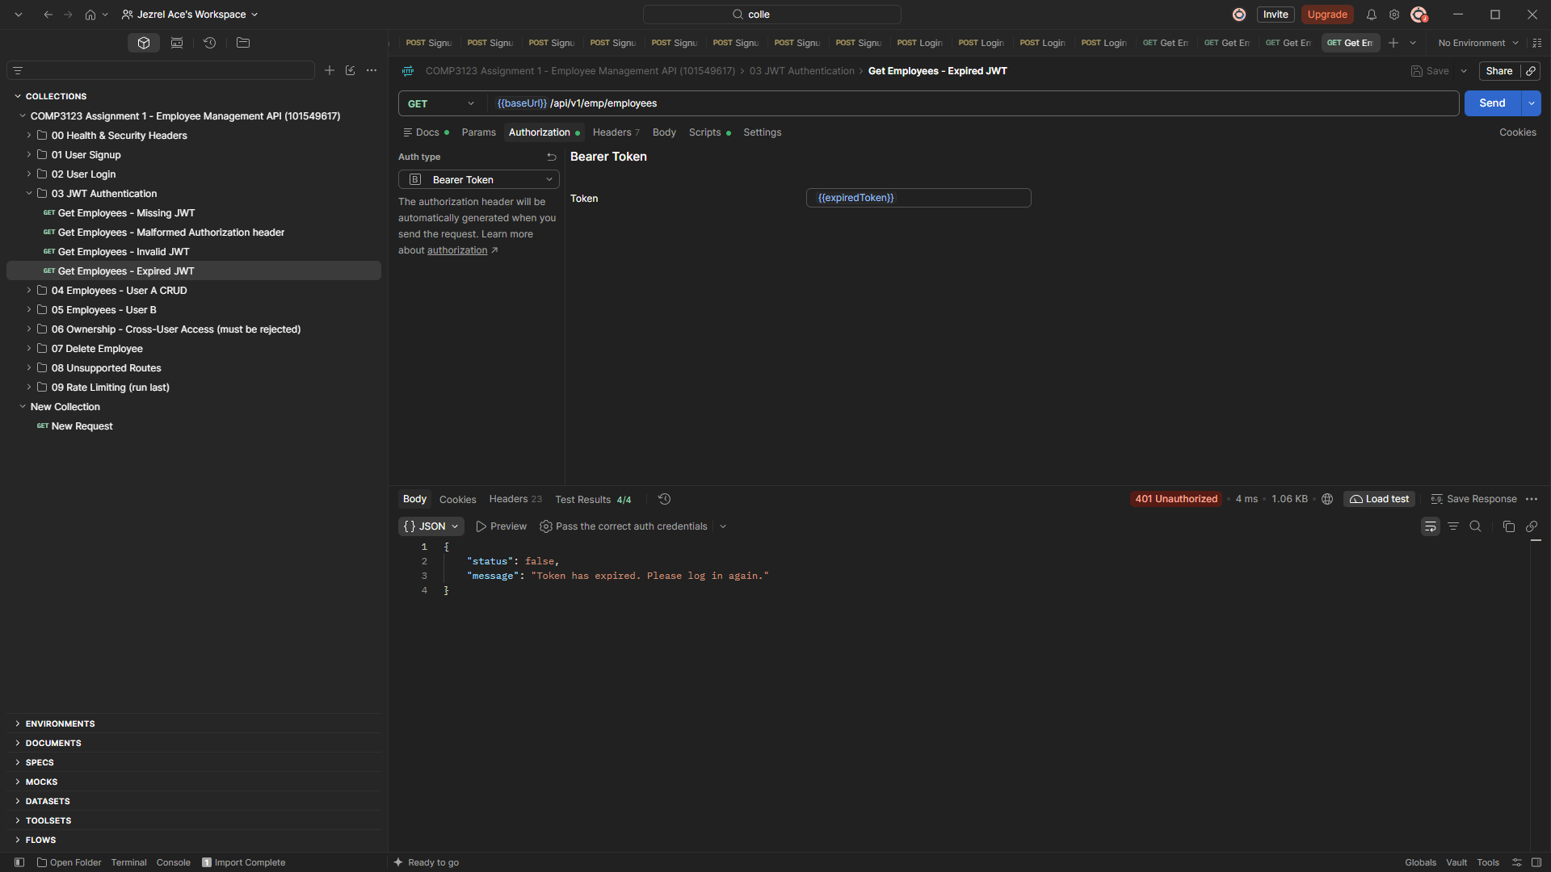
18-jwt-expired-401.png

6. Employee CRUD and Validation (User A)
Figure 20: POST /api/v1/emp/employees returns 201 Created
User A creates an employee. The owner field "user" is set from the JWT to User A's id.
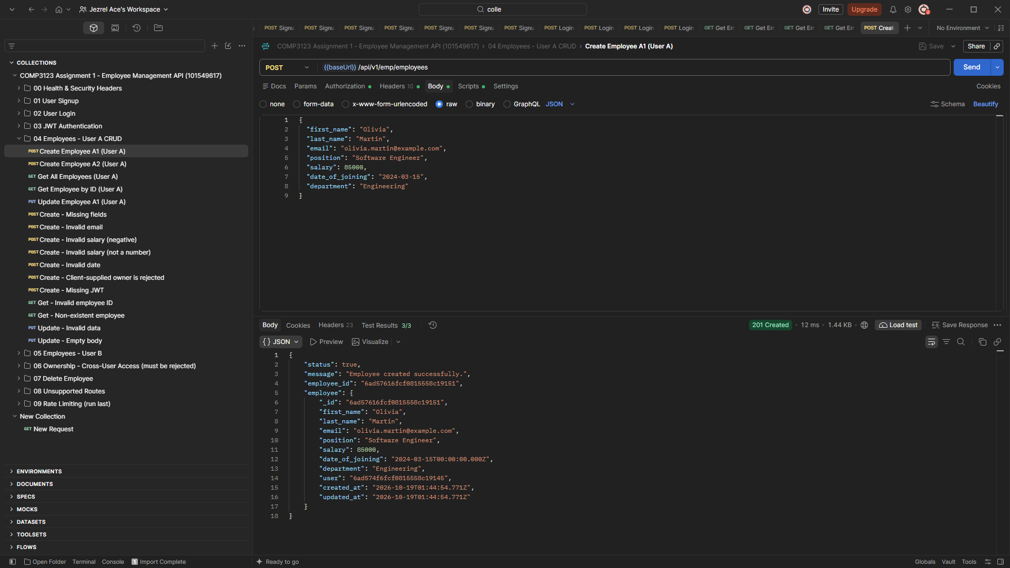
19-employee-create-201.png
Figure 21: GET /api/v1/emp/employees returns 200 OK
User A sees exactly their own 2 employees (count: 2). Every employee has user = User A's id.
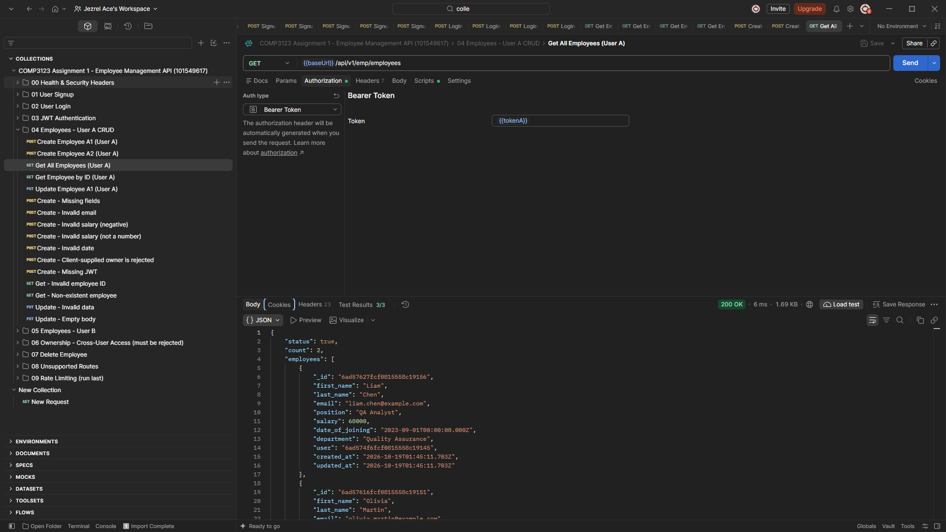
20-employee-list-user-a-200.png
Figure 22: GET /api/v1/emp/employees/{eid} returns 200 OK
User A retrieves one of their own employees by id.
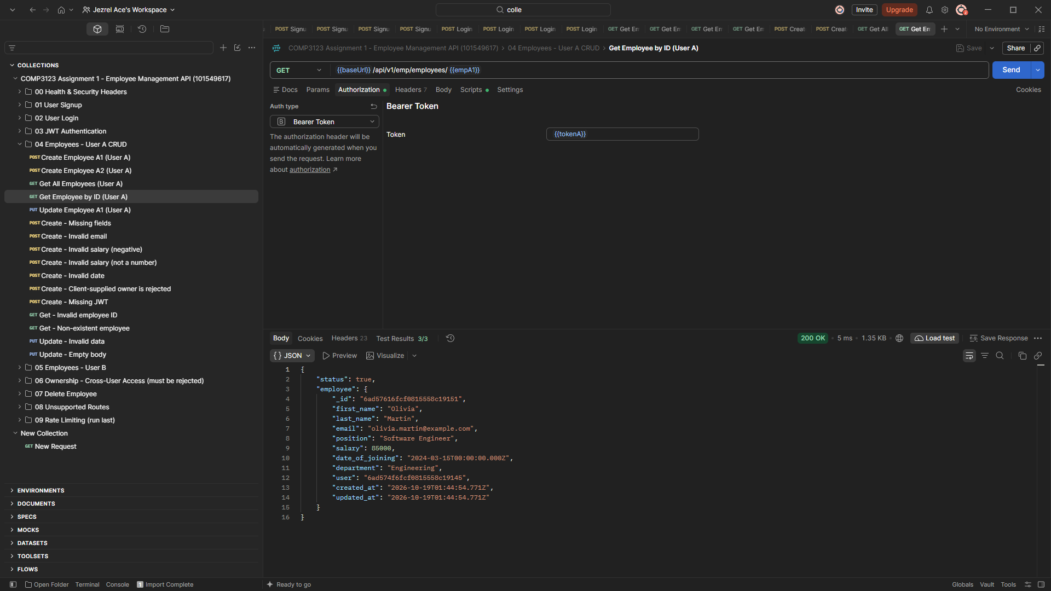
21-employee-get-by-id-200.png
Figure 23: PUT /api/v1/emp/employees/{eid} returns 200 OK
Position and salary are updated; the other fields are unchanged and updated_at changes.
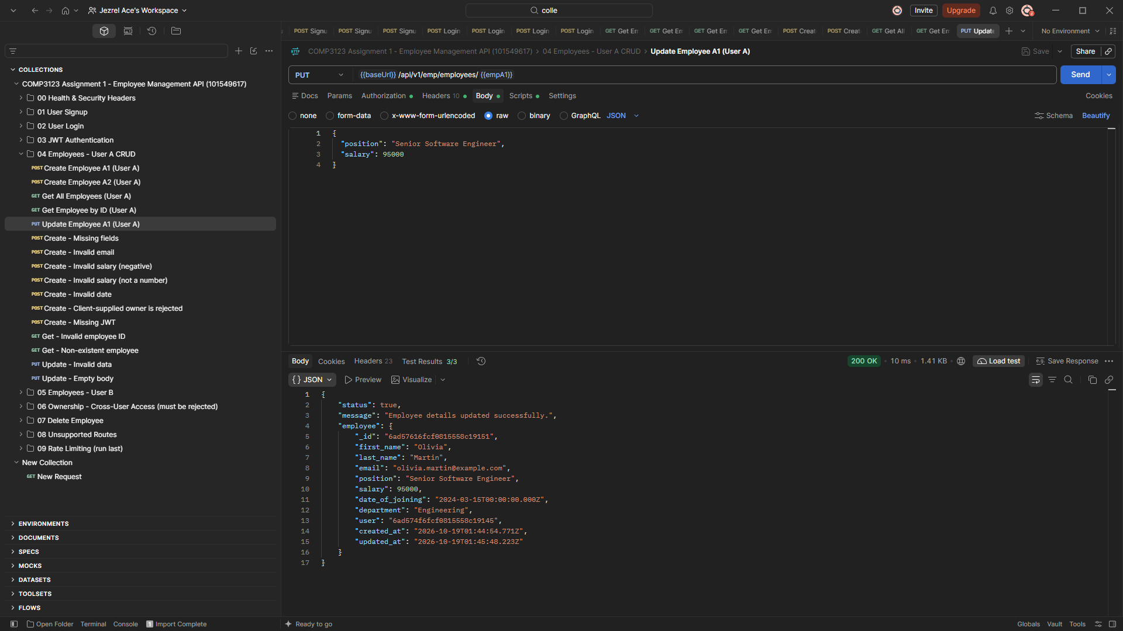
22-employee-update-200.png
Figure 24: Create with missing fields returns 400 Bad Request
Each missing field (last_name, email, position, department, salary, date_of_joining) is reported.
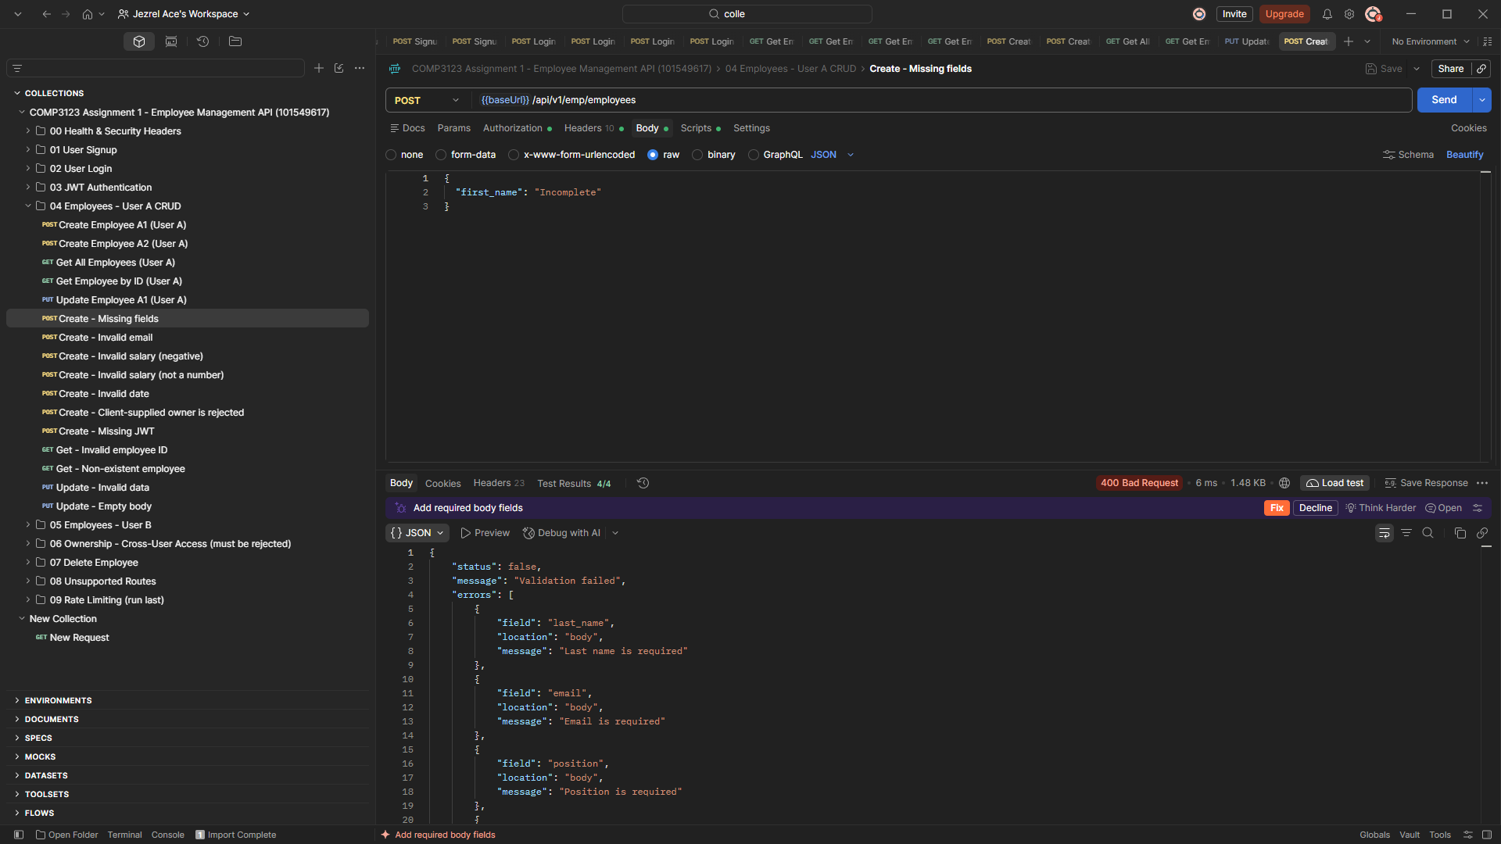
23-employee-missing-fields-400.png
Figure 25: Invalid employee email returns 400 Bad Request
The email field must be a valid email address.
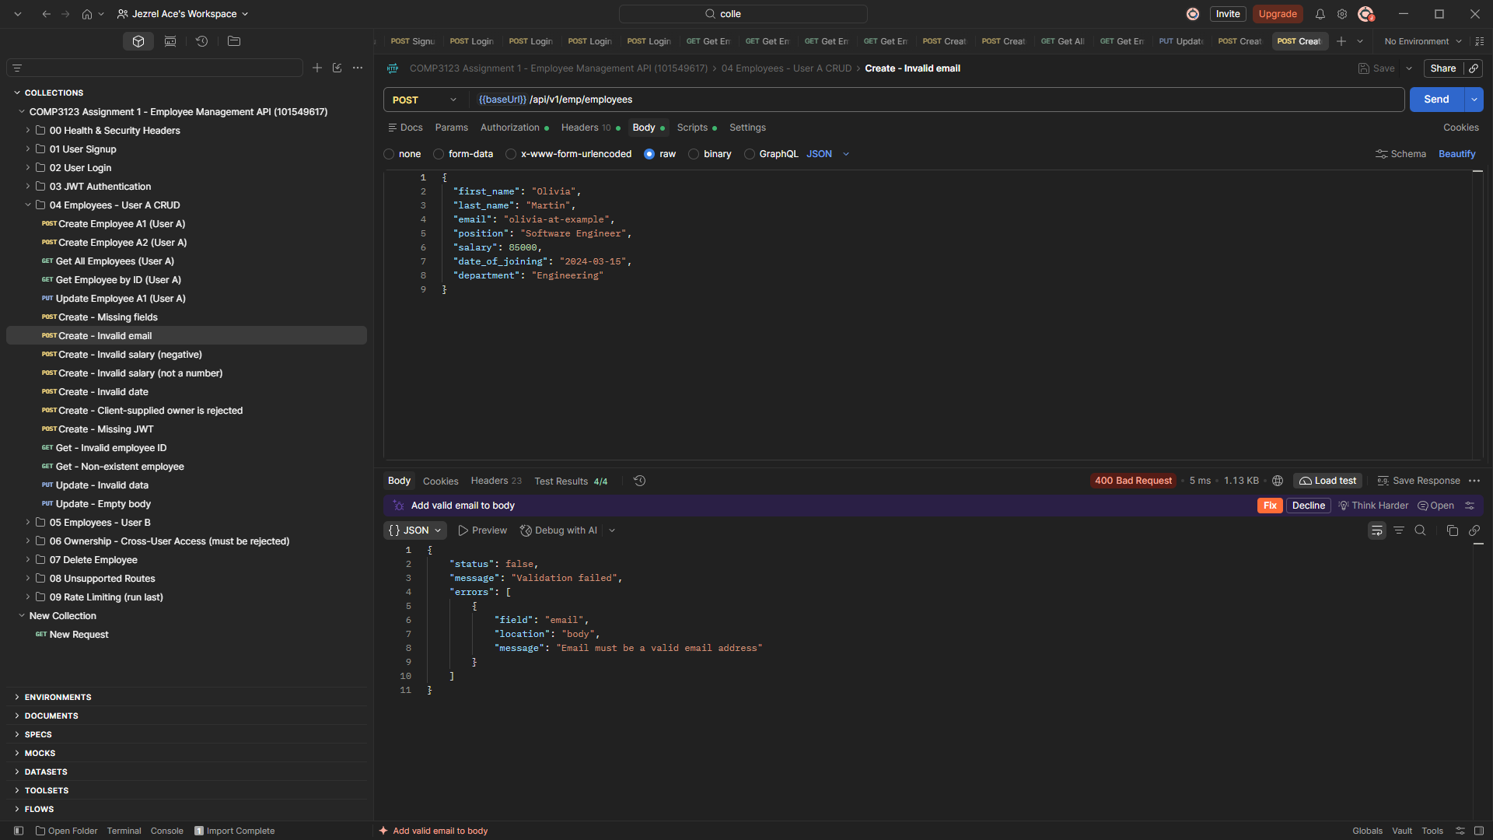
24-employee-invalid-email-400.png
Figure 26: Negative salary returns 400 Bad Request
"Salary must be a positive number".
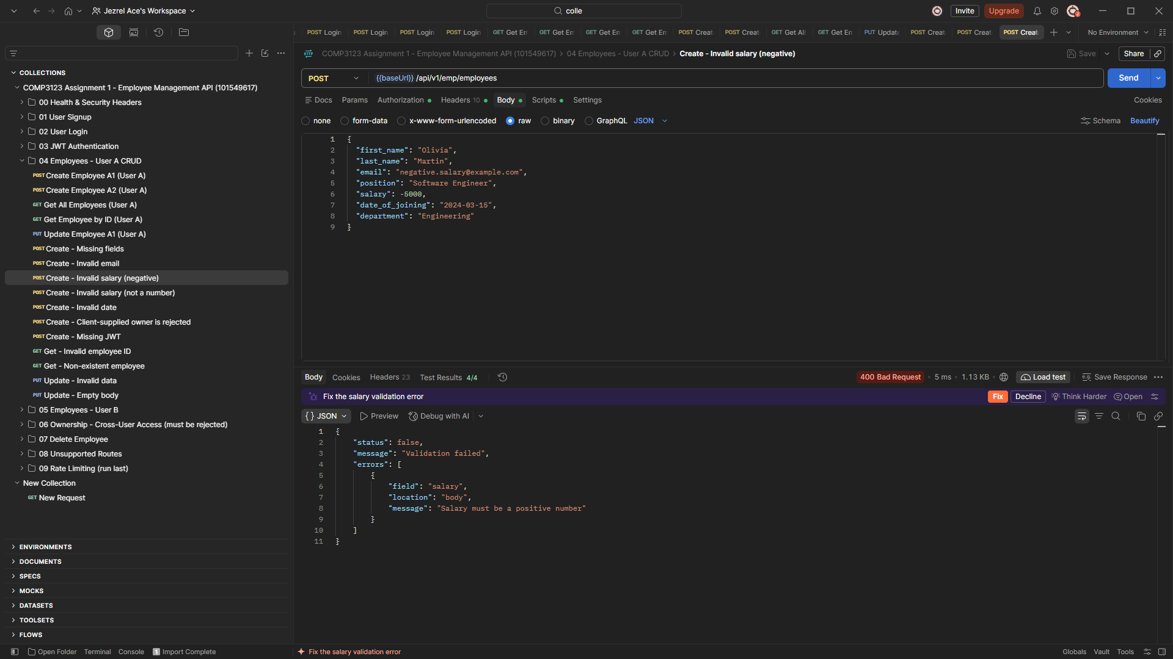
25-employee-invalid-salary-negative-400.png
Figure 27: Non-numeric salary returns 400 Bad Request
"Salary must be a number".
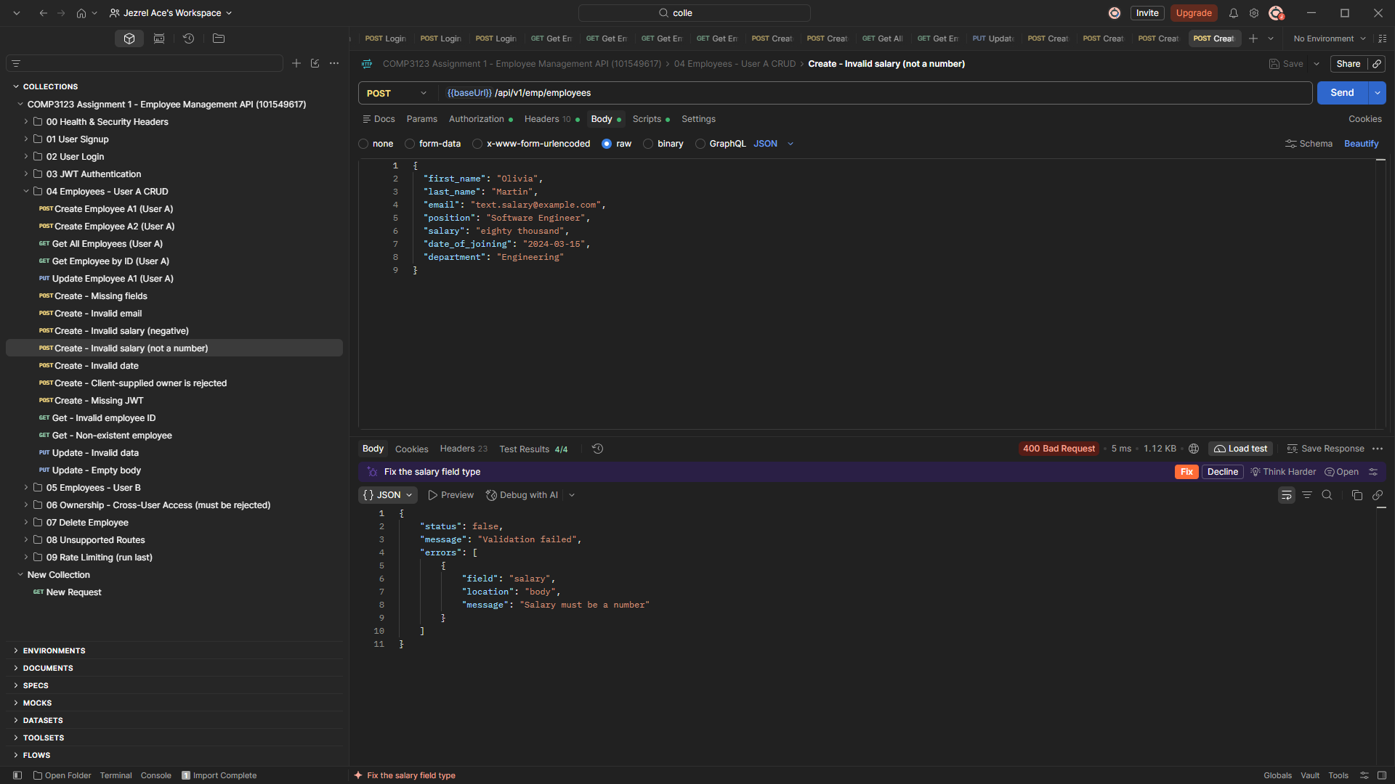
26-employee-invalid-salary-text-400.png
Figure 28: Invalid date returns 400 Bad Request
"2024-13-45" is rejected: date_of_joining must be a valid ISO 8601 date (YYYY-MM-DD).
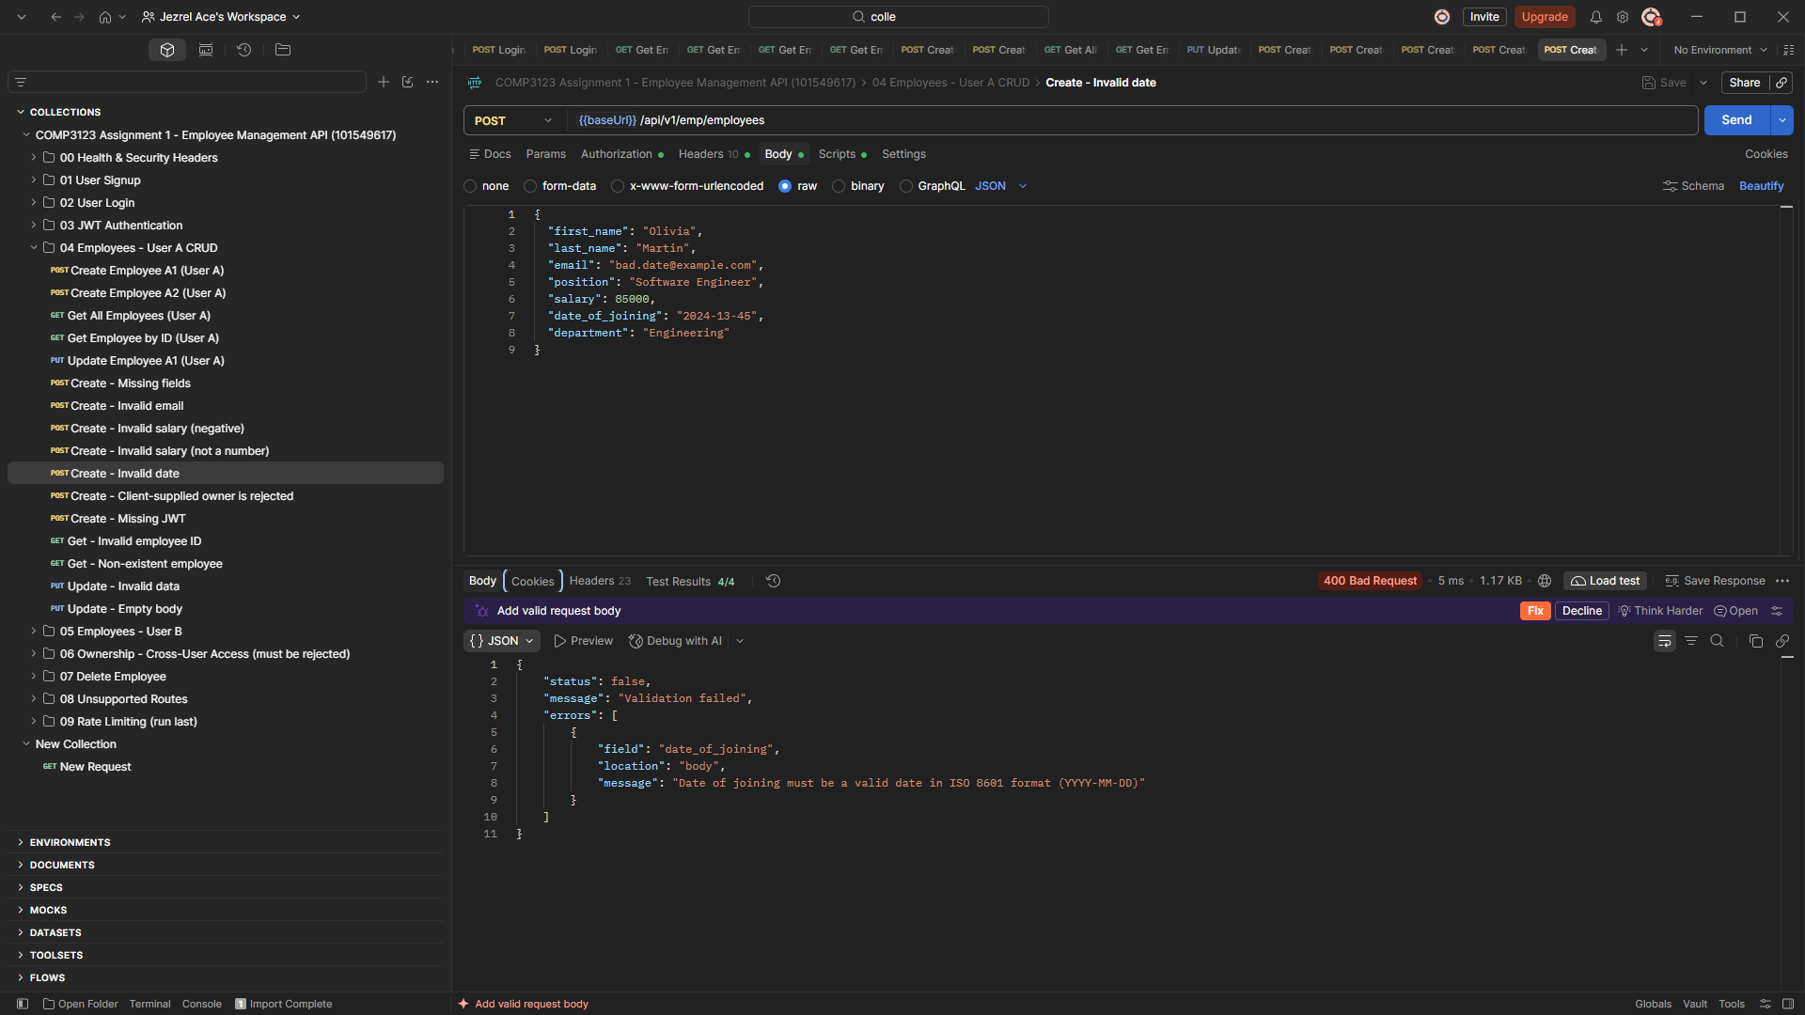
27-employee-invalid-date-400.png
Figure 29: Client-supplied owner is rejected with 400 Bad Request
Sending a "user" field in the body is rejected ("Unknown field 'user' is not allowed"). The owner always comes from the JWT, never from the client.
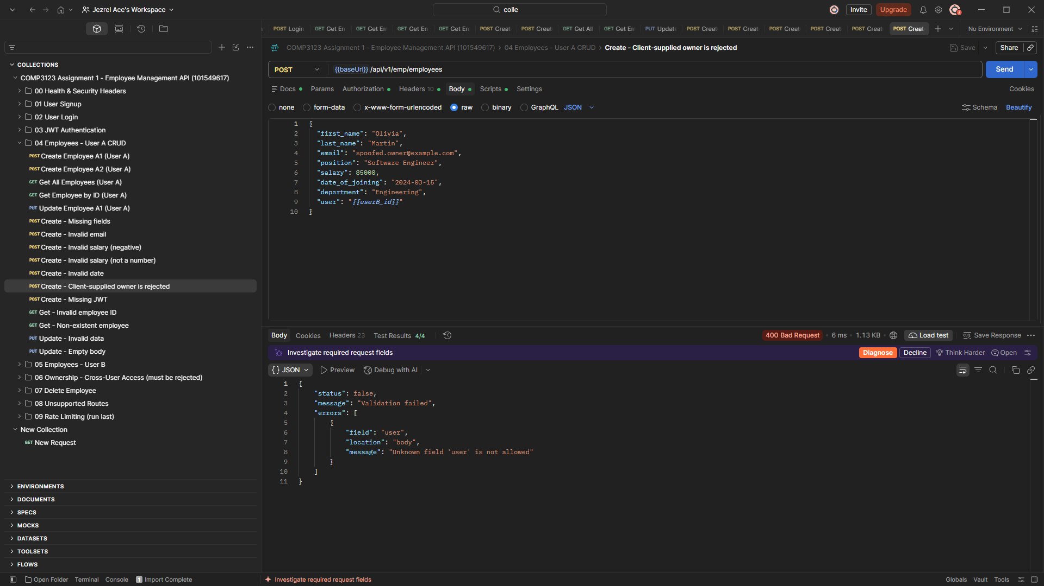
28-employee-client-owner-rejected-400.png
Figure 30: Create employee without a JWT returns 401 Unauthorized
Employee endpoints cannot be used without authentication.
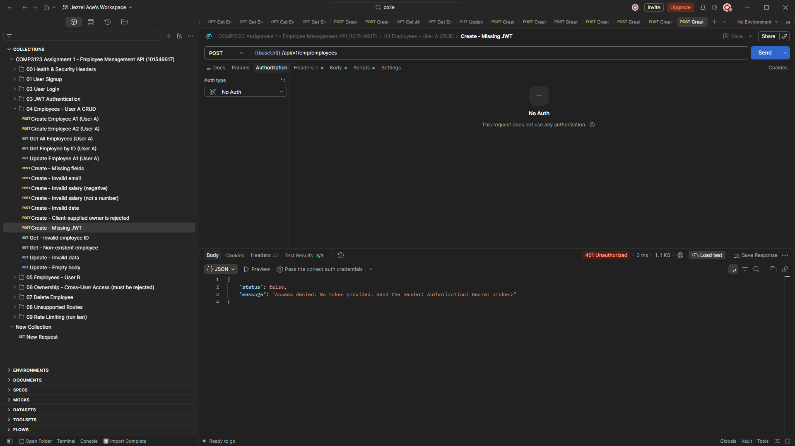
29-employee-create-missing-jwt-401.png
Figure 31: Invalid employee ID returns 400 Bad Request
"not-a-valid-id" is not a MongoDB ObjectId.
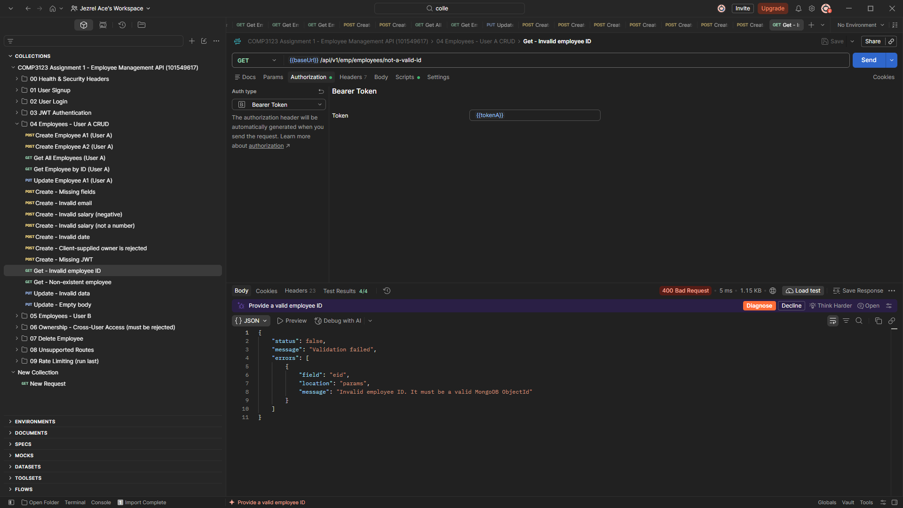
30-employee-invalid-id-400.png
Figure 32: Non-existent employee returns 404 Not Found
A valid ObjectId that does not match any employee: "Employee not found".
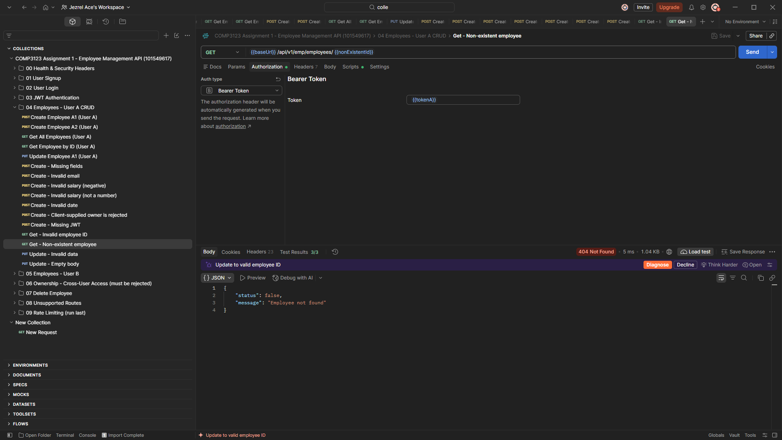
31-employee-not-found-404.png
Figure 33: Update with invalid data returns 400 Bad Request
PUT with salary 0 and an invalid email reports both validation errors.
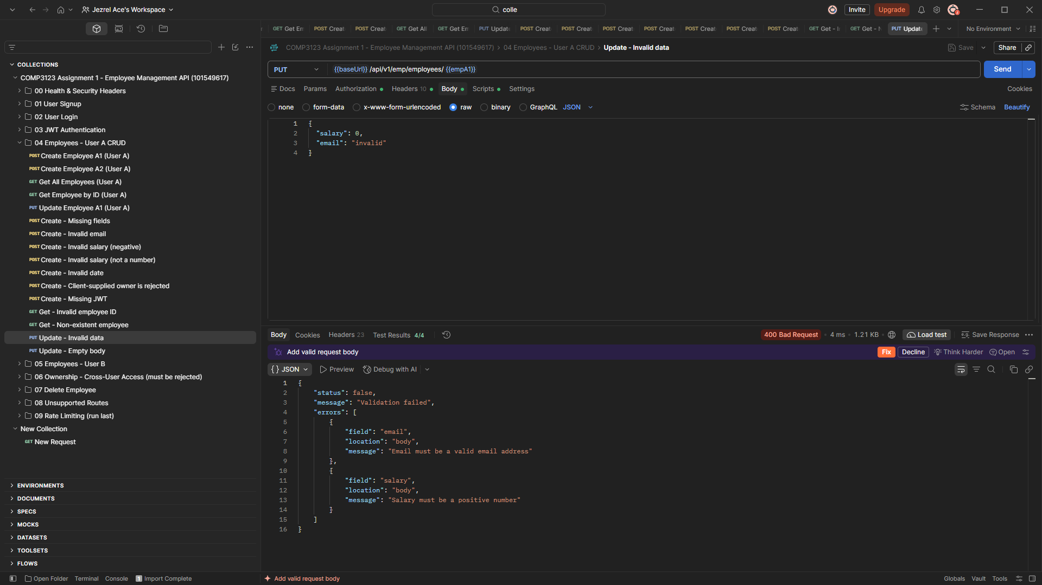
32-employee-update-invalid-400.png

7. Per-User Visibility (User B)
Figure 34: User B creates an employee: 201 Created
The new employee is owned by User B (user = User B's id).
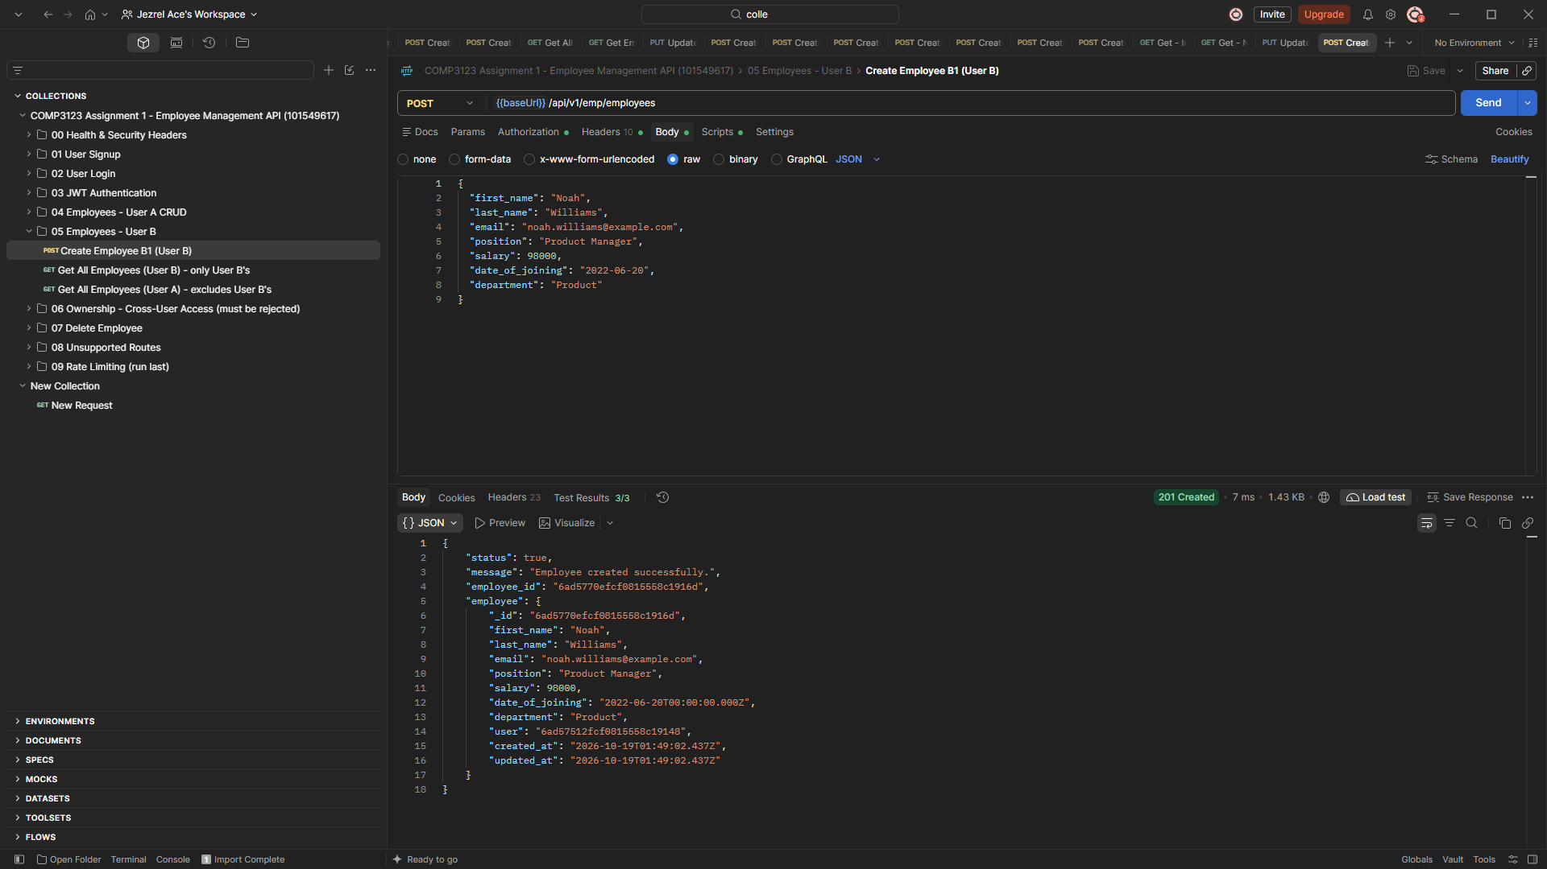
33-user-b-create-employee-201.png
Figure 35: User B only sees User B's employees
GET /api/v1/emp/employees as User B returns count 1, with none of User A's employees.
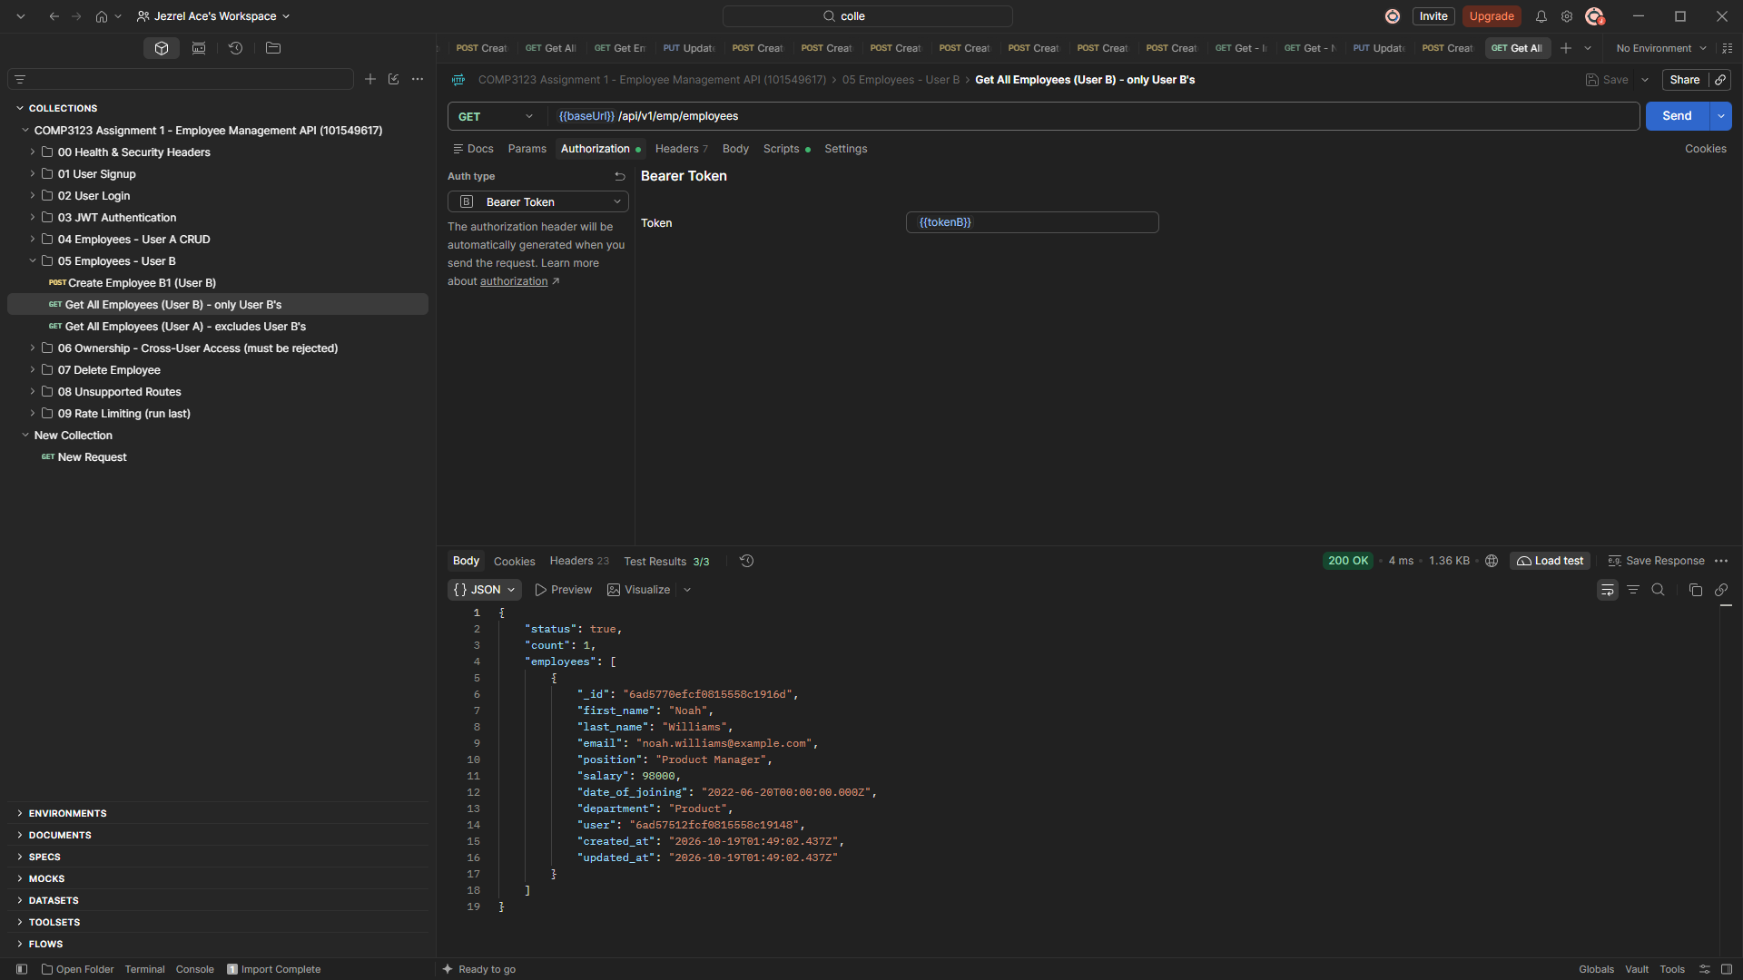
34-user-b-sees-only-own-employees.png
Figure 36: User A does not see User B's employee
The list request as User A passes the test "User A does not see Employee B1".
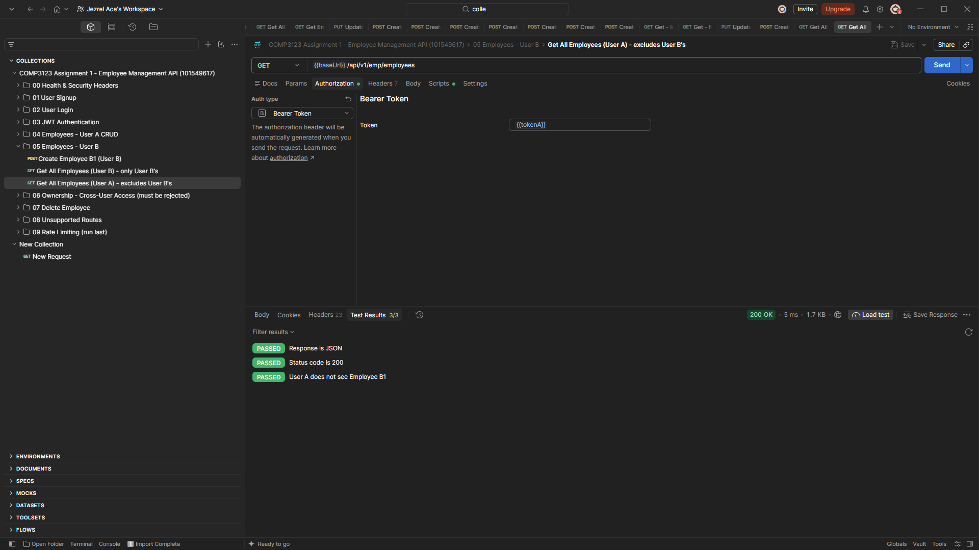
35-user-a-does-not-see-user-b-employee.png

8. Two-User Ownership Test (Cross-User Access Must Be Rejected)
Figure 37: User A GET User B's employee: 403 Forbidden
Changing eid to User B's employee does not bypass authorization.
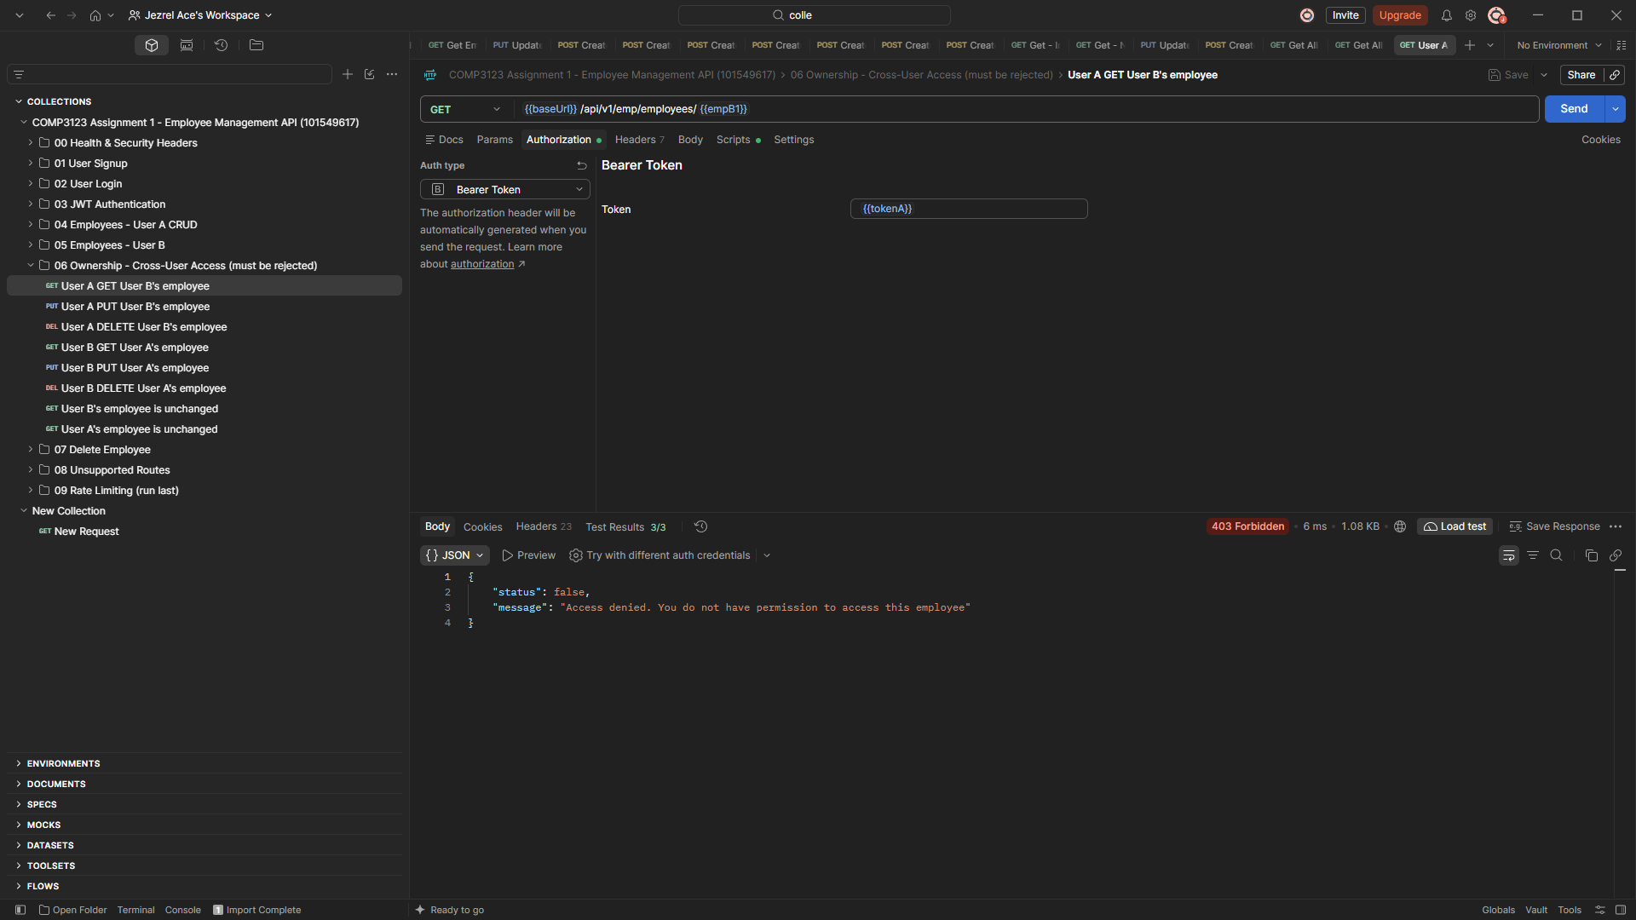
36-ownership-user-a-get-user-b-403.png
Figure 38: User A PUT User B's employee: 403 Forbidden
User A cannot modify User B's employee.
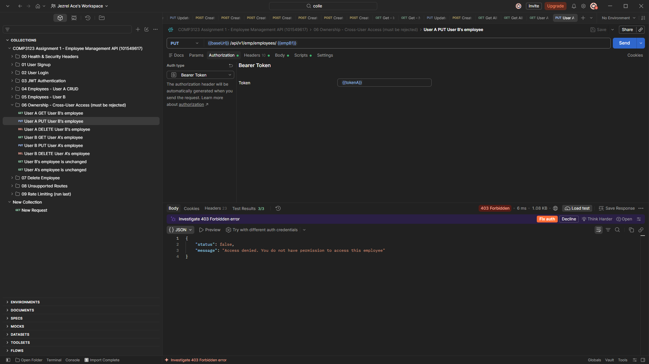
37-ownership-user-a-put-user-b-403.png
Figure 39: User A DELETE User B's employee: 403 Forbidden
User A cannot delete User B's employee through ?eid=.
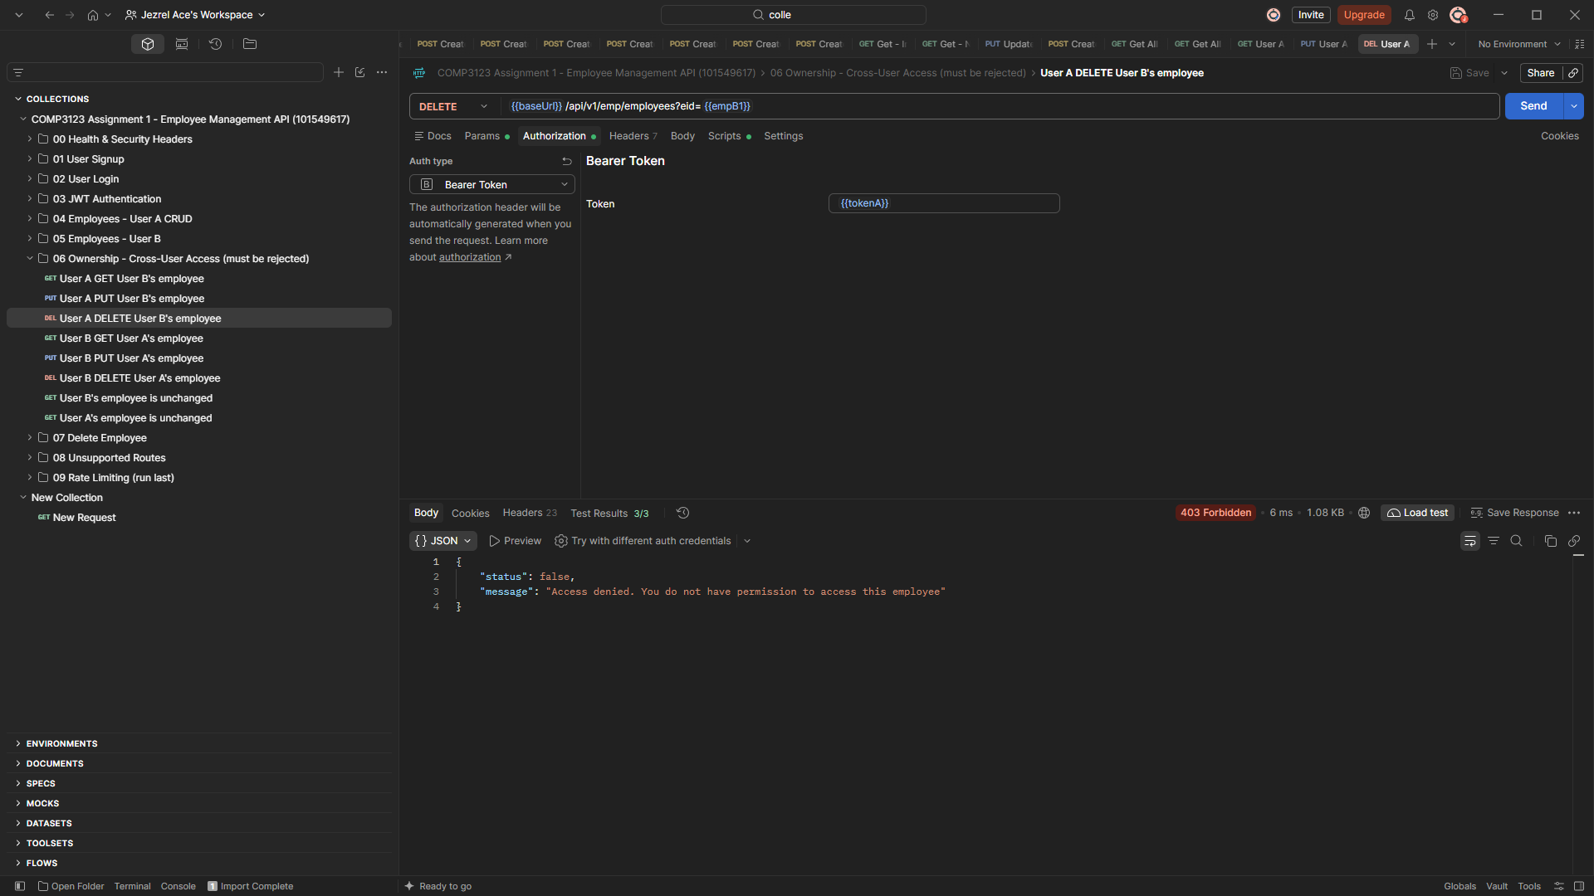
38-ownership-user-a-delete-user-b-403.png
Figure 40: User B GET User A's employee: 403 Forbidden
The reverse direction is rejected too.
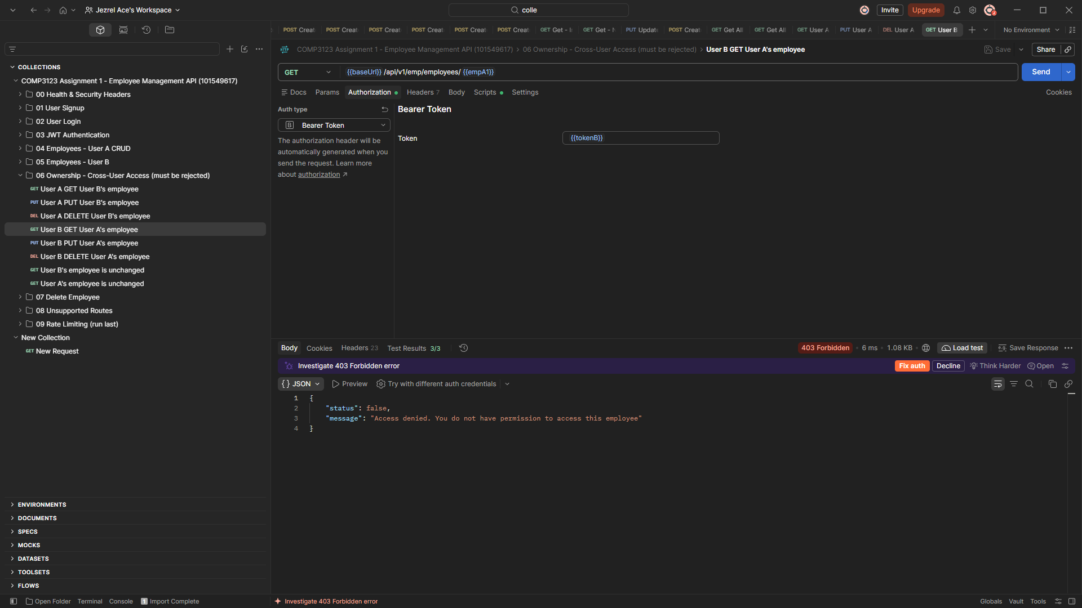
39-ownership-user-b-get-user-a-403.png
Figure 41: User B PUT User A's employee: 403 Forbidden
User B cannot modify User A's employee.
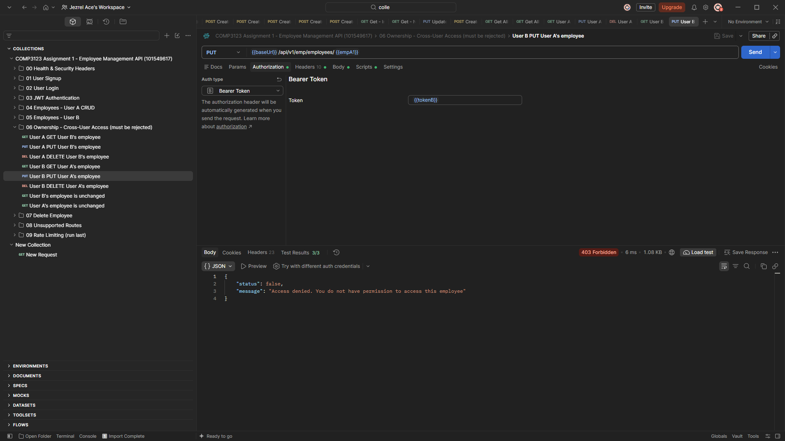
40-ownership-user-b-put-user-a-403.png
Figure 42: User B DELETE User A's employee: 403 Forbidden
User B cannot delete User A's employee.
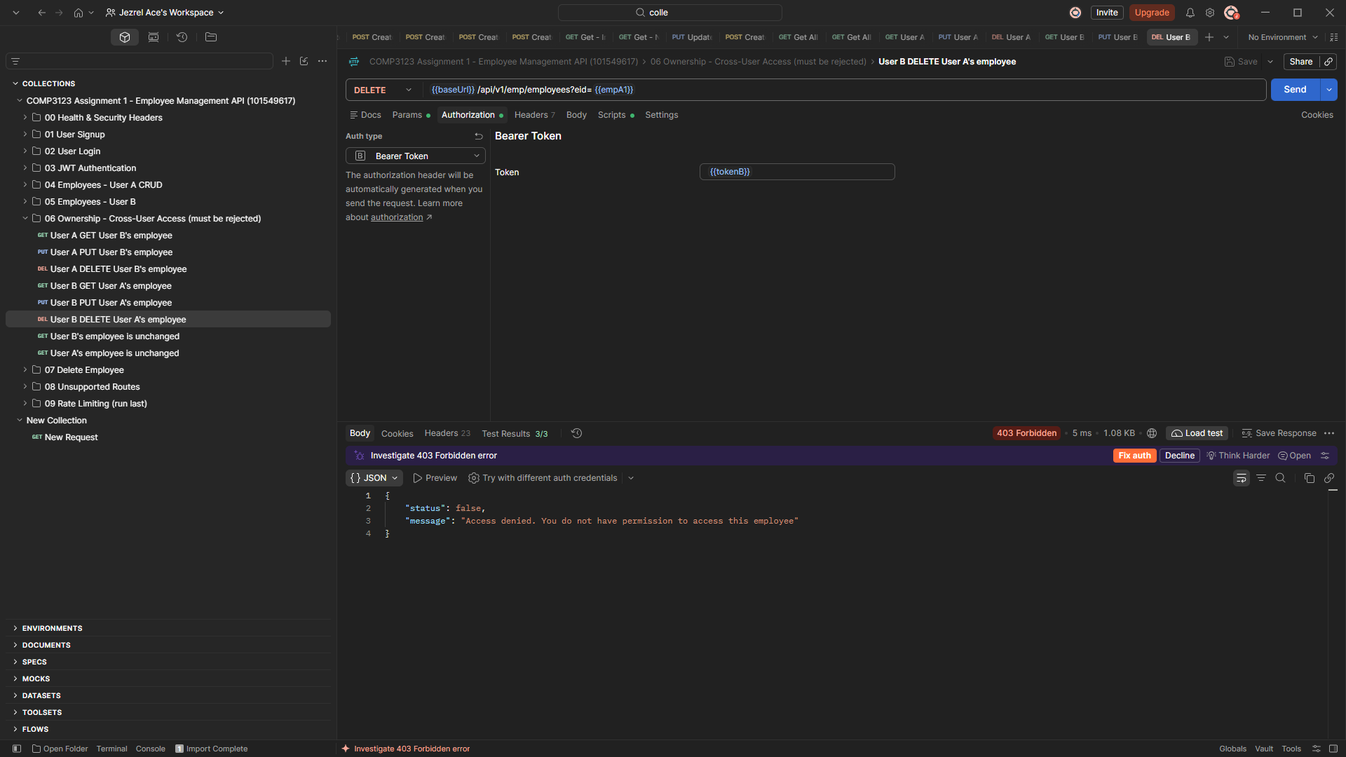
41-ownership-user-b-delete-user-a-403.png
Figure 43: User B's employee is unchanged after the rejected attempts
Salary is still 98000 and updated_at equals created_at, so the cross-user PUT/DELETE had no effect.
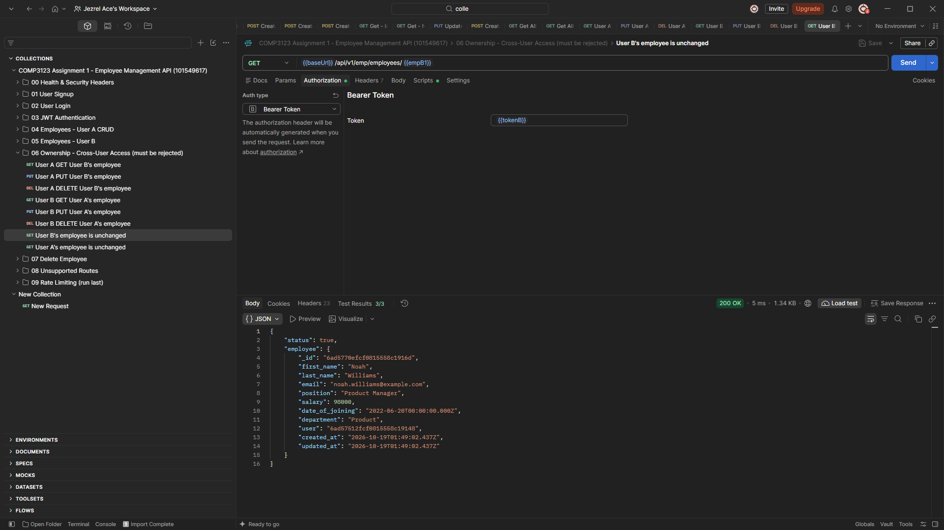
42-ownership-user-b-employee-unchanged.png

9. Delete Employee and Error Handling
Figure 44: DELETE /api/v1/emp/employees?eid=xxx returns 204 No Content
User A deletes their own employee; the response body is empty.
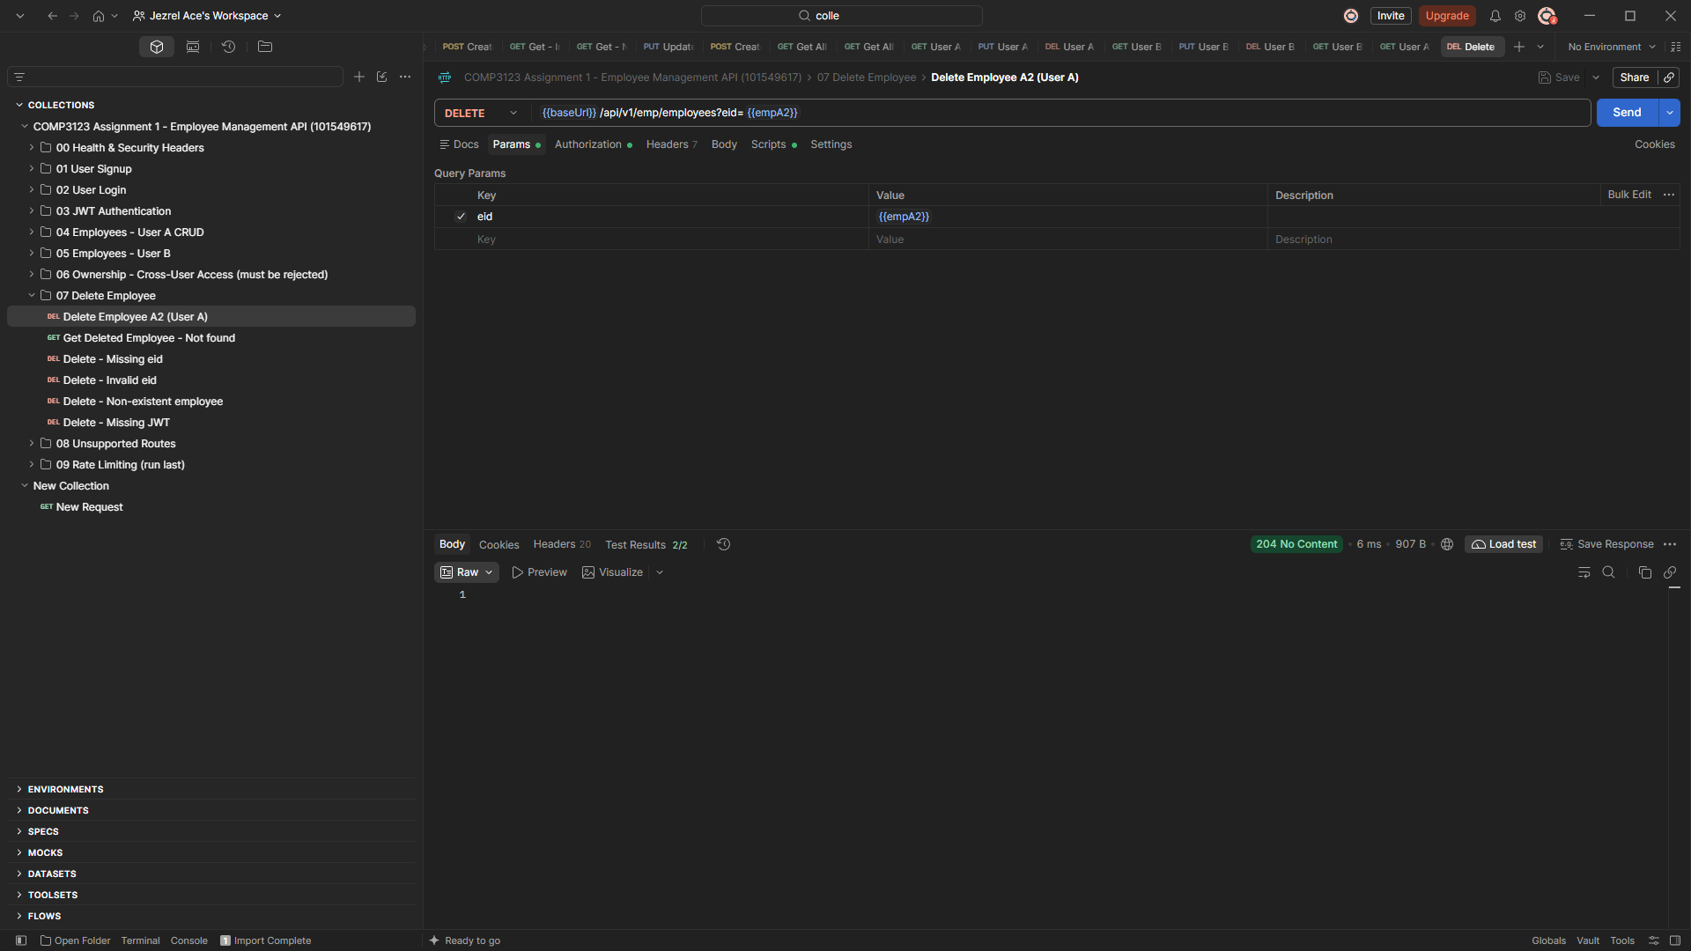
43-employee-delete-204.png
Figure 45: The deleted employee now returns 404 Not Found
Confirms the delete removed the document.
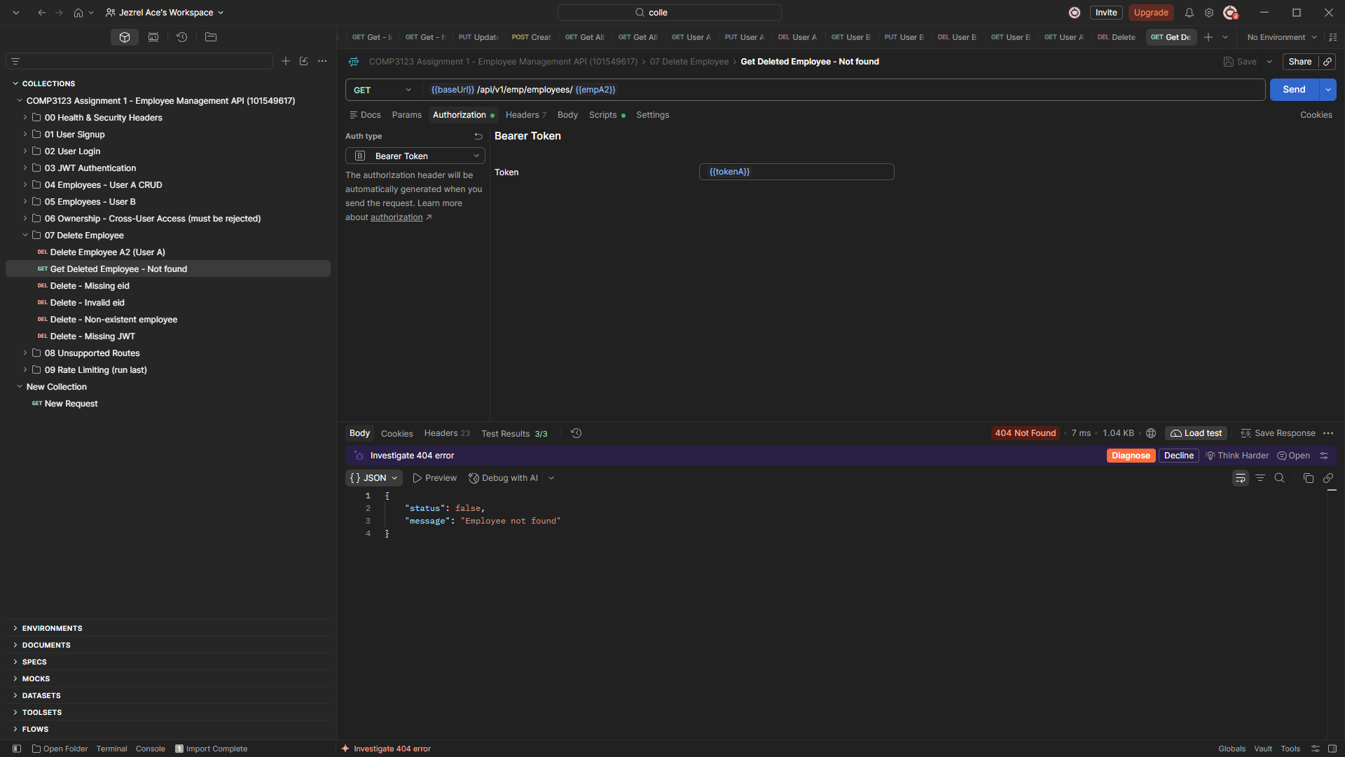
44-employee-deleted-now-404.png
Figure 46: DELETE without eid returns 400 Bad Request
"Employee ID is required as a query parameter: ?eid=<employee id>".
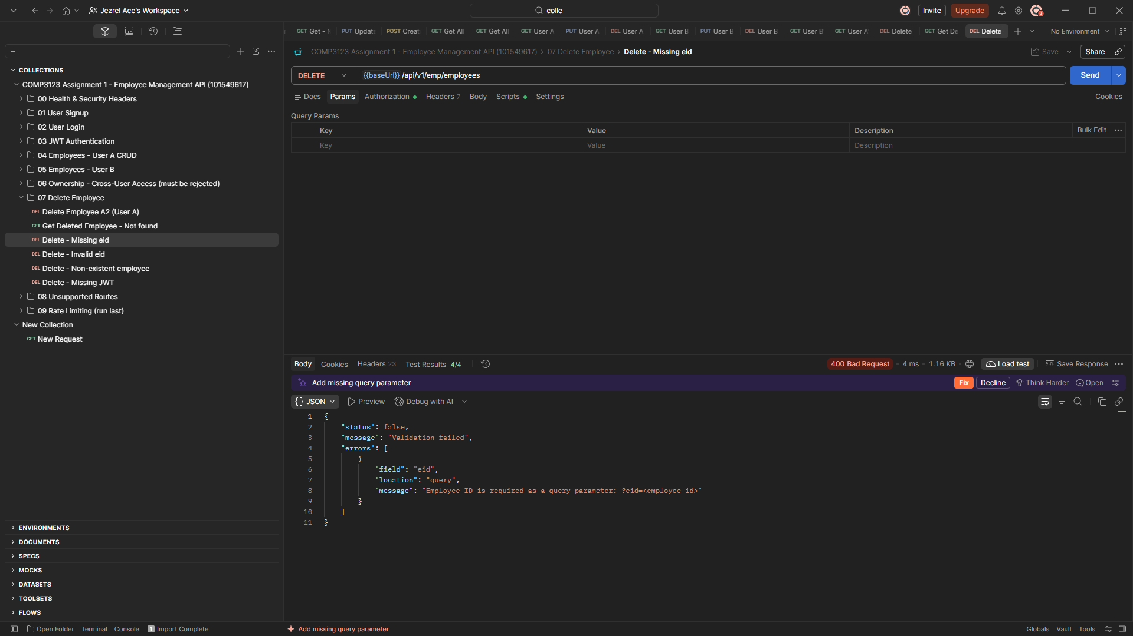
45-employee-delete-missing-eid-400.png
Figure 47: Unsupported route returns a JSON 404
Unknown routes are handled by the 404 middleware: "Route not found: GET /api/v1/does-not-exist".
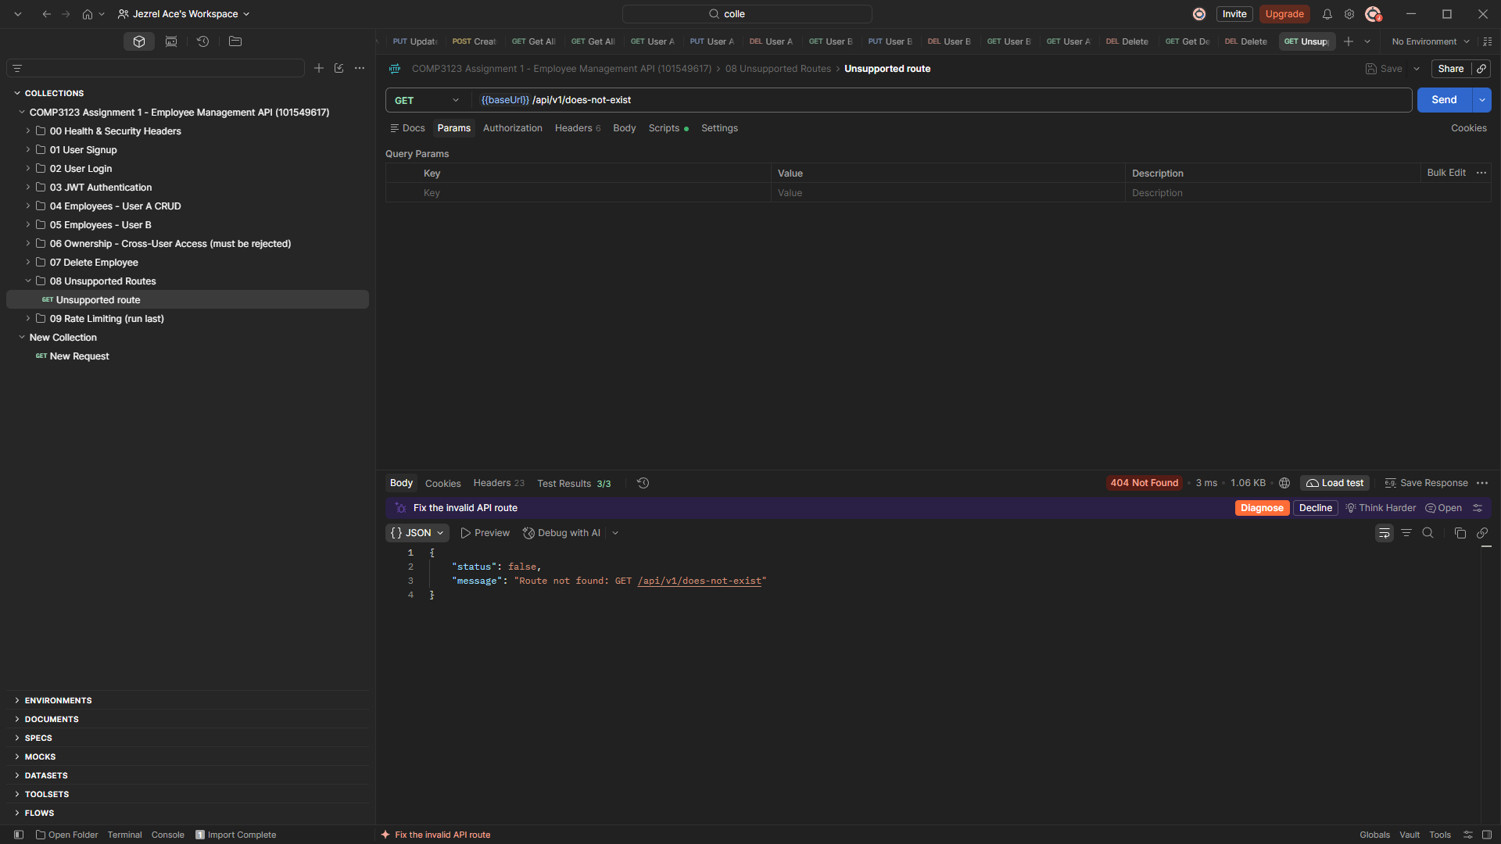
46-unsupported-route-404.png

10. Rate Limiting
Figure 48: Repeated failed logins return 429 Too Many Requests
After 5 failed login attempts within 15 minutes: "Too many failed login attempts from this IP. Please try again after 15 minute(s)."
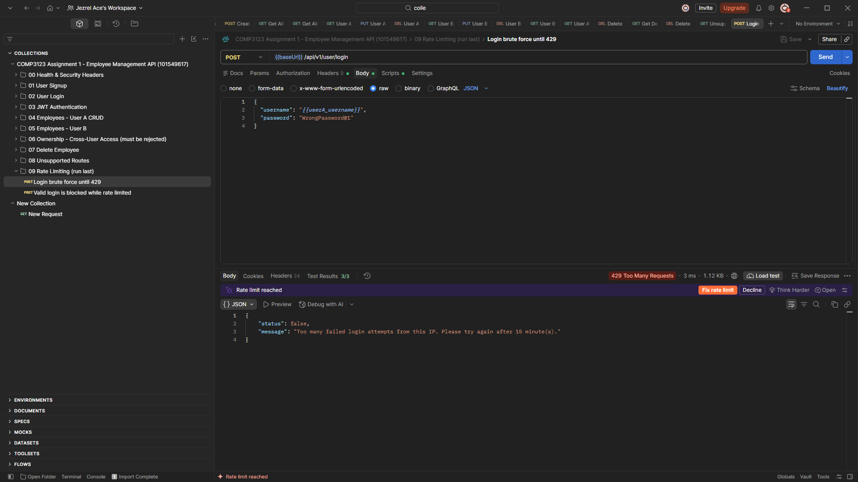
47-rate-limit-429.png
Figure 49: Rate-limit headers on the 429 response
RateLimit-Policy 5;w=900, RateLimit-Limit 5, RateLimit-Remaining 0, RateLimit-Reset and Retry-After tell the client when to retry.
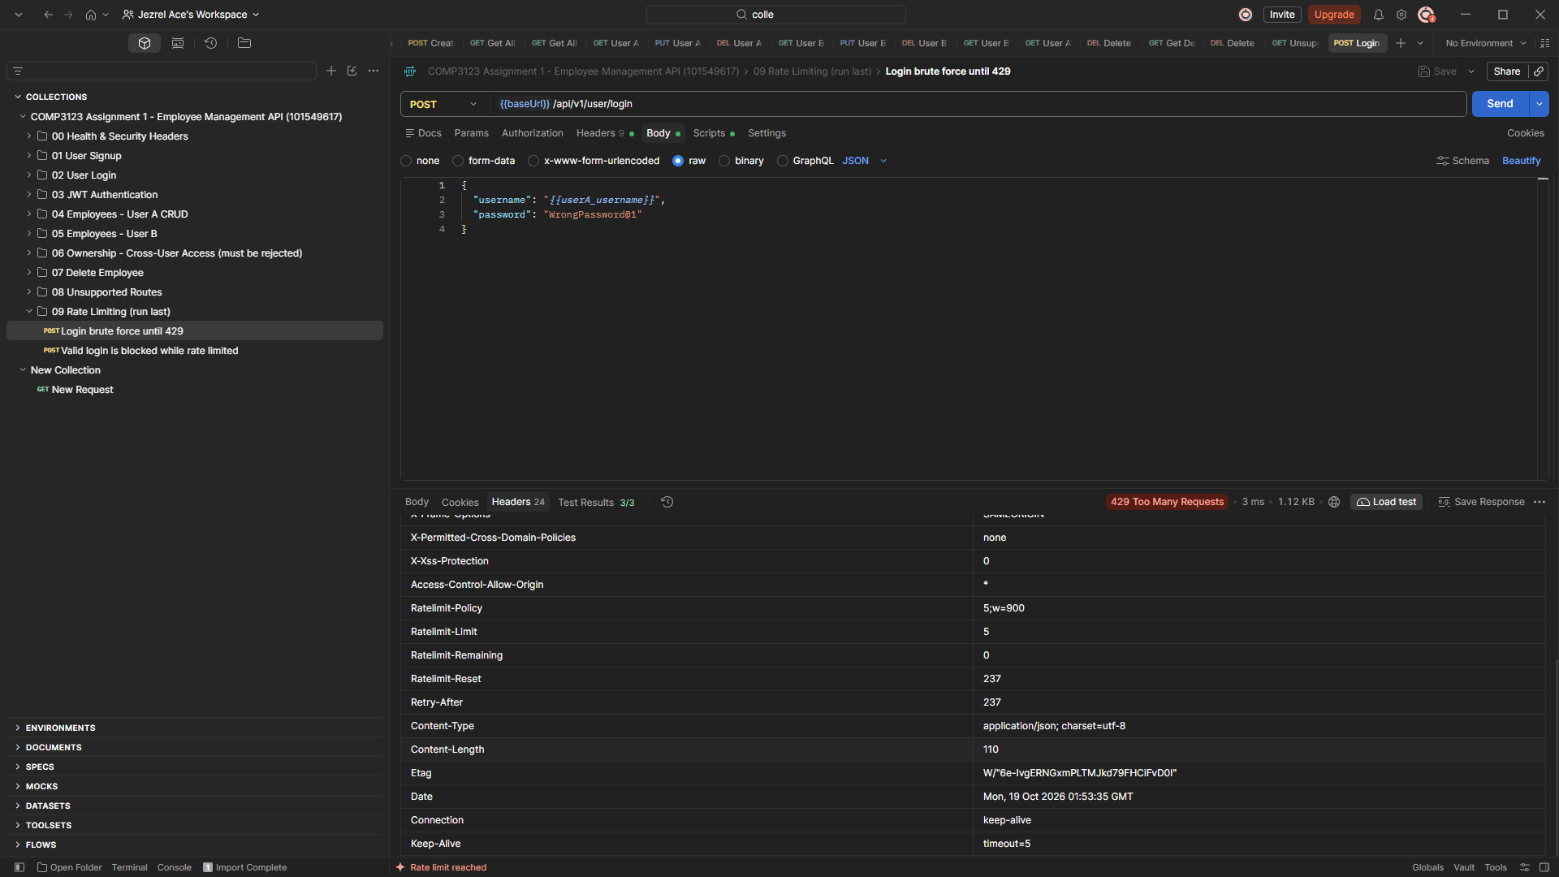
48-rate-limit-headers.png
Figure 50: A correct password is also blocked while rate limited
The block applies to every login from that IP until the window resets, which stops brute-force attacks.
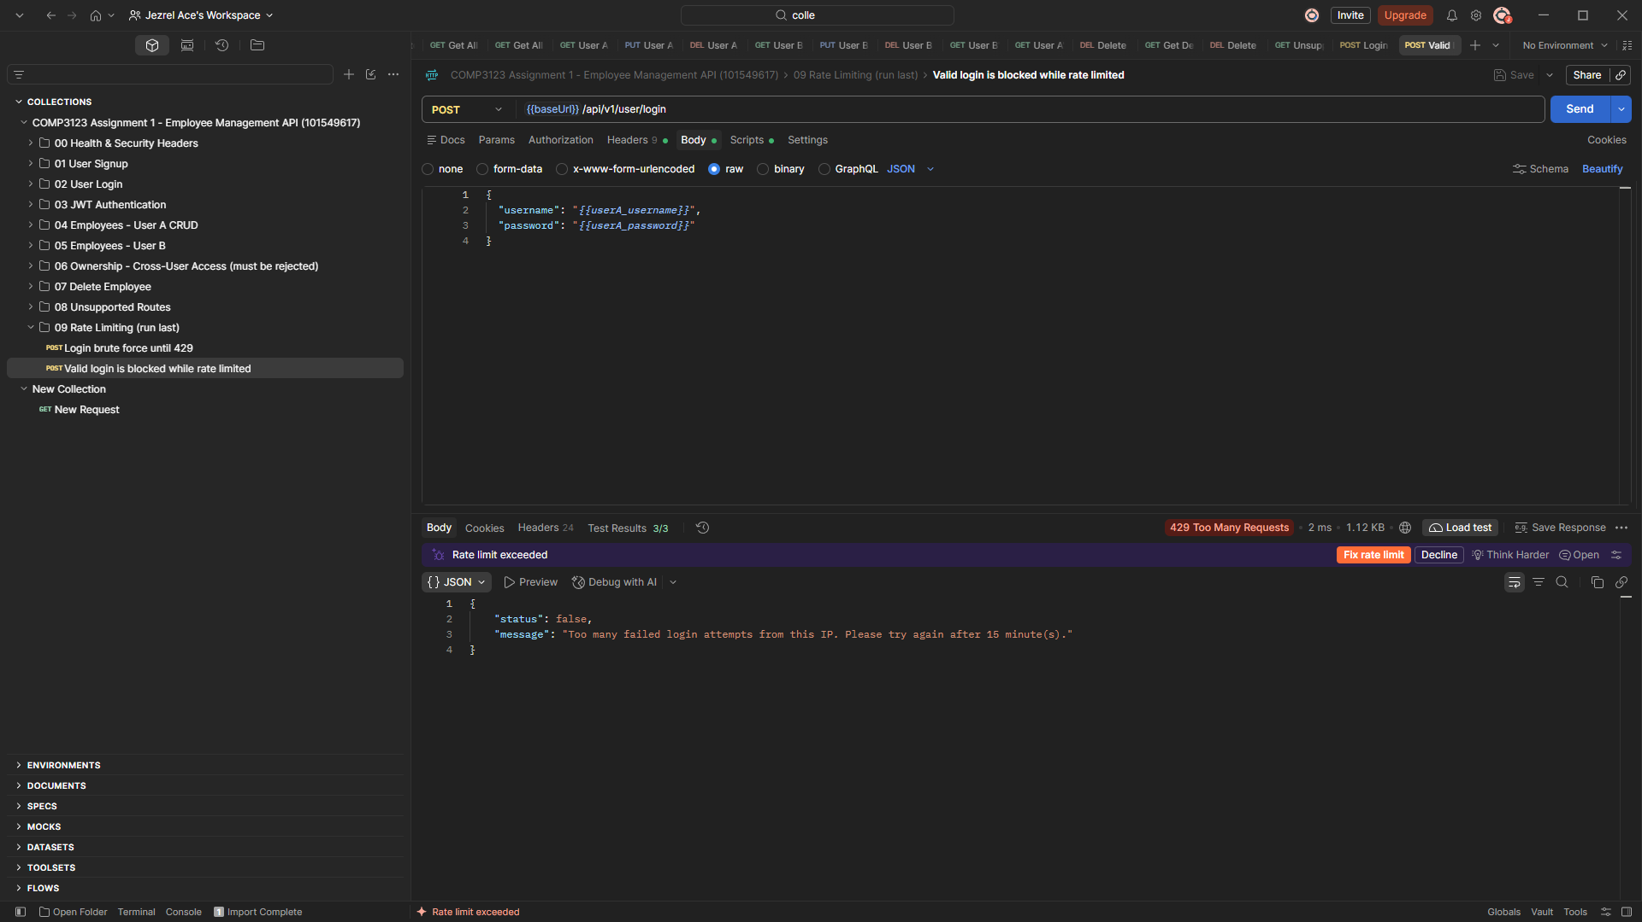
49-rate-limit-valid-login-blocked-429.png

11. MongoDB Evidence (MongoDB Compass)
Figure 51: Database comp3123_assignment1 with users and employees collections
The API uses the required database name; both collections are created by Mongoose.
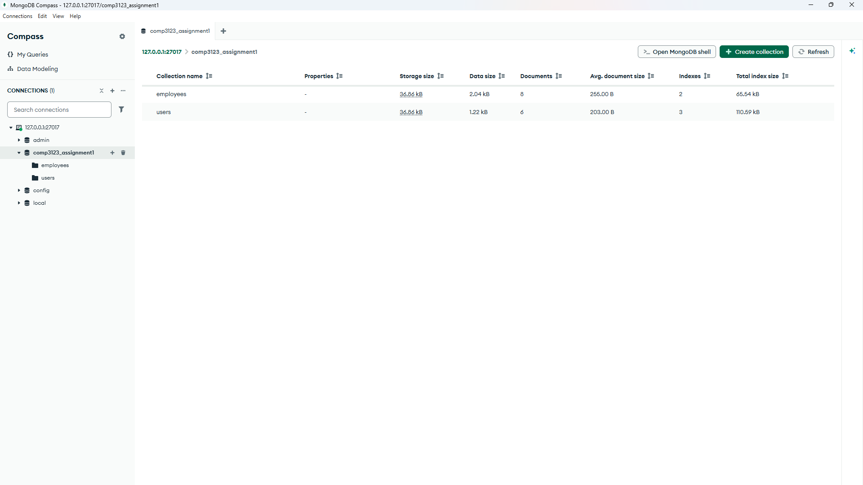
50-mongodb-database-collections.png
Figure 52: users collection: passwords stored as bcrypt hashes
Every password is a bcrypt hash ($2b$12$...), never plain text. Each user has created_at and updated_at timestamps.
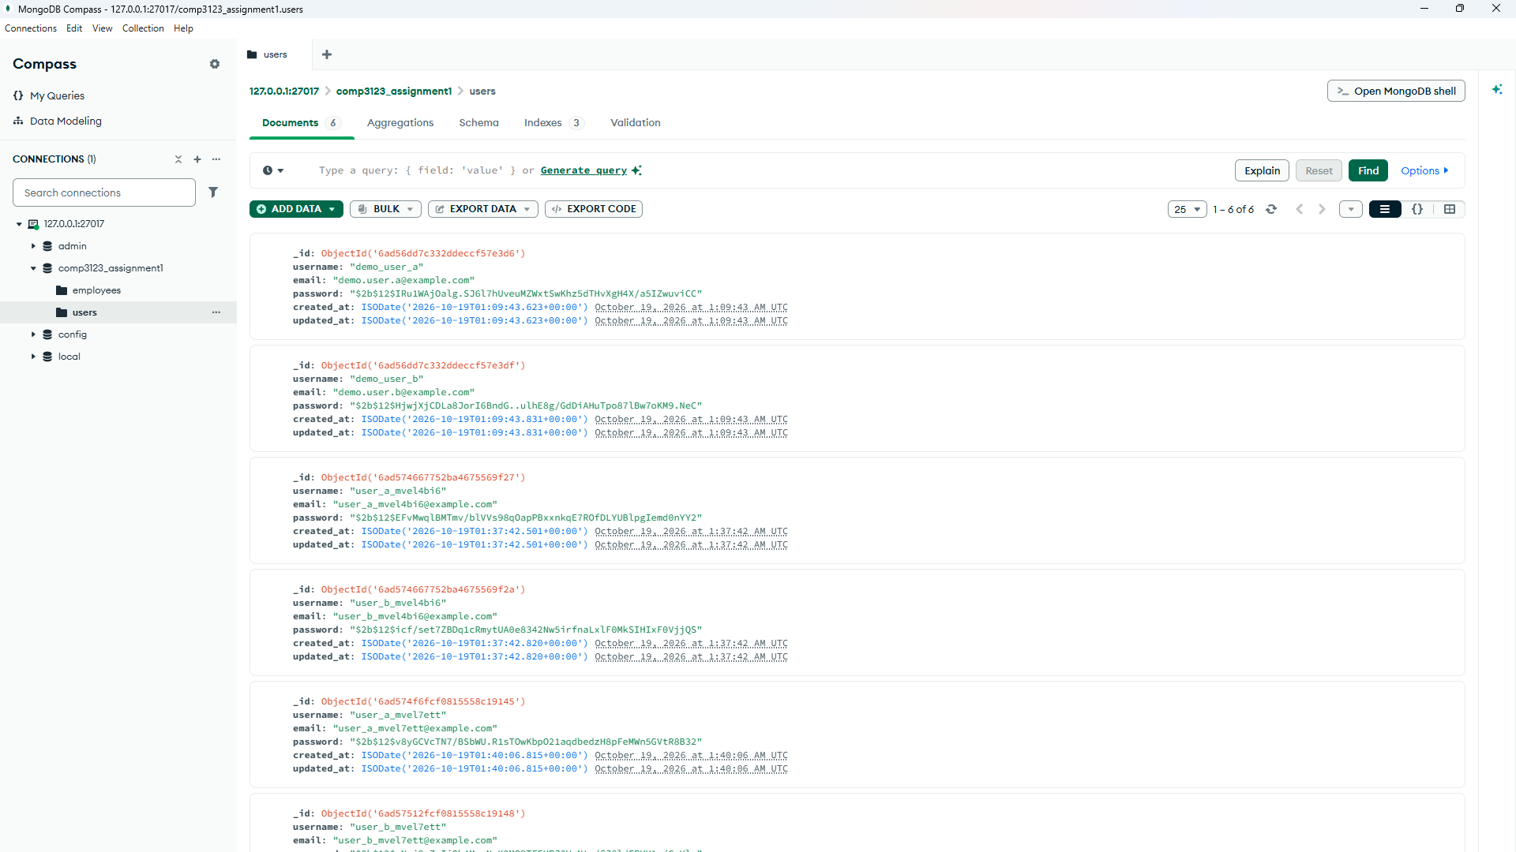
51-mongodb-users-hashed-passwords.png
Figure 53: employees collection: ownership field
Each employee document has user: ObjectId(...) referencing the User who created it, plus timestamps.
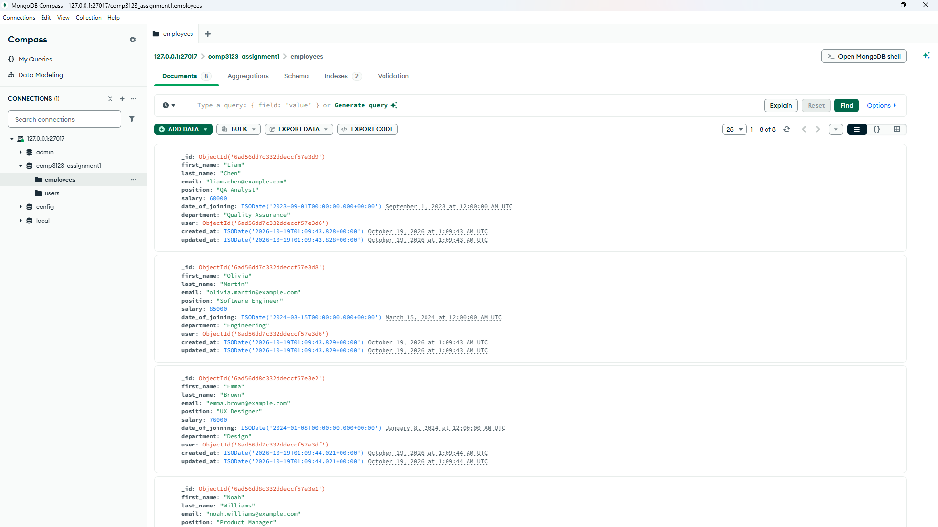
52-mongodb-employees-owner-field.png
Figure 54: User-to-employee relationship
The filter { user: ObjectId('<demo_user_a _id>') } returns only that user's 2 employees (1-2 of 2).
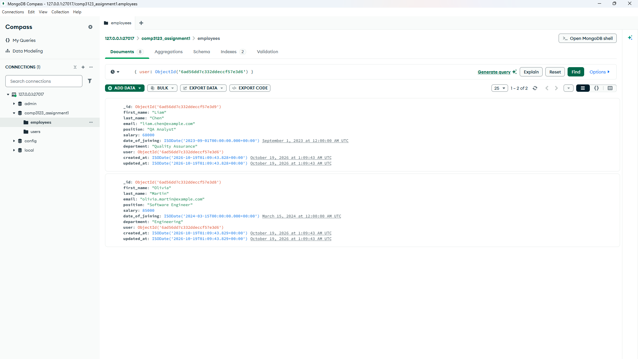
53-mongodb-user-employee-relationship.png
Figure 55: employees indexes
Compound unique index user_1_email_1: fast "my employees" queries, and one user cannot store the same employee email twice.
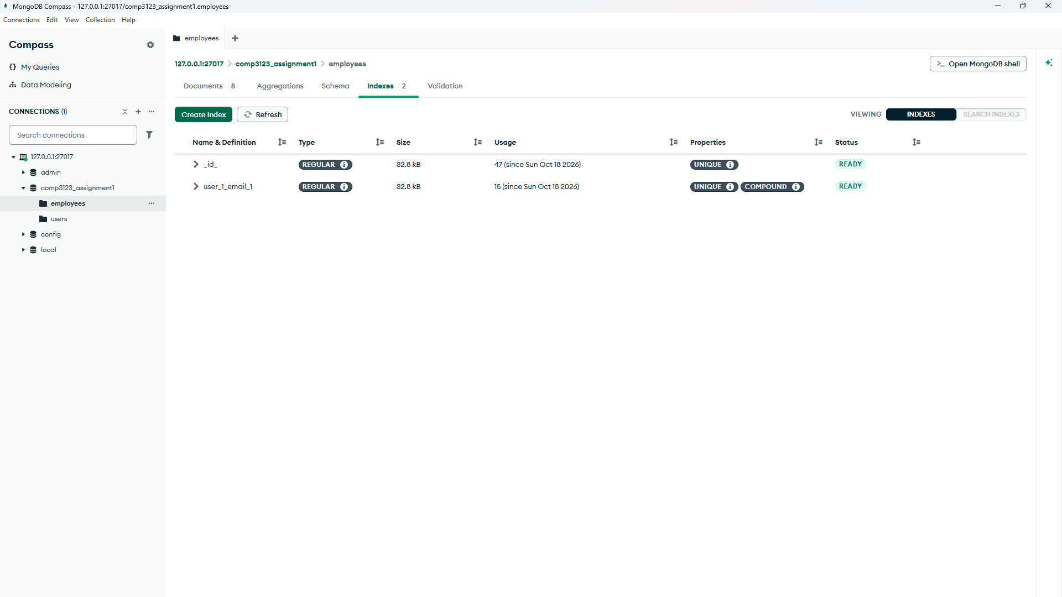
54-mongodb-employees-indexes.png
Figure 56: users indexes
Unique indexes on username and email enforce unique users at the database level.
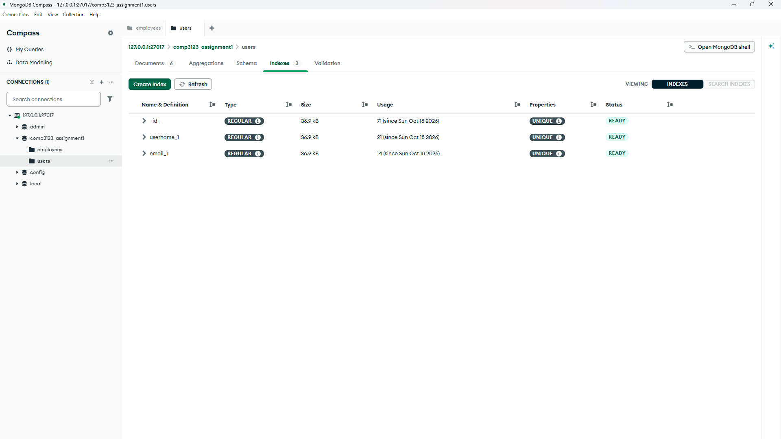
55-mongodb-users-unique-indexes.png

12. Local Logging
Figure 57: logs/app.log: one example of each logged event type
Startup, database connection, request lines (method, path, status, duration), signup, duplicate signup, login success and failure, validation failure, missing and expired token, authorization failure, employee create/update/delete and rate limit exceeded. No passwords or tokens are logged.
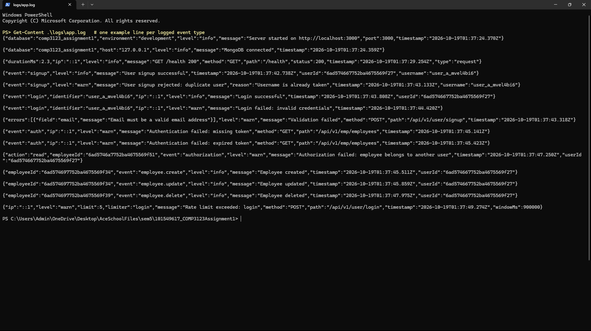
56-local-log-file-events.png
Figure 58: Live server console during testing
Console output while the tests ran: request logs with status codes, failed login attempts and the 429 responses.
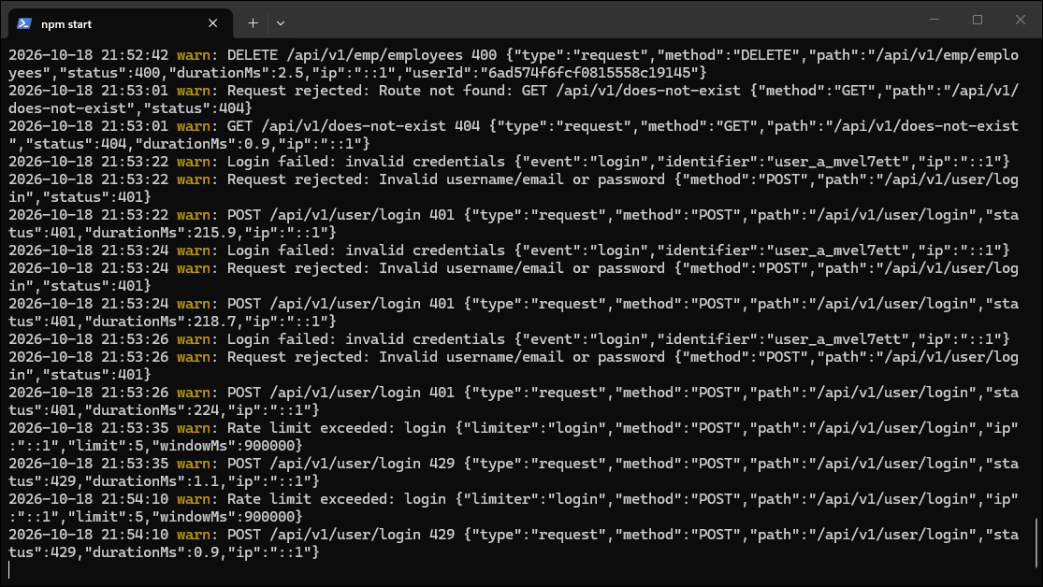
57-server-console-logs.png

