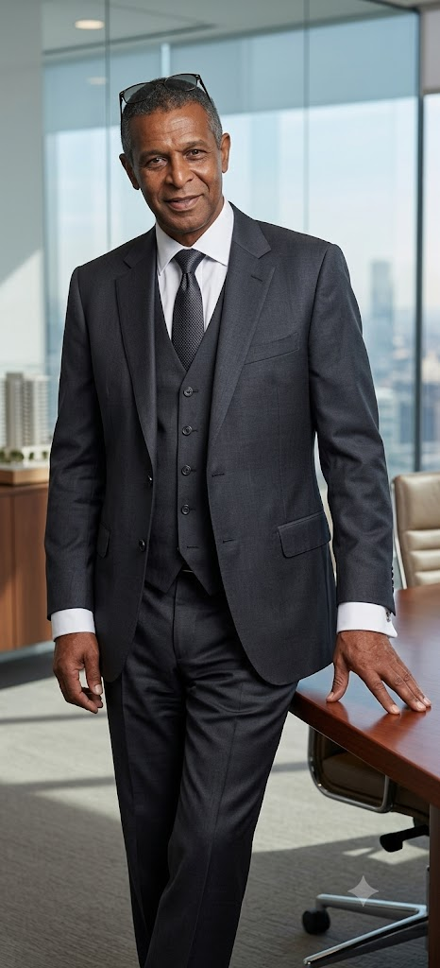 |  | Ronald Barnes  PhD Psychology (2022)

Profile  I sold my business as President and owner of Infinite Quality, Inc. and returned to school in 2012. We developed and sold personal care products to major chains including, Walmart stores, Kmart stores and Walgreens stores. In 2015, I completed my master’s degree in religious studies at the University of Chicago and continued my education for a PhD in psychology. My career objectives and goals changed is the primary reason for my transition from business to Academia. During my tenure at the University of Chicago, I published several articles on Academia.com  https://chicago.academia.edu/RonBarnes  In 2017, I published my first book as an author. The book is entitled “Practice what you preach, preach what you practice”. A trailer on the book can be viewed at  https://www.youtube.com/watch?v=pBbttZXPh5w&feature=youtu.be  I also participated in a television interview on my book “Practice What you Preach, preach what you practice”. The TV interview can be seen at  https://www.youtube.com/watch?v=CYEnpAxiHwA  During my PhD tenure, I have completed a second book, in co-authorship with Attorney Amanda Gray, currently ready to be published, It is entitled,  “The Pyrrhic State of America: Make America Great.”  Another Manuscript that is completed and waiting for publication is entitled, “A Theory on Universal Continuity and Sustainability, Mother Nature’s Revenge”  Another book that will be ready for publication in 2022 is entitled “Everybody wants to go to heaven, but nobody wants to die.” The contents of this book are based on information and research studies by qualified professionals and scholars in the fields of psychology, religion, sociology, science, physics, healthcare, philosophy, and interviews with individuals research evidence concludes are the most religious. In addition to faith, this book gives a logic to the phenomena of life and death with purpose to help people reconcile challenges in their lived experiences.  Other books I have written that will be published this year are:  “The three-fold Mimesis of Human Evolution.”  “An American Reality: White People … LOL  Honors and Affiliations  I am in the Coe College athletic Hall of Fame.  In 2019, I was inducted into Psi Chi, the international Honor society for psychology.  In 2025 I was nominated for and joined The National Society of Leadership and Success (NSLS).  I am a member of Kappa Alpha Psi fraternity  Contact  PHONE:  312-771-8310  312-778-1557  WEBSITE:  https://chicago.academia.edu/RonBarnes  https://www.linkedin.com/in/ronald-barnes-672720277  EMAIL:  ron.barnes7@yahoo.com  ronaldb@uchicago.edu  Hobbies / Professional Extracirricular  Writing / Author  Photography  Member of UChicago Public Safety Advisory Board  Ebenezer Missionary Baptist and Covenant Church –  STEAM (Science, Technology, Engineering, Arts and Math) Program for youth Founder.  Committee Advisory Chicago Education Alliance through Brightstar Church  Contributor to the Chicago Education Alliance  Researcher for Northwestern Hospital Community alignment (1/26 – 5/26)  Researcher for the University of Chicago Comprehensive Care Program (2024-2026) |  | EDUCATION  National Louis University – PhD Community Psychology (2027)  Community Psychology is the process of aligning the objectives and goals of organizations, institutions and governments with the needs of the people in the community. I am currently attending National Louis University and expect to complete my second PhD study in 2026. Nominated for membership and joined The National Society of Leadership and Success (NSLS).  Dunster European University – International Psychology PhD (May, 2026)  America has a different psychology tradition than Europe and other areas of the world. Most Psychology schools outside of America (Europe) focus on existential and transcendental areas of psychology. American psychology is more individual focused. European psychologists tend to be more disposed towards constructionist, soft-determinist, and socialist stances, while Americans may be more “realist”, hard-determinist, or libertarian. This discrepancy is attributed to the lasting impact of behaviorism on American psychology. As I studied and understood the differences it gave me a broader perspective on the diversities in human nature, cognitive constructs and human behaviors.  Grand Canyon University – PhD Learning Psychology (2022)  Integrating technology into the learning process  It was a transformation life experience to pursue my doctorial journey. I realized more potential of my academic, mental and intellectual ability, having achieved a 3.62 GPA out of 4.0. Having completed all my course work and dissertation research for my PhD, helped me to realize the value of knowledge and information.  More so, the learning I experienced is a life asset that is permanent and something I take great pride. My professional objective is to make a significant contribution to society based on my professional, academic, and learned experiences. I was inducted into Psi Chi, the international psychology honor society as a result of my academic accomplishments.  University of Chicago – Divinity School – M.A. Religious Studies  09/ 2012 – 06/ 2015  Having returned to school after years out of the education environment was a challenging experience. The University of Chicago, one of the best learning institutions in the world, prepared me for my doctoral experience. My University of Chicago GPA was 3.2 out of 4.0. While I believe grades are important indicators of learning, more important is the application of what we learn.  Coe College – B.A. Economics  I was not academically focused on undergraduate school. I was an athlete, all-conference and small college all-American. I do regret my lack of interest in academics during this period, however economics was a subject that got my interest. In hindsight, I have a much better understanding of the value of learning and the importance of integrated learning. However, athletics does have significant fundamental advantages in terms of developing a collaborative nature due to the characteristics of team sports. I am in the Coe College athletic Hall of Fame.  WORK EXPERIENCE  CEO of the Metropolitan Education Empowerment and Economic Organization, 2024-Present  A non-profit organization whose purpose is to collaborate with neighborhood organizations (churches, community centers. Etc. to teach STEAM subjects to youth. The objective is to introduce youth to the subject matter so they achieve in their traditional learning environment. We receive support for local Universities in the Chicagoland area.  Additionally, we teach computer use to seniors, basic instruction (email, Office Software –word et AL., shopping online and how to avoid online scam and fraud)  Black Researchers Collective – BRC – Lead Researcher  March 2026  Northwestern hospital has 7,000 square feet of space they indicated will be devoted to community use. We conducted a Community Research program (a Town Hall) for Northwestern Hospital (NW) focused on collecting data on community needs and interest. NW established a location on the Southside of Chicago and our research was centered around data collection via a Town Hall to collect data on the community needs and interest to allow NW to develop their community programs around the community feedback. Approximately 80 community residents were in attendance.  University of Chicago Medicine (1/2024 to 7/2025)  I did medical research and recruit patients from the community for them to participate in research to study a better methodology for delivering health care to the community. The research consist of having one doctor (personal care physician) to attend to the patient in the office, clinic and hospital, should they be hospitalized. The hypothesis is that health outcomes are better when the patient has a relationship with their doctor and has continuity to their healthcare. In addition, more frequent visits (quarterly) to the doctor addresses prevention. Health conditions can be found before they become serious. The research participants are individuals on Medicare A&B.  Infinite Quality, Inc., President  1993 – 2012  We developed and sold personal care bath and body products to major US retailers including Walmart, Walgreens and Kmart. Our first order was $2.5 million. Sold the company in 2012.  Motorola, Inc., Corporate Communicate Manager  1991 – 1993  I was responsible for selecting and implementing the Motorola VSAT satellite system, the Motorola corporate communications voice network, and the Motorola Premise Distribution System (PDS)  AT&T, Communications Consultant; AT&T Western Electric, Software Acquisition and AT&T Bell Laboratories, Network Engineer  1981 - 1991  As a communication consultant, I was responsible for consulting with AT&T customers about using telecommunications to improve their business operations.  At AT&T Western Electric, I was responsible for recommending and securing end user software to allow AT&T business managers to quickly accesses information for making better business decisions.  At AT&T Bell Laboratories I was responsible for the management and operation of the Bell Labs data network of 500 host computers and 3,000 terminal devices connected by high speed T1 fiber cable, coax cable and twisted pair cable.  IBM – Business Application Software Sales  1979 – 1981  I sold end user information software to corporations  Chicago Board of Education – School Teacher  1978 – 1979  Academic areas of interest  The History of Psychology  Religious Psychology / The Psychology of Religion  Integrating technology into the learning process  Personality: Construction, development, and change  Cognitive Psychology  Behavioral Psychology  Environmental Psychology  SKILLS  I consider myself to have a well-rounded integrated skill set involving a basic knowledge of economics, a character based on ethical moral foundation, a keen understanding of human cognitive diversities and ability to evaluate how human cognition translates and manifests in behavior. I understand the value of and internalize a healthy Emotional Intellectual Quotient.  The integration of these skills gives me the ability to make a valuable and significant contribution to society and the environment in which I choose to participate.  My objective in writing books is to explore the phenomena occurring in our world and society then write about the phenomena from a psychology perspective.

