**攻击**

射击效果根据双方直线距离（棋子之间相邻六角格数）裁定结果,当棋子间有不可通视的地形时，射击效果直接裁决无效。

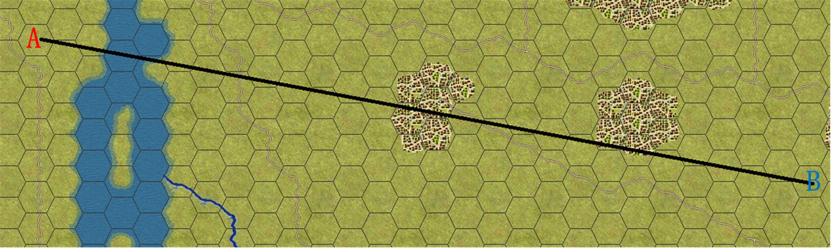

例如A攻击B，直线距离为27，通视，查表得裁决结果。

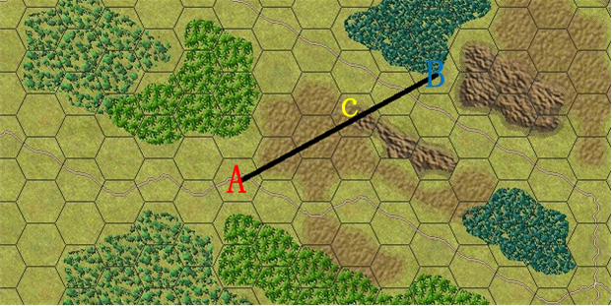

再例如B攻击A，直线距离为5，但C点为不通视地形，攻击无效。

|  |  |  |  |  |  |  |  |  |
| --- | --- | --- | --- | --- | --- | --- | --- | --- |
| 距离 | 1 | 2 | 3 | 4 | 5 | 6 | 7 | 8 |
| 等级 | 8 | 8 | 8 | 8 | 8 | 8 | 8 | 8 |
| 距离 | 9 | 10 | 11-15 | 16-20 | 21-30 | 31-40 | 41-50 | 51-60 |
| 等级 | 8 | 8 | 8 | 8 | 7 | 6 | \ | \ |

|  |  |  |  |  |  |  |  |  |  |  |
| --- | --- | --- | --- | --- | --- | --- | --- | --- | --- | --- |
| 攻击等级  随机数 | 1 | 2 | 3 | 4 | 5 | 6 | 7 | 8 | 9 | 10 |
| 歼灭 |  | 5% | 10% | 15% | 25% | 35% | 45% | 55% | 70% | 90% |
| 失火 |  |  |  |  |  |  |  |  |  | 5% |
| 失动 |  |  |  |  |  |  |  |  |  | 5% |
| 无效 |  |  |  |  |  |  |  |  |  | 5% |