**JUSTCALLUZ(30-03-2013)**

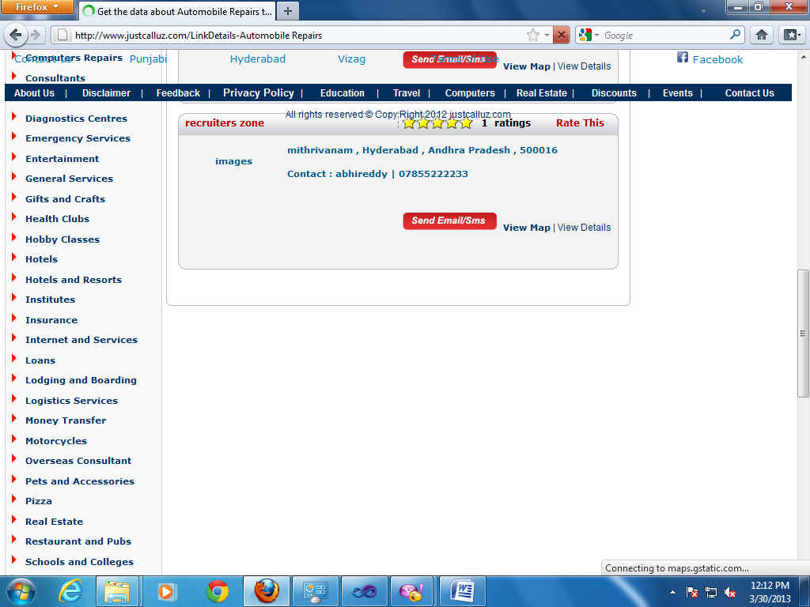

**Images are not displaying here**

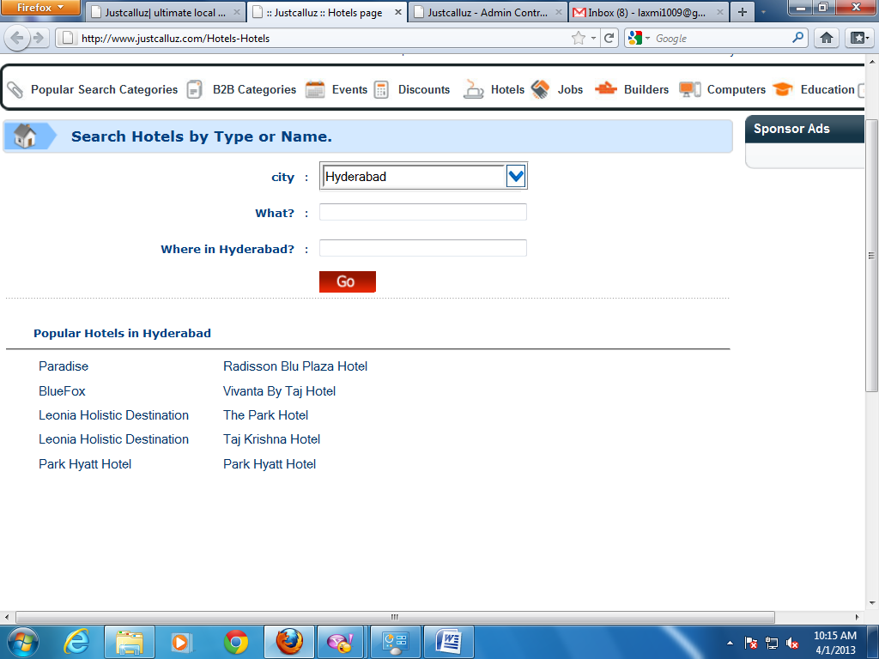

* Leonia holistic destination and park hyatt hotel is repeated.

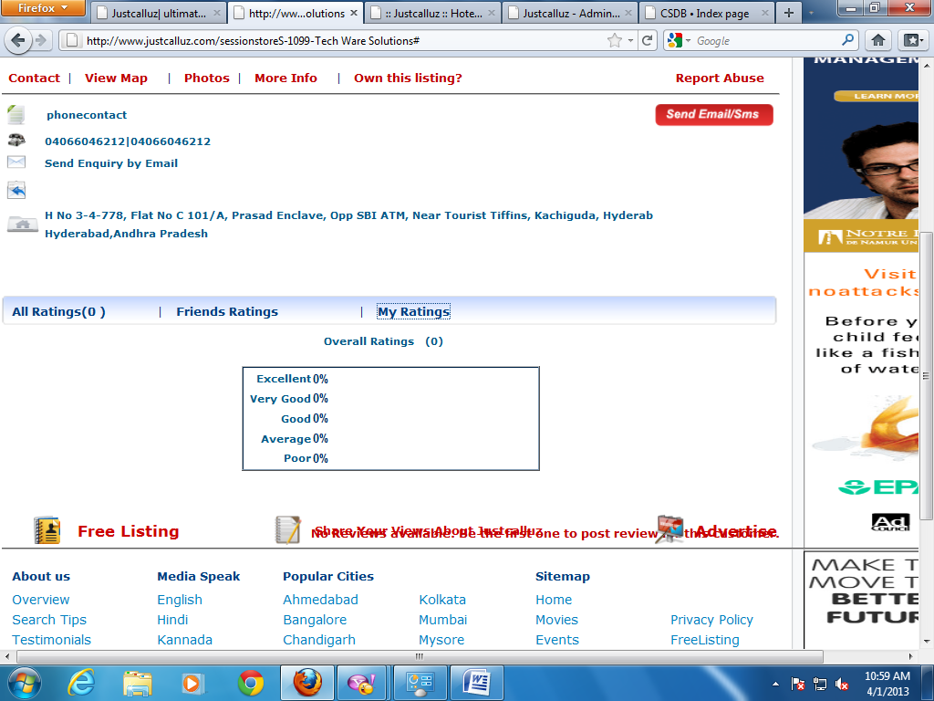

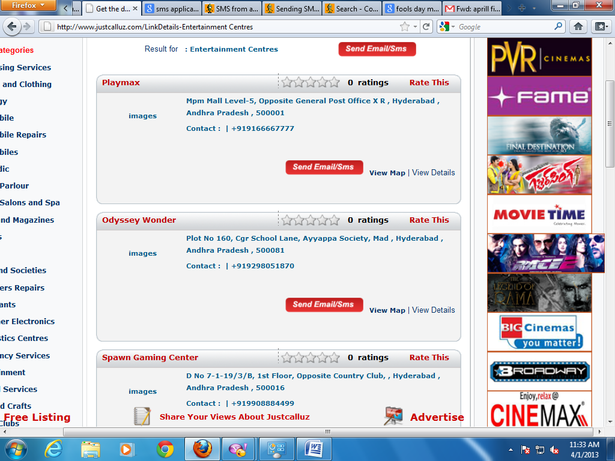

* Image size exceeds here.

Home->Education

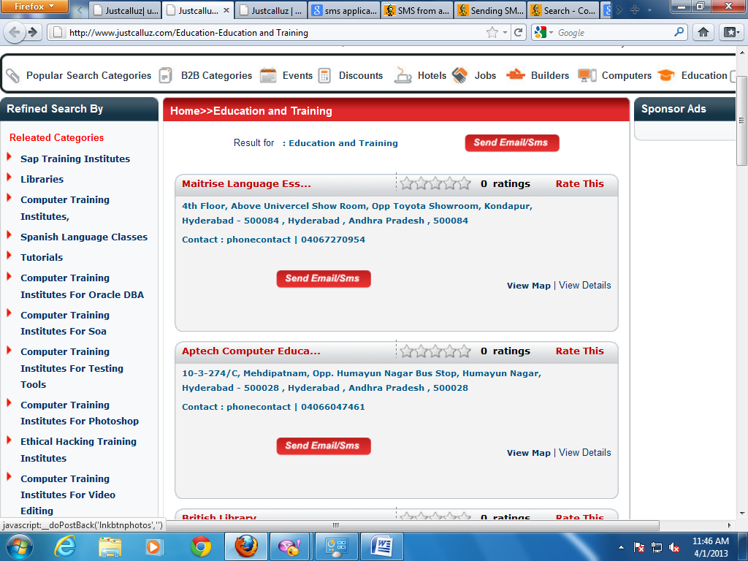

View map is not working properly