Justcalluz

1-4-13:s

In View details: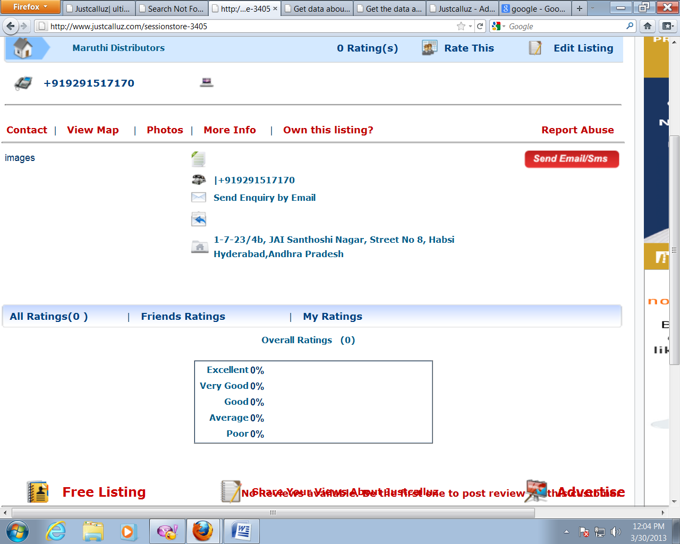

* Here text is mixed.

[Home>>](http://www.justcalluz.com/Home)Home->Motorcycle Dealers-Bajaj

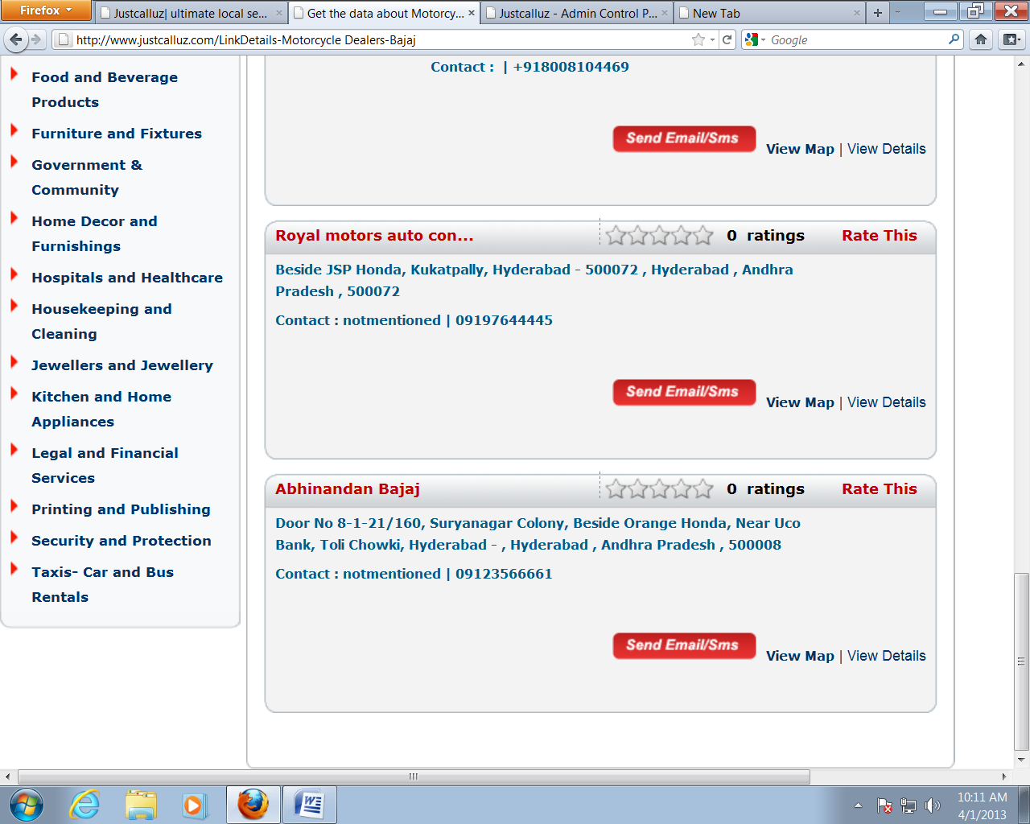

* There is no Previous and next buttons.

In view details: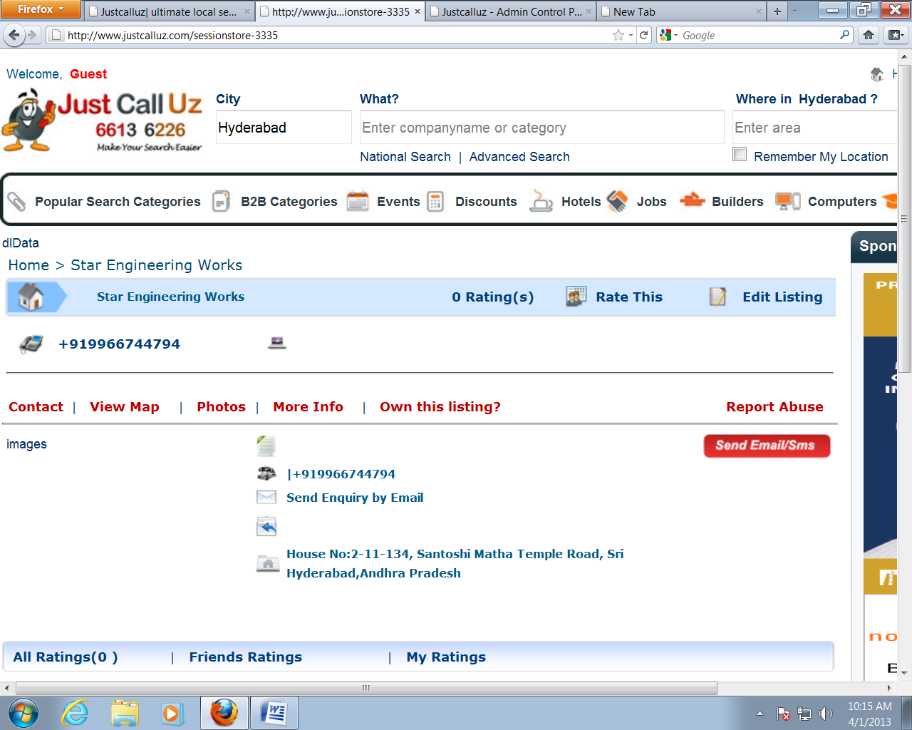

* I think some unnecessary data “dldata” is there.

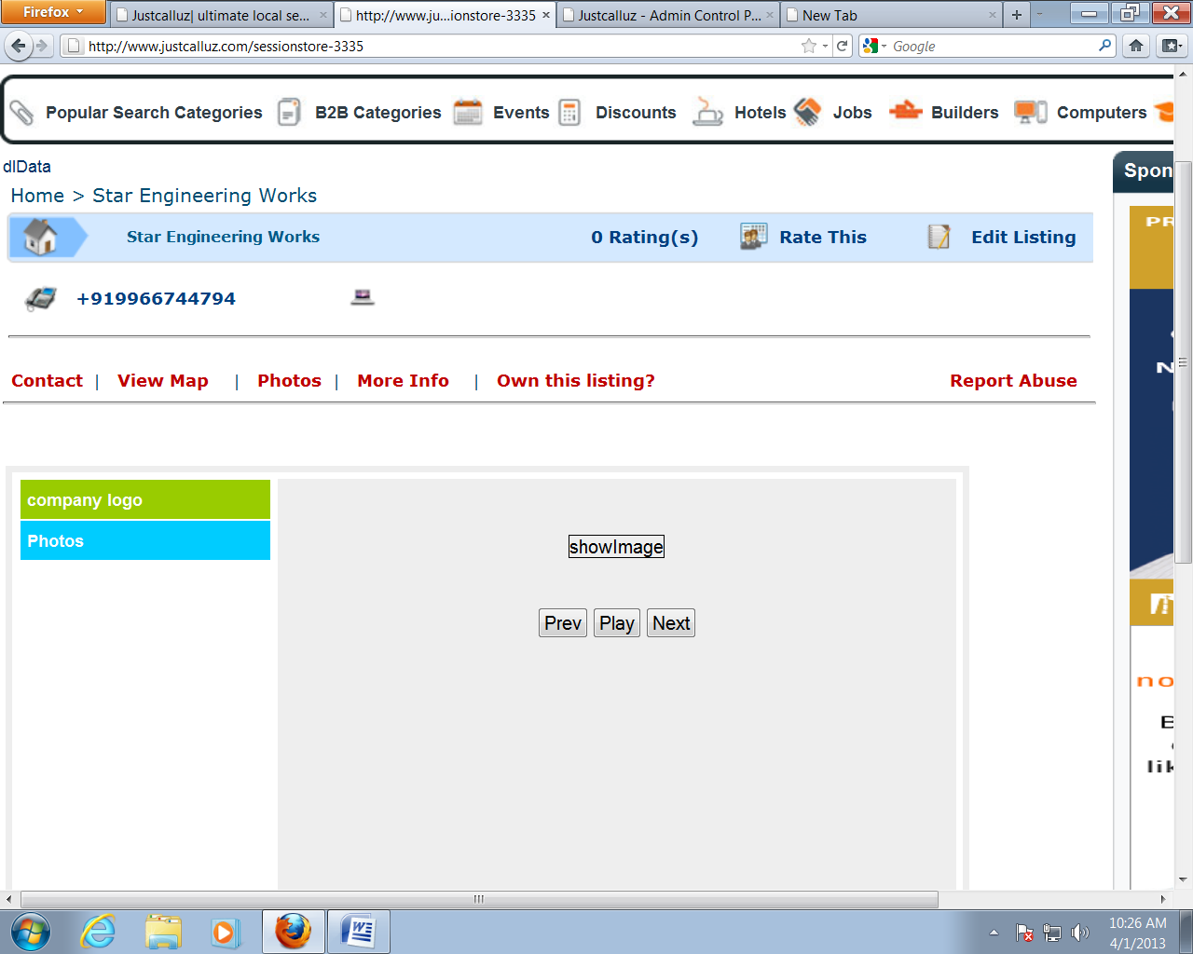

* View map also showing showing same buttons like Photos (it is happened when View map is clicked After photos)

In more Info: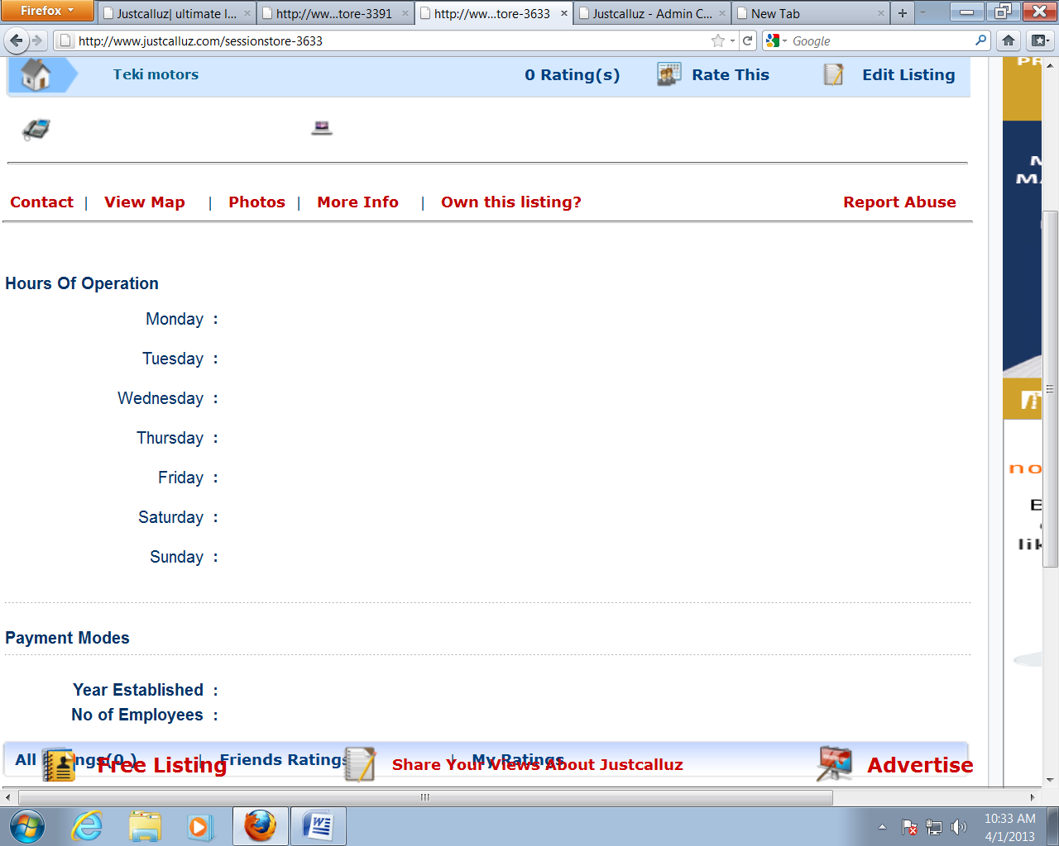

* If there is no more info details I think there is no need to display headings.

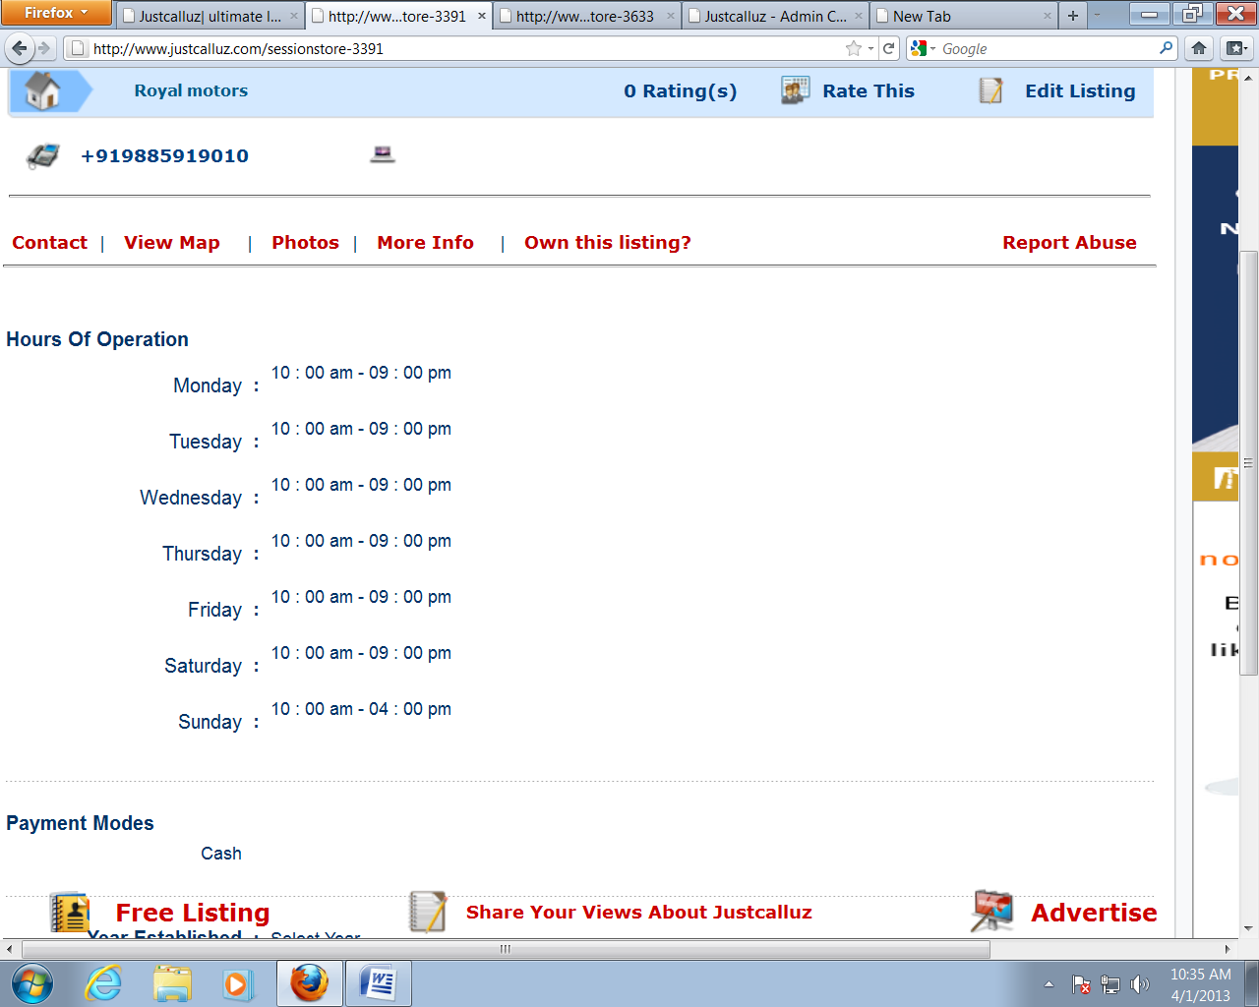

* Alignment of the text is not in the proper format.

In View Details->Photos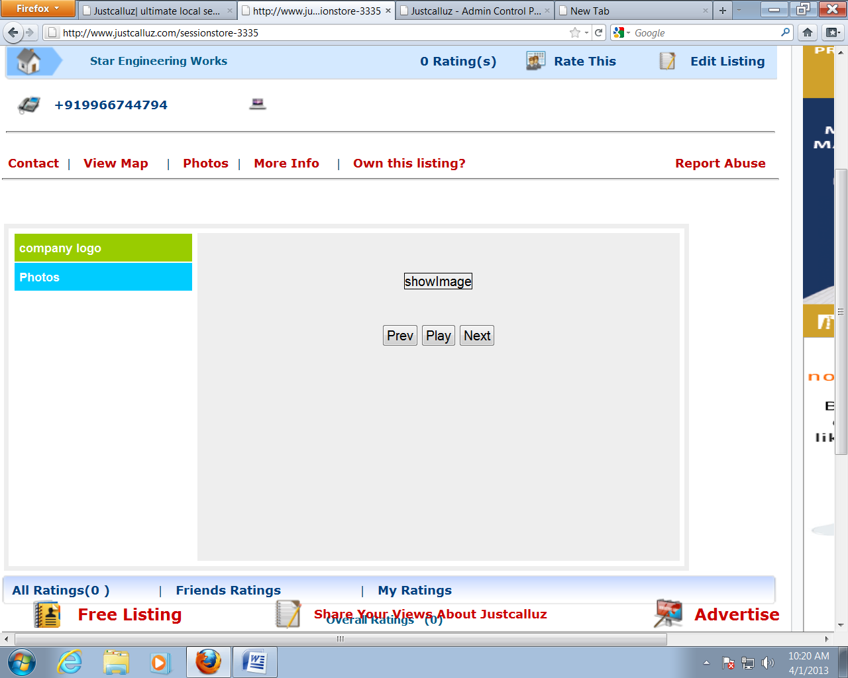

* There is no photos but it is showing Buttons only.

