justcalluz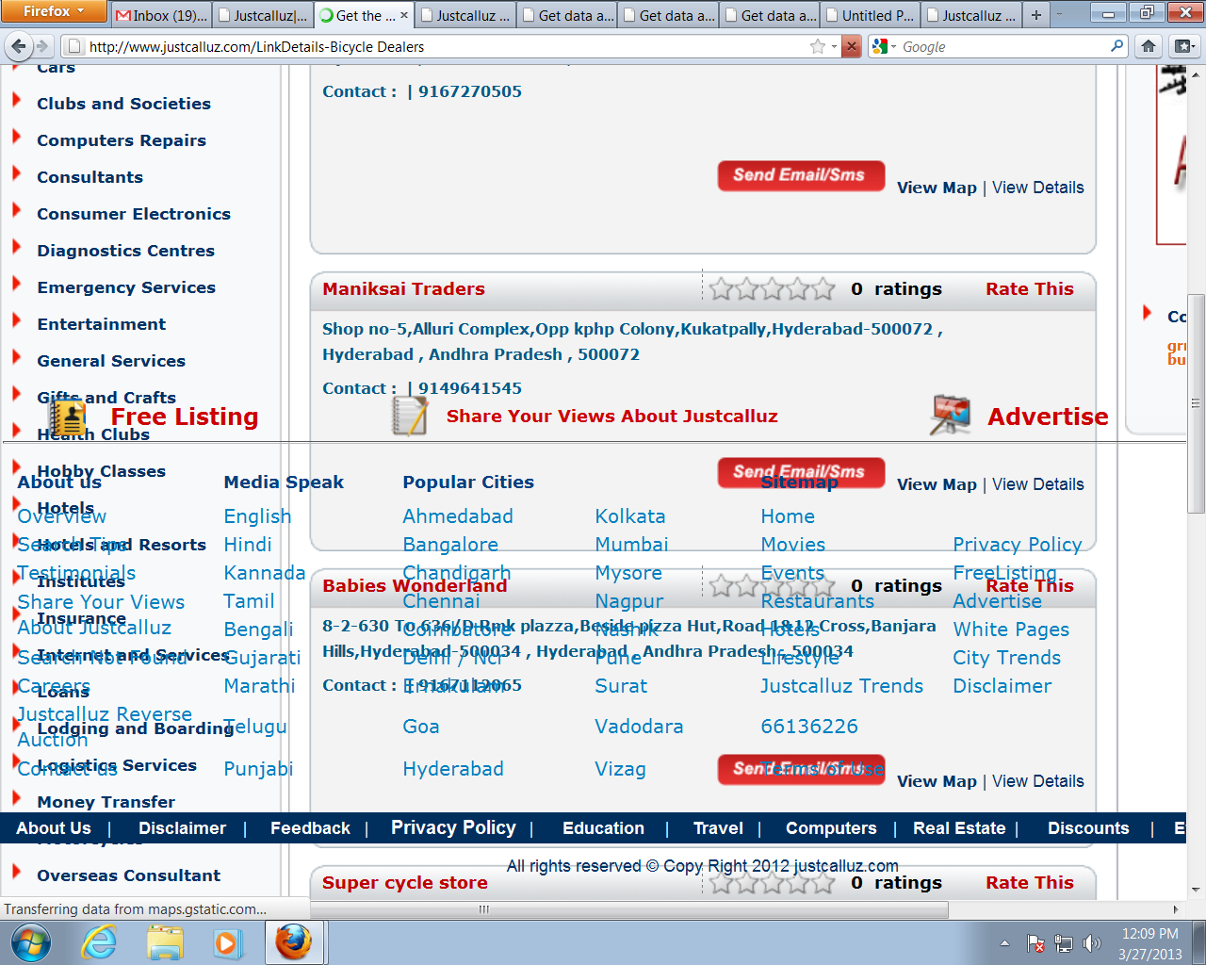

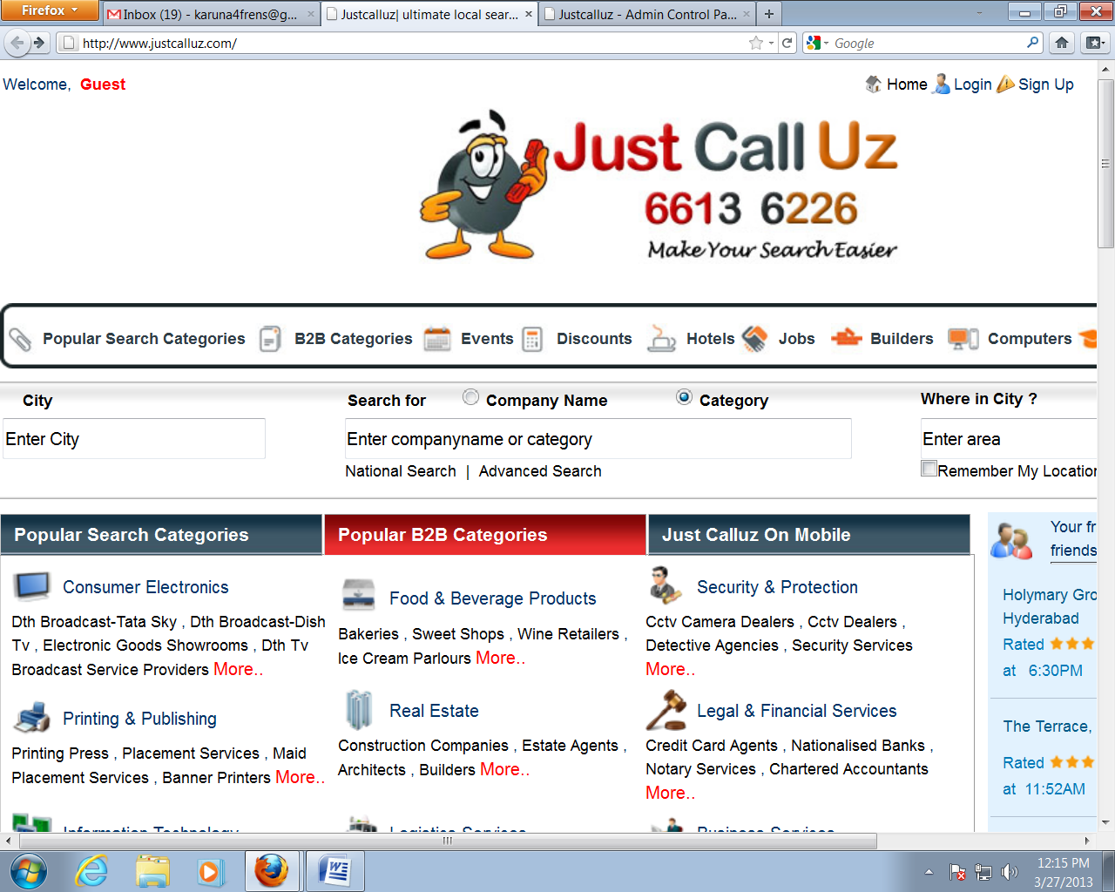

* Home button is not working

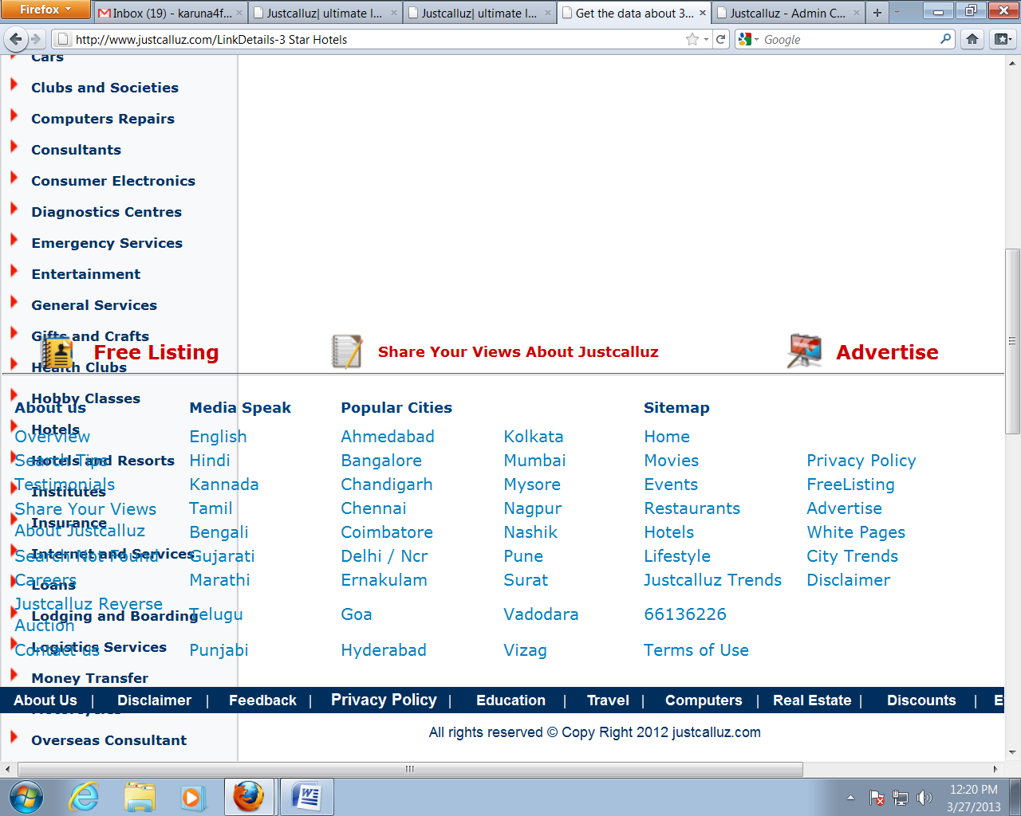iieetttyyyy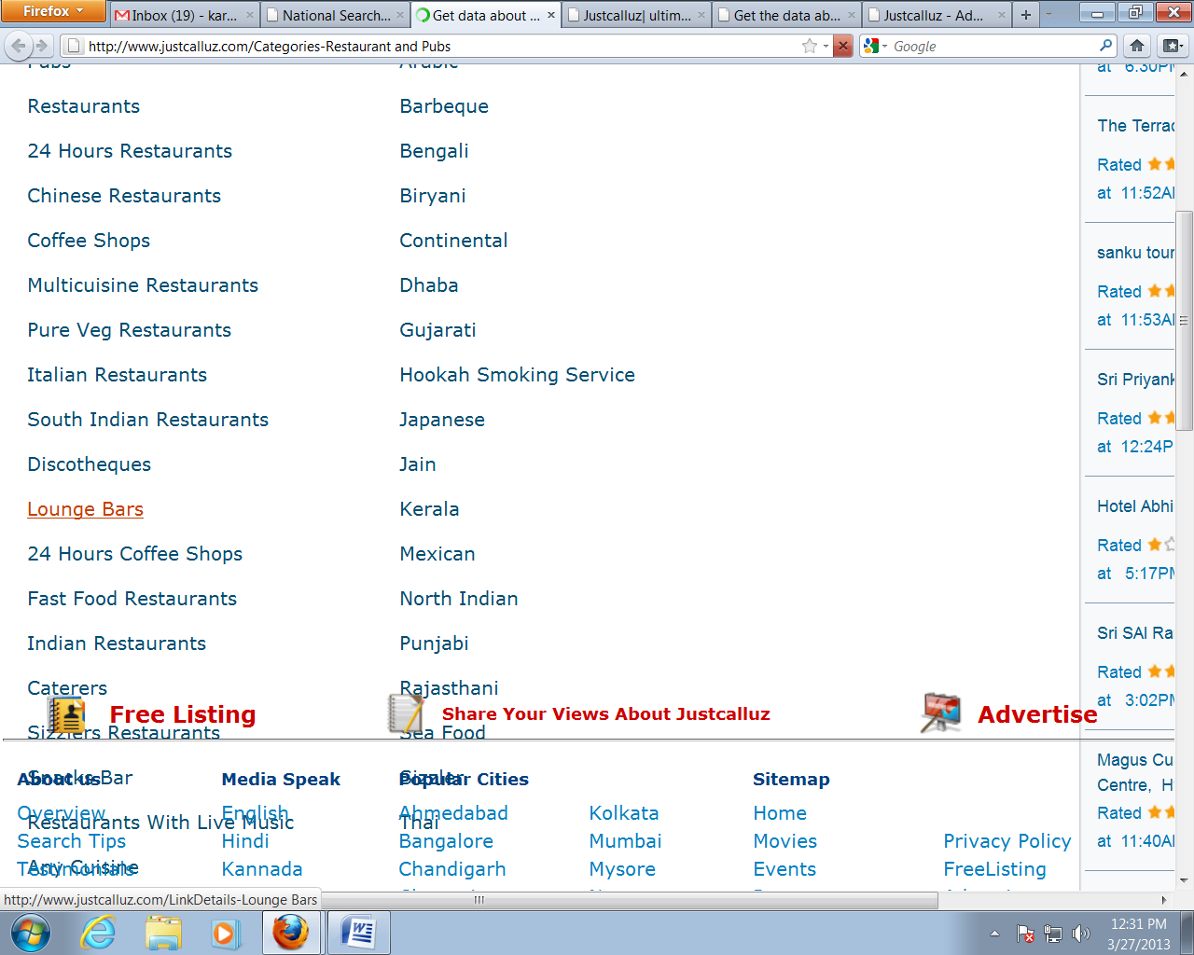

If we click on movies error page is coming like this: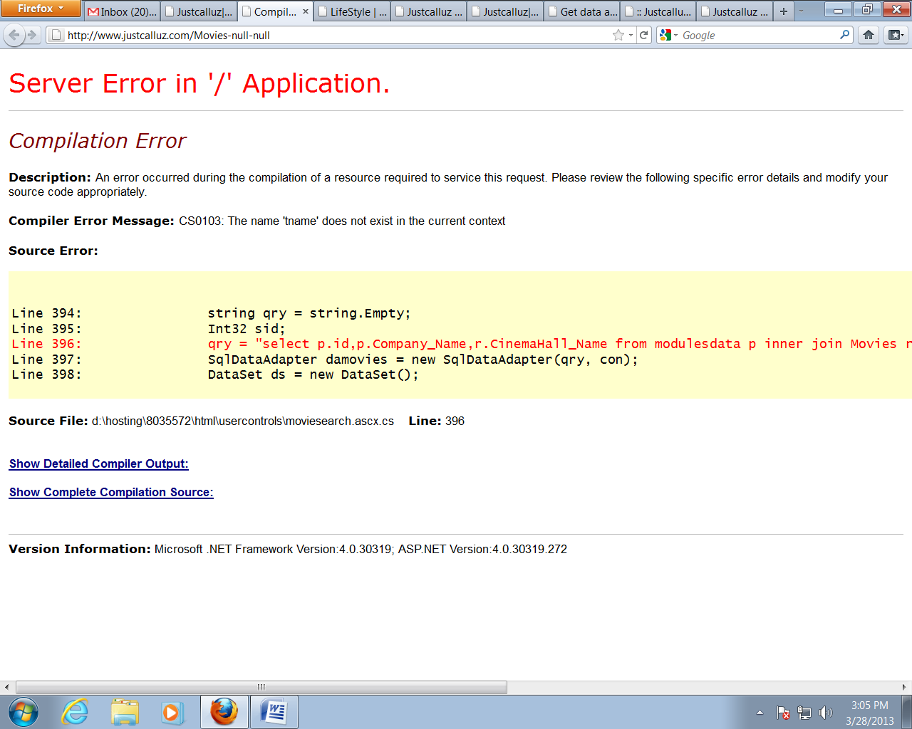

Hotels and Resorts: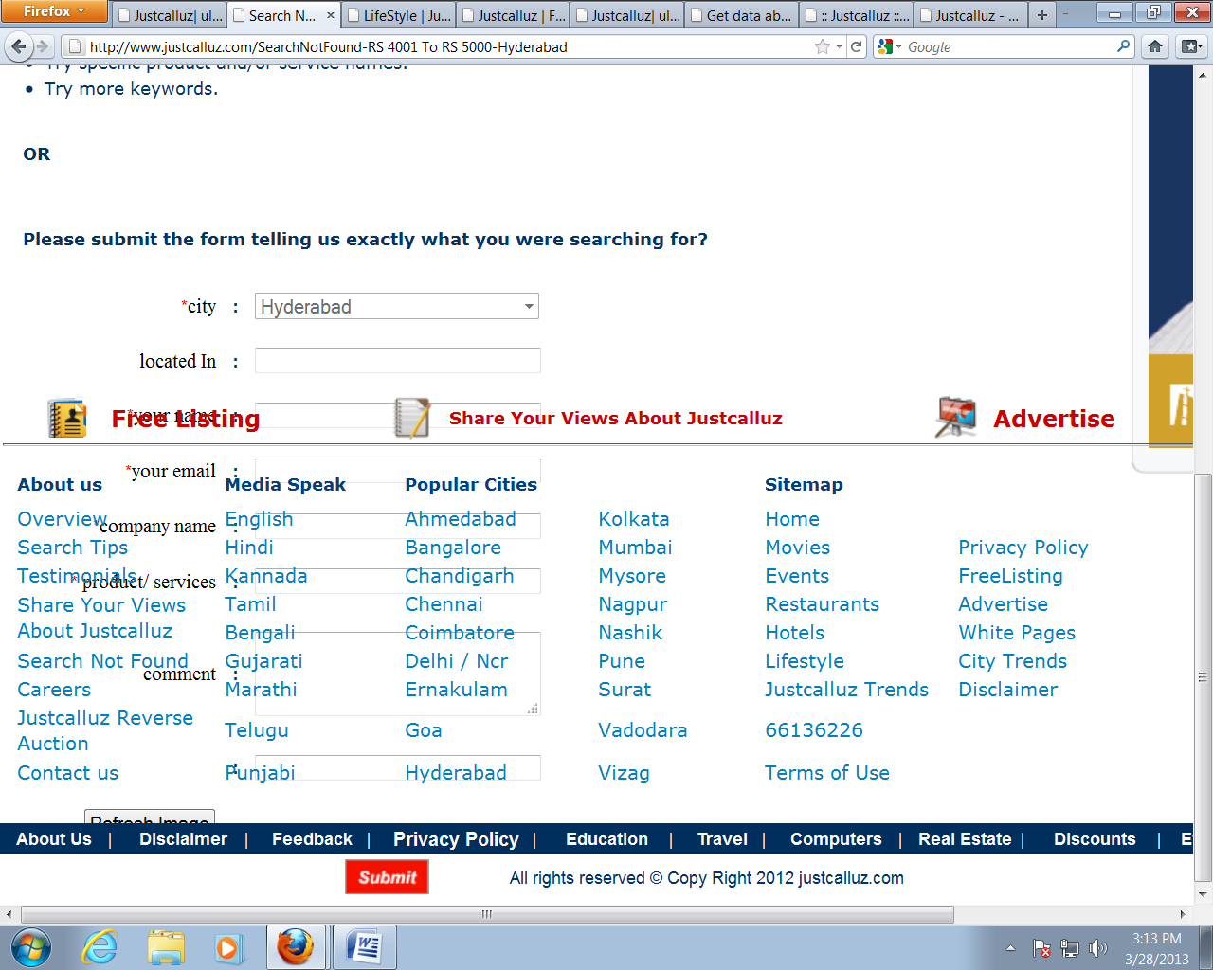

If we click on Hotels and Resorts ->RS 8001& Above Error page is coming like this:

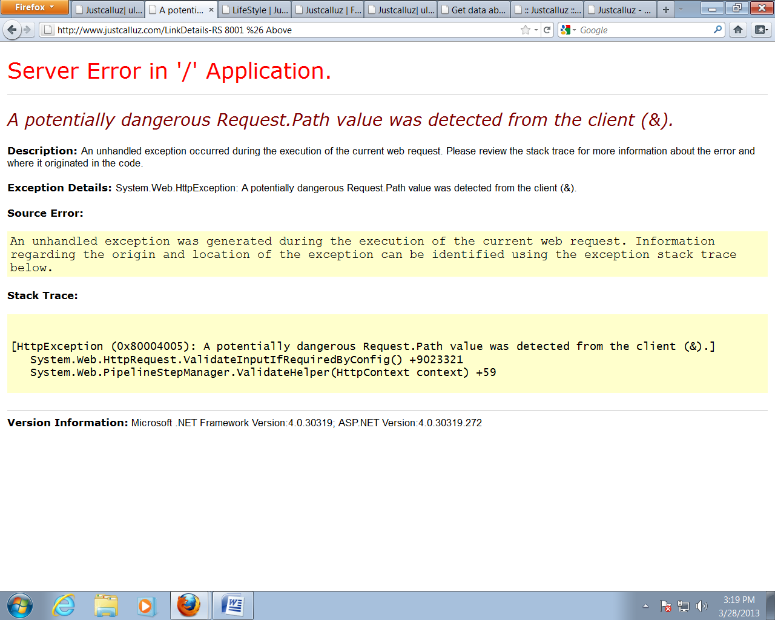

If we click on Hotels and Resorts ->RS 500& Below Error page is coming like this:

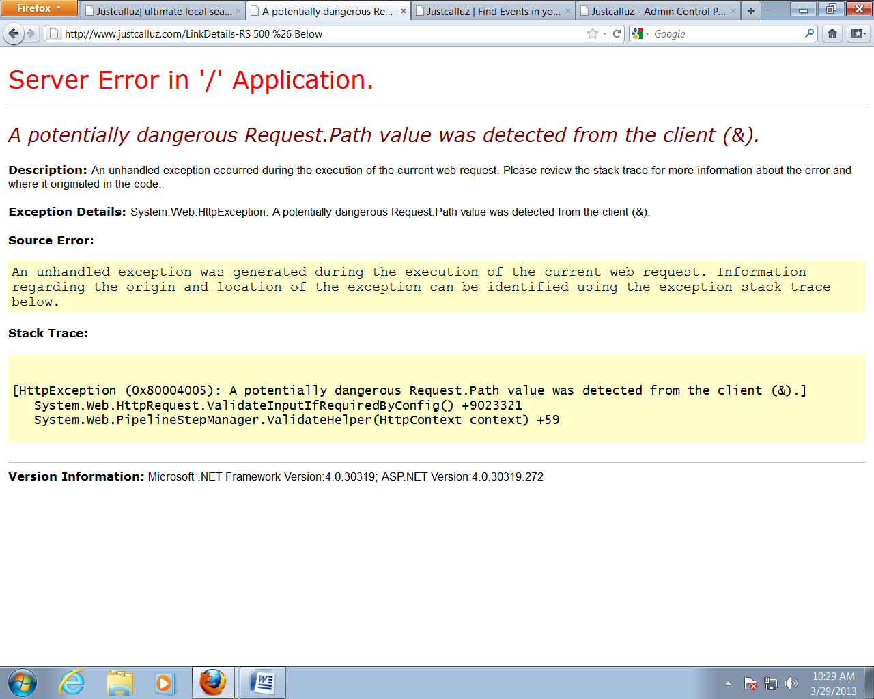

In Restaurant and Pubs: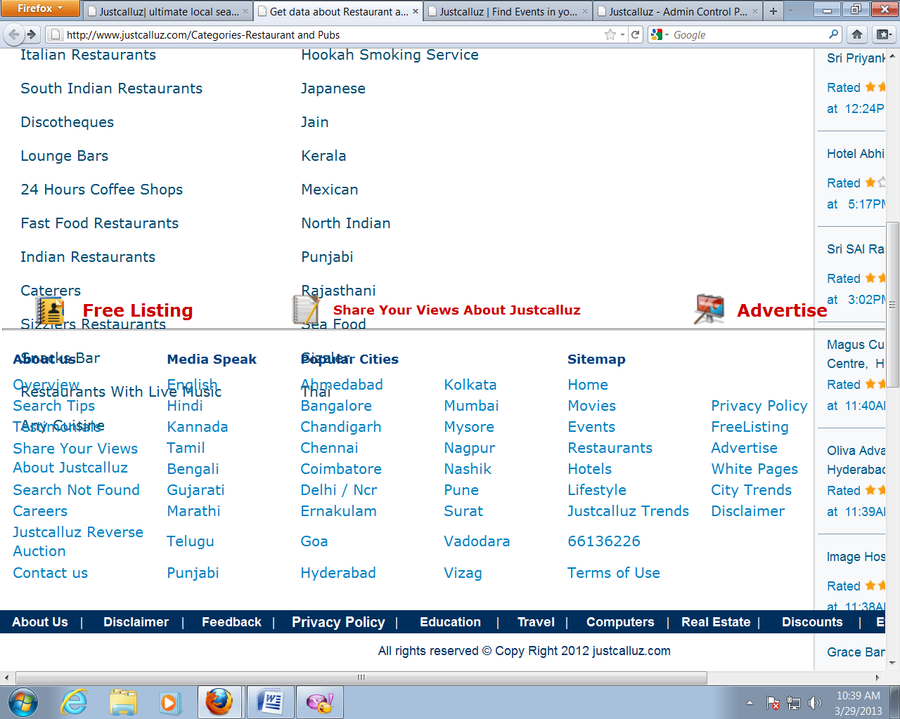

* Categories are Mixing with Footer Menu.

In lifestyle: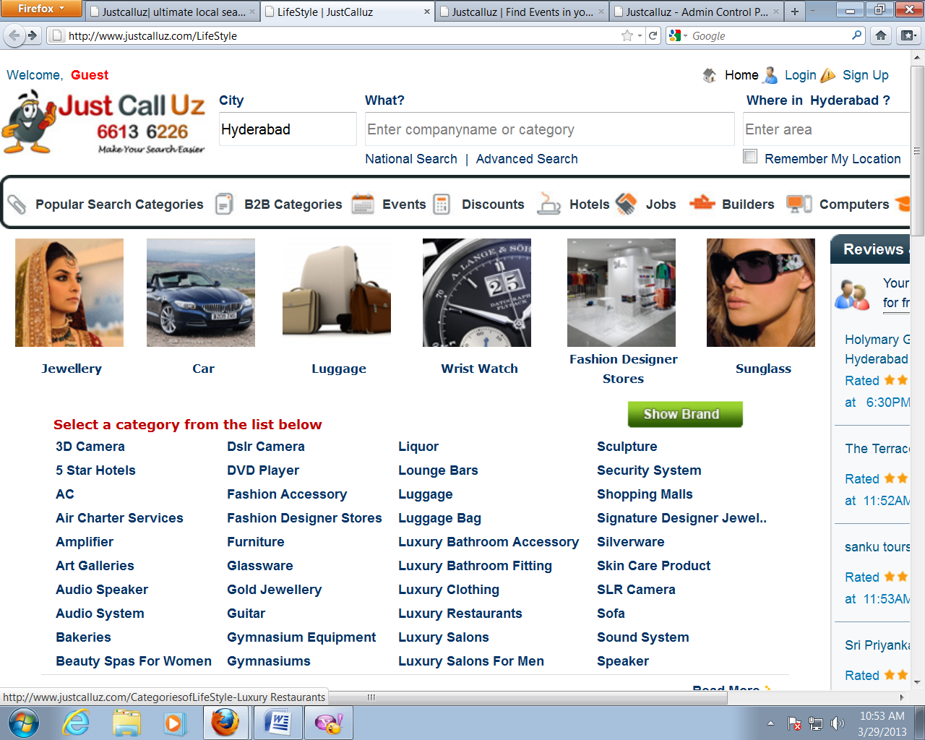

* If we click on these sub categories some sub categories are giving “sorry for the inconvenience page” .

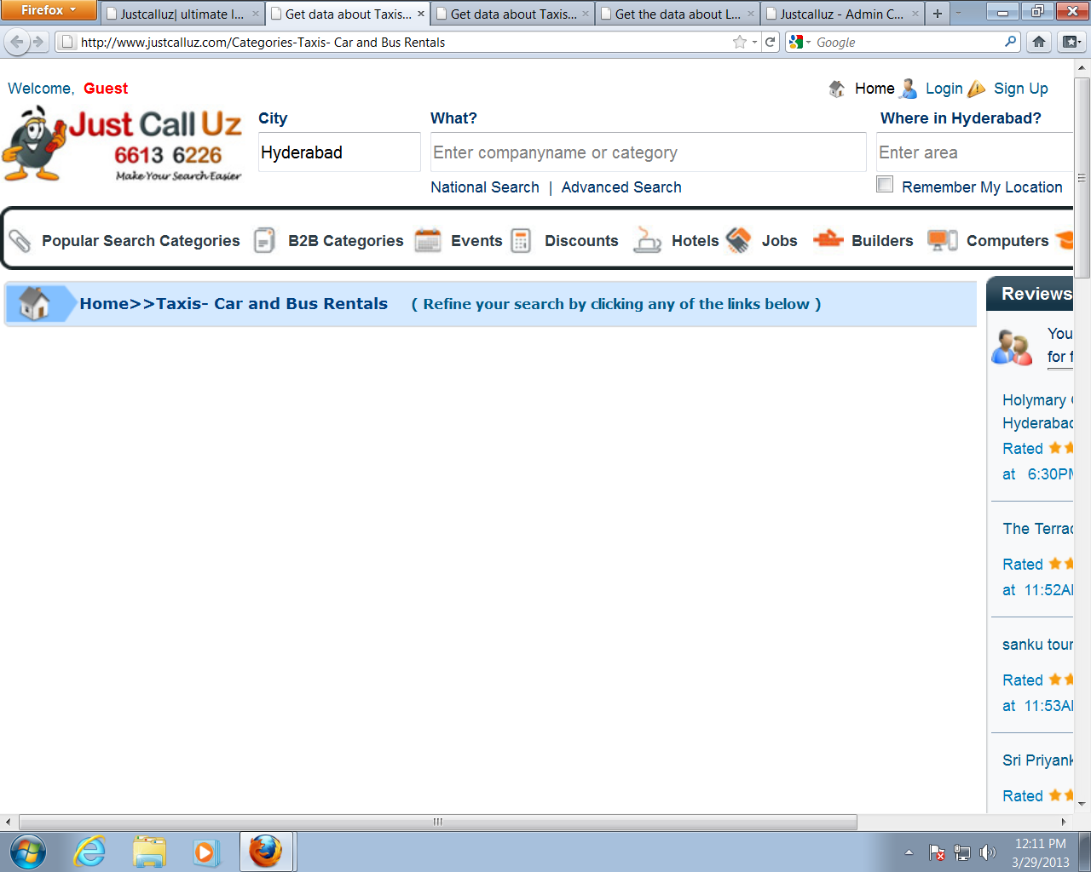

* There is no subcategoriesss