<http://www.justcalluz.com/Result-Hotel%20Management%20Institutes-hyderabad>

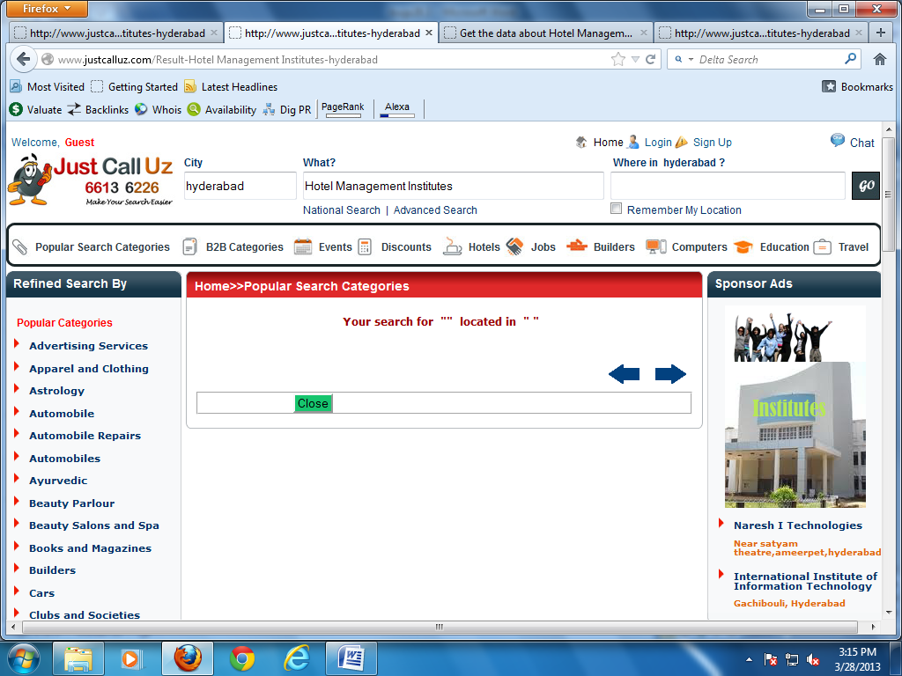

Search option is not working properly

<http://www.justcalluz.com/NationalSearch>

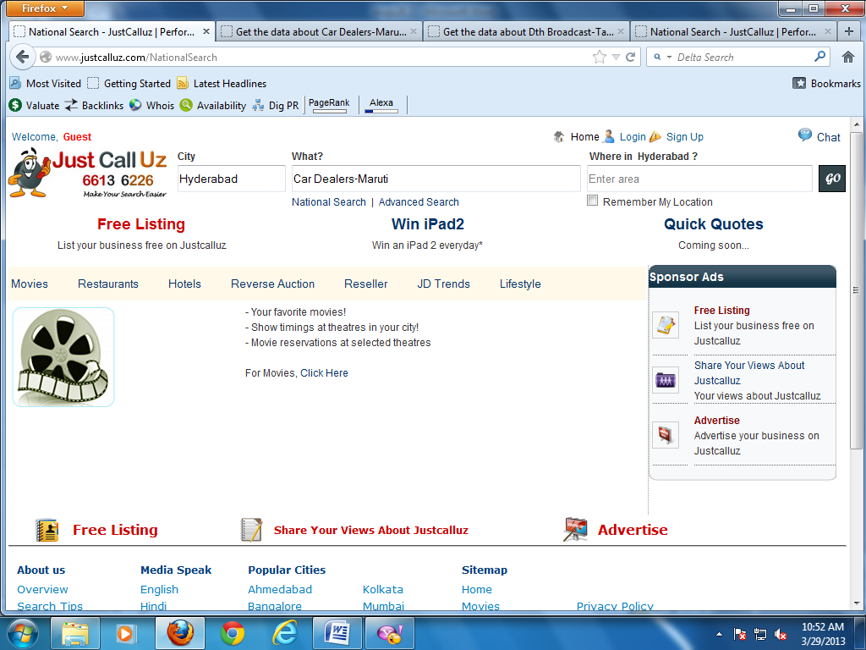

National Search did not work.

(solved)

<http://www.justcalluz.com/>

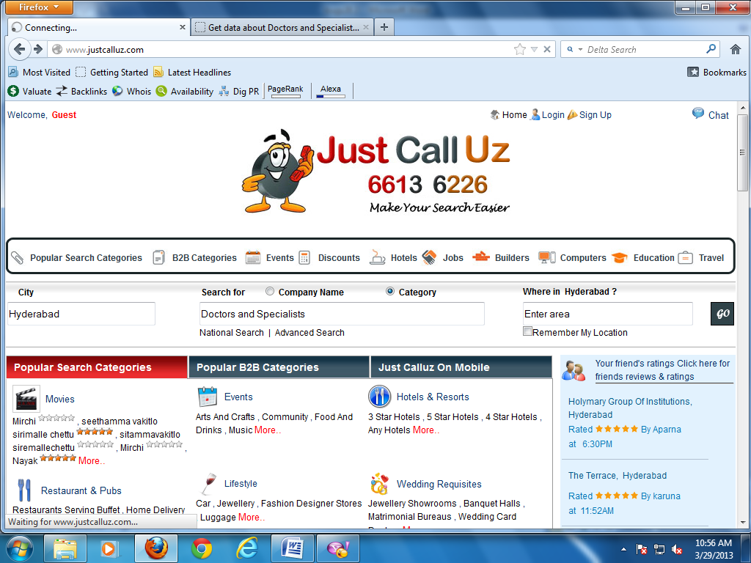

Advanced Search did not work

<http://www.justcalluz.com/Result-Geosafe%20Carriers-Hyderabad>

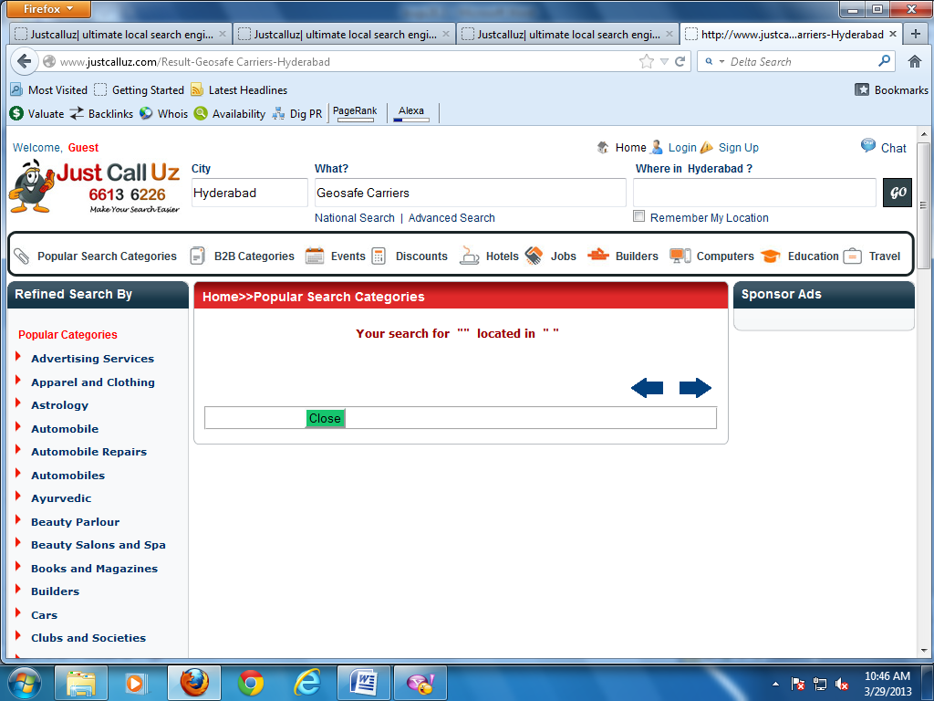

Search could not be worked by company name also.

<http://www.justcalluz.com/Events-AwardCeremonies-events>

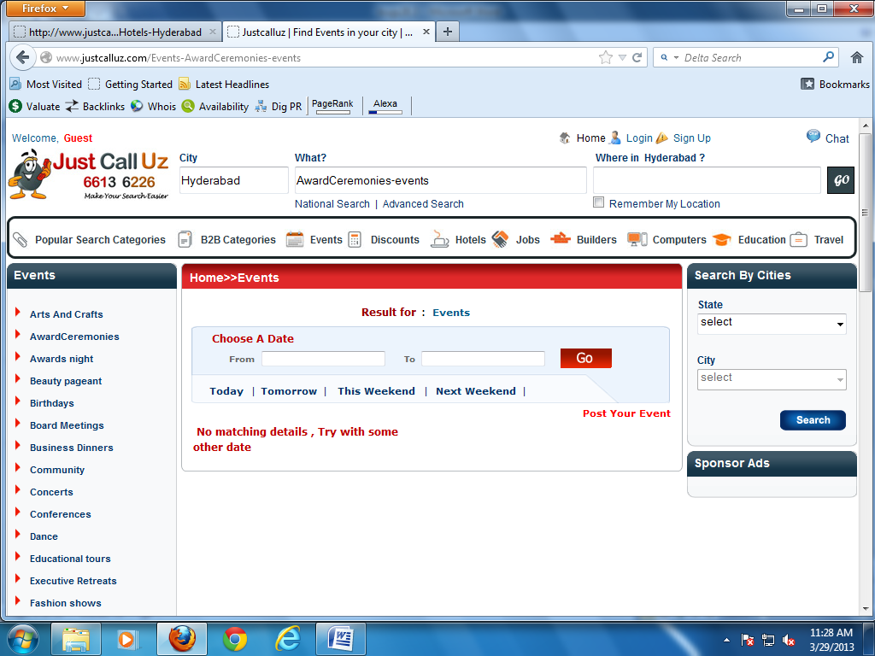

Search Option does not work in events category

<http://www.justcalluz.com/Events-AwardCeremonies-events>

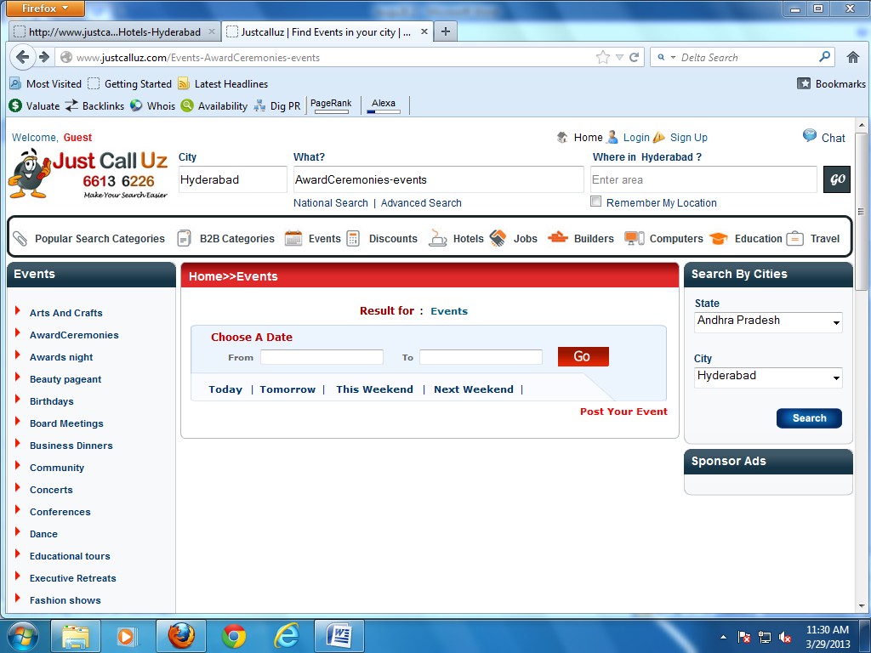

Search button functionality does not work in events module

Choose date search option also does not work.

<http://www.justcalluz.com/Results-Hotels-Hyderabad-3%2bStar%2bHotels-null>

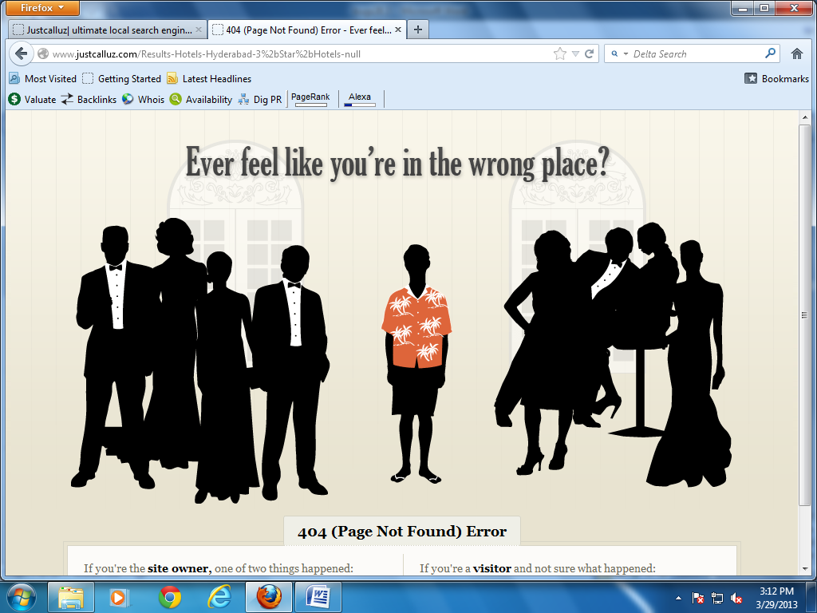

Getting error page in hotels searching by city

<http://www.justcalluz.com/Event-events>

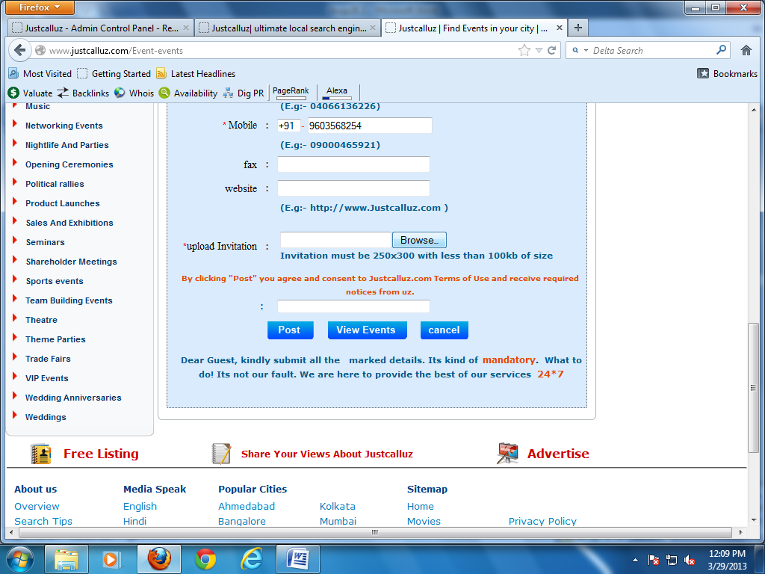

Captcha word does not displayed

<http://www.justcalluz.com/Movies-null-null>

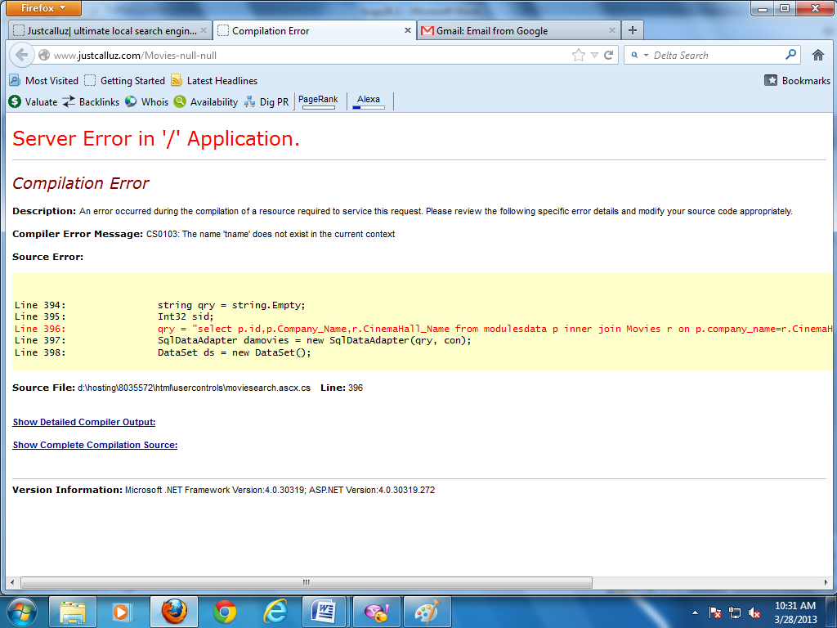

Getting error page in movies category

(solved)

<http://www.justcalluz.com/HttpErrorPage.aspx>

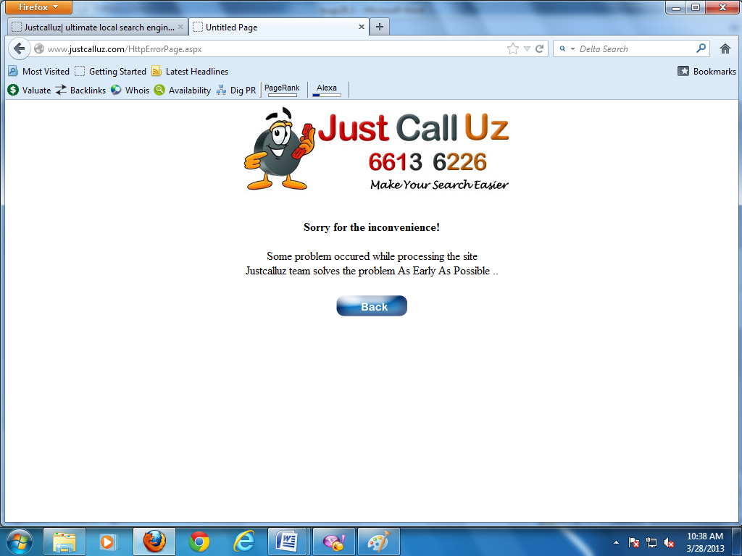

Getting error in events category

(solved)

<http://www.justcalluz.com/sessionstore-571-Hampshire%20Plaza>

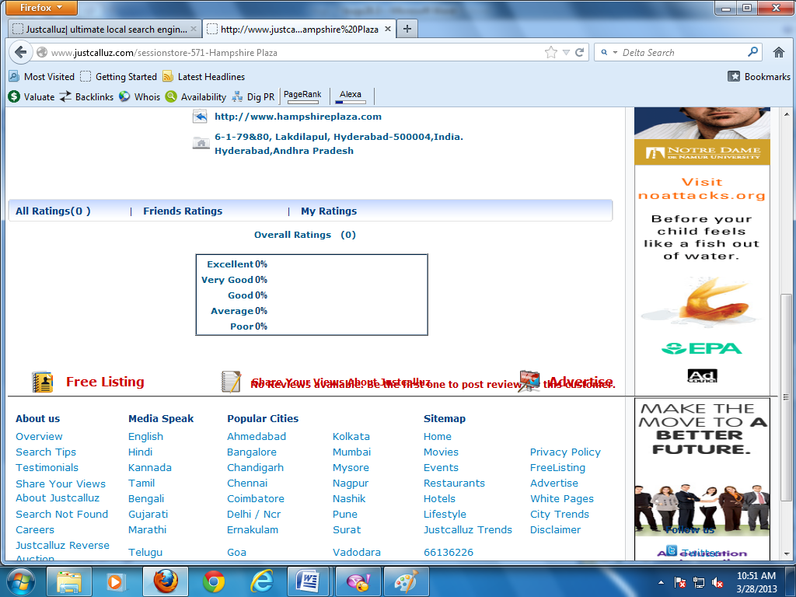

Letters are displayed as blurred

<http://www.justcalluz.com/sessionstore-571-Hampshire%20Plaza>

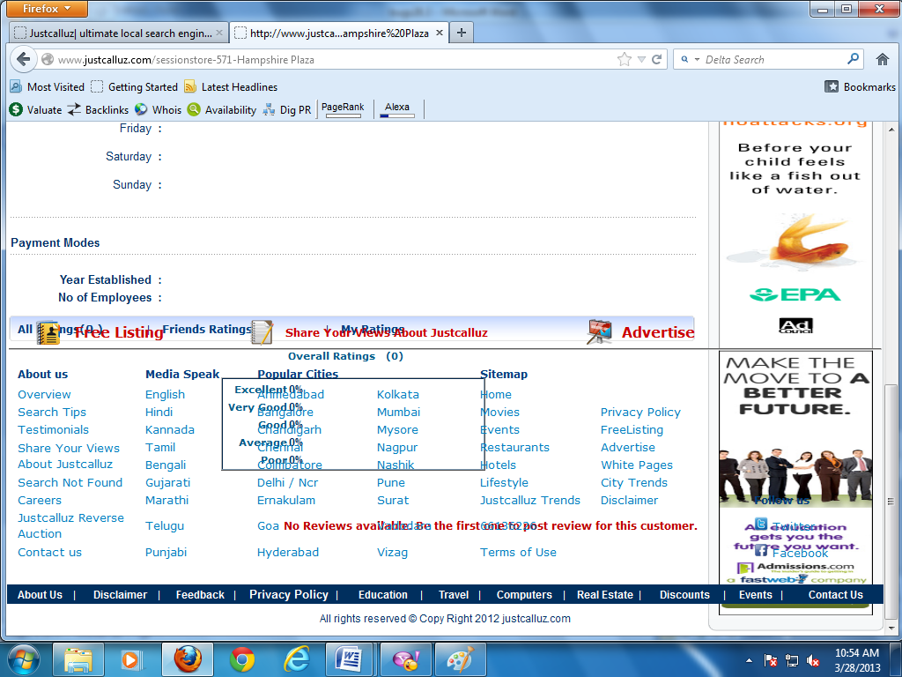

Icons have clumsiness

<http://www.justcalluz.com/LinkDetails-Automobile>

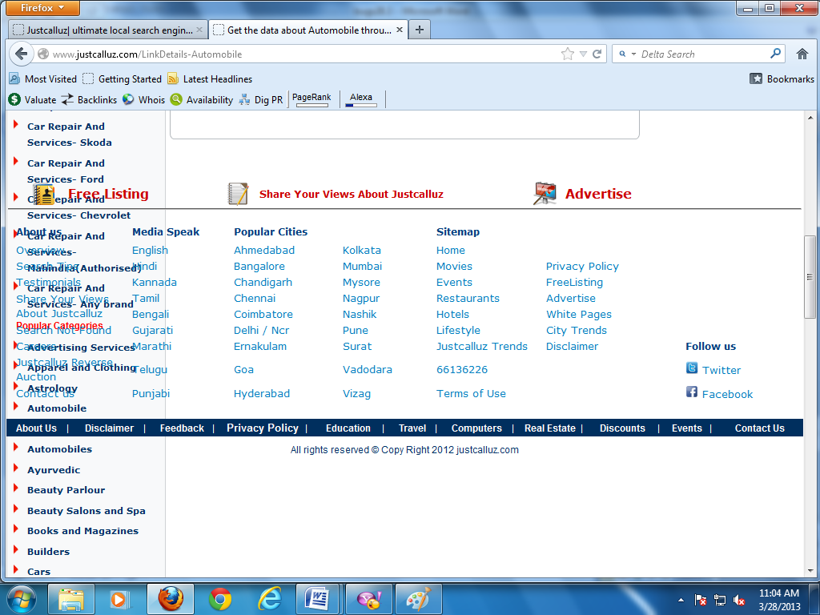

Page not be displayed properly

<http://www.justcalluz.com/LifeStyle>

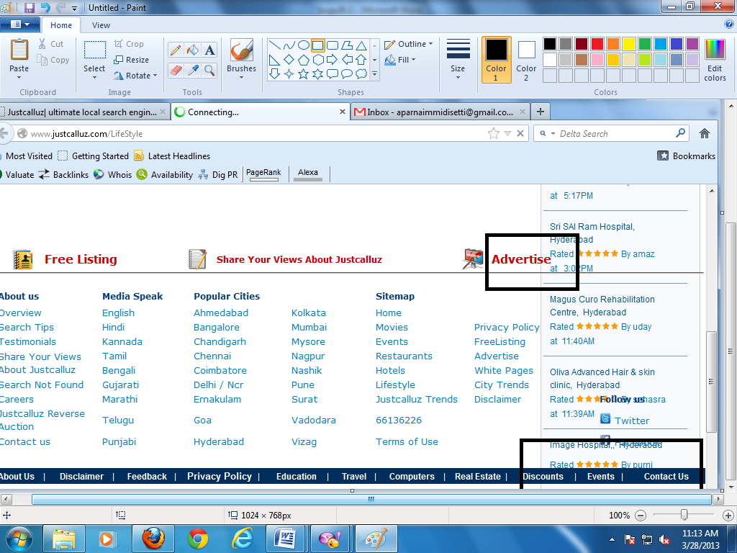

Not properly displayed

<http://www.justcalluz.com/SearchNotFound-Networking%20Equipments-Hyderabad>

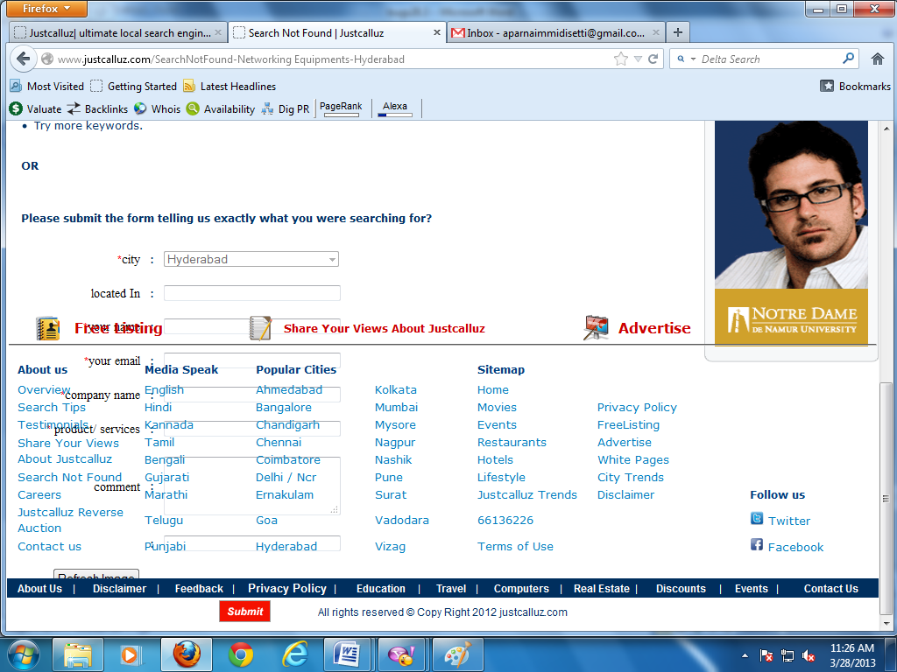

(solved)

<http://www.justcalluz.com/sessionstore-848-Kranthi%20Kiran>

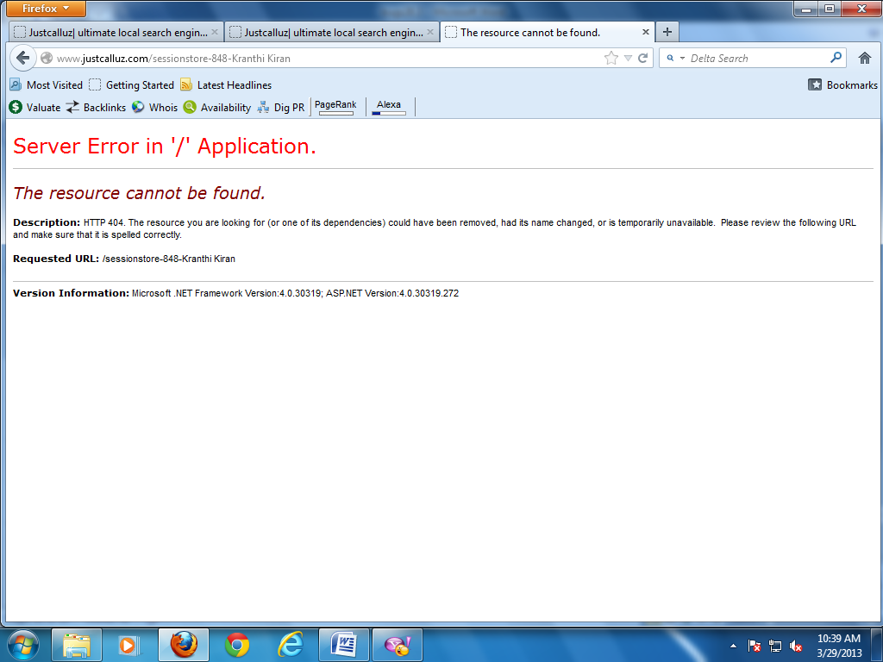

Getting error page when click on company details

(solved)