Recelle May B. Janda

EXERCISE 1

1. Write the complete SQL statement for creating a new database called addressbook
CREATE DATABASE ADDRESSBOOK;

2. Which statement is used to list the information about a table? How do you use this statement?
THE STATEMENT IS:
DESCRIBE table_name;

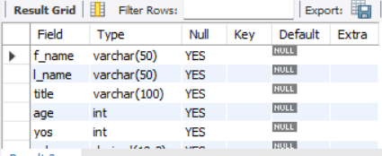
FOR EXAMPLE IN TABLE EPLOYEE_DATA,
DESCRIBE employee_data;
-- THIS DISPLAYS THE STRUCTURE OF THE TABLE — COLUMN NAMES, DATA TYPES, AND OTHER PROPERTIES.

3. How would you list all the databases available on the system?
SHOW DATABASES;
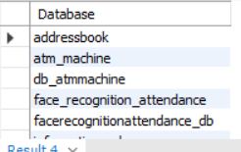

-4. Write the statement for inserting the following data in employee_data table
/*First name: Rudolf
Last name: Reindeer
Title: Business Analyst
Age: 34
Years service: 2
Salary: 95000
Perks: 17000
Email: rudolf@bugnet.com*/
INSERT INTO EMPLOYEE_DATA (F_NAME, L_NAME, TITLE, AGE, YOS, SALARY, PERKS, EMAIL)
VALUES ('Rudolf', 'Reindeer', 'Business Analyst', 34, 2, 95000, 17000, 'rudolf@bugnet.com');
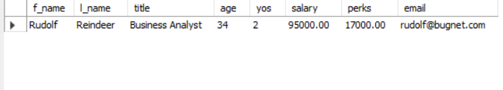

-- 5. Give two forms of the SELECT statement that will list all the data in employee_data table.
SELECT * FROM EMPLOYEE_DATA;
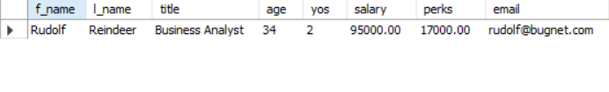
SELECT F_NAME, L_NAME, TITLE, AGE, YOS, SALARY, PERKS, EMAIL FROM EMPLOYEE_DATA;
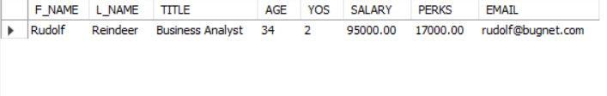

-- 6. What will select f_name, email FROM employee_data; display?
-- IT WILL DISPLAY ONLY THE FIRST NAME AND EMAIL ADDRESSE OF THE EMPLOYEE FROM THE TABLE.
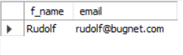

-- 7. Write the statement for listing data from salary, perks, and yos columns of employee_data table.
SELECT salary, perks, yos FROM employee_data;
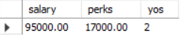

-- 8. How can you find the number of rows in a table using the SELECT statement?
SELECT COUNT(*) FROM employee_data;
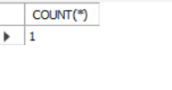

-- 9. What will select salary, l_name FROM employee_data; display?
-- IT WILL DISPLAY THE SALARY AND LAST NAME OF EMPLOYEE FROM THE TABLE.
