**"WR_[MOD]Sedi_2/18 to 2/25"**

**Feb 18.**

-> I've handled the 3 games event today @ 3:40pm. Here are the winners of my event.

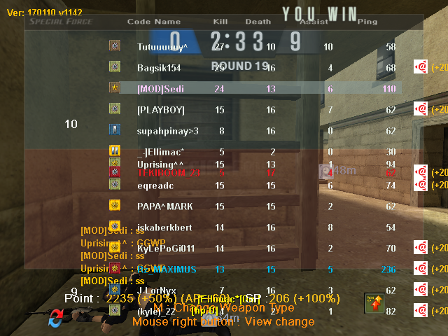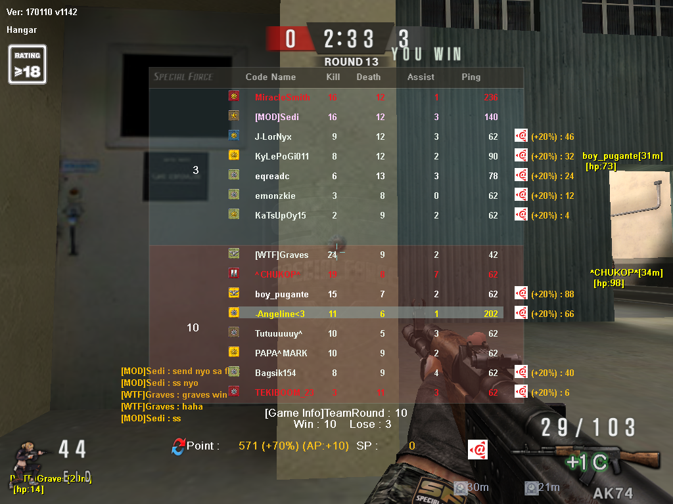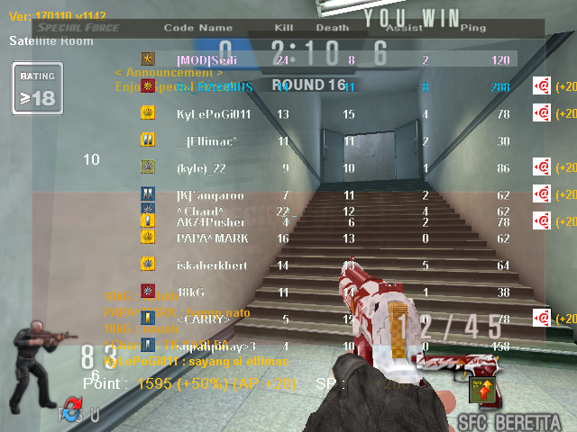

**Feb 19.**

-> I’m focus on Forum (Abuse Reports and Technical Reports). I noted/compile the cheaters name on my personal spreadsheet, after that I will transfer to official mod spreadsheet report. I’ve noted the cheaters reported by community. And also I answered all question/concern on Technical Reports.

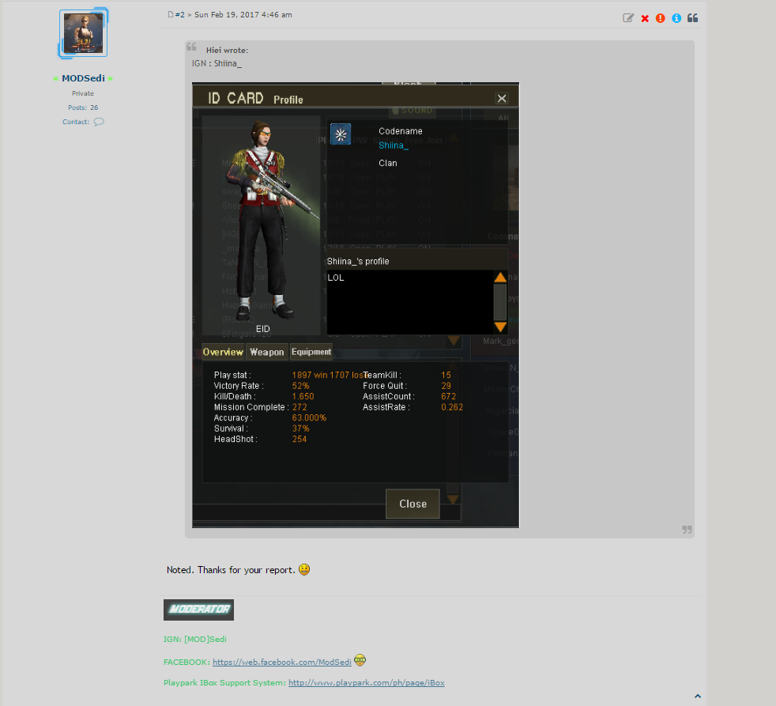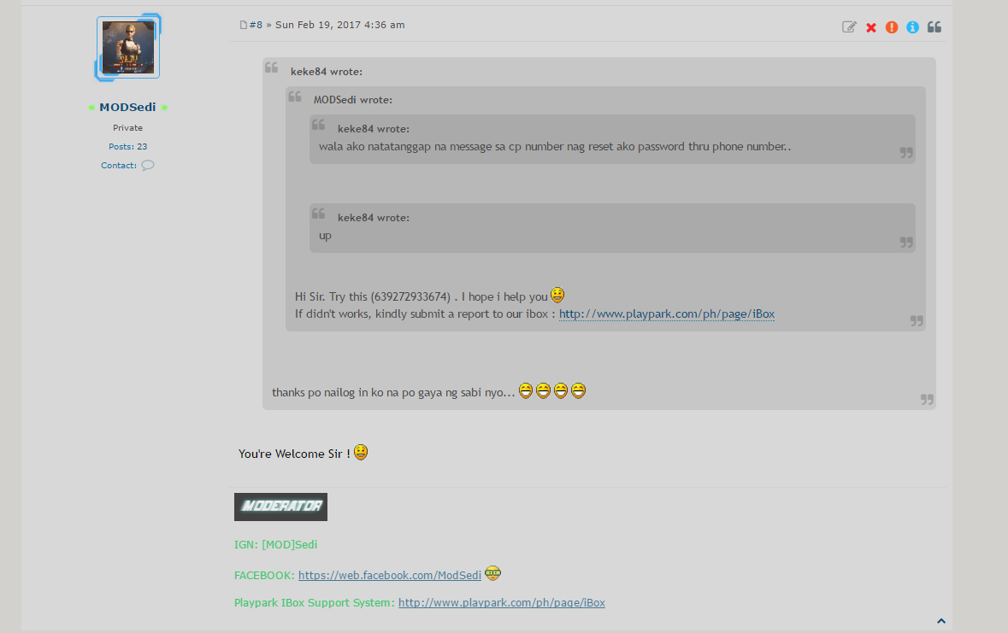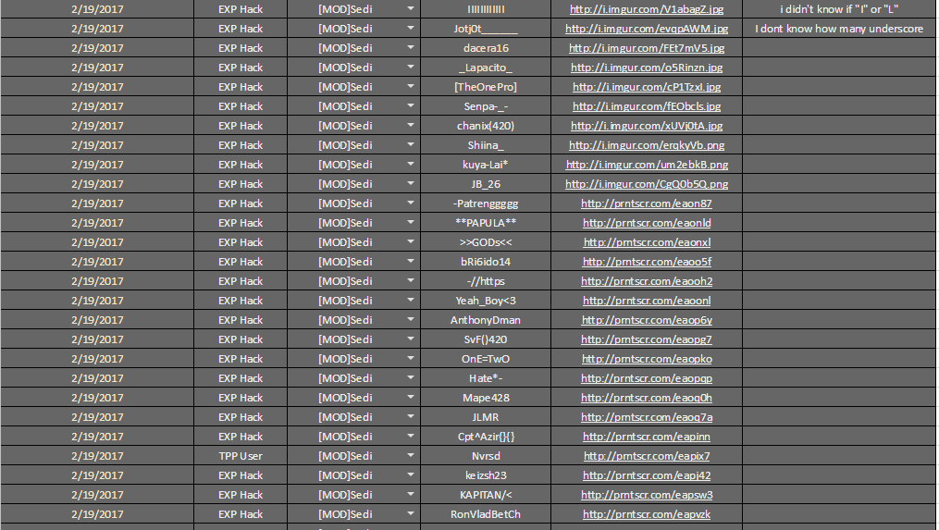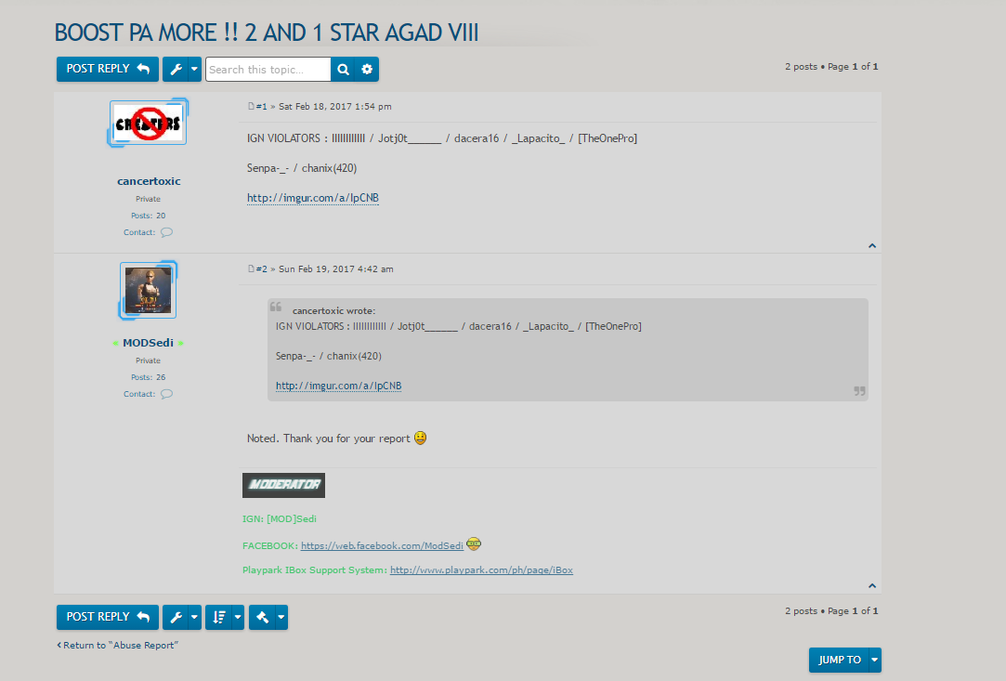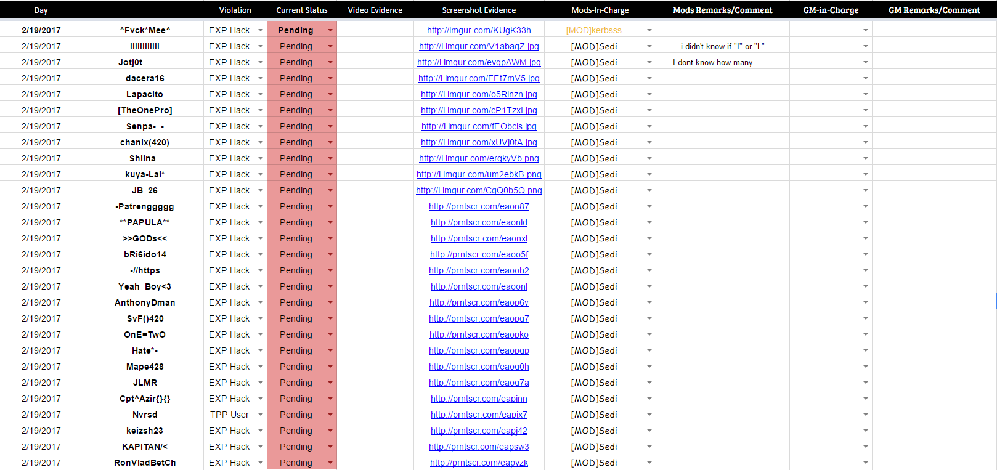

**Feb 20.**

-> I’m focus on Forum (Abuse Reports). I noted/compile the cheaters name to official mod spreadsheet report. I’ve noted the cheaters reported by community. And I answered the people and teach how to follow the instruction on how to report cheaters on forum.

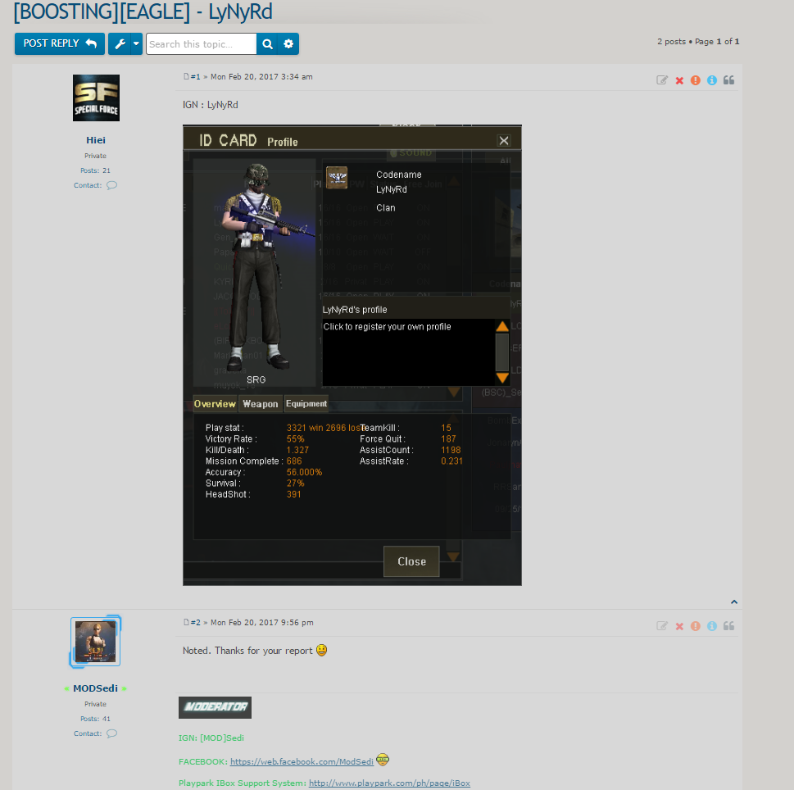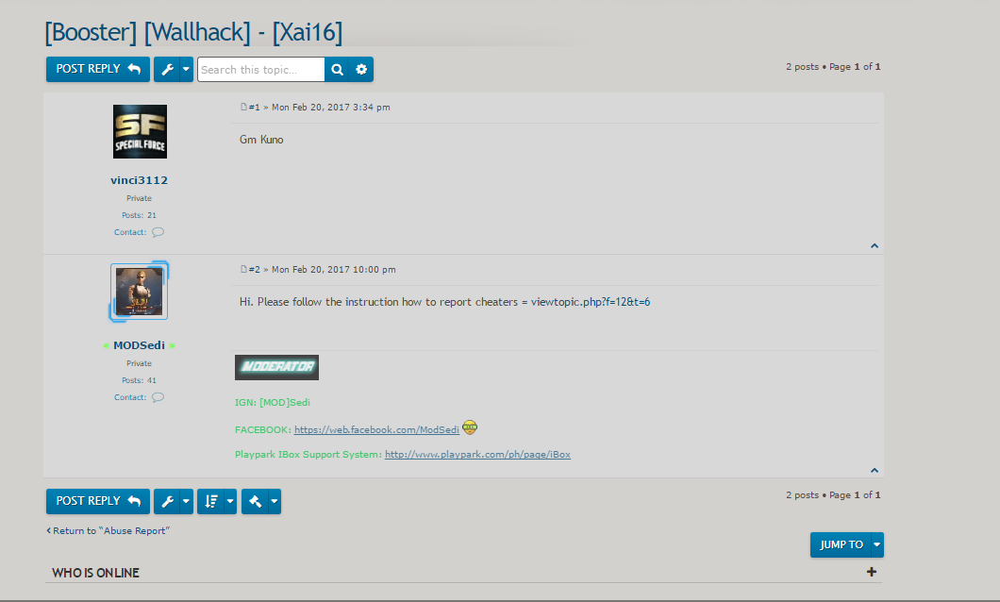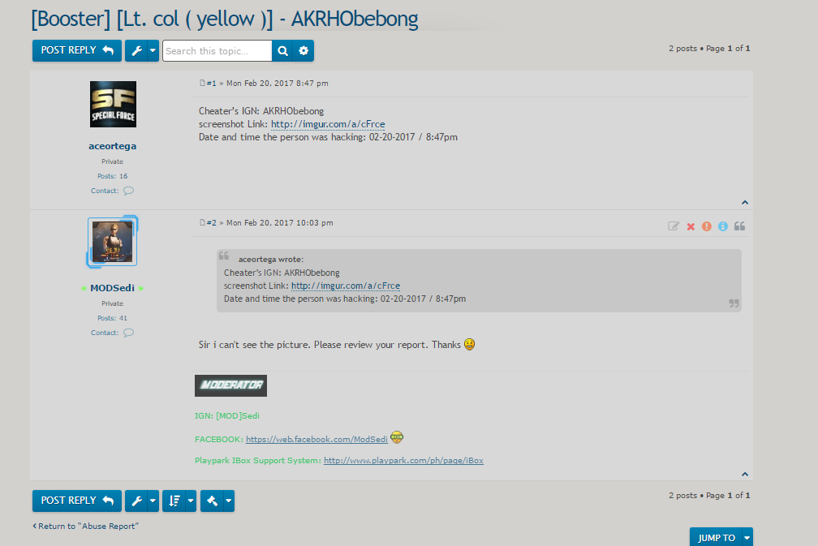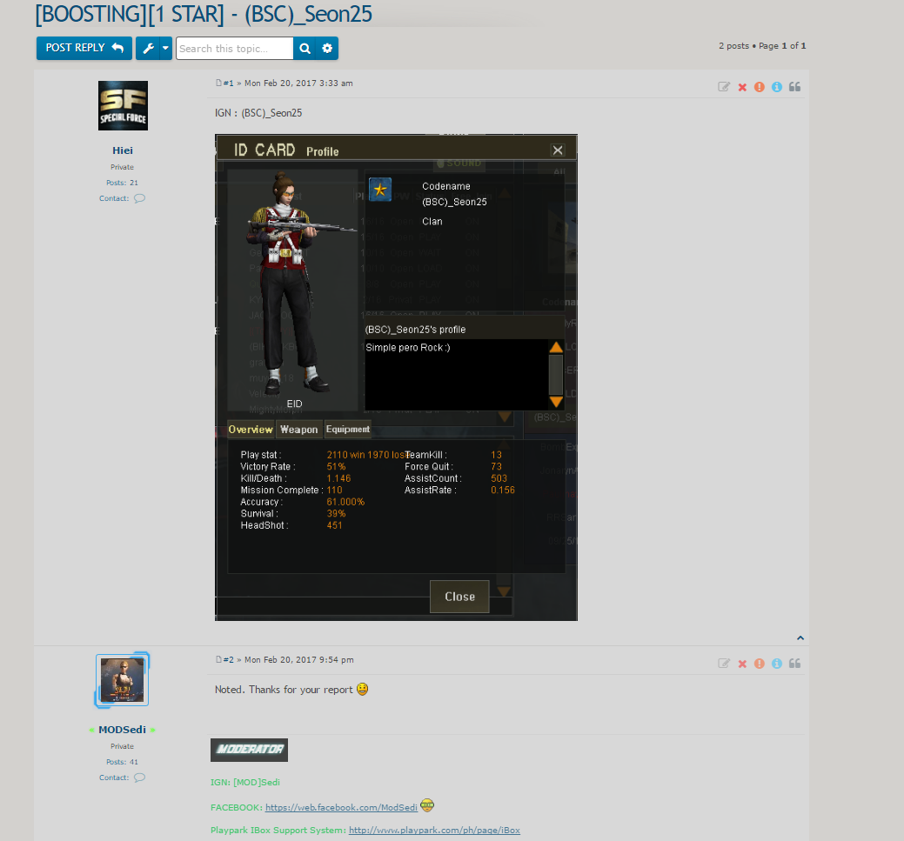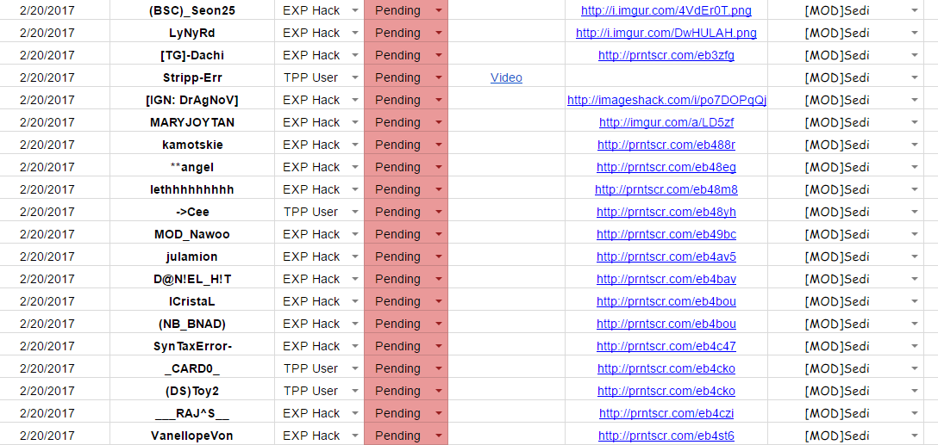

**Feb 21.**

-> I’m focus on Forum (Abuse Reports). I noted/compile the cheaters name to official mod spreadsheet report. I’ve noted the cheaters reported by community.

