Documentation

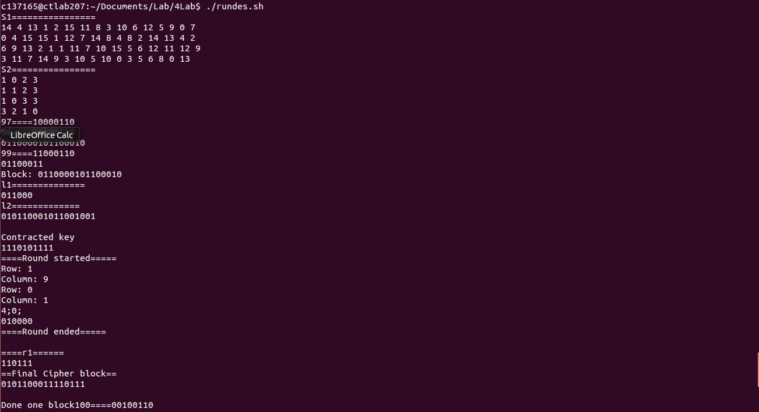
DES ROUND
1. The blocks were divided into 6 and 10
2. the 10 bit block is first xored with the key. The key is split into 4 bit blocks on which left and right shift is done. Then it is expanded to 10bits using PC2.
3. The 10 bit output is then passed through sboxes to get a 6 bit output which is xored with Li-1.
4. the Li and Ri are combined to get the cipher text.
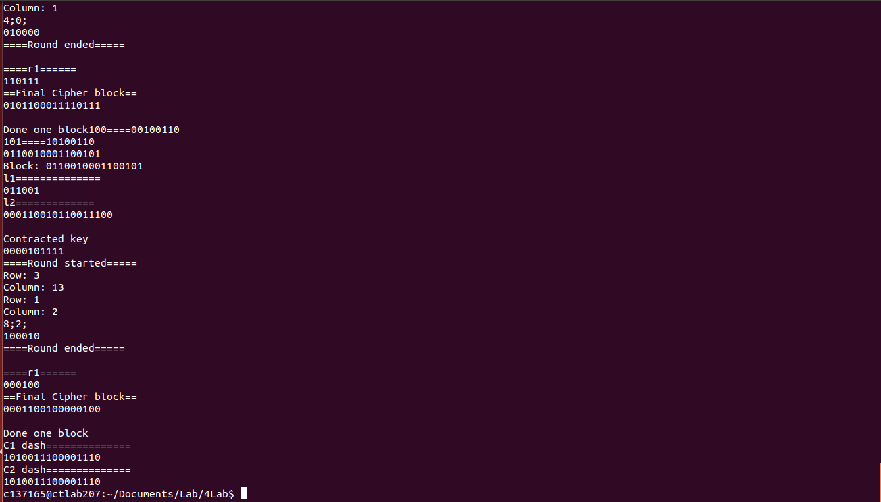
CIPHER Text creation
1. DES is run on both the blocks separately.
2. The IV is first XORed with C1 to produce C1' and C1 is Xored with C2 to produce C2'. These are then Xored to produce C'.

The sbox file and input file is separate ( 137165_des_sbox.txt)
To run the program , run ./137165_runscript.sh

