**ML Classifiers on PIMA Dataset for**

**Blood Pressure and Glucose classification**

**Requirements:**

Language - Python3

Libraries - sklearn, imblearn, pandas, numpy, seaborn, xgboost, scipy, matplotlib

**Metadata**

Total Instances: 636

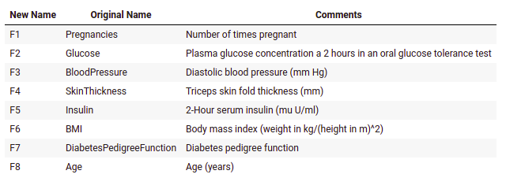

**Preprocessed Dataset (Diabetes)**

* Positive - 198
* Negative - 498

**Swap BloodPressure as Target**

* Normal - 504 (for BP <= 80)
* High - 132 (for BP > 80)

**Swap Glucose as Target**

* Normal - 499 (for Glucose <= 140)
* High - 137 (for Glucose > 140)

**Results**

The metric used here was F1 score

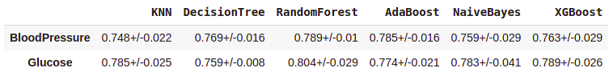

**Data Augmentation for BloodPressure classification**

Technique: SMOTE

No. of Instances - 1008

Class distribution after augmentation:

* Normal - 504 (for BP <= 80)
* High - 504 (for BP > 80)

**Data Augmentation for Glucose classification**

Technique: SMOTE

No. of Instances - 998

Class distribution after augmentation:

* Normal - 499 (for Glucose <= 140)
* High - 499 (for Glucose > 140)

**Results**

Area Under Curve (AUC) scores:

