**ADE2you Management System Requirements Specification**

**Group members:** Alissa Çenga

Drilon Hyseni

Ensild Bici

Accepted by: Dr. Igli Hakrama

**Table of Contents**

1. EXECUTIVE SUMMARY 4
   1. PROJECT OVERVIEW 4
   2. PURPOSE AND SCOPE OF THIS SPECIFICATION 4
2. PRODUCT/SERVICE DESCRIPTION 4
   1. PRODUCT CONTEXT 5
   2. USER CHARACTERISTICS 5
   3. ASSUMPTIONS 7
   4. CONSTRAINTS 7
   5. DEPENDENCIES 7
3. REQUIREMENTS 8
   1. FUNCTIONAL REQUIREMENTS 8
   2. NON-FUNCTIONAL REQUIREMENTS 11
      1. Product Requirements 11
         1. User Interface Requirements 11
         2. Usability 14
         3. Performance 14
         4. Manageability/Maintainability 15
         5. System Interface/Integration 15
         6. Security 15
         7. Data Management 16
         8. Standards Compliance 17
         9. Portability 17
      2. Organizational Requirements 17
         1. Environmental Requirements 17
         2. Operational Requirements 18
         3. Development Requirements 18
      3. External Requirements 18
         1. Ethical Requirements 18
         2. Legislative Requirements 19
4. SOFTWARE DESIGN 21
   1. USER SCENARIOS/USE CASES 21
      1. User Scenarios 21
      2. Use Cases Diagram 29
      3. Use Cases Extended 30
   2. DIAGRAMS 39
      1. Activity Diagrams 39
      2. Swimlane Diagrams 48
      3. State Charts 52
      4. Sequence Diagrams 60
      5. Collaboration Diagrams 67
      6. Class Diagram 74
      7. Object Diagrams 75
      8. Entity Relation Diagram 79
      9. Data Flow Diagrams 81
      10. Component Diagram 84
      11. Deployment Diagram 85

APPENDIX A. SKETCHES 103

# Executive Summary

## Project Overview

We all face difficulties when it comes to fixing something, we lack the knowledge of. What is even more difficult is adapting and finding the time to meet skilled persons which are going to fix your problems. Obviously, we cannot find a solution to any problem in the world but our team is glad to try and relieve some stress when it comes to fixing problems related to your household. As we mentioned, in this fast-paced world it is often hard to find the time needed to take care of various issues that occur within our houses. Let them be, cleaning support, various furniture assembly, installations needed around the house, which are made possible only by someone who is a skilled electrician, plumbers and so on. What we can acknowledge is that some of this complication can be fixed by anyone who finds the desire but we have something else in mind.

What we are suggesting is a home services management system which will consist of an application. This app will take care of the gathering of the most requested services into one platform. By doing so we aim to achieve efficiency and improve the user experience.

## Purpose and Scope of this Specification

Our purpose as developers is to improve the user’s experience and simplify as much as we can the home-services finding and reservation process. The app is going to provide the following:

1. Searching for a specific skilled person/ or company.
2. Booking a specific skilled person.
3. Billing functionalities for the users.
4. Learning new skills.
5. Bidding functions for a specific job description.

# Product/Service Description

Our app is able to provide a way to automate the whole searching and booking process of a specific home-service. Fixing day to day problems in our household is becoming more and more difficult since finding the appropriate persons skilled to offer a solution are not easily to be found.

The product we are offering is available to be used by all the persons involved in this specific process: the users, the workers, the magazines/ companies that offer specific tools, etc. Our app will provide practical solutions to all the requirements presented by the stakeholders.

## Product Context

This product is independent and self-contained. Currently similar products of eye clinic management systems are being developed to benefit from the ease and convenience of having the management system in a web application. Although these products are of a bigger scale and meant for a wide publicum and usually are not affordable to many clinics.

Our product on the other hand will be designed to first and foremost meet the requirements of our current client. This product is not intended to communicate with other systems. It is intended to work within the scope of a specific clinic and its clients.

## User Characteristics

This product is intended to be used from the following users:

* + - Guest (Visitors - no login required)

Guests can come from different age groups and backgrounds. Guests can be users who hold different backgrounds although it can be accessed only by persons who are more than 16 years old. Our app will make possible of offering the users of this view the most part of functionalities that registered users can access. They will be able to check out all the services offered in the app. They can skim through the majority of workers (possibly the top-rated ones for each service) but they cannot book a service/ worker. They will also be able to check out the Learn Skills blog where the workers registered on the app are going to offer their aid to simple users. This will be explained by detail in the User Interface section of the document and the functional requirements section.

* + - Registered Users

Registered users are guests who have already created an account in our app and they are looking forward to profit from the services available in the app, the main one being booking a specific skilled worker to offer some service. Its view will be the same as that of non- registered user but some added functionalities will be available. The workers will be available without restrictions, the magazines and Groups as well. Every detail will be specified in the UI section of the document

* + - Workers

Workers are skilled persons who choose to access the app in order to provide some services to the users of the app. They can register in the app, set up their profiles, and start taking orders from users. They can also form unions with one another in order to provide unified services and they can access magazines in order to acquire all the materials needed to provide a specific service. The workers can access the bidding system powered by the users. They can offer their worker and make their offers for a specific service, while communicating with the users through this system. The workers UI will be specified in the below section as well but the functionalities between users and workers are different.

* + - Magazines

Magazines will include companies who join the app in order to offer some aid to the workers and users as well. Magazines will be able to set up their profile, specifying the NIPT of the company. In their profile they will be able to include all the products offered along with their prices. Payment methods and prices will be included too. Users will be able to search for specific tools and the nearest magazines will be available in the search results. Workers can directly contact the magazines for further details regarding some materials needed for a specific service. Magazine View will be specified and described in the User Interface section of the document as well.

# Requirements

## Functional Requirements

|  |  |  |  |  |  |
| --- | --- | --- | --- | --- | --- |
| **Req#** | **Requirement** | **Comments** | **Priority** | **Date Rvwd** | **SME**  **Reviewed / Approved** |
| BR_G_01 | A user can access the services of the app even though not registered. | A user can check out the available services registered on the app even though he has not created an account. | 2 | 20/04/22 | A.Cenga,  D.Hyseni,  E.Bici |
| BR_G_02 | The app should provide a list of the available services under the Services Menu | The services menu lists out all the accessible services in the app. | 1 | 20/04/22 | A.Cenga, D.HyseniE.Bici |
| BR_P_01 | The app should provide a reduced list of the top-rated workers for each service, for guests. | When accessing a service, guest users are presented to the top 5 workers/ service. | 2 | 20/04/22 | A.Cenga,  D.Hyseni,  E.Bici |
| BR_G_03 | The app must send a verification e-mail to workers who successfully create an account. | Each worker will be verified by a specific team. | 1 | 20/04/22 | A.Cenga,  D.Hyseni,  E.Bici |
| BR_G_04 | The profile of a worker cannot be created if he/ she has not included his working ID. | Part of the verification process of the worker. | 3 | 20/04/22 | A.Cenga,  D.Hyseni,  E.Bici |
| BR_GR_05 | The app should allow the workers to include a calendar of their availability in their account. | The calendar must be available to registered users. | 1 | 20/04/22 | A.Cenga,  D.Hyseni,  E.Bici |
| BR_R_01 | The app should allow the users to give feedback for specific workers. | The feedback’s range is from 0/5 stars to 5/5 stars. | 2 | 20/04/22 | A.Cenga,  D.Hyseni,  E.Bici |

|  |  |  |  |  |  |
| --- | --- | --- | --- | --- | --- |
| **Req#** | **Requirement** | **Comments** | **Priority** | **Date Rvwd** | **SME**  **Reviewed / Approved** |
| BR_R_02 | Users will be able to give feedback only to booked workers. | Only for workers who have offered their service to a specific user. | 1 | 15/04/22 | A.Cenga,  D.Hyseni,  E.Bici |
| BR_R_03 | The app will enable a searching feature through a search bar. | It will be possible to take a closer look of some specific services or workers through the search bar. | 1 | 15/04/22 | A.Cenga,  D.Hyseni,  E.Bici |
| BR_R_04 | The search bar will be functional through the usage of key words. | Each user can include key words for services, workers, magazines and the cured list will show up on the page. | 1 | 15/04/22 | A.Cenga,  D.Hyseni,  E.Bici |
| BR_R_05 | The app will enable searching for specific worker or service/s. | The users can search up by worker name or by service name. | 3 | 15/04/22 | A.Cenga,  D.Hyseni,  E.Bici |
| BR_R_06 | The workers menu will list out all the available workers. | The workers will be divided in service categories in the Worker Menu. | 1 | 15/04/22 | A.Cenga,  D.Hyseni,  E.Bici |
| BR_P_01 | The available workers in the menu will be sorted by default given their rate. | The workers present in the Worker Menu will be sorted in a descending order based on their rate. | 2 | 15/04/22 | D.Rabeli, D.Duma, A.Ligori |
| BR_P_02 | The system should allow the users to log in the app given their credentials. | Login credentials: username,  password | 1 | 15/04/22 | D.Rabeli, D.Duma, A.Ligori |
| BR_P_03 | The system should allow the workers to log in the app given their credentials | Login credentials:  workerID,  password | 1 | 15/04/22 | D.Rabeli, D.Duma, A.Ligori |

|  |  |  |  |  |  |
| --- | --- | --- | --- | --- | --- |
| **Req#** | **Requirement** | **Comments** | **Priority** | **Date Rvwd** | **SME**  **Reviewed / Approved** |
| BR_P_04 | The app should allow the worker to set up a profile picture. | This is a mandatory requirement and the profile picture should be accordingly to the specified terms. | 1 | 25/04/22 | A.Cenga,  D.Hyseni,  E.Bici |
| BR_P_05 | The app should allow the worker to modify the personalized calendar. | If a worker accepts a booking from the user, he inserts it into its personal calendar. | 3 | 25/04/22 | A.Cenga,  D.Hyseni,  E.Bici |
| BR_P_06 | The worker should be allowed to include the price/ service in their profile. | The price offered for each service has to be included by the worker. | 1 | 20/04/22 | A.Cenga,  D.Hyseni,  E.Bici |
| BR_E_01 | The worker should be allowed to include the payment method in their profile. | The payment method to be utilized is based on:  CreditCards,  PayPal,  Bank Account. | 2 | 20/04/22 | A.Cenga,  D.Hyseni,  E.Bici |
| BR_E_02 | The worker should be able to manage the bookings through the app. | A worker accepts or declines a request from a user. | 2 | 20/04/22 | A.Cenga,  D.Hyseni,  E.Bici |
| BR_E_03 | The app should provide a list of auctions under the Auction Section. | The Auction Section lists out all the ongoing auctions sorting them in an ascending order given the deadline. | 2 | 20/04/22 | A.Cenga,  D.Hyseni,  E.Bici |
| BR_E_04 | A user must be registered if he wants to put a project in an auction. | Each registered user is allowed to use the auction functionality. | 2 | 20/04/22 | A.Cenga,  D.Hyseni,  E.Bici |
| BR_E_05 | The project must be explained briefly and must start with a default bid. | The workers can bid only with a price higher than the default bid | 2 | 15/04/22 | A.Cenga,  D.Hyseni,  E.Bici |
| BR_E_06 | The system allows a single user and a group to participate in the auction depending on the user requirement. |  | 2 | 15/04/22 | A.Cenga,  D.Hyseni,  E.Bici |

|  |  |  |  |  |  |
| --- | --- | --- | --- | --- | --- |
| **Req#** | **Requirement** | **Comments** | **Priority** | **Date Rvwd** | **SME**  **Reviewed / Approved** |
| BR_D_01 | The app fires a penalty if workers report 5 auctions of the same user. | Each user account is removed from the app whenever the penalties have reached a limit. | 2 | 20/04/22 | A.Cenga,  D.Hyseni,  E.Bici |
| BR_D_02 | The system allows an auction to be available for only 7 days. | Once an auction is over, the highest bid is selected. | 1 | 20/04/22 | A.Cenga,  D.Hyseni,  E.Bici |
| BR_D_03 | The app processes the booking of the auction the same way as that of a single service. | After an auction is terminated, each involved worker will be booked through the standard way. | 3 | 20/04/22 | A.Cenga,  D.Hyseni,  E.Bici |
| BR_D_04 | The app allows magazines to be registered. | In order to do so it must contain an official NIPT | 2 | 15/04/22 | A.Cenga,  D.Hyseni,  E.Bici |
| BR_D_05 | The system allows magazines to include all the products available. | Under the products section of each magazine profile, all the product available will be displayed. | 3 | 15/04/22 | A.Cenga,  D.Hyseni,  E.Bici |
| BR_GR_05 | The app provides the feedback system for magazines as well. | Each magazine will include the user rating in its profile | 2 | 22/04/22 | A.Cenga,  D.Hyseni,  E.Bici |
| BR_GR_05 | The system allows magazines to login with the respective credentials | Login credentials:  magazineNIPT  password. | 1 | 22/04/22 | A.Cenga,  D.Hyseni,  E.Bici |
| BR_GR_05 | The system monitors reports for each magazine. | If a magazine is reported more than 20 times it will be closed. | 3 | 22/04/22 | A.Cenga,  D.Hyseni,  E.Bici |
| BR_05 | The workers can be organized in groups. | The group section has increased functionalities for users registered as workers. | 2 | 22/04/22 | A.Cenga,  D.Hyseni,  E.Bici |
| BR_22 | The system allows each worker to participate in no more than 2 groups. | Each worker can join a group whenever a specific skill is missing | 2 | 22/04/22 | A.Cenga,  D.Hyseni,  E.Bici |
| BR_GR_22 | A user can access the groups through the groups section. | The users can only check out the available groups and they can book them given a full service required. | 2 | 22/04/22 | A.Cenga,  D.Hyseni,  E.Bici |
| BR_GR_22 | Each group is specialized in a specific full service. | Some default full services will be provided by the system and each worker can join them based on the specified conditions. | 2 | 22/04/22 | A.Cenga,  D.Hyseni,  E.Bici |
| BR_GR_22 | The app allows searching for full services. | Whenever inserting a full service as a key word in the search bar, some specific groups that contain those keywords will be available. | 2 | 22/04/22 | A.Cenga,  D.Hyseni,  E.Bici |
| BR_GR_23 | The system should be able to charge customer and do refunds when needed. | Whenever a user books a service/worker all the procedural payments are performed through the system. | 1 | 22/04/22 | A.Cenga,  D.Hyseni,  E.Bici |
| BR_GR_24 | The system should allow multiple ways of payments. | Payments could be performed through   * Paypal, * CreditCard * Online transfers. | 1 | 22/04/22 | A.Cenga,  D.Hyseni,  E.Bici |
| BR_GR_25 | The system should generate an invoice for each payment | The bill should be generated whenever a service is successfully booked. | 2 | 22/04/22 | A.Cenga,  D.Hyseni,  E.Bici |
| BR_GR_26 | The client should have the right to choose between two types of payment transactions: one-time purchases and periodic purchases. | When user registers and pays a monthly subscription to all courses available by the workers. | 2 | 22/04/22 | A.Cenga,  D.Hyseni,  E.Bici |
| BR_GR_27 | The payment system should be able to support when users enter discount coupons or promotion codes. | An empty field should be available besides the book button used to insert all promocodes and coupons. | 3 | 22/04/22 | A.Cenga,  D.Hyseni,  E.Bici |
| BR_GR_28 | The system will be able to charge customers a fee every time they make a transaction. |  | 1 | 22/04/22 | A.Cenga,  D.Hyseni,  E.Bici |
| BR_GR_29 | The system can see all the types of transactions made inside system and the details for every transaction. | The workers and user will be able to see all the transactions involving their profiles. | 2 | 22/04/22 | A.Cenga,  D.Hyseni,  E.Bici |
| BR_GR_30 | When workers set up their account, they will set up a payment method and a place in database is going to be stored for workers. | The worker should choose before hand the type of payment procedure to be followed by the users. | 1 | 22/04/22 | A.Cenga,  D.Hyseni,  E.Bici |
| BR_GR_31 | Payments details and transactions made for a current worker will be divided in two parts | The transactions made for work and the transactions made for learning purposes. | 2 | 22/04/22 | A.Cenga,  D.Hyseni,  E.Bici |
| BR_GR_32 | When magazines set up their account, they will set up a payment method and a place in database is going to be stored for magazines | They will be able to see the transactions made for a current period of time and their details. | 2 | 22/04/22 | A.Cenga,  D.Hyseni,  E.Bici |
| BR_GR_33 | Workers can upload videos and lectures to the system, every lecture will be checked and verified before posting. | Under the skills learning section, a list of the most liked videos will be displayed. | 1 | 22/04/22 | A.Cenga,  D.Hyseni,  E.Bici |
| BR_GR_34 | Users can search by lecturer name, or by the topic they want to learn. | The search field works just like the main view search field, using keywords. | 2 | 22/04/22 | A.Cenga,  D.Hyseni,  E.Bici |
| BR_GR_35 | System will allow customers to write personal notes on a current course they purchase. | The courses which are available under each worker profile, should provide a short description too. | 3 | 22/04/22 | A.Cenga,  D.Hyseni,  E.Bici |
| BR_GR_36 | The system will reward customers with certificates after following the full course. | The courses organized by the workers will have sponsorships from technical schools which will enable the reward with certificates. | 2 | 22/04/22 | A.Cenga,  D.Hyseni,  E.Bici |
| BR_GR_37 | Workers must publish a description of the course | The course goal, what clients benefits from this course, requirements that are needed to follow this course, etc. | 2 | 22/04/22 | A.Cenga,  D.Hyseni,  E.Bici |
| BR_GR_38 | System will name workers as verified lecturers when posting more than 20 videos. | Whenever the limit of 20 videos is reached, given a specific like amount, the workers become verified lecturers. | 3 | 22/04/22 | A.Cenga,  D.Hyseni,  E.Bici |
| BR_GR_39 | Verified lecturers can make real time online class sessions and post them on the courses after finishing. | For each worker that has more than 20 videos posted a new section will be shown in the worker profile, allowing them to start live sessions. | 2 | 22/04/22 | A.Cenga,  D.Hyseni,  E.Bici |
| BR_GR_40 | Workers have the ability to post documents and quizzes on their courses. |  | 2 | 22/04/22 | A.Cenga,  D.Hyseni,  E.Bici |
| BR_GR_41 | System will generate a private chat between every customer and the worker. | Under the course detail, a simple contact chat will be available so that the users can directly ask course related questions to the worker. | 3 | 22/04/22 | A.Cenga,  D.Hyseni,  E.Bici |
| BR_GR_42 | System will allow reviews on courses | A feedback system will be provided to courses as well, rating them based on different categories from 0/5 to 5/5 stars. | 2 | 22/04/22 | A.Cenga,  D.Hyseni,  E.Bici |
| BR_GR_43 | Worker must upload a text following everything that is explained in lessons, so that system can support screen readers and captioning. | A transcript has to be included under each posted video. | 2 | 22/04/22 | A.Cenga,  D.Hyseni,  E.Bici |

* 1. ***Non-functional requirements***

**3.2.1 Product requirements**

**3.2.1.1 User Interface Requirements**

General UI requirements:

* The user interface should be created in such a way that the main font family to be used is going to be Helvetica, in a big size so that the application will be easily readable.
* The main colors utilized in the app are going to be shades of blue.
* The background must be white.
* The text- color must be black.
* The app is going to have a search bar on top of the homepage.
* On the side of the search bar, a navigation menu will be available which will allow the user to go through different views of the app.
* The log in and registration pages will be accessed through this navigation menu.
* Clicking on the log in section of the navigation menu will redirect the user to the log in page.
* The log in page will be simple, it will enable logging in as a user by default so on top a drop-down combo box will have specified as default value “User Login”.
* Two other values will be present in the drop-down box, worker login and magazine login. Whenever someone a user wants to enter the app as a worker or magazine, he/she must change the value in the combo box from the default inserted value “User Login”.
* The buttons in the app are going to be with a height of 20px, and of color Dark Slate Blue (#483D8B), with white text.
* The login page will contain two other labels associated with the respective input boxes, one responsible for the ID of the user and the other for the password.
* Another button, under the input boxes, will enable logging in into the app.
* A hyperlink “Did you forget your password?” will be available in case the password is forgotten.
* Another hyperlink will be available in case the user does not have an account and it will redirect the user into the registration page.
* The same combo box of types of users will be available in the registration page.
* By default, a user will be able to register into the app as a simple user. Whenever he wants to switch up his registration form, he will have to choose another type of user as a value of the combo box.
* The registration page for a simple user will contain labels and input fields for the respective values:
* Name
* Surname
* Date of Birth
* Gender
* Username
* Password
* Password Confirmation
* E-mail

And a register button.

* The navigation menu will contain a Services button that will redirect the user into the Services view, whenever the user is not logged in into the app.
* When the user is not logged in into the app the visibility of the Services page will be reduced by only allowing the user to see the categories of services offered in the app and some of the top ranked profiles of the workers, not all of them.
* The navigation menu will contain an Extras section which will redirect the user to the extras page, where the courses provided by the workers will be displayed but joined only by users who are already logged in into the app.

User dashboards UI requirements:

* Besides the homepage, the application will contain several dashboards for respective logged in users. All the dashboards will contain the same navigation menu which will be equal as that presented for Not Logged In users of the app but with additional menus based on the type of user logged in into the application.
* The normal user dashboard will contain the following additional menus:
* Profile menu – this menu will be showcased once the user logs in into the app, besides the search bar on top of the homepage, on the leftmost side of the app. In this section, the user will be able to edit all his personal information including his profile picture.
* Booked Services menu – this menu will list all the services booked by the user and their state. Whenever a service is completed the state will change from Being Processed to Completed. Whenever a booking is denied from the Worker, the state will change from Being Processed to Denied. Whenever a booking is cancelled from the User, the state will change from Being Processed to Cancelled.
* Bids menu – this menu will list all the bids provided by the user.
* Notifications section – through this section the user will be informed for any changes occurring to the state of a service, course, feedback and so on.
* The worker dashboard will contain the following additional menus:
* Profile menu – this menu will be showcased once the worker logs in into the app, on the leftmost side of the app. In this section, the worker will be able to edit all his personal information, he will be able to edit his skills, to assess his skills, to manage the bookings he/ she accepts, to access the Calendar.

-The Calendar section - will be available whenever the worker logs in into his account. It will be automatically updated whenever the worker accepts a booking from the user. The worker can incorporate personal notes into the calendar that will not be visible to the user.

* Courses menu – in this menu the worker will be able to upload his courses and videos related to a specific topic.
* Notifications section – through this section the worker will be informed for any possible booking, feedback received and so on.
* The magazine dashboard will contain the following additional menus:
* Profile menu – this menu will be showcased once the magazine logs in into the app, on the leftmost side of the app.
* Notifications section – through this section the magazine will be informed for any possible rental offer or any selling of an item.
* Product menu – in this section the magazine will be able to manage ( add, delete, or modify) the products offered in the magazine.

**3.2.1.2 Usability**

The app should be straightforward and easy to learn and use. When the user first accesses the app, a list of pop-ups (alert windows) will be displayed, demonstrating to the user how to safely navigate through the app, and the functionalities it offers.

Alerts will be used whenever an error is encountered, let this be a user error or a deficiency of the app itself. These alerts will be displayed whenever an error is present, starting from the most basic problem such as inputting the wrong password into the login form and following up an error occurring throughout the payment process. These alerts should explain the problem concisely and briefly.

When possible, the app will replace text input fields with input selections in order to minimize the errors.

**3.2.1.3 Performance**

The application shouldn’t take more than 3 seconds to load the homepage. For every other operation performed it shouldn’t take more than 7 seconds.

Since it is a web application, the minimum requirement the user of the system should have is a stable internet connection so that the web app can run with no effort.

3.2.1.3.1 Capacity

1. Software Design
   1. User Scenarios/Use Cases

4.1.1 User scenarios.

1. Scenario title: Worker log-in into the app.
2. The worker opens the application.
3. The homepage of the app shows up and the worker clicks on the registration section
4. At the registration section he acknowledges that he already is registered in the app by clicking the login button
5. After that he enters the log-in view where he specifies, he’s entering as a worker.
6. After doing so, he is required to enter his credentials, his worker ID and the password.
7. The worker clicks on the Log- in button and the worker view is available to our app’s user.
8. Scenario title: User log-in into the app.
9. The user opens the application.
10. The homepage of the app shows up and the user clicks on the registration section.
11. At the registration section he acknowledges that he/ she is already registered in the app by clicking the login button.
12. After that he enters the log-in view, where he specifies, he’s entering as a normal user that seeks to book a service.
13. After doing so, he/she is required to enter his/her credentials, his personal ID and password.
14. The user clicks on the Log-in button and the user view is available to our app’s user.
15. Scenario title: Magazine log-in into the app
16. The magazine opens the application
17. The homepage of the app shows up and the magazine clicks on the registration section.
18. At the registration section he acknowledges that it is already registered in the app by clicking the login button.
19. After that, the magazine enters the log-in view where it specifies that the magazine’s is entering as a magazine to provide functionalities.
20. After doing so, the magazine is required to enter the credentials, the NIPT and password.
21. The magazine clicks on the Log- in button and the respective view becomes available.
22. Scenario title: Worker registration into the app.
23. The worker opens the application.
24. The homepage of the app shows up and the worker clicks on the registration section.
25. At the registration section he specifies that he/ she is registering as a worker.
26. He is required to enter the worker id, to create a password and verify it, to enter his/her name and surname.
27. After doing so, he clicks on verify.
28. The respective team deals with the verification of the account.
29. After 1 week, the account is opened.
30. Scenario title: User registration into the app.
31. The user opens the application.
32. The homepage of the app shows up and the user clicks on the registration section.
33. By default, the user registration form is displayed.
34. The user fills up the required boxes, such as personal id, name, surname, password, confirmation of the password, e-mail, and username.
35. The user clicks on register.
36. The account is created.
37. Scenario title: Magazine registration into the app.
38. The magazine owner opens the application.
39. The homepage of the app shows up and the owner or manager must click on the registration section.
40. At the registration section the owner specifies that it is registering a magazine.
41. After clicking the magazine button, the registration form shows up.
42. The magazine enters the credentials such as, name of the magazine, password, confirmation of the password, NIPT number, address and phone number.
43. The magazine clicks on register.
44. The account is created instantly.
45. Scenario title: Worker offers a service.
46. The worker makes sure he/she is logged in into the application.
47. The worker accesses his profile and clicks on Services Offered.
48. On the top right of the section he clicks the “+” button.
49. He specifies the service price and details and then enters “Publish”.
50. The Service is updated in his profile and added in the general Services section.
51. Scenario title: User wants to book a service.
52. The user opens the application.
53. The user makes sure he is logged in.
54. On top of the homepage there is located the search bar.
55. The user searches for the required service.
56. The search bar outputs by default the workers that offer these services ranked from cheaper to most expensive.
57. The user chooses one worker that fulfills the needed requirements.
58. The user clicks on book after setting a date based on the availability calendar of the worker.
59. Scenario title: Worker accepts a booking request.
60. The worker opens the app.
61. He/ she makes sure he/ she is logged in.
62. In the notifications section of his profile he checks for recent bookings.
63. The worker finds it suitable to work for the user.
64. The worker clicks the acceptance button.
65. An instance of the meeting will be automatically inserted in the calendar.
66. A notification is sent to the user by the app.
67. Scenario title: Worker does not accept a booking request.
68. The worker opens the app.
69. He/ she makes sure he/ she is logged into the app.
70. In the notifications section of his profile he checks for recent bookings.
71. The worker does not find it suitable to work for the user.
72. The worker declines the booking.
73. A notification is sent to the user by the app.
74. Scenario title: The user bids a service.
75. The user makes sure he is logged in. Then he enters the services section of the app.
76. On the top right of this section, a bidding button is available.
77. The user clicks on this button.
78. The user specifies the service to be completed.
79. The bid is published in the section along with other user’s bids.
80. Scenario title: The worker throws a bid.
81. The worker makes sure he is logged in. Then he enters the services section of the app.
82. Inside of this section a bidding button is available.
83. The worker cannot throw any new bids but it can access those published by the user.
84. Whenever a service is suitable, he bids on the offer.
85. Scenario title: The user performs a payment.
86. The user makes sure he is logged in. Then he/ she enters the services section of the app.
87. He chooses a preferred service.
88. He books the service. To fully perform a booking, he needs to process the payment.
89. He clicks on the Pay section of the service.
90. He chooses between three possible offered methods: PayPal, Credit/Debit Card, 2Checkout, which is a global payment processing solution. The last and first option redirect the user to the specified website, meanwhile the second option allows the user to enter the credit/ debit card information through the website and processes the payment in place.
91. After proceeding and confirming the payment, the status of the service is on pending.
92. Scenario title: The worker checks the notifications section.
93. The worker makes sure he is logged in. He then accesses the notifications section from the menu bar, which will be available only if the user is logged in into the web-app.
94. The worker clicks the notifications section.
95. Scenario title: The worker clears up the notifications section.
96. The worker makes sure he is logged in. He can then access the notifications section.
97. He clicks on the notifications section found in the menu bar.
98. He checks the checkbox found on the right of the service.
99. He then selects “Select all” button.
100. After selecting all the notifications, he clicks on Delete.
101. The notification section gets cleared up.
102. Scenario title: The user fails to process a payment when choosing Debit/Credit card method.
103. The user makes sure he is logged in.
104. The user books a service and then clicks on the Pay button.
105. The user chooses the second method of payment, Debit/Credit Card.
106. The user enters the Debit/Credit card information.
107. The card is declined.
108. The state of the service is automatically rejected.
109. Scenario title: The user specifies details to the worker.
110. The user makes sure he is logged in.
111. The user books a service and then clicks on the Pay button.
112. The user successfully performs the payment of the service. After clicking Process payment, a prompt message shows up where the user is asked if he wants to specify further details.
113. The user writes on the prompt the details and clicks “Finish”.
114. Two separate notifications are sent to the worker account, one specifying the service booked and the user account, and another contain the service details.
115. Scenario title: The user utilizes the map to find the nearest service.
116. The user makes sure he is logged in.
117. The user accesses the search bar.
118. The user inputs the specified key words to search a certain service.
119. The user clicks on the map icon after clicking enter.
120. The position of the user is displayed through a light blue circle, meanwhile the services/ workers available are displayed through red triangles.
121. The user clicks on the desired service and books it.
122. Scenario title: The worker orders extra tools from the magazine.
123. The worker makes sure he is logged in.
124. The worker accesses the search bar.
125. The worker inputs the specified keywords to search for a certain needed tool.
126. The worker clicks on the needed tool, from a specific magazine and it is redirected to the magazine profile.
127. The worker adds as many items as he wants and clicks on process order.
128. Scenario title: The worker specifies extra cost.
129. The worker makes sure he is logged in.
130. The worker accesses the notifications section through the menu bar.
131. The worker accepts a booking and checks for a description notification from the user.
132. The worker clicks on the description and a prompt shows up.
133. In the prompt the worker is required to accept the description and then if needed, add additional comments regarding extra costs added to the price.
134. The worker specifies the extra costs and clicks Send.
135. A notification is sent to the user.
136. Scenario title: The worker pays for the tools in person.
137. The worker makes sure he is logged in.
138. The worker selects the desired items from a magazine.
139. The worker clicks on process order.
140. The worker chooses the first payment method, payment in person.
141. The worker clicks finish and the order is placed.
142. Scenario title: The worker pays for the tools using credit/debit card.
143. The worker makes sure he is logged in.
144. The worker selects the desired items from a magazine.
145. The worker clicks on process order.
146. The worker chooses the second payment method, payment through Credit/Debit Card.
147. The worker is required to fill out the card details.
148. The worker clicks finish and the order is placed.
149. Scenario title: The worker adds notes to the services in the calendar.
150. The worker makes sure he is logged in.
151. The worker accesses his profile.
152. The worker clicks on the calendar icon on the top right of the screen.
153. The worker clicks on an inserted service in the calendar.
154. “Add notes” will be displayed.
155. The worker adds desired notes.
156. Scenario title: The worker creates a course.
157. The worker makes sure he is logged in.
158. The worker accesses the courses section through the menu bar.
159. The worker clicks on the “+” on the top right of the section.
160. The new course page will be displayed.
161. The worker specifies a name, a description and uploads the first lecture of the course.
162. The course is created and displayed on the worker profile.
163. Scenario title: The user registers into a course from the worker profile.
164. The user makes sure he is logged in.
165. The user searches the full name of the worker by accessing the search bar.
166. The user clicks on the desired user’s profile.
167. The user scrolls down in the profile and accesses the courses offered section.
168. The user selects a course and clicks on “Enroll”.
169. The user is enrolled and a notification is sent to the worker offering the course.
170. Scenario title: The user provides feedback for a service.
171. The user makes sure he is logged in.
172. The user can provide feedback only to services he has already booked.
173. He accesses the services section.
174. He selects the service he wants to give feedback to.
175. He clicks the comments section of the service.
176. He selects the desired number of stars from 5 maximum ones and can add additional comments if he wants to provide a detailed feedback.
177. After finishing, the user clicks “Post” and a notification is sent to the worker providing the service.
178. Scenario title: The user provides feedback for a worker.
179. The user makes sure he is logged in.
180. The user can provide feedback only to workers he has already booked.
181. To access the workers, the user goes to the services section of the web application and then selects the desired worker by clicking the profile through the booked service.
182. The user accesses the profile of the worker and goes to the feedback section.
183. He selects the desired number of stars from 5 maximum ones and can add additional comments if he wants to provide a detailed feedback.
184. After finishing, the user clicks “Post” and a notification is sent to the worker providing the service.
185. Scenario title: A service is removed from the calendar.
186. The worker makes sure he is logged in.
187. The worker accesses the notifications section.
188. The worker accepts certain bookings and the minute he does so the bookings are represented in the calendar of the worker.
189. After the date has passed the Calendar automatically removes the services from it.
190. Scenario title: The user register into a course from the courses section.
191. The user makes sure he is logged in.
192. The user accesses the courses section from the menu bar.
193. The user accesses the search bar in the courses section.
194. The user searches for a specific course using certain specified keywords.
195. The desired course gets selected by the user.
196. The user is enrolled into the course by clicking the Enroll button and a notification is sent to the worker offering the course.

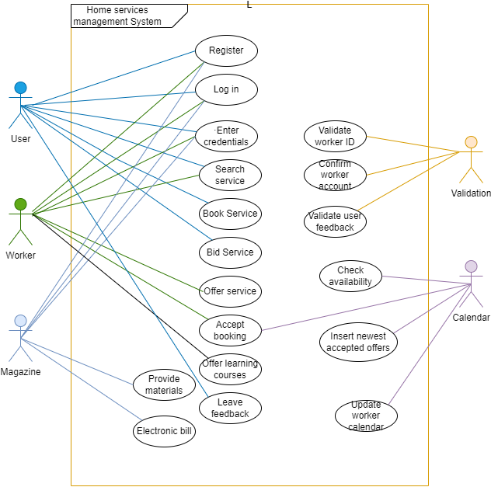

**4.1.3 Use Case extended**

|  |  |
| --- | --- |
| **UC_1.1** | **Register** |
| **Summary** | Each user of the web application can access further services by creating an account. |
| **Actors** | Normal users, Worker, Magazine |
| **Description** | Users access the homepage of the application and enter the registration page. They choose the preferred type of registration and fill out the required sections. After terminating and going through the specific procedures, the account will be created. |
| **Pre-Condition** | Users should create an account while having a stable internet connection in order to access all the functionalities provided by the app. |
| **Post-Condition** | Users will be redirected to the homepage with added functionalities. |

|  |  |
| --- | --- |
| **UC_1.2** | **Log in** |
| **Summary** | Each user can login into the app by entering the credentials specified by the user type. |
| **Actors** | Normal users, Worker, Magazine |
| **Description** | Users can access the functionalities of the application by entering the specified credentials specified while creating their account. The users can enter these credentials in the login page, while first specifying their type and then filling out the required input boxes. |
| **Pre-Condition** | Users must have first created an account. |
| **Post-Condition** | Users will be redirected to the homepage with added functionalities. |

|  |  |
| --- | --- |
| **UC_1.3** | **Enter credentials** |
| **Summary** | Each user is required to enter the specific credentials before logging in. |
| **Actors** | Normal users, Worker, Magazine |
| **Description** | Users access the login page through the homepage which is first presented when they first open the app. In order to successfully login into the app they must enter the specific credentials required according to the user type. |
| **Pre-Condition** | Users must have an account. |
| **Post-Condition** | Users will be successfully redirected to the homepage with added functionalities. |

|  |  |
| --- | --- |
| **UC_2.1** | **Search service** |
| **Summary** | Each user and worker can search a service through the search bar. |
| **Actors** | Normal users, Worker |
| **Description** | The search bar can be accessed by both workers and users which will be logged in into the system. Through a set of keywords, the workers and users can search for a desired service offered by the app. |
| **Pre-Condition** | Users and workers must be logged in. |
| **Post-Condition** | A set of services matching the keywords will be displayed in the services section of the web-app. |

|  |  |
| --- | --- |
| **UC_3.1** | **Book Service** |
| **Summary** | Each user can book a service offered from the workers. |
| **Actors** | Normal users |
| **Description** | Once a user is logged in into the web application, he can search for a desired service through the aid of the search bar. Once he found a specific service, he clicks on book and goes through all the procedures before finalizing the booking. |
| **Pre-Condition** | Users must be logged in. |
| **Post-Condition** | The booking request has now been sent to the worker offering the booking, waiting for approval. |

|  |  |
| --- | --- |
| **UC_3.2** | **Bid Service** |
| **Summary** | Each user can bid a service for the workers to accept. |
| **Actors** | Normal users |
| **Description** | Once a user is logged in into the web application, he can choose to put up an offer for a specific service required. Once he accesses the services section, he can then choose the bidding section. In this section, he clicks on the “+” button which will redirect him to a form type page, where he will be required to enter the details for the service needed and his/her personal information. After finishing he clicks the “Publish” button. |
| **Pre-Condition** | Users must be logged in. |
| **Post-Condition** | The bid has now been published into the bids section, waiting for the workers to place their bid based on the primary minimal price. |

|  |  |
| --- | --- |
| **UC_3.3** | **Leave feedback** |
| **Summary** | Each user can leave feedback for either a service or a worker. |
| **Actors** | Normal users |
| **Description** | The user is allowed to leave feedback only to services he has already booked. To do so he first accesses the services section. On the top right he can find his “interests”. He selects a service whose state is booked and he can leave a feedback on the comments section. If he wants to leave a feedback to the worker, he clicks on the worker’s name which will redirect him to the worker profile where he can follow the same procedure to leave a feedback. |
| **Pre-Condition** | Users must be logged in. |
| **Post-Condition** | The feedback is posted on the worker’s profile or the service. A notification will be sent to the worker. |

|  |  |
| --- | --- |
| **UC_4.1** | **Offer Service** |
| **Summary** | Each worker can specify the services offered by him/her into his account. |
| **Actors** | Worker |
| **Description** | The worker can access and modify the services offered into the Services Section accessed through their personal profile. To add a new service, they must click the “+” button and specify all the required details needed to add a service such as price, and extra details. Once finished he must click the “Publish” button. |
| **Pre-Condition** | Worker must be logged in. |
| **Post-Condition** | The service is now posted on both the worker profile and the general services section which is easily accessed by users. |

|  |  |
| --- | --- |
| **UC_4.2** | **Offer Learning Course** |
| **Summary** | Each worker can specify the courses offered by him/her into the worker account. |
| **Actors** | Worker |
| **Description** | The worker can access the courses offered by him/her into the worker account. In the section courses offered, all the created courses will be made available to the users. Whenever he wants to add a new course he clicks on the “+” button found in the top right of the courses section. He specifies the course name and details. After finishing he clicks “Publish”. |
| **Pre-Condition** | Worker must be logged in. |
| **Post-Condition** | The course is now posted on both the worker profile and the general courses section which is easily accessed by users. |

|  |  |
| --- | --- |
| **UC_5.1** | **Accept booking** |
| **Summary** | Each worker can accept the booking through the notifications section and the calendar is updated. |
| **Actors** | Worker, Calendar |
| **Description** | The worker can manage the bookings through the notifications section of the web- application. Once he accepts the booked service from a user, a notification is sent to the user, the state of a service changes and the calendar’s date corresponding to the booked service gets filled automatically. |
| **Pre-Condition** | Worker must be logged in. |
| **Post-Condition** | After accepting the booking, the calendar gets updated automatically. |

|  |  |
| --- | --- |
| **UC_6.1** | **Check Availability** |
| **Summary** | The Calendar can automatically check whether a specific date is available or not. |
| **Actors** | Calendar |
| **Description** | Whenever a worker decides to accept a booked service the calendar automatically checks whether the specified date from the user is available or not. If the date is not available, the calendar won’t be updated, else the calendar adds the specified service in the given date. |
| **Pre-Condition** | No pre-conditions apply. |
| **Post-Condition** | In both cases a notification is sent to the user, notifying him with the state of the booked service. |

|  |  |
| --- | --- |
| **UC_6.2** | **Insert newest accepted offers** |
| **Summary** | The Calendar can automatically update the calendar whenever the worker accepts a booking. |
| **Actors** | Calendar |
| **Description** | Whenever a worker decides to accept a booked service the calendar checks for availability. Once a slot for the service is found, the service is added into the calendar. |
| **Pre-Condition** | No pre-conditions apply. |
| **Post-Condition** | A notification is sent to the user, informing him/ her for the calendar update. |

|  |  |
| --- | --- |
| **UC_6.3** | **Update worker calendar** |
| **Summary** | The Calendar can automatically update the calendar whenever the worker completes a booked service or a user cancels a booked service. |
| **Actors** | Calendar |
| **Description** | Whenever a worker completes a service or the user decides to cancel the service, the calendar gets updates and it clears up the spots occupied by these past services. |
| **Pre-Condition** | No pre-conditions apply. |
| **Post-Condition** | A notification is sent to the user, informing him/ her for the calendar update. |

|  |  |
| --- | --- |
| **UC_7.1** | **Provide materials** |
| **Summary** | The magazine provides additional tools to workers in need. |
| **Actors** | Magazine |
| **Description** | Whenever a worker requires extra tools to complete a service, the magazine enables its tools to be rented or sold in the web application. All the tools will be listed in the magazine profile and the worker can access them through the search bar keyword discovery or by searching directly the magazine name. |
| **Pre-Condition** | The magazine must have inserted all the available tools and materials. |
| **Post-Condition** | A notification is sent whenever the worker orders some materials. |

|  |  |
| --- | --- |
| **UC_7.2** | **Electronic Bill** |
| **Summary** | The magazine provides an electronic bill for all the tools/ materials ordered through the web- application. |
| **Actors** | Magazine |
| **Description** | Whenever a worker rents or orders some extra tools and materials from a magazine using the second payment method, Credit/Debit Card, an electronic bill will be sent to the worker’s email account automatically. |
| **Pre-Condition** | No pre-conditions apply. |
| **Post-Condition** | A notification is sent to the worker, notifying the procedure ending. |

|  |  |
| --- | --- |
| **UC_8.1** | **Validate worker ID** |
| **Summary** | Whenever a new worker enters the database, the worker ID gets verified before creating the account. |
| **Actors** | Validation |
| **Description** | The validation team accesses the database of the web- application. Whenever a new worker creates an account, before finalizing the account the validation team makes sure the worker ID entered is valid and registered according to the state legislature. |
| **Pre-Condition** | The validation team must access only the newly added IDs of the database. |
| **Post-Condition** | The valid worker IDs go through the process of finalizing the worker accounts. |

|  |  |
| --- | --- |
| **UC_8.2** | **Confirm Worker Account** |
| **Summary** | Once the worker ID is validated, the account gets finalized. |
| **Actors** | Validation |
| **Description** | After the process of validating the worker ID is completed, the account of the worker takes 2 to 3 days before gaining all functionalities available to a worker. The validation team makes sure all the added services and courses inserted from the worker, are appropriate. |
| **Pre-Condition** | The validation team accesses the credentials of every verified Worker ID account. |
| **Post-Condition** | A notification describing the successful creation of the account is sent to the worker’s email address. |

|  |  |
| --- | --- |
| **UC_8.3** | **Validate user feedback** |
| **Summary** | Once a user leaves a feedback, the validation team verifies if the comment does not violate the community guidelines. |
| **Actors** | Validation |
| **Description** | Whenever a user leaves a feedback on a service or the worker offering that service, once the comment is published, the validation team accesses it through a database. If the comment does not violate the guidelines, the comment is successfully published, else the comment gets removed. |
| **Pre-Condition** | No pre-conditions apply. |
| **Post-Condition** | The comment gets published or not according to the final result. |

ERD:

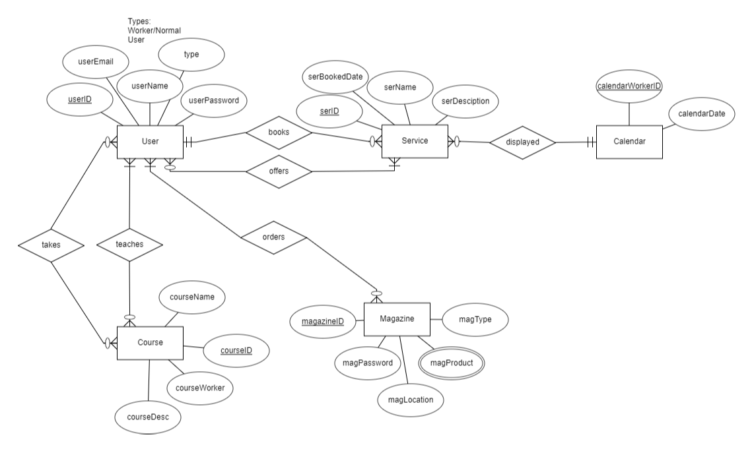

Activity diagrams:

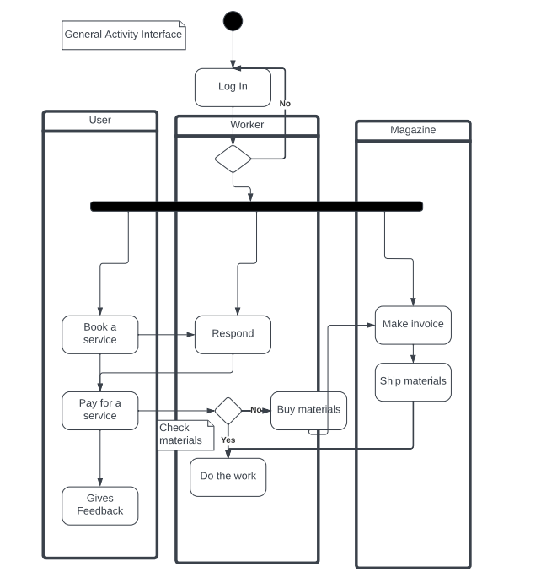

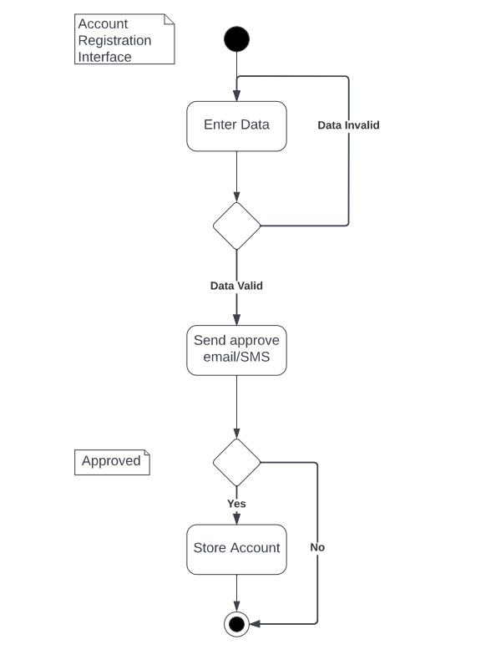

Sequence Diagrams:

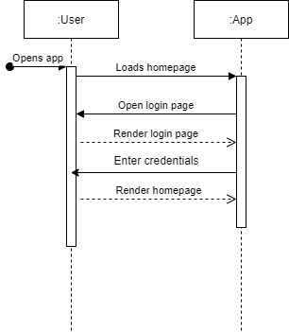

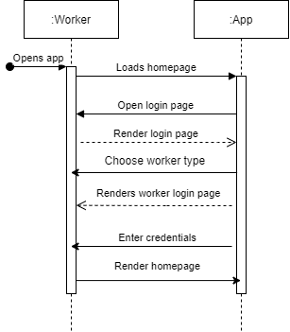

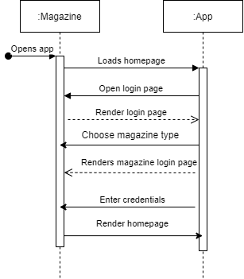

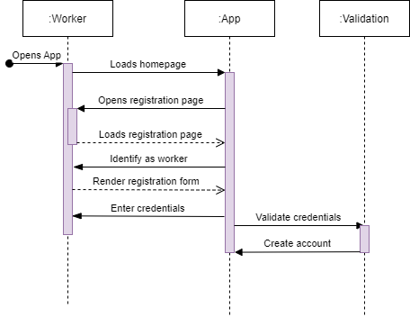

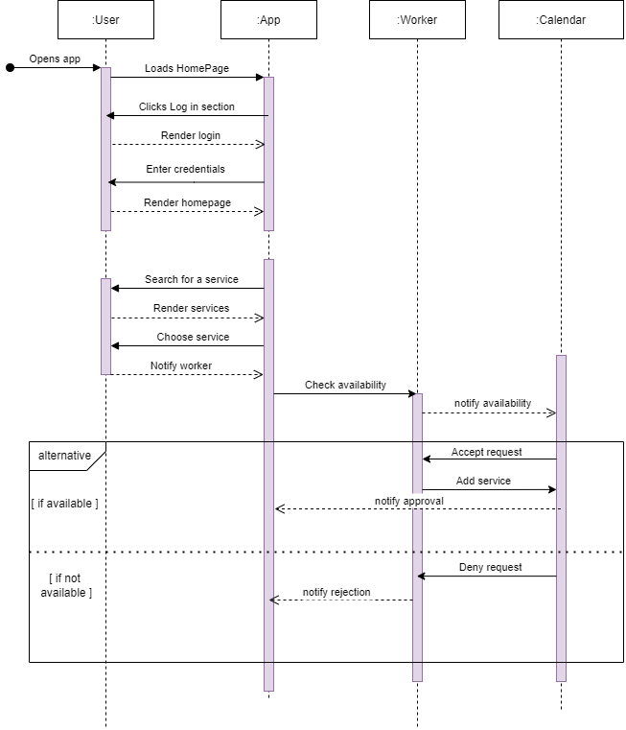

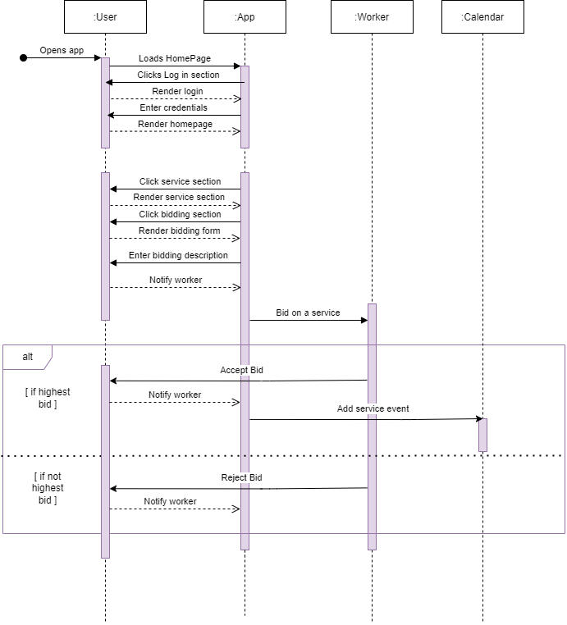

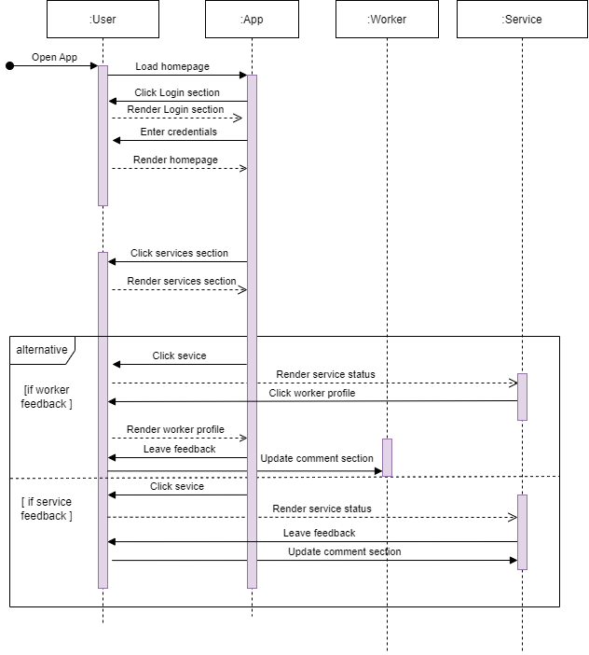

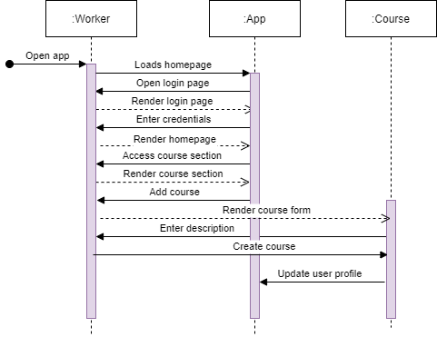

**Collaboration Diagrams:**

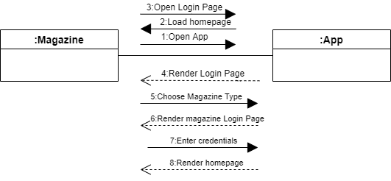

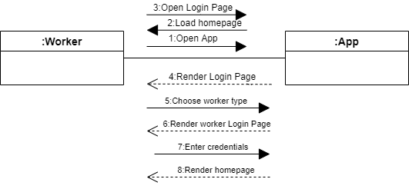

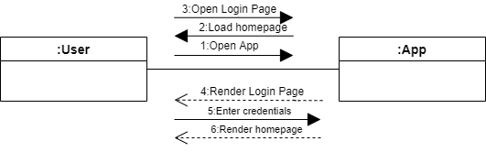

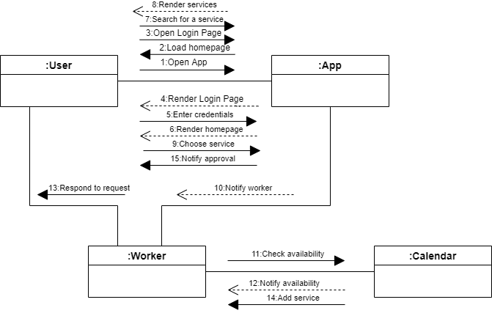

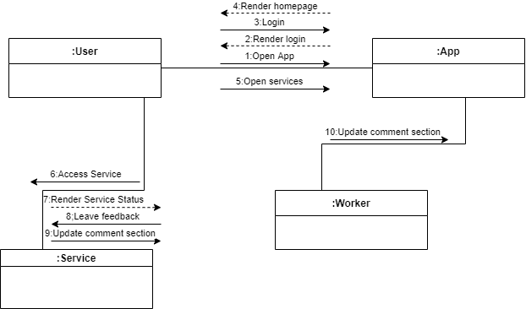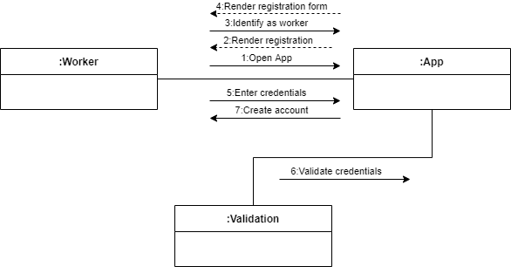

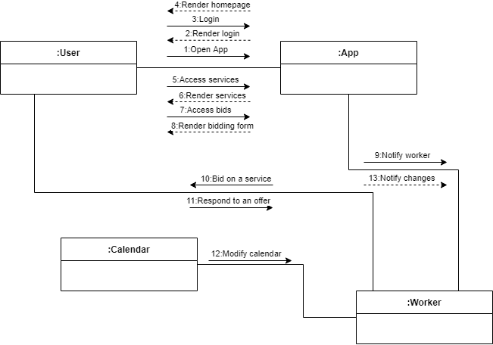

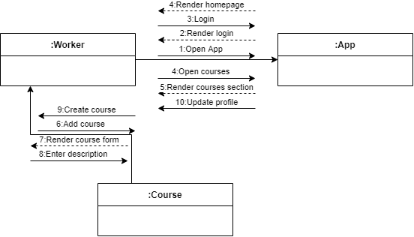

BPMN:

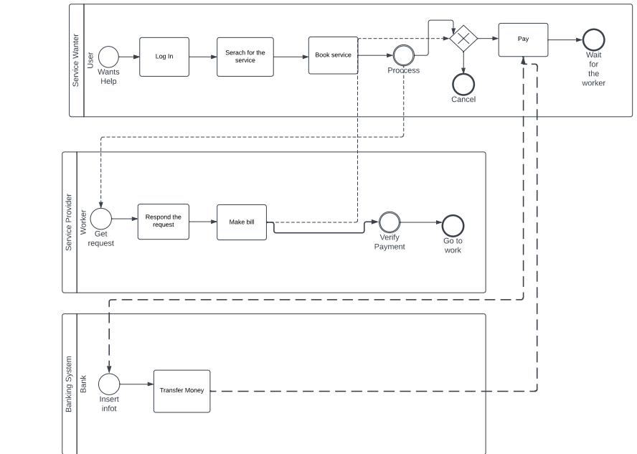

State Diagram:

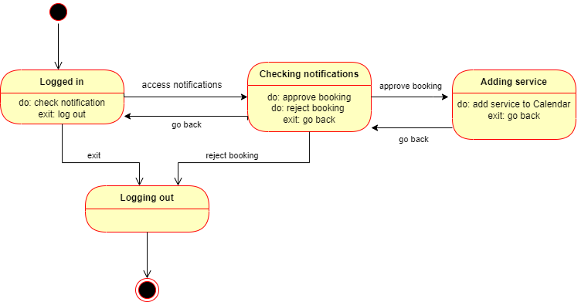

DFD:

