**System Modeling**

Vehicle Dynamics:

$$P_{V,const}\left(V,x,t\right)=P_{aero}(V,x,t)+P_{grade}(V,x)+P_{roll}(V,x)+P_{bear}(V)$$

$$P_{aero}\left(V,x,t\right)= \frac{1}{2}∙ρ\left(x,t\right)∙C_{d}∙A∙V_{eff,x}^{2}\left(V,x,t\right)∙V$$

$$P_{grade}(V,x)= m∙g∙sin⁡(α\left(x\right))∙V$$

$$P_{roll}\left(V,x\right)= m∙g∙C_{r}∙cos⁡(α\left(x\right))∙V$$

$$P_{bear}\left(V\right)= {(N}_{front}\frac{T_{front}}{r_{w}}+N_{rear}\frac{T_{rear}}{r_{w}})∙V$$

$$P_{VD}\left(V,x,t\right)= P_{V,const}\left(V,x,t\right)+m∙a(P_{mot,el},V,x,t)∙V$$

Motor Dynamics

$$P_{mot,mec}\left(P_{mot,el}\right)=\left\{\begin{aligned}e_{mot}∙P_{mot,el}-P_{0} ,if P_{mot,el}≥P_{0} \\ \frac{P_{mot,el}}{e_{mot}}-P_{0} ,if P_{mot,el}<P_{0}\end{aligned}\right.$$

$$P_{mot,el}=control variable u$$

Power Balance

$$P_{VD}\left(V,x,t\right)= P_{mot,mec}(P_{mot,el})$$

$$a(P_{mot,el},V,x,t)=\dot{V}=\ddot{x}=\frac{P_{mot,mec}(P_{mot,el})- P_{V,const}(V,x,t)}{m∙V}$$

Battery Power Balance (with Sandia PV model)

$$P_{bat}={\dot{E}}_{bat}=P_{PV}(V,x,t)-P_{mot,el}$$

$$P_{PV}\left(V,x,t\right)=A_{PV}∙G\left(x,t\right)∙η_{PV}∙η_{CF}(V,x,t)∙η_{loss}$$

$$η_{loss}=η_{wire}∙η_{MPPT}∙η_{mismatch}$$

$$η_{CF}\left(V,x,t\right)=1-λ_{PV}∙(ϑ_{PV}\left(V,x,t\right)-ϑ_{STC})$$

Sandia (complicated):

$$ϑ_{PV}\left(V,x,t\right)=G\left(x,t\right)∙\exp\left(υ+κ∙V_{eff}\right)+ϑ_{amb}\left(x,t\right)+\frac{G(x,t)}{G_{0}}∙∆ϑ$$

NOCT (simpler (no wind) but needs tests if parameters not available)

$$ϑ_{PV}\left(V,x,t\right)=ϑ_{amb}\left(x,t\right)+\frac{NOCT-20}{80}∙S$$

**System ID**

Vehicle Dynamics:

* $ρ\left(x,t\right)$ (air density) -> weather data
* Cd (drag coefficient) -> aCe
* A (frontal car surface) -> aCe
* $V_{eff,x}^{}\left(V,x,t\right)$ (effective frontal wind velocity) -> weather data
* m (mass) -> aCe
* $g$ (gravity constant) -> 9.81 m/s2
* (angle of street) -> data available
* Cr (roll friction coefficient) -> aCe
* $N_{front}$ (number of front bear rings) -> aCe
* $N_{rear}$ (number of rear bear rings) -> aCe
* $T_{front}$ (friction torque in one front bear ring) -> aCe
* $T_{rear}$ (friction torque in one rear bear ring) -> aCe

Motor Dynamics:

* emot (motor efficiency) -> aCe (motor efficiency map)
* P0 (idle losses) -> aCe (need to get current value)

PV:

* APV (PV area) (aCe) -> 4 m2 (competition)
* G(x,t) (global irradiance) -> weather data
* $η_{PV}$ (solar panel efficiency) -> aCe
* $η_{wire}$ (wire efficiency) -> aCe (looking into it 98-99%)
* $η_{MPPT}$ (MPPT efficiency) -> aCe (looking into it 98-99%)
* $η_{mismatch}$ (mismatch efficiency) -> aCe (looking into it 98-99%)
* $λ_{PV}$ (power loss coefficient) -> aCe
* $ϑ_{STC}$ (standard condition temperature) -> 25 C
* $υ$, $κ$, $∆ϑ$ (sandia model parameters) -> tricky (some values available)
* $V_{eff}$ (effective wind speed) -> weather data
* $ϑ_{amb}\left(x,t\right)$ (ambient temperature) -> weather data
* $G_{0}$ (reference global irradiance) -> 1000 W/m2
* (nominal operating cell temperature) -> aCe
* $S$ (insolation coefficient) -> aCe (might be tricky to calculate)

**Optimal Control Problem Definition**

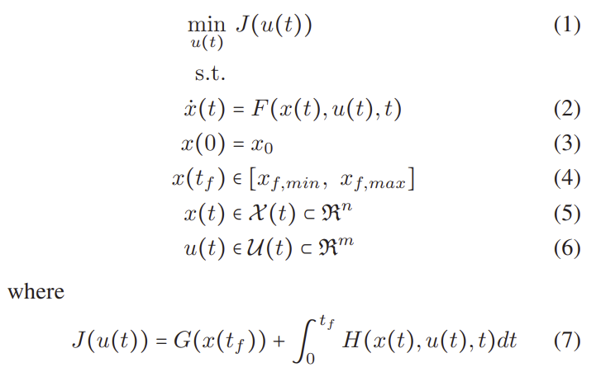

Time domain (t):

$$J=\min_{P_{mot,el}} \int_{0}^{t}{ds}$$

$${\dot{x}}_{t,d}=\left\{\begin{aligned}{\dot{E}}_{bat} \\ \dot{V} \\ \dot{x}\end{aligned}=\left\{\begin{aligned}P_{PV}(V,x,t)-P_{mot,el} \\ \frac{P_{mot,mec}(P_{mot,el})- P_{V,const}\left(V,x,t\right)}{m∙V} \\ V\end{aligned}\right.\right.$$

$$u\left(t\right)=P_{mot,el} ,-5kW<u\left(t\right)<5kW$$

Space domain (x):

$$\frac{dt}{ds}=\frac{1}{V}$$

$$J=\min_{P_{mot,el}} \int_{0}^{s}{\frac{1}{V}ds}$$

$${\dot{x}}_{sp,d}=\left\{\begin{aligned}{\dot{E}}_{bat} \\ \dot{V} \\ \dot{t}\end{aligned}=\left\{\begin{aligned}\frac{P_{PV}(V,x,t)-P_{mot,el}}{V} \\ \frac{P_{mot,mec}(P_{mot,el})- P_{V,const}\left(V,x,t\right)}{m∙V^{2}} \\ V^{-1}\end{aligned}\right.\right.$$

$$u\left(x\right)=P_{mot,el} ,-5kW<u\left(t\right)<5kW$$

Initial conditions:

$$x_{0}=0$$

$$t_{0}=0$$

$$V_{0}=60\frac{km}{h}$$

$${SoC}_{0}=100 \%=\frac{E_{bat}}{E_{bat,max}}$$

End conditions:

$$x_{f}=3020 km$$

$$t_{f}=optimal$$

$$V_{f}=60\frac{km}{h}$$

$${SoC}_{f}=10\%=\frac{E_{bat}}{E_{bat,max}}$$

Constraints:

$$V_{min}(x)≤V≤V_{street}(x)$$

$$V_{min}(x)=\left\{\begin{aligned}60\frac{km}{h} ,if V_{street}(x)≥60\frac{km}{h} \\ 30\frac{km}{h} ,if V_{street}(x)<60\frac{km}{h}\end{aligned}\right.$$

$$V_{max}\left(x\right)=V_{street}(x)$$

$$if x=\left[Stop1, Stop2, …\right]→Control stop condition$$

$$if t=17:00→Over night stop condition$$

$$if t_{driver}=2.5 h→Driver switch condition$$

$$SoC≥10\%=\frac{E_{bat}}{E_{bat,max}}$$

$$8:00≤t_{drive}≤17:00$$