Personnel Information:

Name: Tom

Department: Development

The differences between SaveDataPage and SaveFilePage, and how to use them in combination.

The differences between SaveDataPage and SaveFilePage:

Binary stream and Form field can be saved to the page specified by SaveFilePage. The modified files can be saved to the page directly.

Data in the DataRegion in Word, data in the cells in Excel and Form field can be saved to the page specified by SaveDataPage.

Only FileRequest object can be created in the page specified by SaveFilePage.

Only WordDocument object in Aceoffix.ExcelReader namespace or in Aceoffix.WordReader namespace can be created in the page specified by SaveDataPage.

When you only need to save the modified file without extracting the content in the file, you can use SaveFilePage method.

When you need to extract the content in the document or the content inputted by users, you can use SaveDataPage method.

How to use these methods to save data and file simultaneously? Taking word as the example:

Java code:

AceoffixCtrl aceCtrl = new AceoffixCtrl(request);

aceCtrl.setServerPage("../server.ace"); //set server page.

……

aceCtrl.setSaveDataPage("saveData.jsp");// Set the page specified by SaveDataPage

aceCtrl.setSaveFilePage("savefile.jsp");//Set the page specified by DaveFilePge

//If you want to save the data in the opened Word document, you have to open the document in docSubmitForm mode.

aceCtrl.openDocument("doc/test.doc",OpenModeType.docSubmitForm,"Tom"); aceCtrl.setTagId("AceoffixCtrl1");// Required

The following code shows how to get data from SaveData.jsp page:

WordDocument doc = new WordDocument(request, response);

// Get the submitted data

String Name = doc.openDataRegion("Name").getValue();

String Number = doc.openDataRegion("Number").getValue();

……

The following code shows how to get data from SaveFile.jsp page:

FileRequest freq = new FileRequest(request, response);

freq.saveToFile(request.getSession().getServletContext().getRealPath("saveDataAndFile/doc/") + "/" + freq.getFileName());

freq.close();

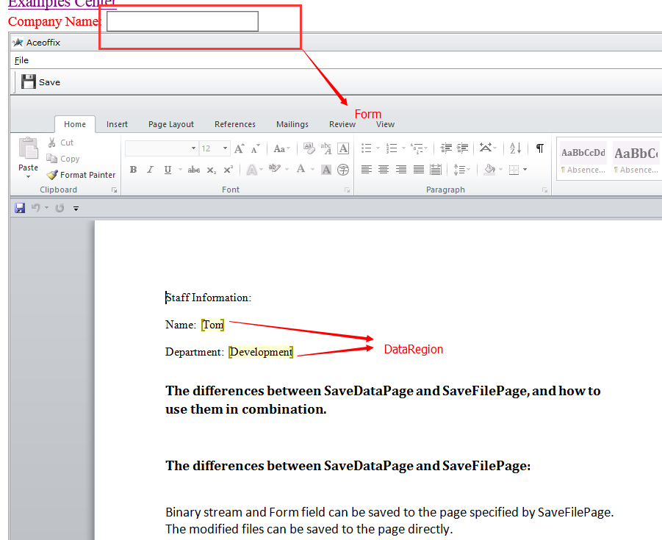

Figure 1 Page of the opened document

Note: Please refer to the full code example of the following demo in AceoffixDemo to learn how to save the Word document and its data in the specified region simultaneously.

1.28 Simultaneously save the Word document and its data in the specified region (take Word as the example). Please refer to the Aceoffix_help if any code puzzles you.

By far, we may have following questions about how Aceoffix save file and data:

1. If saving data is failed, will Aceoffix save file?

2. Does Aceoffix save data first, or file first?

3. Can we use transaction control to solve this issue?

Aceoffix will save the data first, and then the file. We cannot use transaction control to solve this issue, because they are two different servlets that process the pages of saving data and saving file. In other words, they are two different actions. However, we can simulate a “transaction” by setting a field in database to identify the state. For example, we use flag to indicate the state, and its initial value is false. When saving data is successful, the flag is true; when that’s failed, the flag is false. Then we can judge the state of data saving from the value of flag in the SaveFile.jsp page. Based on the result, we can determine whether the file will be saved.