H.O.M.E. Co-Op

Administrative Guide

Revision History

Version # | Description of Changes | Issue Date | Author
1.0 | Original release | 10/6/2013 | Chris Ryan
1.1 | Completed the School Admin section | 11/2/2013 | Chris Ryan
1.2 | Updated with Email documentation | 6/13/2014 | Chris Ryan

TABLE OF CONTENTS

1 OVERVIEW 4
2 frequent admin activities 4
2.1 Activating a new family 4
3 Infrequent Admin Activities 5
3.1 Preparing a new semester 5
3.2 Graduating Grades 6
3.3 Sending bulk email 6
4 Email Architecture 6
4.1 MailGun Mailing Lists Overview 7
4.2 Sending Bulk Email 7
5 Admin section (School) 7
5.1 Course: Course Catalog 8
5.2 Course: Locations 8
5.3 Course: Types 9
5.4 Email: Lists 9
5.5 Events 10
5.6 Events: Enrollment 10
5.7 Events: Fee Per 10
5.8 Family Member Records 10
5.9 Family Records 11
5.10 Family Role/Benefits 11
5.11 Family Member Roles 11
5.12 Family: Workflow 12
5.13 People: Assistant 12
5.14 People: Grade List 12
5.15 People: Student Types 13
5.16 People: Students 14
5.17 People: Teachers 14
5.18 Schedule: Assistant Enrollment 14
5.19 Schedule: Master Schedule 14
5.20 Schedule: Student Enrollment 15
5.21 Semester: Class Dates 15
5.22 Semester: Grades 16
5.23 Semester: Period List 17
5.24 Semester: Semester List 17

OVERVIEW
This document…..

frequent admin activities

Activating a new family
A new family record will automatically be inactive and the user will be unable to log into the site. Manual intervention is required to activate the family and family member. This is a very simple process.

- Log into the Admin section of the website.
- Click on “Family Record”
- Click on the family name
- Click on the “Activate” and also select the proper Role/Benefit
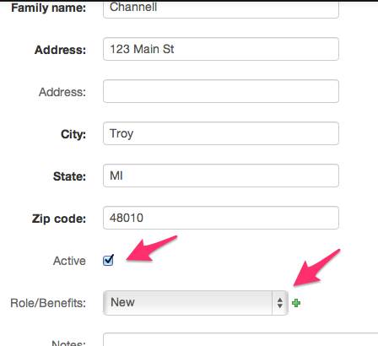
- Save your changes
- From the Admin section of the website, click on “Family Member Records”
- Select the proper Family Member Role, Gender, and click on the Active.
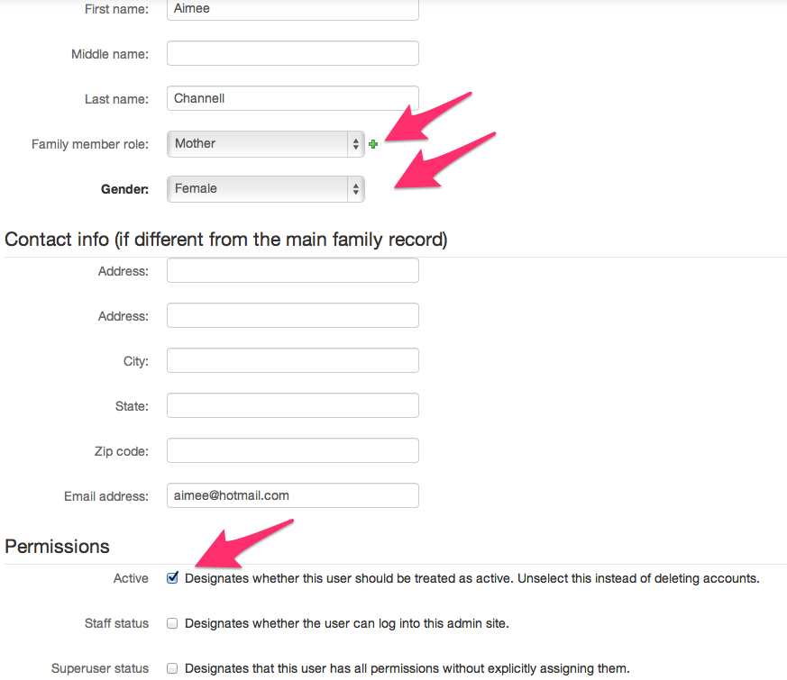
- Save your changes.
- The new family (specifically, this family member) will have access to the site. She can log in and add her children.

Infrequent Admin Activities

Preparing a new semester
Preparing for a new semester is a simple process. The following items need to be completed and it is best to do so in the order presented. Each of these items is fully explained in this document so this section just presents a concise checklist. Some of these items are system wide and so they don’t need to be completed for each semester. Since this is a complete list, you can use it for the very first semester you set up.

In this document is an “Admin Section” that describes all of the tables in the database and provides examples for each one. The names in the list below match these table names and can be found in the “Admin” section of the website.

Perform these steps in the order listed.

  - Add Semester (Semester: Semester List)
  - Add Period and assign to Semester (Semester: Period List)
  - (Optional) Add Semester Grade (Semester: Grades)
  - (Optional) Add Course Type (Course: Types)
  - (Optional) Add Course Locations (Course: Locations)
  - (Optional) Add grades (People: Grade List)
  - (Optional) Graduate Grades (usually done before the Fall semester only)
  - Add semester class dates (Semester: Class Dates)
  - (Optional) Add family membership (Family Role/Benefits)
  - (Optional) Add Family Member Roles (Family member roles)
  - (Optional) Assign teachers (People: Teachers)
  - (Optional) Assign students (People: Students)
  - (Optional) Assign assistants (People: Assistant)
  - (Optional) Add CourseCatalog records
  - (Optional) Add Family Member Records
  - Create the actual schedule by assigning courses.

Graduating Grades
Once a year, you will want to graduate grades. This will move students up to the next grade. Of course, as mentioned in the previous section there may be “grades” that are promoted unto themselves (preschool, for example).

This process is very easy to do.

Log into the Admin site
Click on Increment Grades
Review the list.
- You MUST not have any blank grades in the Current column. If you do, go into the Student record, and set that student’s grade.
- You MUST not have any blank grades in the Next column. If you do, go into the Grades record and select the proper Next Grade.
When you are ready to actually execute this process and graduate these students, type the word “INCREMENT” (in all capital letters) and then click the “Increment Grades” button.

That’s it.

Sending bulk email
Create an email to email@mg.flchomegroup.com
The first word of the subject MUST be the email list that you want to send to:
kneemail This is the subject for prayer requests

NOTE: I did not add colons or anything to that first word. The email list is "kneemail", not "kneemail:" or " kneemail" or "kneemail@mgflchomegroup.com"

Then, create and send the email. You can add multiple attachments to it if you want.

What will happen is that the first word of the subject line will be used tell FRED what emil list to send it to. Before it sends it, it will remove the first word.

Example: The following subject:
‘

Will be sent to kneemail@mg.flchomegroup.com with the subject "This is the subject for prayer requests"

The FROM address will be your email address that you sent the email from (kimberly.ryan@gmail.com). Nowhere will the email list (kneemail@mg.flchomegroup.com) or email@mg.flchomegroup.com show up.

Email Architecture
Transactional (i.e. password reset) and bulk email (notification to every family member) is handled by MailGun (www.mailgun.org). This service provides a rich feature set and is easily integrated into the FRED application.

An account is configured on MailGun for the FRED application. A number of mailing lists are set up as well as routes (explained below). The mailing lists are created through the FRED Administration section of the website and the lists are populated by a script that runs nightly on the web server. These processes are detailed below.

Discussion of creating a mailing list is explained in the “Admin Section” of this document. The following discussion concerns the technical aspects of the integration between FRED and MailGun.

MailGun Mailing Lists Overview

When a FRED admin creates a mailing list in the Administration section of the website, a record is placed in the FRED database and that mailing list becomes available to users for subscription. However, there is no immediate interaction with MailGun. This means that the mailing list, and any subscribers, do not yet exist on the MailGun servers.

Once per night a script (manage_maillist.sh) runs on the web server. This script communicates with MailGun and creates any necessary mailing lists. It then reconciles all of the email addresses for all of the email lists between FRED and MailGun. It is during this time that subscribers are added and removed from the relevant email lists. When the script finishes, the subscription list for each email list matches between FRED and MailGun. Only after this point can you email the subscribers of the list.

Sending Bulk Email

Sending to an email list is simple for the user but not straight forward in the application. Care has to be taken to ensure only authorized personnel are able to send email to the list. Because of the limitations of MailGun, realization of this goal was more complicated than necessary.

An administrator creates an email addressed to email@mg.flchomegroup.com
The first word in the subject of the email must be the name of the email list (i.e. studentcouncil). The rest of the text in the subject line is irrelevant for this process.

Once the email is sent, MailGun accepts the message addressed to email@mg.flchomegroup.com.

There is a route set up that looks for an email addressed to email@mg.flchomegroup.com. When an email is received that matches this route, the message is sent via HTTP POST to FRED.

In FRED, send_email is the function that receives this POST. It removes the first word of the subject and appends that to the @mg.flchomegroup.com text. It then verifies that the resulting email address is a valid email list. If it is not, it creates and sends a failure email to the sender. If the email list does exist, the email header is reformatted: the sender email address remains but the recipient (“to”) address is changed to the target email list (studentcouncil@mg.flchomegroup.com).

As an illustration:

me@home.com -> email@mg.flchomegroup.com (subject: studentcouncil This is my subject) -> mailgun HTTP POST to FRED -> FRED replaces “to” with studentcouncil@mg.flchomegroup.com -> MailGun -> MailGun sends email to group

Admin section (School)
The administrative portion of the website contains all of the tools necessary to manage the application. In this area you can set up a semester, modify courses, add families, and complete many other activities. Each link in the “School” section of this main page is explained in this section of the documentation.

Course: Course Catalog
This section contains a complete library of courses that could be scheduled for one or more semesters. This library is populated by users as they add courses that they might teach. Since the list is available to every logged in user, it can be used to provide ideas for future classes.

The following fields are available in this section:

Course Name: This is a short name for the course. Examples might include Writing 101, Fun with Math, etc.

Course Description: A full description of the course should be entered in this field. You can create paragraphs, and format the text as necessary. Future enhancements might provide for more robust editing features (bold, bullets, etc)

Course Owner: (optional): If a course owner (teacher) is assigned to this course then that person will have the ability to modify and even delete the course.

Min Class Size: What is the minimum number of students necessary for this course to be run?

Max Class Size: What is the maximum number of students that this course can manage?

Resources Needed: (optional): List any resources that are necessary to successfully run this course. Examples might include a white board, overhead projector, etc.

Student Resources Required: (optional): List any items that a student must bring to this course. This information will be displayed on the website to the user when he/she is enrolling.

Number of Assistants Required: How many assistants do you need in this course?

Notes: (optional) Personal notes that are not shown on the website.

Setup minutes required before: How many minutes do you need before each class to prepare?

Teardown minutes required after class: How many minutes do you need after each class to clean up?

Private Notes: (optional): This is yet another section for entering notes. Text here will never be shown on the website.

Course Type: Typical use includes selecting if this is a Co-Op or Professional course.

Course Fee: What is the charge for this course?

Material Fee: What is the charge for materials?
Grades: You can select one or more grades that this course is targeted towards. A parent can enroll a child in the course regardless of what grade that child is in. However, the selections you make in this field will provide the ideal grade that the child should be in before enrolling in this course.

Course: Locations
Quite simply, this table stores the rooms or locations that are available as classrooms.

Name: Enter the name of the room or area that can be assigned to a schedule. Example: “Room 1”

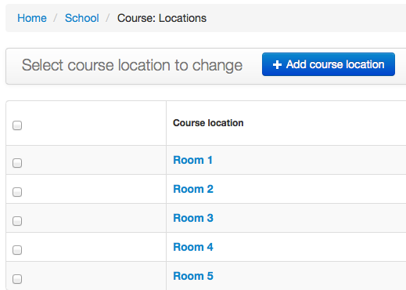

Course: Types
Sometimes you need to group types of courses. Typically, the records that are entered here are: “Co-Op” and “Professional”.

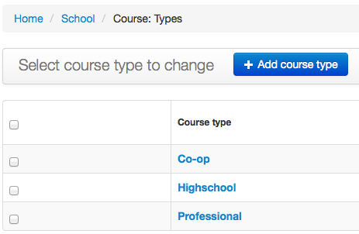

Email: Lists
This table manages the email lists that are available for users to subscribe to. Once a day, a script runs on the web server and reconciles these lists to MailGun (the email service). Note, you’ll not see an “all” email list in this table. That’s because we set that up separately and ensure that all active families are included in the list. There is no “opt-out” for that list.

Email: This is the email that will be used by FRED when it sends out the email. You don’t need to know this email address because you will be sending email to email@mg.flchomegroup.com.

Display Name: This is the name that will show up on the front end of the site for the users.

Description: This will show up as the description of the list. Keep it very short (just a few words)

Active: If this flag is not set, the email list will not show up on the list for the users.

Events
TBD

Events: Enrollment
TBD

Events: Fee Per
TBD

Family Member Records
This is one of the key tables in the application. Each family member contains a record in this table that houses their specific information.

Although many of these fields are self explanatory, some others require more detailed information.

Username: Currently, a child will have a username assigned but no password. This restricts that child from logging into the application. You can set a password here for access but be careful when doing so. Currently the application is configured so that any member of the family can change any family record. Future enhancements will restrict this functionality.

Family: This is a lookup from the “Family Record” table. The Family table stores general information about the family and this field ties the family member to that record.

Family Member Role: The application makes decisions based on the value that is set in this field. For example, a “Child” role might not have the ability to make changes to any other family member’s schedule. See the section in this document that discusses this table in more detail.

Contact Information (if different from the main family record): Most of the time these fields will be left blank. However, in the event that this child lives at an address that is different from the address in the “Family Record” record, it can be recorded here.

Active: If this flag is not set, the user is unable to log into the application.

Staff Status: This should ONLY be used for those administrators that have access to the “Admin” section of the application. Most users should have this flag UNSET.

Superuser Status: This should ONLY be used for the most trusted, and knowledgeable administrators of the site. This flag allows the user unrestricted access to all of the functions of the application. This type of access can allow for the destruction of data, etc.

Groups: This is not used and can be ignored.

User Permissions: This is not used and can be ignored.

Family Records
This is one of the key tables in the application. Each family contains a single row in this table that provides information about the family.

Family Name: This is a unique name that identifies a family. Typically the value will be the family’s last name (Smith) but if that record exists, then a family member’s first name is appended to it (Smith.Kim). Any text can be used but it must be unique in the table.

Active: This flag must be set to mark the family active. Note: This flag is independent of the Active flag in the Family Member Records table. If this flag is blank but the Active flag for a family member is checked, then that user can still log into the application. Currently, this flag is just used for communications (sending an email to just active families).

Role/Benefits: Each value can be defined with an enrollment date. This is the date that is designated as the first day a family in this group is eligible to enroll their children in a course.

Family Role/Benefits
Some co-op organizations set different enrollment dates based on the role that a family member plays in the group. For example, maybe the administrators can enroll earlier than the teachers or new families.

Family Role: The name of the role. Examples include “Leadership”, “Teachers”, “Returning”, and “New”

Enrollment date: The date that the group can begin enrolling in a course. This will change for each semester. It can also be left blank. If it is blank, enrollment is open immediately.

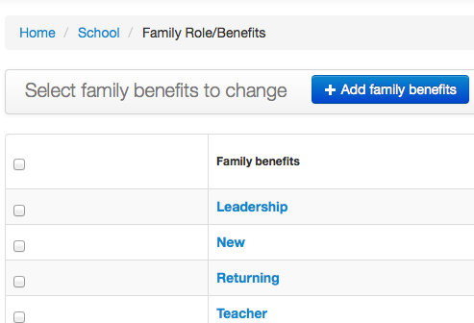

Family Member Roles
This defines the roles of a family member. For example, “Father”, “Mother”, and “Child”. NOTE: Currently, “Child” MUST BE DEFINED AS THE FIRST RECORD IN THE DATABASE. I know that is a stupid rule but it is required until a future enhancement can be completed.

When a family adds a new member, it automatically assigns the role of “Child” to that member. The administrator can go into the site and modify the role to any other role.

Role: The name of the role. Examples include “Father”, “Mother”, and “Child”

Considered a parent role: Checking this flag will allow members that are assigned this role have full authority over all family members.

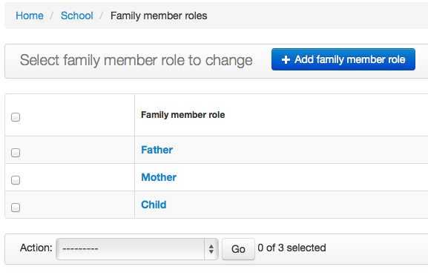

Family: Workflow
TBD

People: Assistant
A family member can be designated as any one of several positions. This is the table that is used to assign a family member to the position of “assistant”. As an assistant, the family member can be assigned to classes (as an assistant). This is accomplished by “enrolling” the assistant in the course; the same process as used to enroll a student in a course. Remember, the assistant can only enroll in the course as an assistant if there are open slots for that position. The number of assistants requested are set in the course catalog.

People: Grade List
This table stores the different grade levels that are assigned to each student. Since the admin can graduate every student from one grade to the next, the system needs to know what that next grade level is. For example, you might set “1” as a grade and “2” as the next grade.

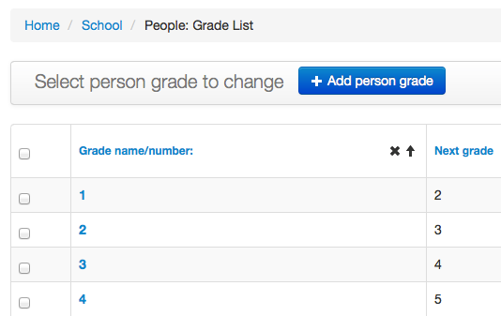

The system is designed to automatically graduate students from one grade to the next. However, there are times when this is not desirable. For example, children from birth through age 4 might be grouped together in the Nursery. To do this simply set the “Next grade” equal to the selected grade and save the record. It sounds complicated but a screenshot is shown below.

Remember, for the Nursery “grade”, a student will have to manually be “graduated” to Preschool (or some other grade) when they reach a certain age. There is nothing that automatically does this for you.

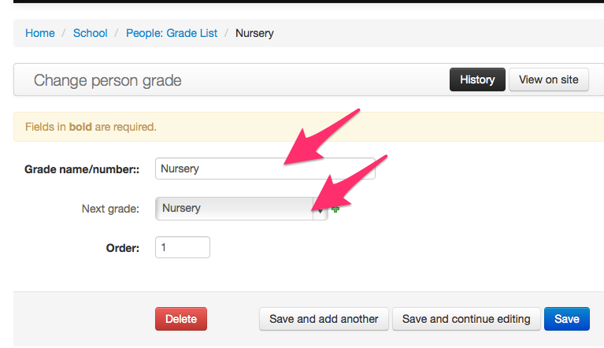

People: Student Types
Each student must be assigned a student type. This is only used for any type of reporting that you might do and a student has the same privileges regardless of what student type they are assigned to. Examples of student types include: “Co-op” and “Drop Off”.

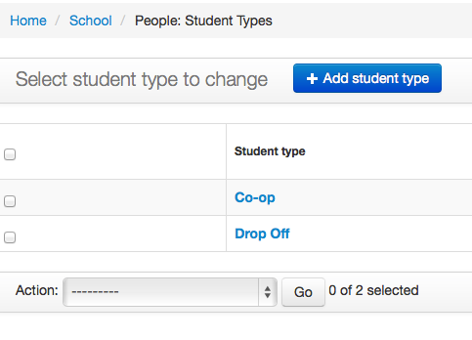

People: Students
A family member can be assigned as a student in the application. Typically, this is done when a parent logs into the site and clicks on “Add a Child.” The child that is added is automatically added to this table (as well as to the family member table). However, the application admin can also manually add a family member from any family to this table.

A family member MUST be a student to be enrolled in any course.

People: Teachers
A family member can be designated as any one of several positions. This is the table that is used to assign a family member to the position of “teacher”. As a teacher, the family member can add and modify course catalog records and can be assigned to teach a course.

Schedule: Assistant Enrollment
Once a family member (as an assistant) enrolls in a course, the application will add a record to this table.

IMPORTANT: You should NEVER enroll an assistant using this table. You should ALWAYS do it from the front end of the website (as that family member). Why? When an assistant enrolls in a course, the system automatically searches for, and removes them from any other course that they might already be enrolled in for that semester and period. If you do it from this admin page, it doesn’t seem to work right. So, it’s best to use this to remove an assistant from a course but not to add one.

Schedule: Master Schedule
This table stores a record for every course that is scheduled in a given semester. The fields are all selection fields (drop down or multiple-select) and are all from other tables throughout the application.

Teacher Field – Remember that each course in the Course Catalog has a teacher assigned to it. That family member has ownership of the course and can modify it as necessary. In the Master Schedule, you can assign one or more teachers to this course. Note, however, that these teachers are not the owners of the course so they cannot modify it in the course catalog. Typically, however, a single person will be the owner of the course as well as the teacher. But, it doesn’t have to be like that.

Why would it not be?

We’ll, let’s say Susie added a course in the Course Catalog called “Singing and Dancing.” That semester she taught the class so she was assigned to the “Teacher Field” in this table. Since she is the course owner in the Course Catalog, she can modify as necessary. She is also the teacher for this course this semester so she is assigned as such in this table.

Now, a few semesters later, Jackie decides to teach a course. She likes the “Singing and Dancing” course that Susie created and decides that she would like to offer it. Susie is not offering it this semester but probably will again in the future. So, the admin assigns Jackie as the teacher for this course in this table. In this situation, Susie is still the owner of the course in the Course Catalog so she can modify the course as necessary, but Jackie is the teacher of that course for this semester. She will teach it but she cannot modify the course in the Course Catalog.

Grades – The logic is similar to that of the Teacher Field described above. However, we are talking about grade levels instead of teachers. Let’s expand on the example above with Susie and Jackie. Susie normally teaches this class for 1st and 2nd graders. However, for this semester she is not teaching the course but Jackie is. However, Jackie wants to teach 3rd and 4th grade children. In this case, the admin will assign these grades to the schedule. But, if you look at the course in the Course Catalog, it will still show 1st and 2nd grade. Why? Because only Susie can change that. The admin assigned this class to a different set of grade levels. Very flexible.

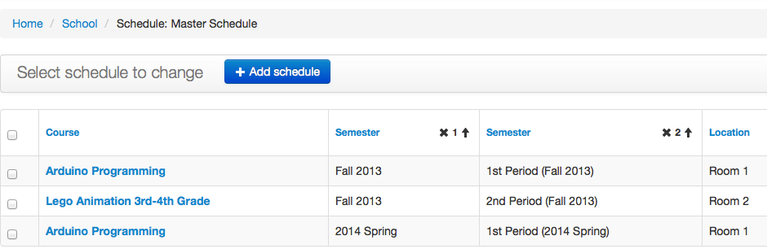

Schedule: Student Enrollment
Once a family member (as a student) enrolls in a course, the application will add a record to this table.

IMPORTANT: You should NEVER enroll a student using this table. You should ALWAYS do it from the front end of the website (as that family member). Why? When a student enrolls in a course, the system automatically searches for, and removes them from any other course that they might already be enrolled in for that semester and period. If you do it from this admin page, it doesn’t seem to work right. So, it’s best to use this to remove a student from a course but not to add one.

Semester: Class Dates
Use this table to record all of the class dates for each semester. Currently, this table is used when creating attendance sheets and other reports.

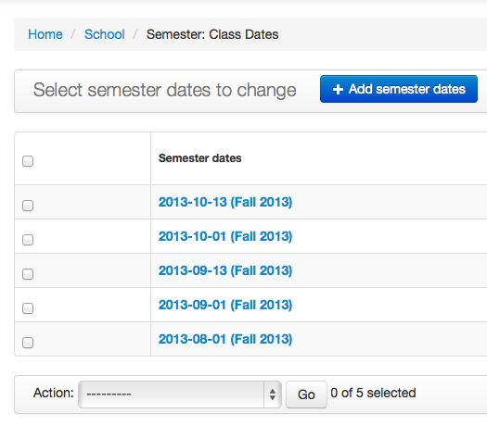

Semester: Grades
This table stores the different grade levels that are assigned to each course. In general, these are usually groups of grades (1st – 2nd Grade, 3rd-4th Grade, etc) and are assigned to each course in the course catalog. There is a “Next Grade” column but it may be removed in the future because it doesn’t make sense to have the column in this table. I don’t see a reason to “graduate” a set of courses from one grade group to the next.

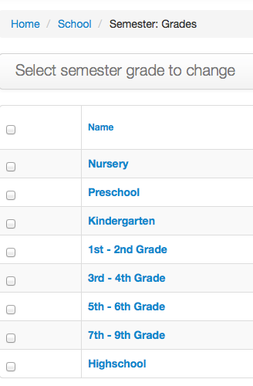

Semester: Period List
Each semester contains one or more periods. The period number is used to sort the list of periods. That way, you can have periods called “First Period” and “Second Period” and they will be sorted properly.

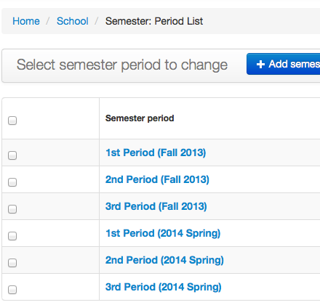

Semester: Semester List
Every schedule is tied to a semester list. In fact, semesters are really core to the entire application.

