You’ve worked hard!
Sign-up today to be a part of this year’s

Youth Arts Fair

A unique place to showcase your art and talent all under one roof!

Original works or works done in class are welcome!


Entries may include:

Art – painted, hand-drawn, photography, clay/sculpting, other

Music – solo or group acts, bands, instrumental or vocal
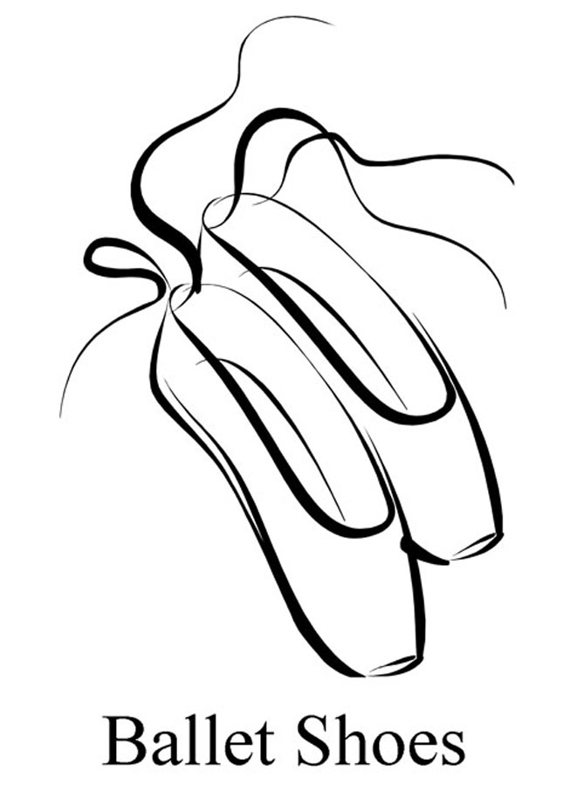

Drama – short sketch, dramatic
reading, monologue

Dance – lyrical, liturgical, ballet, other

Friday, April 28, 2017
6:30 – 9:00 pm

Youth Arts Fair sponsored by
CROSSROADS CHURCH
34500 Six Mile Road, Livonia, Michigan 48152
(located in the Worship Center in the lower level of Trinity Church)

Youth Arts Fair entries open to anyone ages 5-19
Registrations accepted through Monday, April 24
Registration Cost: Free
Visit www.CrossroadsNow.org to learn more

Everyone is welcome to join us for this great event!
Bake Sale refreshments will be available.
Donations and Bake Sale proceeds will go toward
Crossroads’ “Hope for the City 2017” youth mission trip.

Crossroads Church • info@CrossroadsNow.org • 734.338.5149

Here’s what people are saying about the
Youth Arts Fair

“Thanks so much for hosting the Youth Arts Fair!”
– Arts Fair Vocal Participant

“This is such a great event, what a blessing it was for us.”
– Arts Fair Dance Participant

“The Arts Fair was so much fun. I enjoyed playing and singing.
Looking forward to participating again.”
– Arts Fair, Instrumental & Vocal Participant

“Thanks for the wonderful evening. What a blessing.”
– Parents of Arts Fair Dance Participant

“I really enjoyed the Arts Fair and the
opportunity it gave me to play in front of people.”
– Arts Fair Instrumental Participant

“This was a wonderful opportunity last year and is being offered again.
Please consider participating again this year.”
– Metro-Detroit Area Music Instructor

“Had a great time! When can I sign up again?”
– Arts Fair Instrumental Participant

“Thank you so much for the honor to be a part of the Youth Art Fair. It
was amazing to see so much talent!!! All from the next generation
of worshippers. Wow! Seriously wow! What a great idea to create an
outlet for the youth to display their talents for the Lord. My dancers
and parents . . . LOVED it! Thanks again for the opportunity. . . .
God bless you and your church. Please let us know in the future if
you have another event like this...
we would love to come enjoy it and/be a part of it if possible.”
– Metro-Detroit Area Dance Instructor

