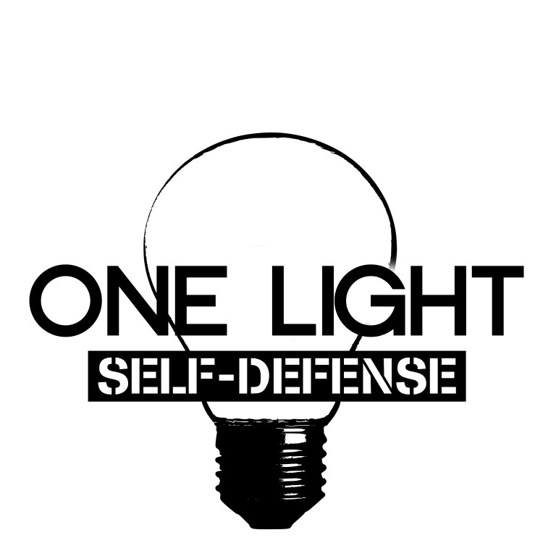

**One Light**

Self-Defense Waiver

Attire: Comfortable clothes & gym shoes

(Please refrain from wearing jewelry.)

Name: _____________________________________________________ Age: ______________

Phone: __________________________________________________________________________

Email: ___________________________________________________________________________

I understand, acknowledge, and hold Parkview Christian Church and its self-defense volunteers harmless from any liability arising out of my participation in this activity. I accept the risk involved in this event and know that I may suffer or experience personal injury or bodily damage; I fully assume responsibility for such risk.

Signature: _________________________________________ Date: ____________________

Parent Signature ___________________________________ Date: ____________________

(if under 18)