ID: 16521261

Name: Phan Minh Toàn

Assignment: Week 4

Course: SE313.K21.PMCL

Want

Properties: Yes, No

Yes: 6

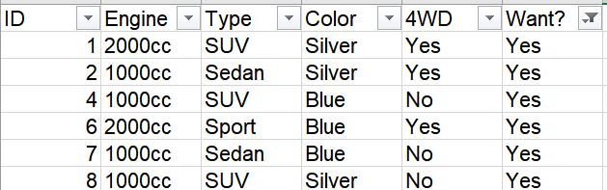

No: 2

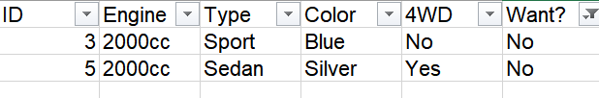

H(S) = - 6/8 * log(6/8) – 2/8 * log(2/8) = 0.56

4WD

Properties: Yes, No

Yes: 4

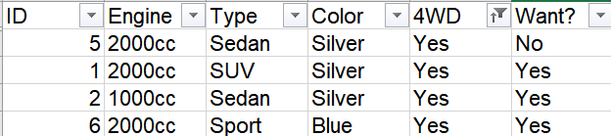

H(S_Yes) = -1/4 * log(1/4) – ¾ * log(3/4) = 0.56

No: 4

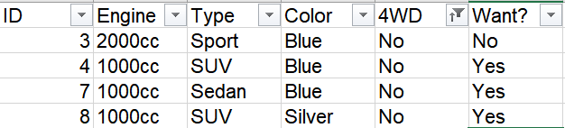

H(S_No) = -1/4 * log(1/4) – ¾ * log(3/4) = 0.56

H(4WD, S) = 4/8 *H(S_Yes) + 4/8 *H(S_No) = 0.56

Gain(S, 4WD) = H(S) – H(4WD, S) = 0

Color

Properties: Blue, Silver

Blue: 4

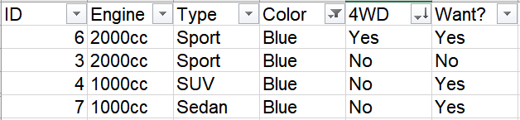

H(S_Blue) = -1/4 * log(1/4) – ¾ * log(3/4) = 0.56

Silver: 4

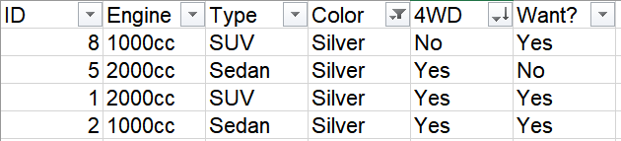

H(S_Silver) = -1/4 * log(1/4) – ¾ * log(3/4) = 0.56

H(Color, S) = 4/8 *H(S_Yes) + 4/8 *H(S_No) = 0.56

Gain(S, Color) = H(S) – H(Color, S) = 0

Type

Properties: Sedan, Sport, SUV

Sedan: 3

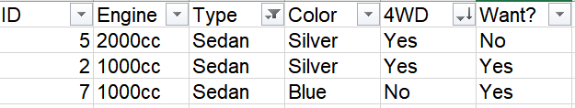

H(S_Sedan) = -1/3 * log(1/3) – 2/3 * log(2/3) = 0.64

Sport: 2

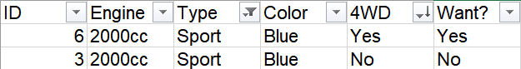

H(S_Sport) = -1/2 * log(1/2) – 1/2 * log(1/2) = 0.69

SUV: 3

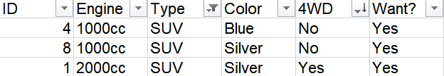

H(S_SUV) = -3/3 * log(3/3) – 0/3 * log(0/3) = 0

H(Type, S) = 3/8 *H(S_Seden) + 2/8 *H(S_Sport) + 3/8 * H(S_SUV) = 0.41

Gain(S, Type) = H(S) – H(Type, S) = 0.15

Engine

Properties:1000cc, 2000cc

1000cc: 4

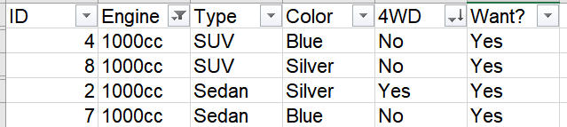

H(S_1000cc) = -4/4 * log(4/4) – 0/4 * log(0/4) = 0

2000cc: 4

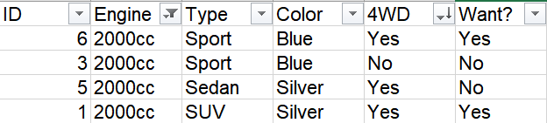

H(S_2000cc) = -1/2 * log(1/2) – 1/2 * log(1/2) = 0.69

H(Engine, S) = 4/8 *H(S_1000cc) + 4/8 *H(S_2000cc) = 0.34

Gain(S,Engine) = H(S) – H(Engine, S) = 0.22

Decision Tree:

