

PORTUGUESE CONTINGENT
EUTM RCA
SIGCP
Integrated Portuguese Contingent Management System

USER AND ADMINISTRATION MANUAL
Functional, operational and technical guide
Edition 1.1 | August 2026 | Internal use

Document control
Field | Information
Title | SIGCP User and Administration Manual
Version | 1.0
Date | August 2026
Classification | Internal use
Application | SIGCP.exe — local application with browser interface
Document owner | SCH TM FILIPE FONSECA
Approved by | COR CAV CARLOS MACHADO

Revision history
Version | Date | Change | Author
1.0 | 27-08-2026 | Full reissue aligned with application v2.6.0 | SCH TM FILIPE FONSECA

Contents
Document control 2
Revision history 2
Contents 3
1. Overview 5
1.1 Operating principles 5
2. Installation, startup and shutdown 5
2.1 Requirements 5
2.2 Installation 6
2.3 Daily use 6
2.4 Proper shutdown 6
3. Profiles, access and responsibilities 7
4. Navigation and common rules 8
5. Monthly calendar 9
5.1 Record or change a meal 9
5.2 Export and printing 9
5.3 Team Management 9
5.4 Dishwashing Duty Roster 10
6. Individual Welfare 11
6.1 Documents and exports 11
6.2 Cash Management 12
7. My Leave 13
7.1 New request 13
7.2 Changes and cancellation 13
8. Leave Management 14
8.1 List and filters 14
8.2 Current personnel and history 14
8.3 Decisions and deletion 14
8.4 Calendar and monthly printing 14
9. Temporary SNR replacement 16
10. Personnel 17
10.1 Create or edit person 17
10.2 Access and roles 17
11. Administration 18
11.1 Settings and rules 18
11.2 Public holidays and Day Off 18
11.3 Export JSON 18
12. Audit 19
12.1 Efficient search 19
13. Automatic backups 20
13.1 Location and retention 20
13.2 What to do when a warning appears 20
14. Restore and recovery 21
15. Security and data protection 21
16. Troubleshooting 22
17. Recommended routines 22
18. Handover checklist 23
19. Help and User Manual 23

1. Overview
SIGCP centralises monthly planning, support teams, the dishwashing duty roster, individual Welfares, Cash Management, leave management, personnel, operational documents and database administration. The application runs on the computer and provides its interface through the browser at a local address protected by authentication.

1.1 Operating principles
- A single SQLite database contains the operational information.
- Access to pages and actions depends on Access Types and the SNR/Welfare Manager roles.
- Relevant changes are recorded in the Audit log.
- Login triggers an automatic backup; a backup failure is reported without preventing access.
- Personnel are listed with those currently on mission first; within each group, they are sorted by rank and then by seniority date.
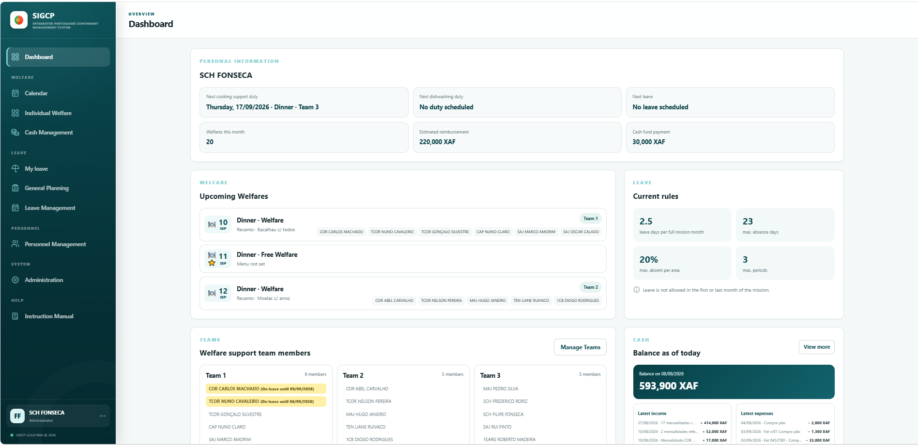.
Figure 00 — Home screen and main menu

2. Installation, startup and shutdown

2.1 Requirements
- Windows 10/11.
- Modern browser: Microsoft Edge, Google Chrome or Mozilla Firefox.
- Read and write permissions for the database folder and its corresponding db_backup folder.
- Access to the network path when the database is located on a server.

2.2 Installation
- Copy the file SIGCP.exe, which is located in the shared folder of the Portuguese contingent, as shown in Figure 01, to your computer.
- Run SIGCP.exe that is on your computer and this is the one you will use at all times.
- If no database is configured, select the SQLite file indicated by the administration.
- Wait for the browser to open automatically.
- Log in using your NIM and assigned password.
Configured database The selected location is saved in the local Windows profile. The db_backup folder is created next to the database, not next to the executable.

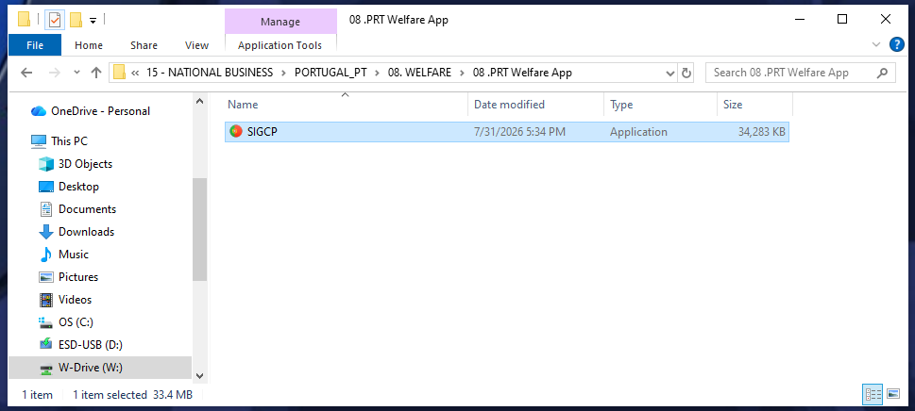
Figure 01 — Location of the application to be copied

2.3 Daily use
If SIGCP is already running, a second launch connects to the existing instance. Do not create manual copies of the database while the application is in use.

2.4 Proper shutdown
- Use the Close application option in the user menu.
- Confirm shutdown of the local server.
- Close old SIGCP tabs in the browser.
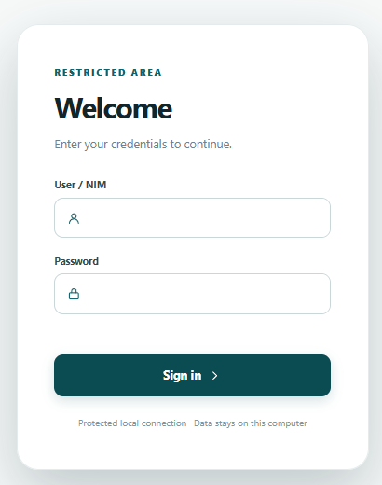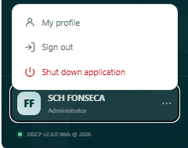
Figure 02 — Login and session options

3. Profiles, access and responsibilities
Access Types define operational modules. The SNR and Welfare Manager roles are separate assignments and can only be granted by Administrators. A user may hold multiple access rights when necessary.
Profile/role | Main capability
Administrator | Full access, personnel, settings, audit, deletion of leave periods and database export.
Monthly Welfare Management | Preparation of the monthly plan and editing of meals in the calendar.
Menu Management | View the menu; editing meals requires Monthly Welfare Management, Administrator or Welfare Manager access.
Individual Welfare Management | Management of the contingent’s individual Welfares.
Cash Management | Management of cash inflows, outflows, balances and forecasts.
Cook | Identifies those who are part of the team responsible for preparing Welfares at the Recanto; appears in the Teams PDF report.
Personnel/Leave Management | Functional access to personnel/leave management according to the permissions shown.
Read-only | View protected data without making changes.
SNR | Decision on other people’s requests, management notifications and temporary appointment of a replacement.
Welfare Manager | Operations and documents reserved for the manager; may edit meals in the calendar.

Notification separation Notifications in “My Leave” are personal. The notification badge in “Leave Management” belongs to the SNR and contains only requests from other people.

4. Navigation and common rules
- Planning: Monthly Calendar and Individual Welfare.
- Leave: My Leave and Leave Management.
- Personnel: list, data, entitlements and SNR replacement.
- System: Administration and Audit, for Administrators only.
Dates and times are selected in separate, aligned fields, ensuring browser compatibility. Always confirm the date, hour and minutes before saving.
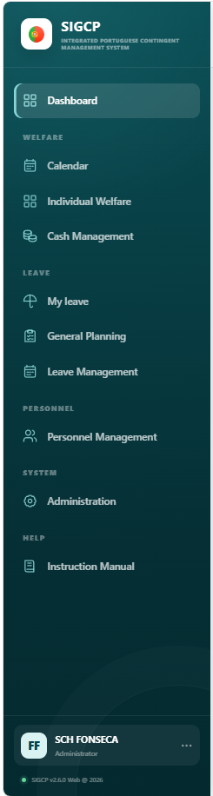.
Figure 03 — Navigation structure

5. Monthly calendar
The Monthly Calendar shows Welfare activity by day and meal. Editing is limited to Monthly Welfare Management, Administrator and Welfare Manager; all other profiles have read-only access.

5.1 Record or change a meal
- Select the year and month.
- Select the required day/meal.
- Fill in the information provided in the form.
- Save and confirm the update in the grid.

5.2 Export and printing
The Export PDF button generates the plan for the displayed period. Before issuing it, confirm the month, entries, Day Offs and menu.
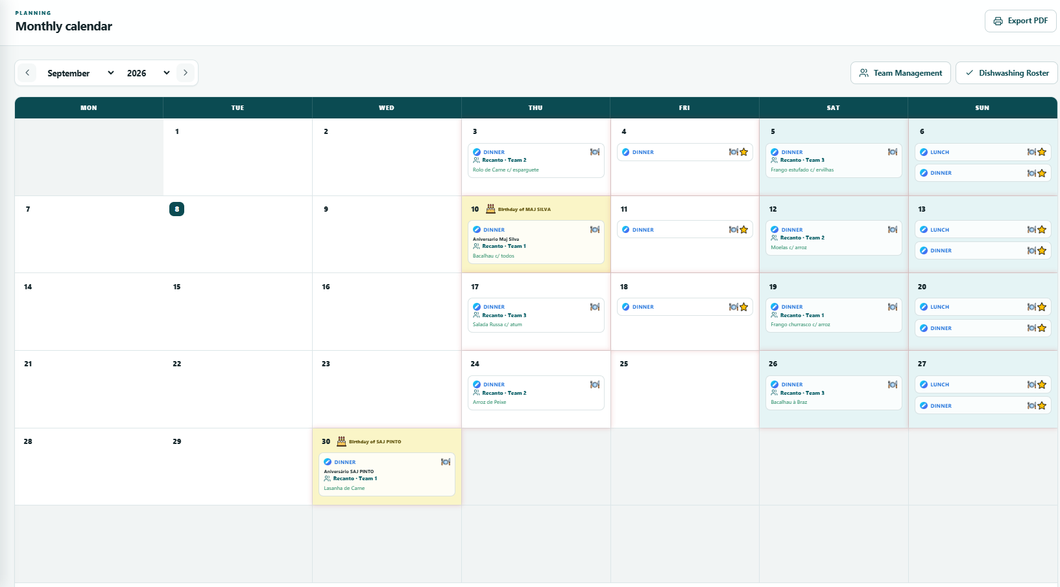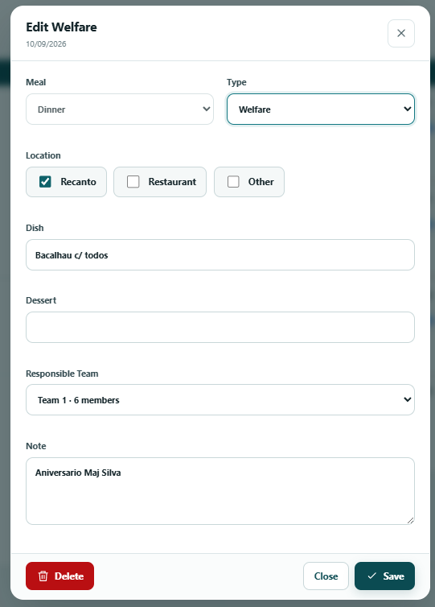
Figure 04 — Monthly calendar and meal editing

5.3 Team Management
Team Management organises the teams that support meal preparation. Each person may belong to only one Team and is automatically excluded after their mission departure date.
- Open Team Management from the Calendar.
- Create or select the Team.
- Add the available members.
- Confirm the composition and return to the calendar.
The PDF export shows, on a landscape A4 page, the current Team composition, cooks, ongoing or future approved leave, the logo and the issue date/time.
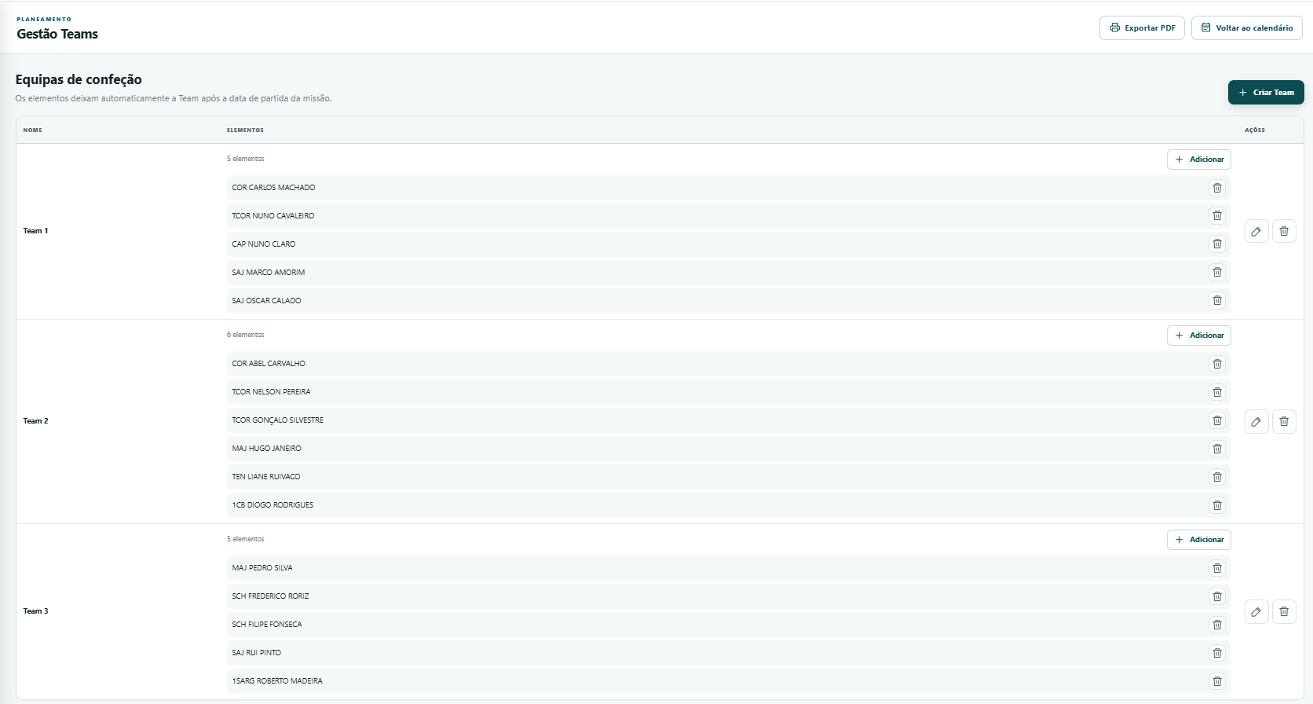
Figure 05 — Team Management

5.4 Dishwashing Duty Roster
The Dishwashing Duty Roster assigns two service members to weekend duties. The application respects unavailability, leave and eligibility, and allows the roster to be saved or printed according to permissions.
- Open Dishwashing Duty Roster in the Calendar.
- Select the required period.
- Generate or adjust the roster when authorised.
- Save and use Print to issue the document.
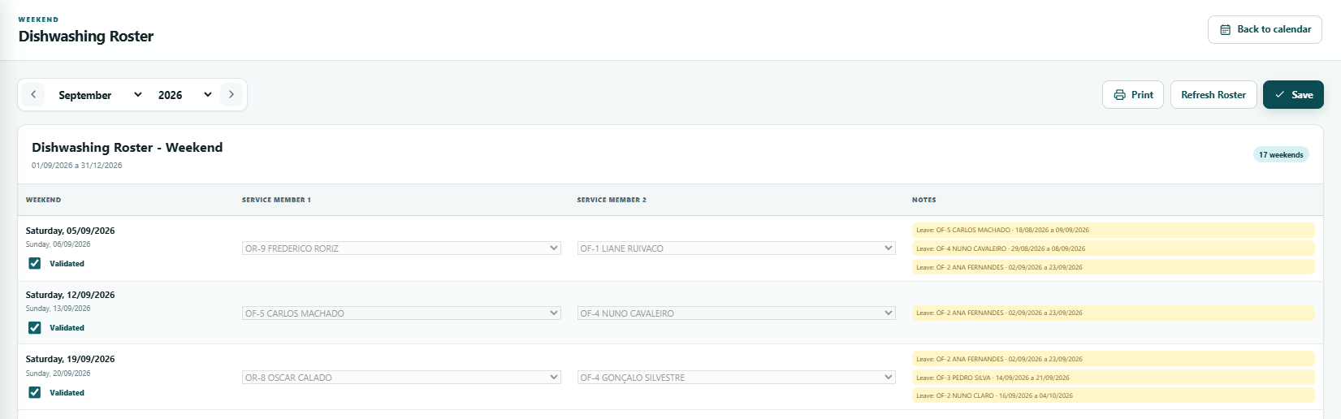
Figure 06 — Dishwashing Duty Roster

6. Individual Welfare
The individual area allows entries to be viewed and, when authorised, corrected by person. Unsaved changes are flagged and the application asks for confirmation before leaving the page.
- Save pending changes before changing month.
- Locking the month prevents further changes; only Administrators and Welfare Managers can manage the lock.
- Reset entries restores the original Welfares for the period.
- Approved leave is automatically reflected in the affected meals.

6.1 Documents and exports
Depending on permissions, individual printing, weekly export, Request, Request HOTO, Service Note, XFA Distribution and reimbursement documentation are available. Always check the reference numbers shown in the warnings before finalising the document.
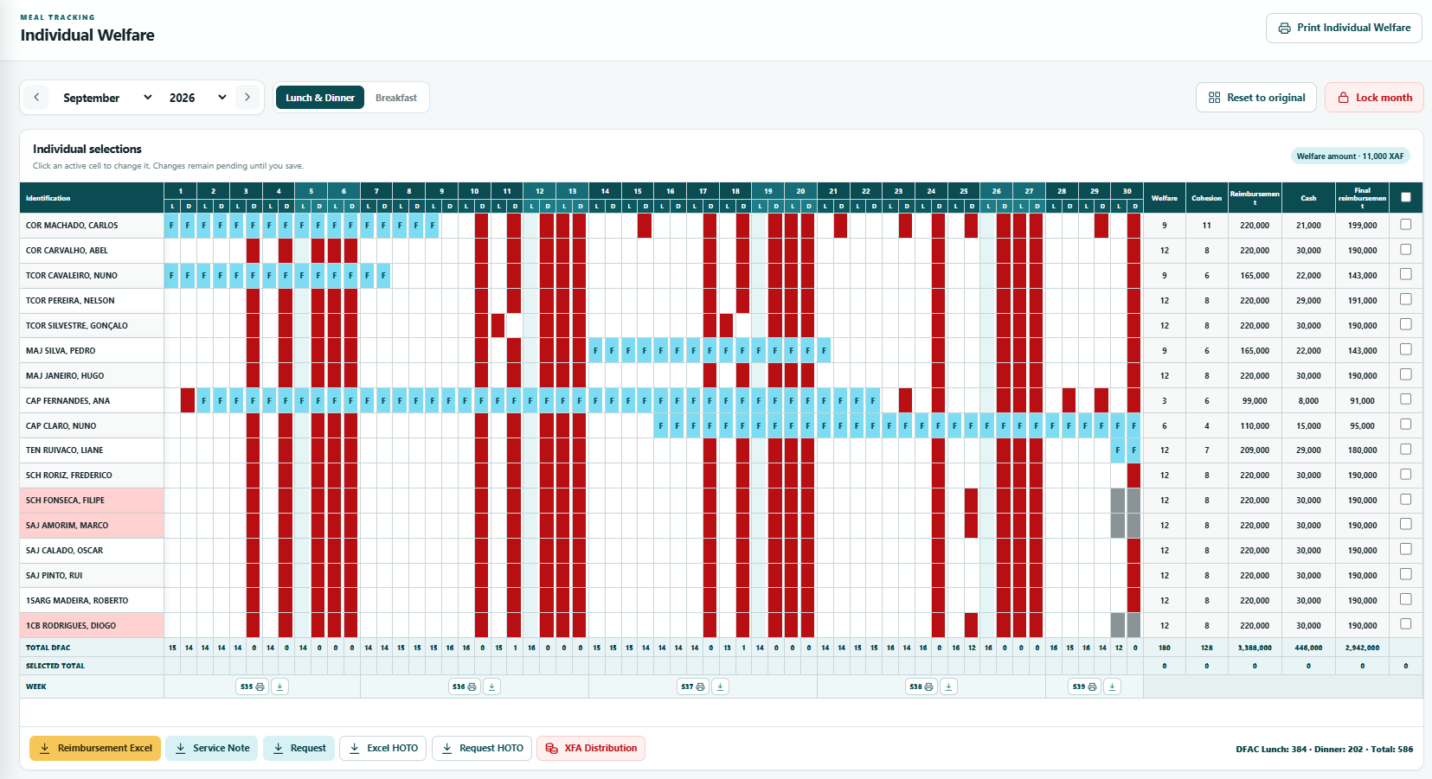
Figure 07 — Individual Welfare
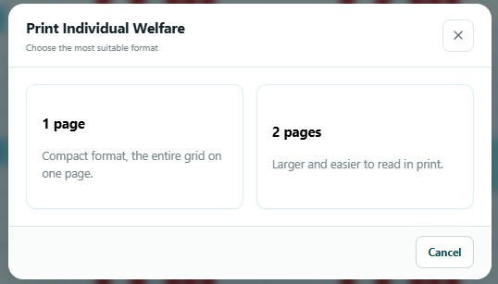
Figure 08 — Printing and document options

6.2 Cash Management
Cash Management brings together the balance, inflows, outflows and forecasts associated with the contingent. The Dashboard shows a summary; the dedicated area allows transactions to be viewed and, when authorised, recorded.
- Always confirm the date, type, amount, description and associated person before saving.
- Use the filters to view historical transactions.
- Corrections must preserve traceability in the Audit log.
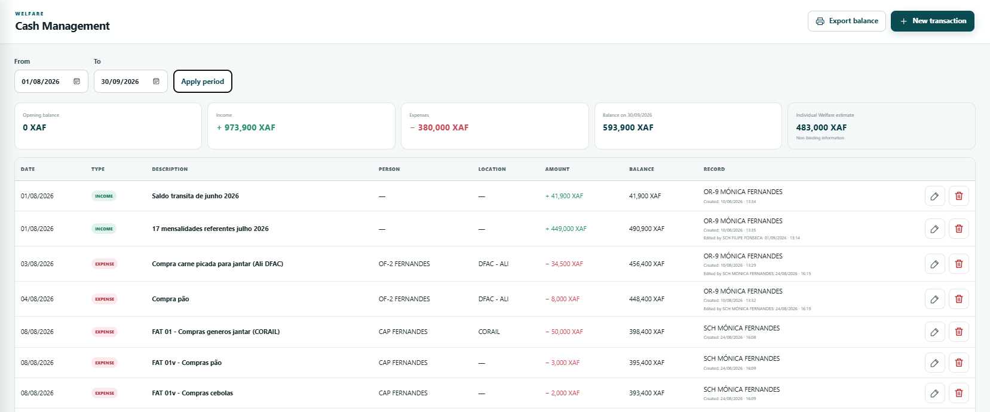
Figure 09 — Cash Management

7. My Leave
This area is personal: each user views their periods, submits requests and follows decisions without mixing them with SNR management notifications.

7.1 New request
- Click New leave request.
- Select the departure and arrival date and time.
- Enter airline/flight and remarks where applicable.
- Read any overlap warnings or planning rules.
- Acknowledge the warnings and submit.

7.2 Changes and cancellation
A change to or cancellation of an approved period remains pending a decision. Until SNR approval, the previously approved period remains reflected in Individual Welfare.
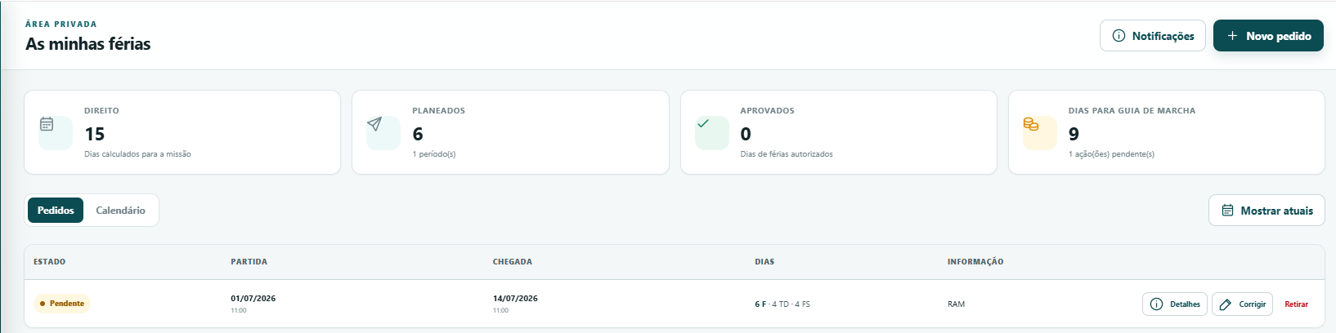
Figure 10 — My Leave
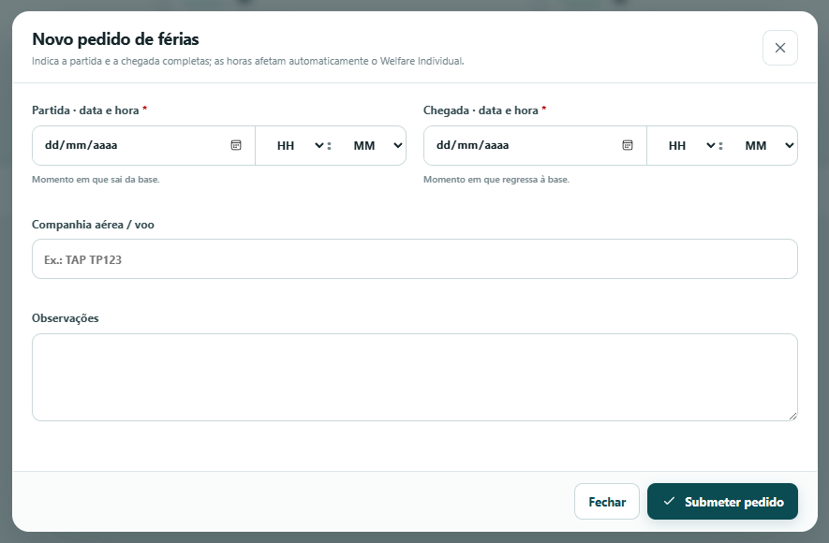
Figure 11 — New leave request

8. Leave Management
Leave Management brings together decisions, planning, calendar and reports. The SNR decides only on requests from other people and cannot approve their own request.

8.1 List and filters
- All: displays all applicable statuses.
- Pending: displays requests requiring a decision.
- Approved: displays approved leave.
- Cancelled: displays cancelled leave.
- Only one status filter can be active at a time; search and area may narrow the results.
Button colours match the card colours. Printing uses the active filter and adjusts the title, for example “Leave pending approval”.

8.2 Current personnel and history
By default, Total Personnel counts only those still on mission and the Excel file includes only those people and their respective data. When Include Past Personnel is enabled, the total covers all personnel and the Excel report is likewise expanded to include everyone.
Sorting rule Personnel are sorted first by rank and then by seniority date. Those who have already left the mission appear at the end, with the same sorting applied within that group.

8.3 Decisions and deletion
The SNR may approve, return or reject other people’s requests according to their status. Only the requester may use Correct on a pending or returned request. Administrators have a Delete button at any stage; this deletion is permanent and must be used only to correct improper records.

8.4 Calendar and monthly printing
On the Calendar tab, select the month and use Print to issue exactly the displayed month, with title and legend. Row order follows rank and seniority. Days before arrival and after departure from the mission appear in dark grey and do not count as presence.
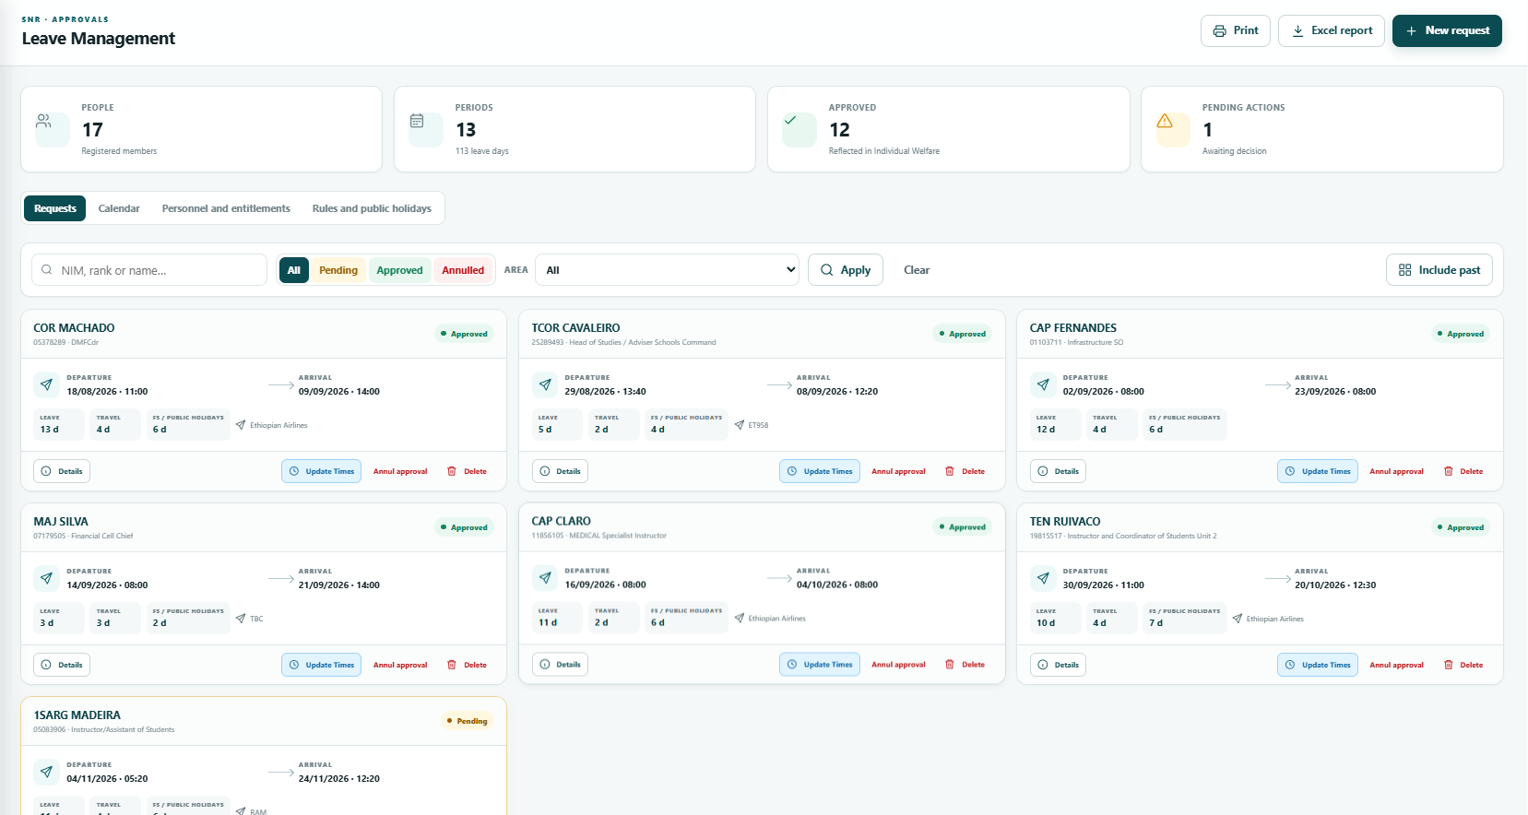
Figure 12 — Leave Management — list and filters
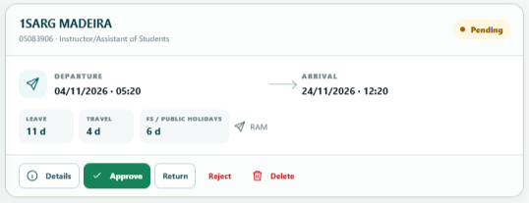
Figure 13 — Request details and decision
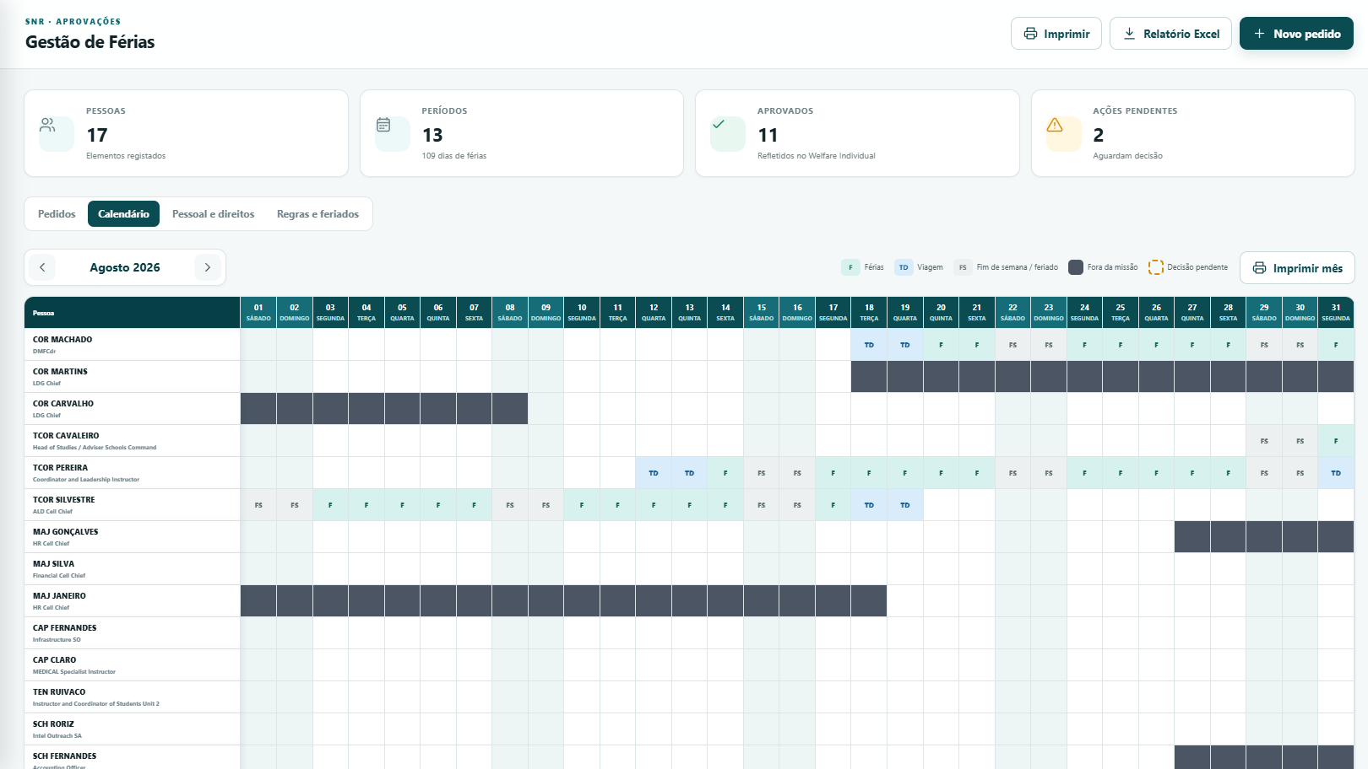
Figure 14 — Monthly leave calendar

9. Temporary SNR replacement
The appointed SNR may designate a person to temporarily assume the duties during their leave. The option is also available to Administrators.
- Open Personnel and edit the profile of the selected person.
- Enable the SNR replacement checkbox.
- Enter the start date and end date.
- Save.
- To remove the appointment, click Clear and save.

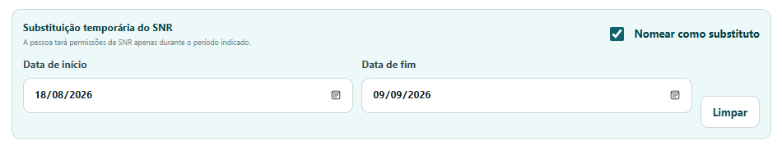
Figure 15 — Appointment of SNR replacement

10. Personnel
The personnel list brings together identification, mission, contact details, functional area, Position No., seniority, access rights and entitlements. Those who have left the mission are placed at the end of the list.

10.1 Create or edit person
- Enter NIM, rank, first name and surname.
- Record the mission start and end dates and seniority date.
- In the same group, enter Functional Area and Position No.
- Enter Service Mobile Phone when the person is the Welfare Manager.
- Total Leave Days (manual) overrides the automatic calculation when completed.

10.2 Access and roles
Only Administrators change Access Types and assign the SNR/Welfare Manager roles. For non-administrator users, the form displays the values as read-only with this explicitly indicated.

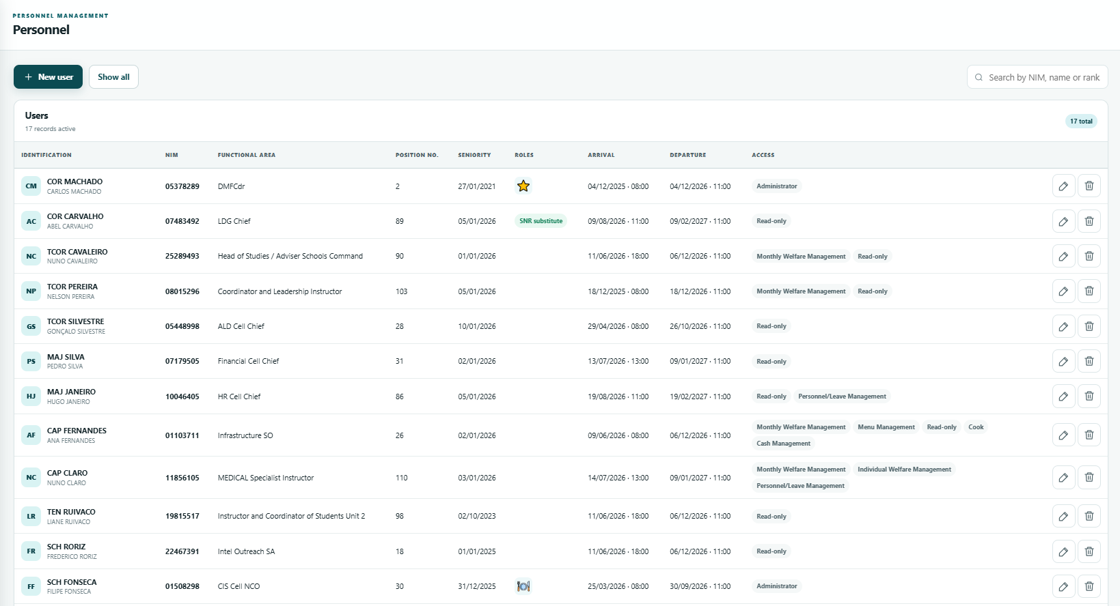
Figure 16 — Personnel list
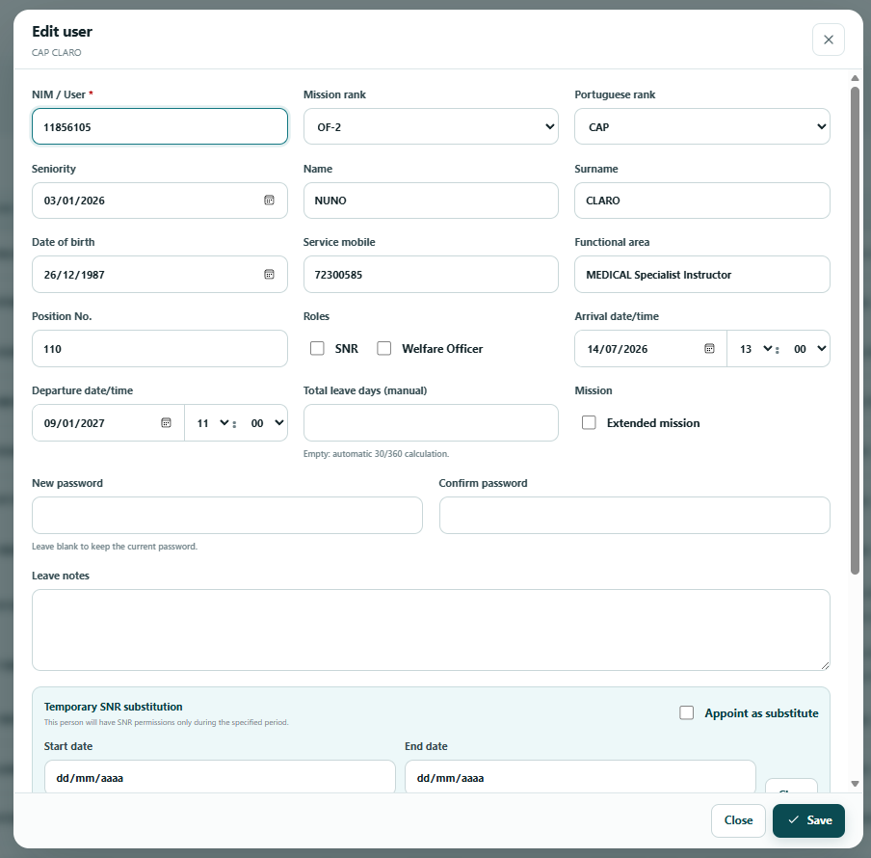
Figure 17 — Add/edit person

11. Administration
Administration is reserved for Administrators and brings together settings, user control, planning rules, public holidays, Day Off, technical export and Audit.

11.1 Settings and rules
Before changing parameters, record the previous value and the reason. Some changes affect future calculations and reports; confirm the calendar year and functional limits before saving.

11.2 Public holidays and Day Off
Active public holidays are considered FS in leave calculations. Day Offs must be maintained in accordance with the applicable service order.

11.3 Export JSON
Export JSON creates a logical copy of tables and records for diagnostics or archiving. It does not replace the SQLite backup for operational recovery.
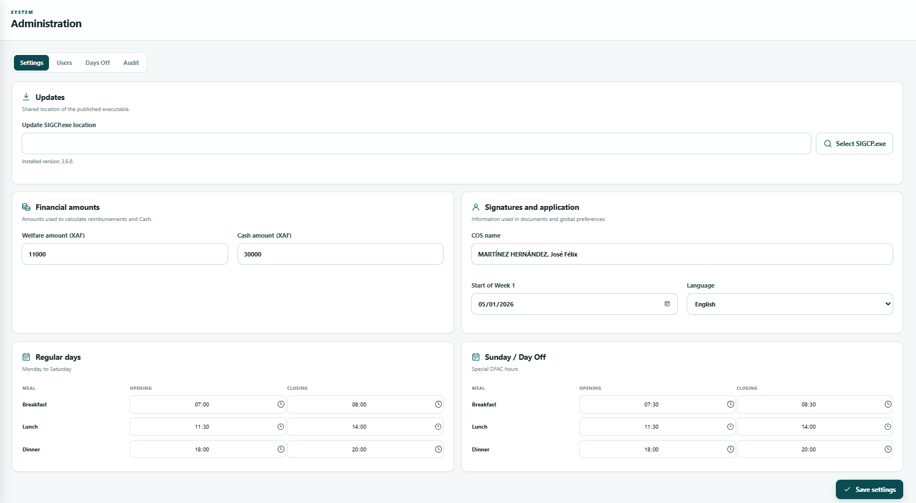
Figure 18 — Administration — settings

12. Audit
The Audit log records completed operations that change data. Credentials, passwords and tokens are hidden. By default, only changes from the current month are shown, reducing volume and speeding up consultation.

12.1 Efficient search
- Open Administration > Audit.
- Set dates when you want to view earlier periods.
- Search by user, action, entity or relevant content.
- Apply the filters.
- Open the record details to compare before/after data.
Results are paginated to maintain performance when there are many records. Refine the dates and text before navigating to additional pages.
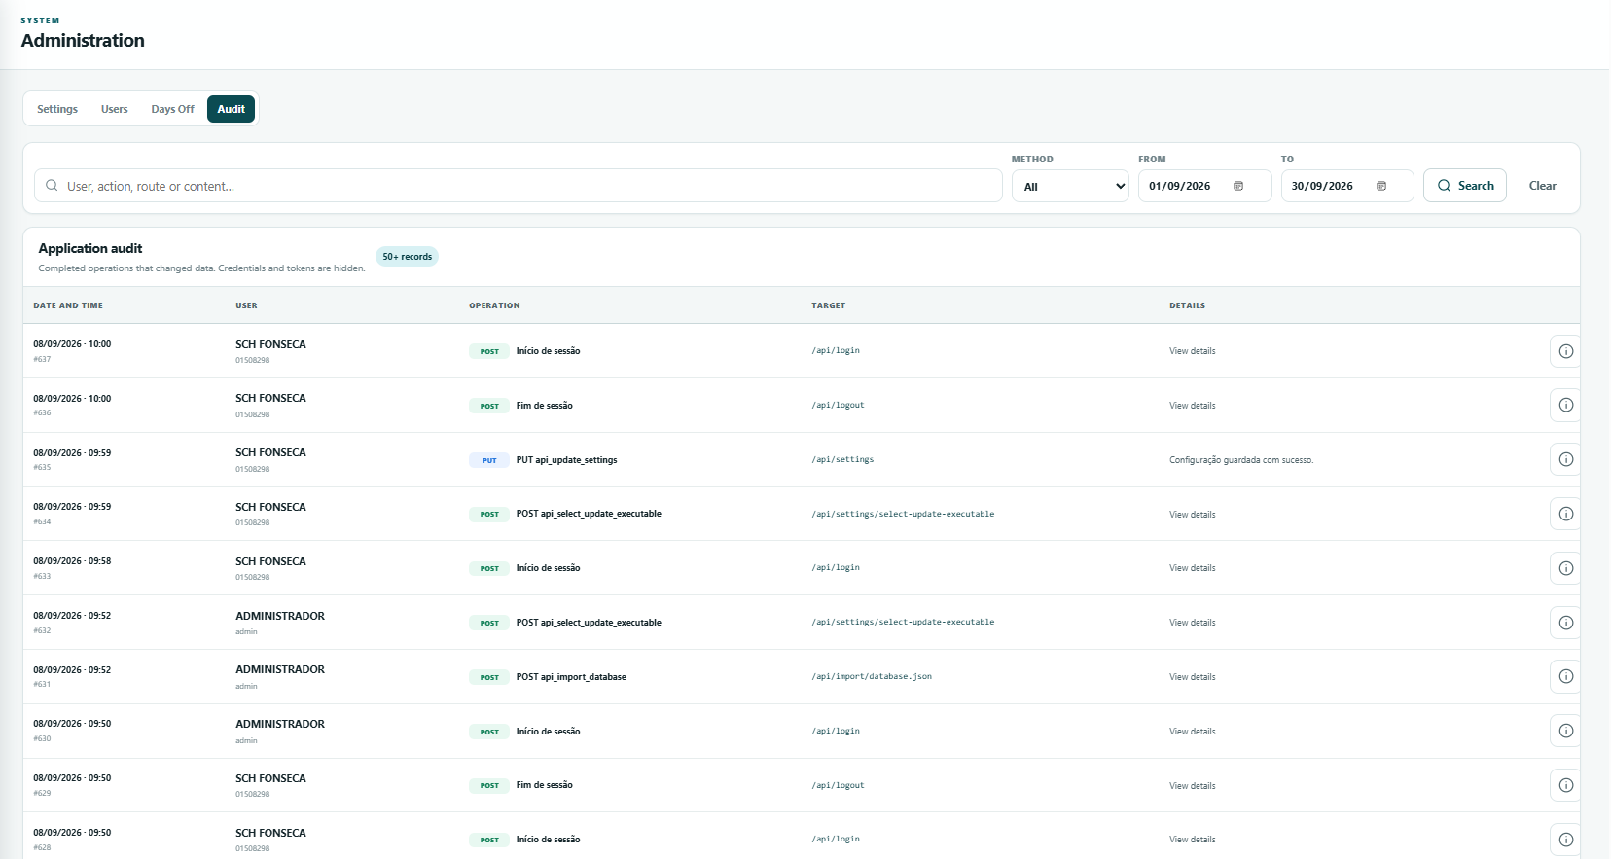
Figure 19 — Audit and filters

13. Automatic backups
At each login, SIGCP attempts to produce a consistent snapshot of the database. The process uses the SQLite backup mechanism, verifies the integrity of the copy and only then makes it available in the final folder.

13.1 Location and retention
- Source: SQLite file configured for SIGCP.
- Destination: db_backup folder next to the database.
- Organisation: a folder identified by date and time for each run.
- Automatic retention: the 20 most recent copies.
- Failure to delete an old copy does not invalidate a newly completed backup.

13.2 What to do when a warning appears
- Record the message displayed at login.
- Confirm that sufficient disk space is available.
- Confirm create, write and read permissions at the destination.
- If using a network location, confirm the server connection and Windows credentials.
- Resolve the cause and log in again to repeat the backup.
Continuity Login is not blocked by a backup failure, but the warning must be addressed the same day. An operational application without recent backups presents a risk of data loss.

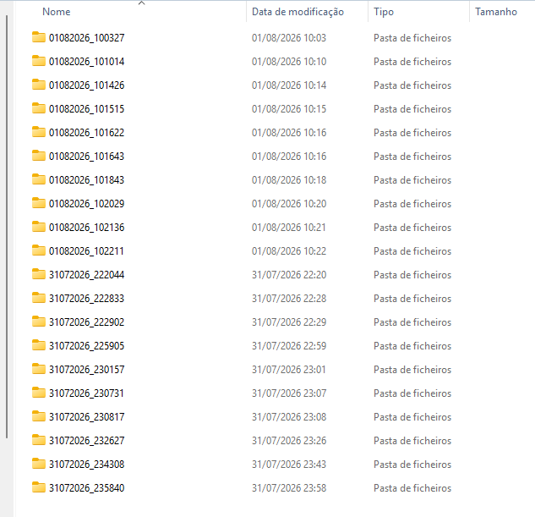
Figure 20 — db_backup folder structure

14. Restore and recovery
Administrative operation The restore must be performed by an authorised person, with all SIGCP instances closed and after preserving the current database.

- Inform users and completely close SIGCP on all computers.
- Identify the latest valid copy in the db_backup folder and confirm its date/time.
- Create an additional backup copy of the current file, even if it is damaged.
- Copy the SQLite file from the selected backup to the configured location, keeping the expected filename.
- Start SIGCP on a single computer and validate login, personnel, calendar, leave and audit.
- Only after validation should general access be authorised and the incident/restore documented.
Never replace the database while an application instance is connected. In a network environment, also confirm that there are no active SIGCP.exe processes on other workstations.

15. Security and data protection
- Assign only the access rights essential to the role.
- Promptly disable or adjust profiles for personnel leaving their duties.
- Do not share passwords or send the database through unauthorised channels.
- Protect backups under the same rules as the main database.
- Use the Audit log for investigation, control and accountability.
- Avoid screenshots containing passwords, unnecessary personal data or sensitive network paths.

16. Troubleshooting
Symptom | Check/action
The browser does not open | Confirm that SIGCP.exe is running and open http://127.0.0.1:52147 in the browser.
Local port in use | Close old SIGCP instances; confirm in Task Manager before restarting.
Database not found | Select the correct file again and confirm access to the network path.
Backup warning | Check space, permissions and connectivity; log in again after resolving the issue.
I cannot edit meals | Confirm Monthly Welfare Management, Administrator or Welfare Manager access.
I cannot see Administration | The page is for Administrators only.
Request does not appear to the SNR | Confirm that it belongs to another person, the request status and the validity of the SNR replacement.
Time misaligned or control displayed differently | Refresh the browser; separate date/time fields ensure compatibility with Firefox.
Excel contains past personnel | Disable Include Past Personnel before exporting.
Manual contents out of date | Regenerate the manual from the source and confirm the chapter structure.

17. Recommended routines
Frequency | Routine
Daily | Check backup warnings, pending requests, notifications and planning changes.
Weekly | Confirm recent backups, review SNR replacements and validate the data of incoming/outgoing personnel.
Monthly | Review access rights, lock the completed period, export required reports and consult the Audit log.
Before rotation | Validate mission dates, rank, seniority, Functional Area, Position No. and leave entitlements.
After an incident | Preserve evidence, consult the Audit log, validate backups and record recovery actions.

18. Handover checklist
- Database location and server owner confirmed.
- Latest valid backup identified and restore procedure tested/documented.
- Administrators, SNR and Welfare Manager updated.
- Temporary replacements reviewed and dates valid.
- Current/past personnel and their respective mission dates validated.
- Pending leave periods addressed.
- Completed months locked and reports archived.
- Audit log reviewed for relevant changes.
- Manual updated with screenshots from the production version.

19. Help and User Manual
At the bottom of the sidebar, the HELP section contains access to the User Manual. When clicked, the browser opens a new tab directly with the PDF file embedded in the application.

