EPITOME MODEL ISLAMIC SCHOOLS
1ST TERM EXAMINATION
FOR SENIOR SECONDARY SECTION
2025/2026 ACADEMIC SESSION
BIOLOGY

Name: | Class: Year 10 (S. S. 1) | Time Allowed: 2hours
FOR MARKERS ONLY
Sections in Paper | Scores Obtainable | Scores Obtained
Section A (Objectives)
Section B (Theory)
Total Scores
Do not start until you are told to do so

SECTION A – ANSWER ALL QUESTIONS
- The basic unit of life is
(a)species (b)cells (c)tissues (d)organs

- Angiosperm belong to the class
(a)thallophyta (b)bryophyte
(c)spermatophyta (d)pteridophyta

- The study of animals is called
(a)Botany (b)Ecology (c)Zoology (d)Entomology

- One of these is not a characteristic of living things
(a)Smiling (b)Growth (c)Feeding (d)Reproduction

- Which of the following organism exist as a colony?
(a)Amoeba (b)Volvox (c)Euglena (d)Paramecium

- Shrimps, spiders and crabs belong to the group of animals called
(a)arthropoda (b)nematoda
(c)coelenterate (d)Mollusca

- One of these is regarded as the father of cells
(a)Robert Hooke (b)Felix Dwardin
(c)Mathias Schleiden (d)Carl Linneaus

- One of these brought about taxonomy
(a)Carl Linneaus (b)Mathias Schleiden
(c)Robert Hooke (d)Felix Dwardin
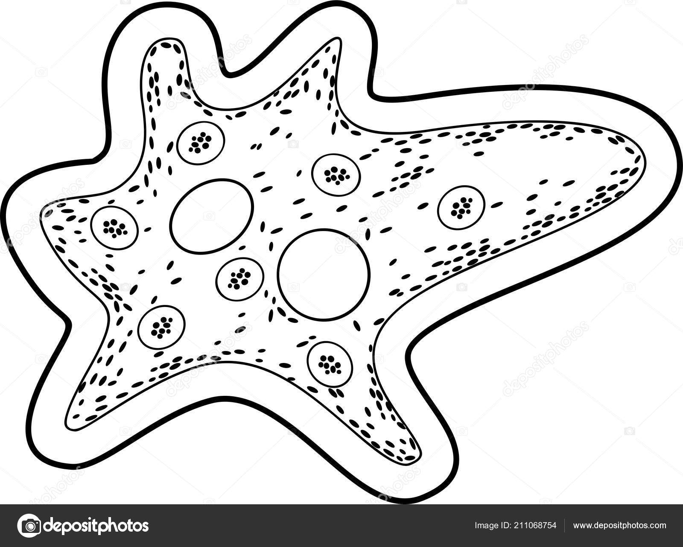

- The structure above represent .....organism
(a)Euglena (b)Paramecium (c)Amoeba (d)Volvox

- The part labeled III is the
(a)endoderm (b)ectoderm
(c)nucleus (d)food vacuole

- Contractile vacuole is the part labeled
(a)II (b)III (c)I (d)IV

- Which of these is not correct about fish?
(a)Live in water
(b)Skin is covered with scales
(c)Perspires(sweats) through the gill
(d)They are poikilothermic

- The following are levels of organization of life except
(a)cells (b)organs (c)organisms (d)tissues

- The largest and strongest bone in human body is the
(a)radius (b)ulna (c)tibia (d)femur

- The two Greek words which biology was coined from are
(a)Bios and logo (b)Bios and logos
(c)Bios and Lagos (d)Bios and Lagoon

- A system is the .....level of organization of life
(a)1st (b)2nd (c)4th (d)3rd

- A group of similar cells form a layer called
(a)organs (b)tissues (c)system (d)organism

- A cell without a membrane bound nucleus is called
(a)Protista cell (b)prokaryotic cell
(c)eukaryotic cell (d)bacterial cell

- One of these is not a phylum in animal kingdom
(a)Mollusca (b)Annelida (c)Nematoda (d)Insecta

- One of these organisms is slippers-shaped
(a)Amoeba (b)Euglena
(c)Paramecium (d)Chlamydomonas

Use the diagram below to answer questions 21-23

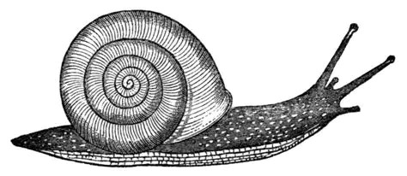
IV
I

II

III
V

- The organism above belong to the phylum
(a)Arthropoda (b)Mollusca
(c)Chordate (d)Annelida

- The part labelled IV is called
(a)foot (b)shell (c)tentacle (d)mouth

- The used for sight sensation are
(a)I and III (b)IV and II (c)V and II (d)I and II

- The cell theory was postulated in the year
(a)1939 (b)1858 (c)1839 (d)1855

- One of these is not an animal characteristics of euglena
(a)possession of eye spot
(b)possession of flagellum
(c)possession of chloroplast
(d)possession of contractile vacuole

- The removal of metabolic waste from living organisms is called
(a)egestion (b)digestion (c)secretion (d)excretion

- The ability of living organisms to perpetuate their kind is called
(a)production (b)reproduction
(c)conjugation (d)replication

- All are control measures of harmful micro-organisms except
(a)high temperature (b)sterilization
(c)inhygiene (d)hygiene

- One of these scientists put to an end the theory of spontaneous generation
(a)Rudolf Von Virchow (b)Theodor Schwann
(c)Mathias Schleiden (d)Robert Hooke

- The sudden retraction of body or body parts from a noticed environmental change is termed
(a)irritation (b)irrigation (c)irritability (d)stimulus

- The fusion of male gamete and female gamete is called
(a)zygote (b)gametocyte (c)progeny (d)fertilization

- When living organisms feed on solid food substances that must be digested before absorption, it is termed
(a)parasitic (b)symbiotic (c)saprophytic (d)holozoic

- All hereditary information of a living organism is stored in
(a)nucleus (b)nucleolus (c)lysosome (d)ribosomes

- One of these organelles controls the green pigmentation of plants leaves
(a)Chlorophyll (b)Chloroplast
(c)Vacuole (d)Lysosome

- All are examples of protozoa except
(a)Amoeba (b)Paramecium
(c)Trypanosome (d)Algae

- The surface of leaves and the wings of insects contains........that makes them proof
(a)hyphae (b)spores (c)chitin (d)mycelium

- One of these undergo saprophytic mode of nutrition
(a)Protozoa (b)Plants (c)Animals (d)Fungi

- A tentative answer to a question raised by scientific observation is called
(a)Testing (b)Theory (c)Hypothesis (d)Law

- One of these is not true about plants
(a)Growth is indefinite and apical
(b)Growth is definite and intercalary
(c)Slow response to stimulus
(d)Undergo holophytic mode of nutrition

- C₆H₁₂0₆ + 60₂ 6C0₂ + 6H₂0 + energy is a common equation that summarizes
(a)excretion (b)respiration
(c)adaptation (d)nutrition

- Urine is stored temporarily in one of the following
(a)Liver (b)Kidney (c)Gall bladder (d)Bladder

- Monocot plants are easily recognized by
(a)short leaves with a petiole
(b)long leaves with parallel veins
(c)short leaves with many veins
(d)long leaves with interconnected veins

- One of these is a unicellular organism
(a)Spirogyra (b)Hydra (c)Amoeba (d)Cat

- All are branches of biology except
(a)Zoology (b)Geology
(c)Botany (d)Microbiology

- Which of the does not control harmful microbes?
(a)Hygiene (b)High temperature
(c)Inhygiene (d)Sterilization

- The power house of the cell is the
(a)nucleus (b)nucleolus
(c)golgi apparatus (d)mitochondrion

- One of these structures cannot be found in the nucleus of a cell
(a)Genes (b)Ribosomes
(c)Chromosomes (d)Nucleolus

- All are advantages of complexity in higher organism except
(a)cellular differentiation
(b)internal structural specialization
(c)difficulties in acquisition of essential materials
(d)mutual interdependence between component cells

- Amoeba uses one of the following for movement
(a)Flagella (b)Cilia (c)Legs (d)Pseudopodia

- One of these play a major role in protein synthesis
(a)Centrioles (b)Ribosomes
(c)Lysosomes (d)Mitochondrion

