**Code Documentation for Seaborn Heat Map Visualization**

Adeniji Oluwagbemiga Daniel

**Brief Description**

The dataset provided shows Life expectancy and GDP Per capita numbers for different countries, indicating also their continents for every 5 years between 1952 and 2007. The purpose is to create a heat map for this data using Python Seaborn.

**Import Python packages**

We import the following Python packages:

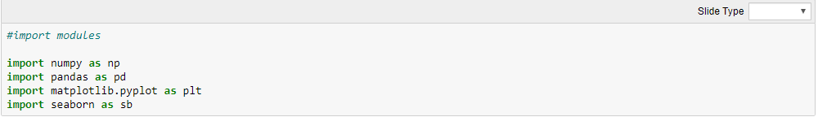

**Read, Convert and Split the dataset**

Since it is a csv file, we will use the read_csv function from pandas. We will then convert into a dataframe and split the comma separated values on a single column into multiple columns

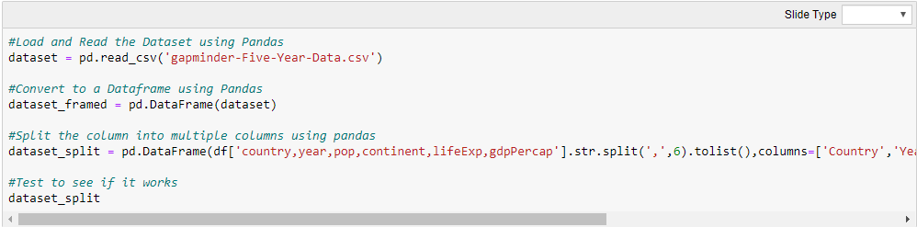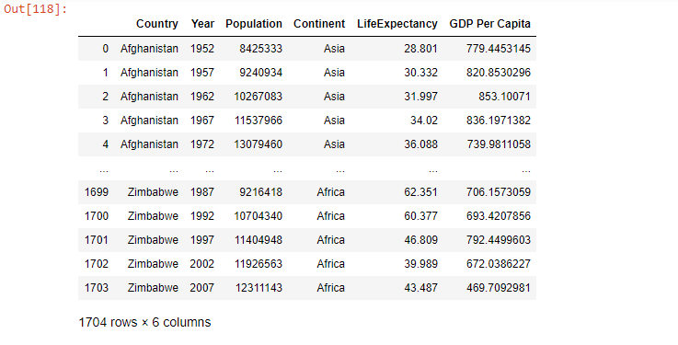

**Convert LifeExp from String to Numbers**

Since we have used the .str.split() to split the single column into several columns, we would need to convert the LifeExp string to numbers.

**Create Pivot Table**

We will then use the .pivot_table() to create a pivot table for the dataset with ‘Continent’ as the index, ‘Year’ in the columns and ‘LifeExpectancy’ filled within the cells. The **aggfunc** operation is used to average the values for LifeExpectancy in order to remove duplicates and create a definite shape for the dataset.

**Create the Heatmap**

Finally, we create the heatmap using the heatmap function. This is available in the Seaborn python package. The **annot** argument helps to add numbers to the heatmap (annotation).The **sb.set** helps to increase or reduce the font scale of the heatmap numbers.

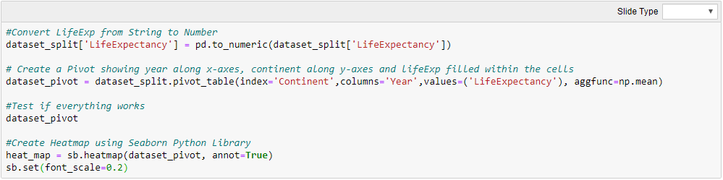

**Result**

The result shows the heatmap visualization.

