CPE301 – SPRING 2019

Design Assignment 1A

Student Name: Allis Hierholzer

Student #: 2000160356

Student Email: hierholz@unlv.nevada.edu

Primary Github address: https://github.com/acexhp/submission_da.git

Directory: Repository/cpe301/DesignAssignment/DA1A

Task:

Q: Write, simulate, and demonstrate using Atmel Studio 7 an assembly code for the AVR ATMEGA328p microcontroller that performs the following functions:

1. Perform a multiplication of a 16-bit multiplicand with an 8-bit multiplier without using the MUL instruction. Use iterative addition to perform the above multiplication.

2. Registers R25:R24 hold the 16-bit multiplicand, R22 hold 8-bit multiplier, and R20:R19:R18 should hold the result.

3. Verify your algorithm and answers using the AVR mul instruction or C or any high-level program.

4. Determine the execution time @ 16MHz/#cycles of your algorithm using the simulation.

1. **COMPONENTS LIST AND CONNECTION BLOCK DIAGRAM w/ PINS**

N/A

1. **INITIAL/MODIFIED/DEVELOPED CODE OF TASK 1/A**

.org 0 ;Giving a memory place to start

.SET m1 = 0xFF ;Sets value for variable m1 -> highest 8bits of multiplicand

.SET m2 = 0xFF ;Sets value for variable m2 -> lowest 8bits of multiplicand

.SET m3 = 0xFF ;Sets value for variable m3 -> 8bits multiplier

LDI R25, m1 ;R25 = m1

LDI R24, m2 ;R24 = m2

LDI R22, m3 ;R22 = m3

CLR R26 ;Clears R26 to R30

CLR R27

CLR R28

CLR R29

CLR R30

Loop: ;Multiplies 16bits x 8bits using iterative addition

ADD R18, R24 ;R18 = R18 + R24

ADC R19, R25 ;R19 = R19 + R25 + carry

ADC R20, R26 ;R20 = R20 + R26 + carry

DEC R22 ;Decrements R22 by 1

BRNE Loop ;Branches to label Loop until R22 = 0

Verify: ;Verifies 16bits x 8bits using the MUL instruction

LDI R22, m3 ;R22 = m3

MUL R24, R22 ;R24 x R22 (product automatically stored in R0 & R1)

MOV R27, R0 ;Moves values in R0 to R27

MOV R28, R1 ;Moves values in R1 to R28

MUL R25, R22 ;R25 x R22 (product automatically stored in R0 & R1)

MOV R29, R1 ;Moves values in R0 to R29

ADD R28, R0 ;R28 = R28 + R0

ADC R29, R30 ;R29 = R29 + R30 + carry

;At the end of "Verify" label,

;R18 should be the same as R27

;R19 should be the same as R28

;R20 should be the same as R29

Done:

JMP Done ;Program ends

1. **DEVELOPED MODIFIED CODE OF TASK 2/A from TASK 1/A**

N/A

1. **SCHEMATICS**

N/A

1. **SCREENSHOTS OF EACH TASK OUTPUT (ATMEL STUDIO OUTPUT)**

Example 1: 65,535 x 255 = 16,711,425 🡪 FFFF x FF = FEFF01

Using iterative addition, results are stored in R18 = 01, R19 = FF, R20 = FE

Using MUL instruction, results are stored in R27= 01, R28 = FF, R29 = FE

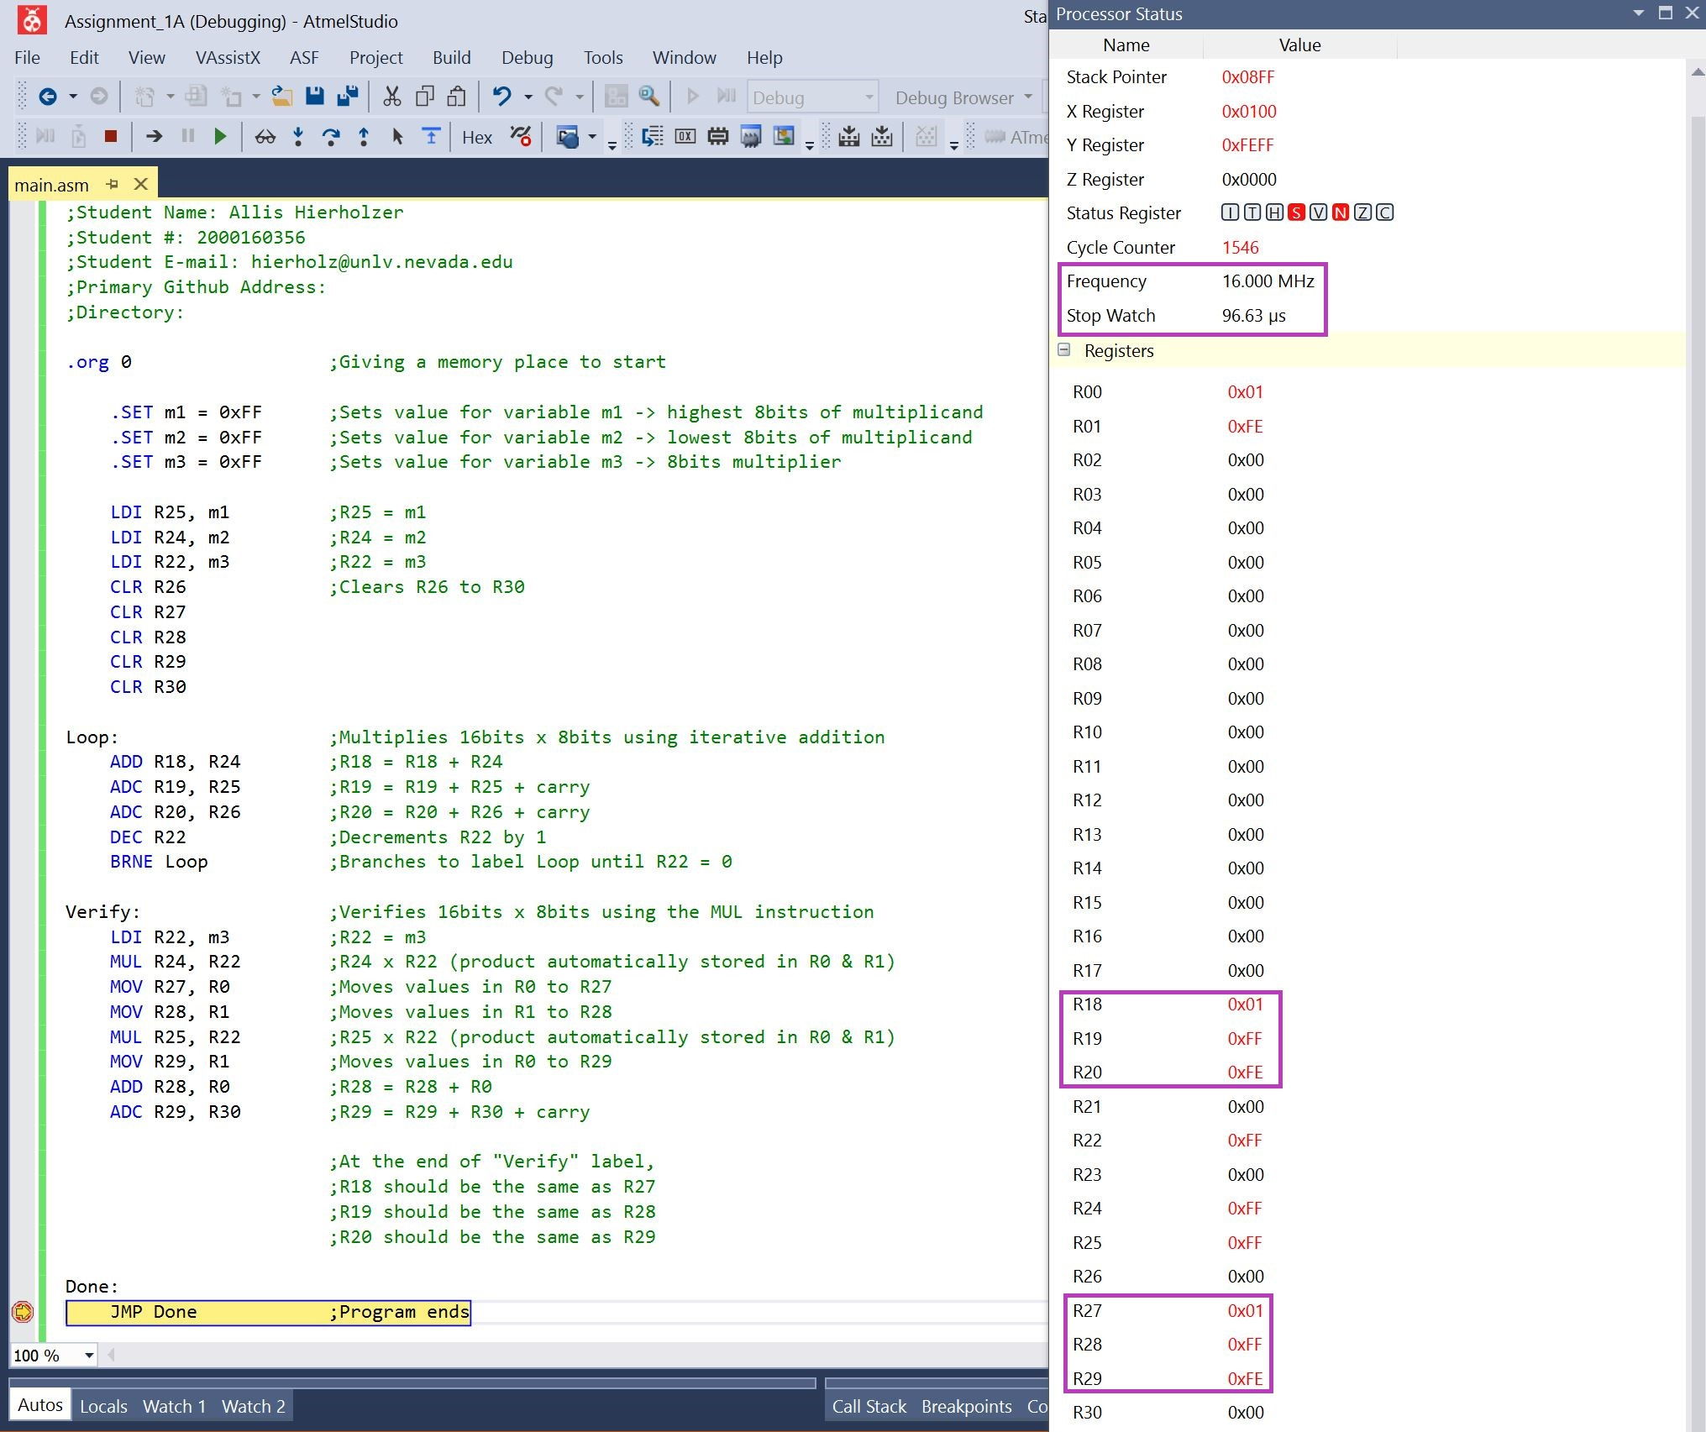

Example 2: 43,981 x 239 = 10,511,459 🡪 ABCD x EF = A06463

Using iterative addition, results are stored in R18 = 63, R19 = 64, R20 = A0

Using MUL instruction, results are stored in R27= 63, R28 = 64, R29 = A0

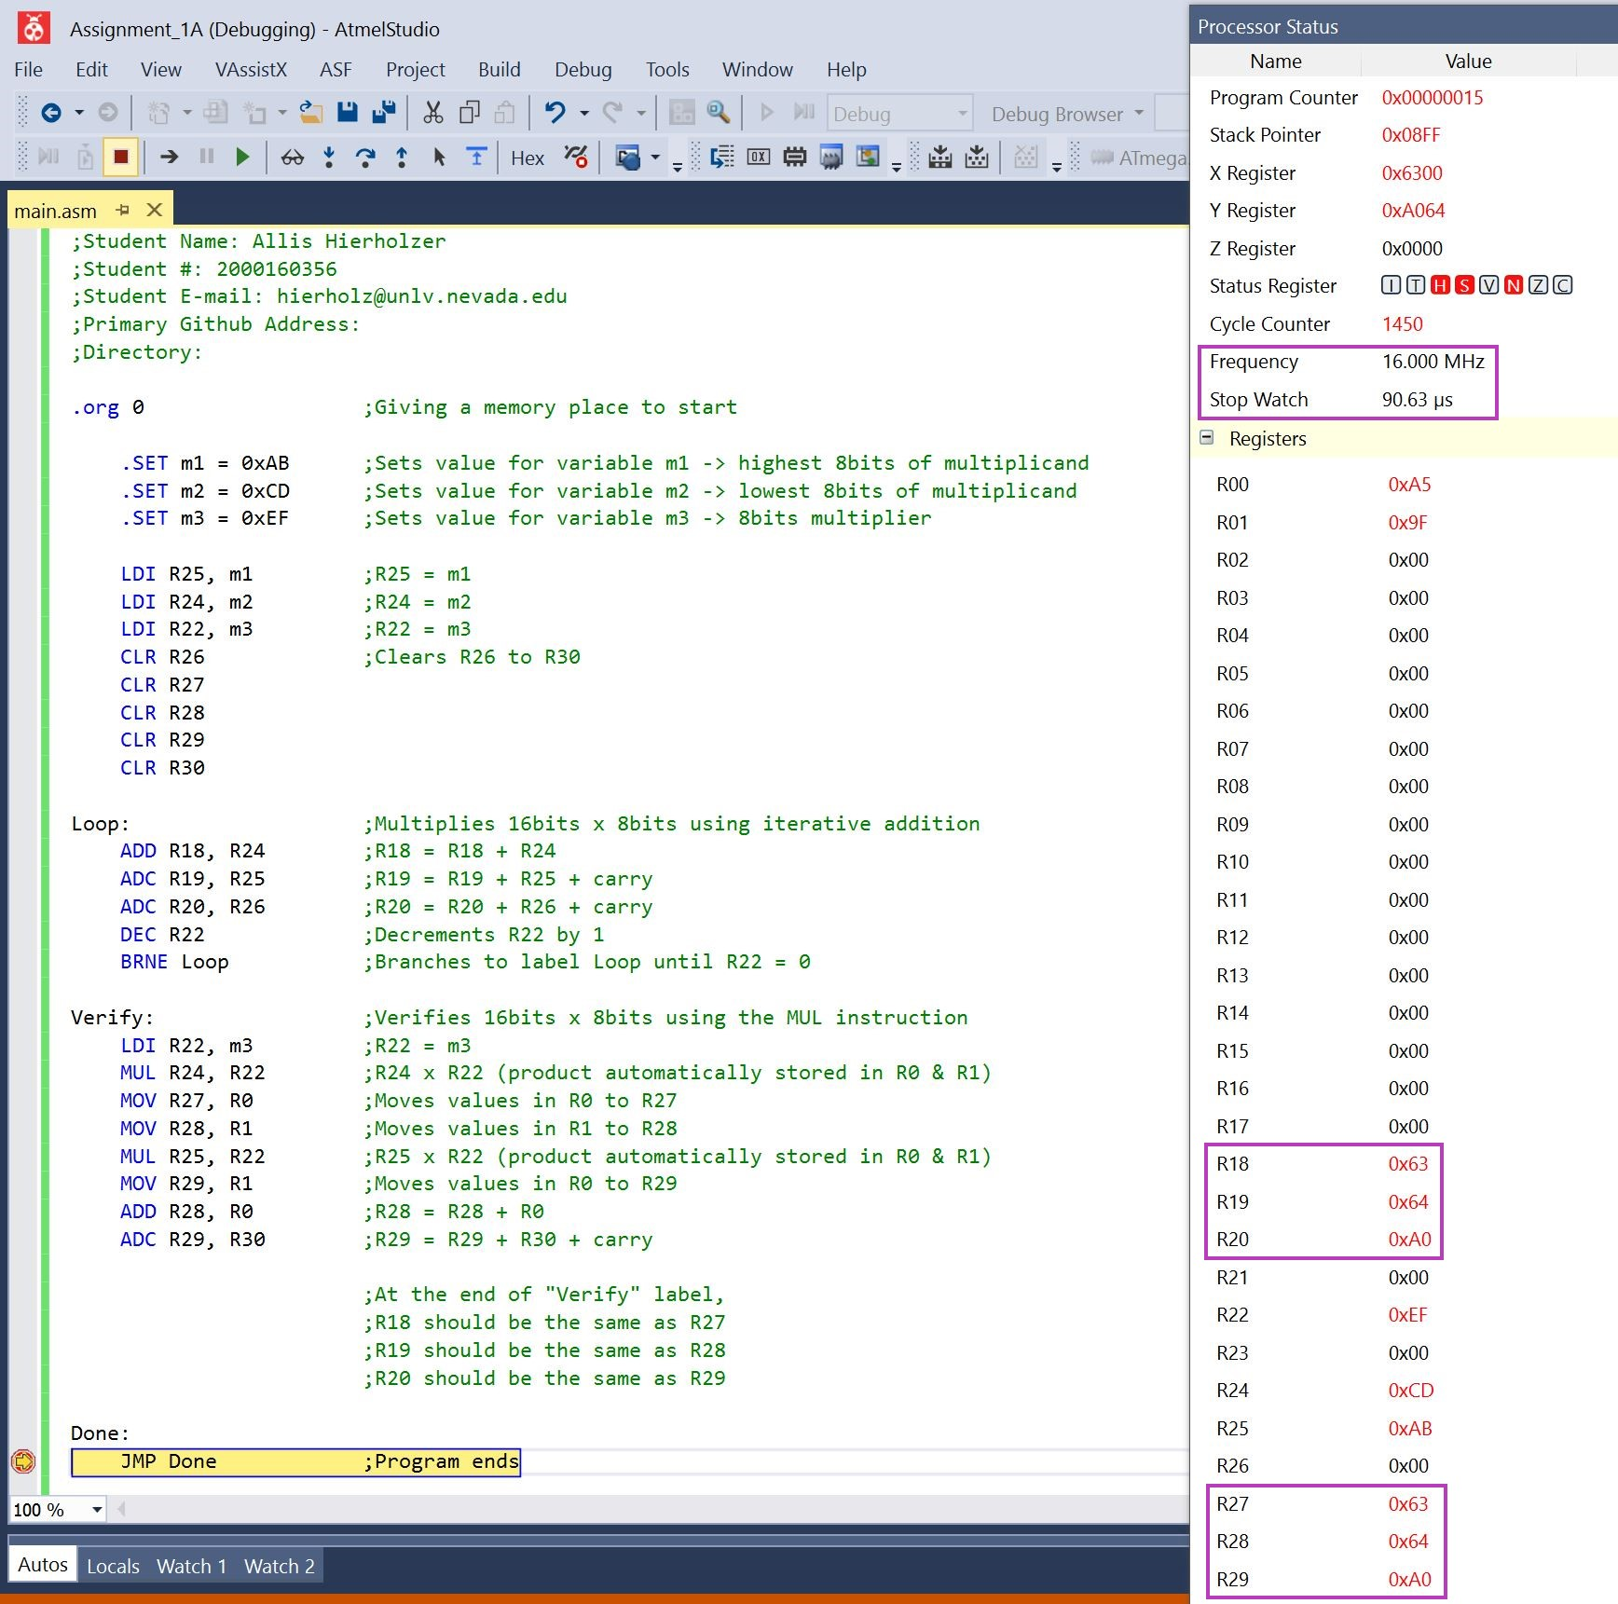

1. **SCREENSHOT OF EACH DEMO (BOARD SETUP)**

N/A

1. **VIDEO LINKS OF EACH DEMO**

N/A

1. **GITHUB LINK OF THIS DA**

<https://github.com/acexhp/submission_da.git>

**Student Academic Misconduct Policy**

<http://studentconduct.unlv.edu/misconduct/policy.html>

“This assignment submission is my own, original work”.

Allis Hierholzer