CPE301 – SPRING 2019

Design Assignment 2C

Student Name: Allis Hierholzer

Student #: 2000160356

Student Email: hierholz@unlv.nevada.edu

Primary Github address: https://github.com/acexhp/submission_da.git

Directory: Repository/cpe301/DesignAssignment/DA2C

Task:

The goal of the assignment is use GPIO and delays using Timers and Interrupts:

1. Implement Design Assignment 2A using Timer 0 – normal mode. Count OVF occurrence if needed. Do not use interrupts.

2. Implement Design Assignment 2A using TIMER0_OVF_vect interrupt mechanism in normal mode.

3. Implement Design Assignment 2A using TIMER0_COMPA_vect interrupt mechanism in CTC mode.

Submission:

The following are required for successful completion of the design assignment:

a. AVR C code that has been compiled and working for all four tasks. Verify the period and duty cycle of the waveforms in simulation and emulation.

b. The C code should be well documented with explanation of every instruction.

c. A word document that contains the code with comments, complete schematics, that includes the AVR, components connected on the breadboard and LED should be included. Follow the template provided.

d. A snapshot of the board with connected components and a video of the complete LED bar blink sequence should be recorded and uploaded to Youtube and the line to be provided for each task.

e. The git directory should have DA2\DA2T1, DA2\DA2T2, … folders, with one doc file and video link file.

1. **COMPONENTS LIST AND CONNECTION BLOCK DIAGRAM w/ PINS**

* ATMEGA328P XPLAINED MINI
* MULTIFUNCTION SHIELD
* ATMEL STUDIO 7.0
* Oscilloscope

1. **INITIAL/MODIFIED/DEVELOPED CODE OF TASK 1/A**

**1A**

#define *F_CPU* 16000000UL //clock runs at 16 MHz

#include <avr/io.h>

#include<util/delay.h>

int main()

{

int overflow = 0; //initialize overflow

DDRB |= (1 << DDB2); //PB2 as output

TCCR0A = 0;

TCNT0 = 0x00; //start timer

TCCR0B = (1 << CS02) | (1 << CS00); //pre-scaler = 1024

while (1){

while ((TIFR0 & 0x01) == 0); //detects overflow

TCNT0 = 0x00; //resets counter

TIFR0 = 0x01; //reset overflow flag

overflow++; //inc overflow

if (overflow <= 26) //led on

PORTB = (0 << DDB2);

else PORTB = (1 << DDB2);

if (overflow == 44) {

overflow = 0; //turns off led

}

}

}

**1B**

#define *F_CPU* 16000000UL //clock runs at 16 MHz

#include <avr/io.h>

#include<util/delay.h>

int overflow = 0; //initialize overflow

int main()

{

DDRB |= (1<<2); //set PORTB2 as output

PORTB |= (1<<2); //Turn LED off

DDRC &= (0<<2); // set PORTC1 for input

PORTC |= (1<<2); // enable pull-up

TCCR0A = 0;

TCCR0B = (1 << CS02) | (1 << CS00); //pre-scaler = 1024

//when the PINC is pressed, LED pulses

while (1) {

if (!(PINC & (1<<PINC1)))

{

overflow = 0;

TCNT0 = 0;

}

while ((TIFR0 & 0x01) == 0); //detects overflow

TCNT0 = 0x00; //resets counter

TIFR0 = 0x01; //reset overflow flag

overflow++; //inc overflow

if (overflow <= 69) //led turns on

PORTB = (0 << DDB2);

else PORTB = (1 << DDB2); //led off

}

return 0;

}

**2A**

#define *F_CPU* 16000000UL //clock runs at 16 MHz

#include <avr/io.h>

#include<avr/interrupt.h>

int overflow = 0; //initialize overflow

int main(void)

{

DDRB |= (1 << DDB2); //PB2 as output

TIMSK0 |= (1 << TOIE0); //enables interrupt

TCNT0 = 0; //start counter

sei(); //enables interrupt

TCCR0B = (1 << CS02) | (1 << CS00); //pre-scaler = 1024

while (1)

{

}

}

ISR (TIMER0_OVF_vect) //timer0 overflow interrupt

{

while ((TIFR0 & 0x01) == 0); //detects overflow

TCNT0 = 0x00; //resets counter

TIFR0 = 0x01; //reset overflow flag

overflow++; //inc overflow

if (overflow <= 13) //led on (13 instead of 26 because...

PORTB = (0 << DDB2); //... overflow is being doubled)

else PORTB = (1 << DDB2);

if (overflow == 22) {

overflow = 0; //turns off led

}

}

**2B**

#define *F_CPU* 16000000UL //clock runs at 16 MHz

#include <avr/io.h>

#include<avr/interrupt.h>

int overflow = 0; //initialize overflow

int main(void)

{

DDRB |= (1 << DDB2); //PB2 as output

TIMSK0 |= (1 << TOIE0); //enables interrupt

TCNT0 = 0; //start counter

sei(); //enables interrupt

TCCR0B = (1 << CS02) | (1 << CS00); //pre-scaler = 1024

while (1)

{

}

}

ISR (TIMER0_OVF_vect) //timer0 overflow interrupt

{

while (1) {

if (!(PINC & (1<<PINC1)))

{

overflow = 0;

TCNT0 = 0;

}

while ((TIFR0 & 0x01) == 0); //detects overflow

TCNT0 = 0x00; //resets counter

TIFR0 = 0x01; //reset overflow flag

overflow++; //inc overflow

if (overflow <= 69) //led turns on

PORTB = (0 << DDB2);

else PORTB = (1 << DDB2); //led off

}

}

**3A**

#define *F_CPU* 16000000UL //clock runs at 16 MHz

#include <avr/io.h>

#include<avr/interrupt.h>

int overflow = 0; //initialize overflow

int main(void)

{

DDRB |= (1 << DDB2); //PB2 as output

TCNT0 = 0; //start counter

OCR0A = 255; //load compare reg value

TCCR0A |= (1 << WGM01); //set to ctc mode

TIMSK0 |= (1 << OCIE0A); //set interrupt on compare match

TCCR0B = (1 << CS02) | (1 << CS00); //pre-scaler = 1024

sei(); //enables interrupt

while (1)

{

}

}

ISR (TIMER0_COMPA_vect) //timer0 overflow interrupt

{

while ((TIFR0 & 0x02) == 0); //detects overflow

TCNT0 = 0x00; //resets counter

TIFR0 = 0x02; //reset overflow flag

overflow++; //inc overflow

if (overflow <= 13) //led on (13 instead of 26 because...

PORTB = (0 << DDB2); //... overflow is being doubled)

else PORTB = (1 << DDB2);

if (overflow == 22) {

overflow = 0; //turns off led

}

}

**3B**

#define *F_CPU* 16000000UL //clock runs at 16 MHz

#include <avr/io.h>

#include<avr/interrupt.h>

int overflow = 0; //initialize overflow

int main(void)

{

DDRB |= (1 << DDB2); //PB2 as output

TCNT0 = 0; //start counter

OCR0A = 255; //load compare reg value

TCCR0A |= (1 << WGM01); //set to ctc mode

TIMSK0 |= (1 << OCIE0A); //set interrupt on compare match

TCCR0B = (1 << CS02) | (1 << CS00); //pre-scaler = 1024

sei(); //enables interrupt

while (1)

{

}

}

ISR (TIMER0_COMPA_vect) //timer0 overflow interrupt

{

while (1) {

if (!(PINC & (1<<PINC1)))

{

overflow = 0;

TCNT0 = 0;

}

while ((TIFR0 & 0x02) == 0); //detects overflow

TCNT0 = 0x00; //resets counter

TIFR0 = 0x02; //reset overflow flag

overflow++; //inc overflow

if (overflow <= 69) //led turns on

PORTB = (0 << DDB2);

else PORTB = (1 << DDB2); //led off

}

}

1. **SCHEMATICS**

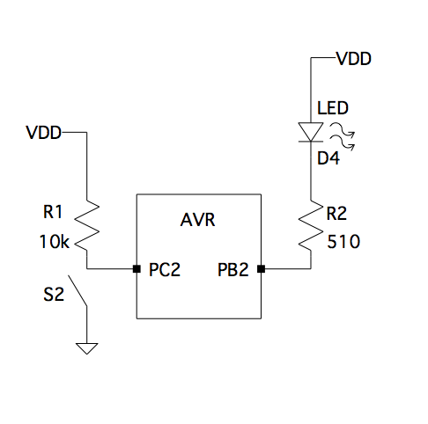

1. **SCREENSHOTS OF EACH TASK OUTPUT (ATMEL STUDIO OUTPUT)**

**1A**

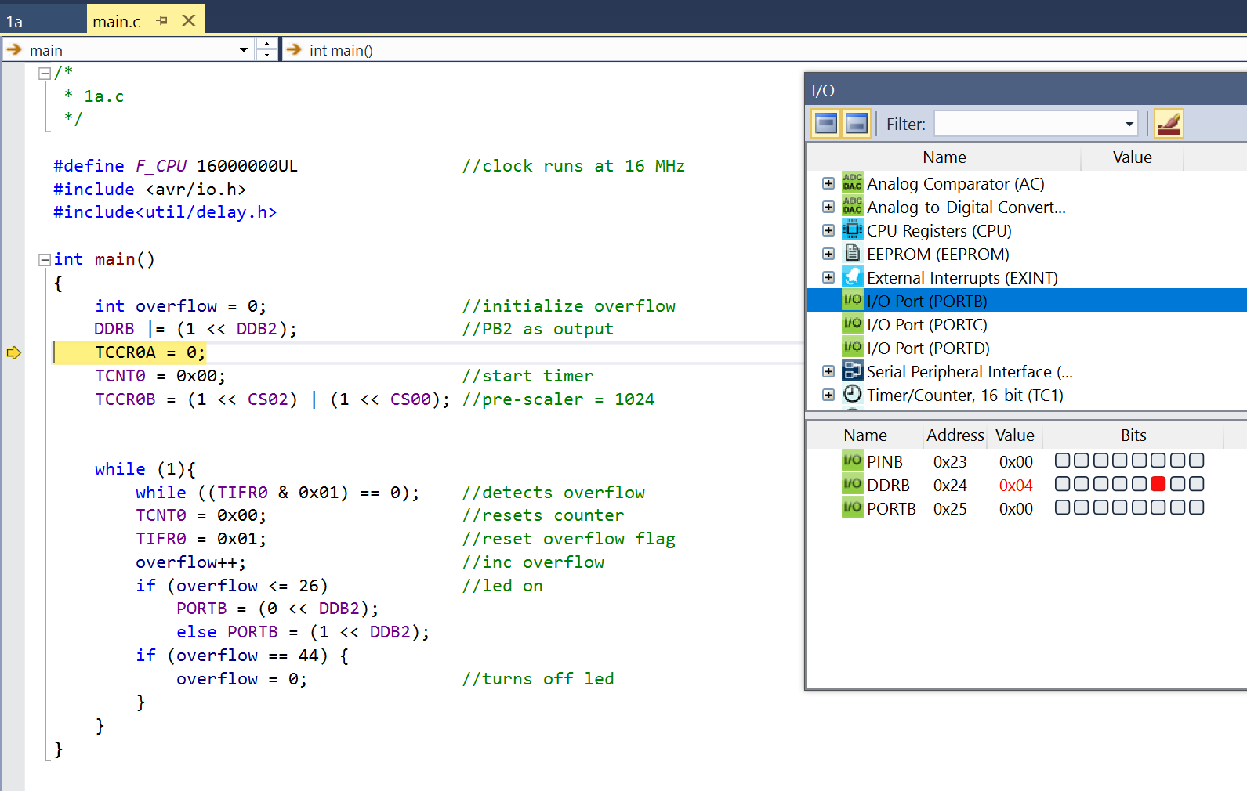

**1B**

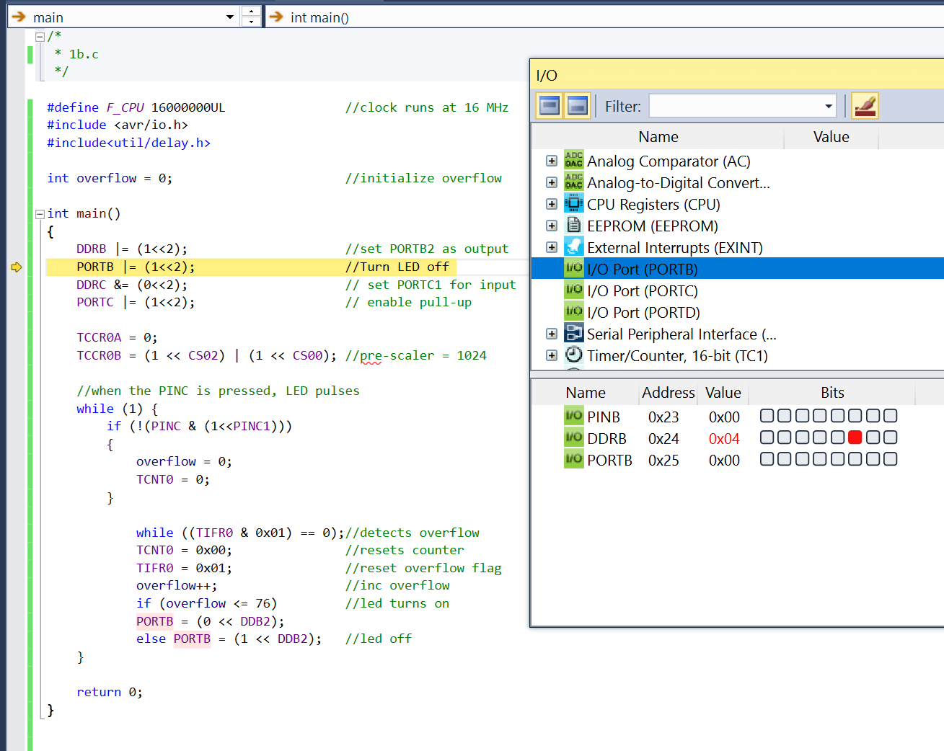

**2A**

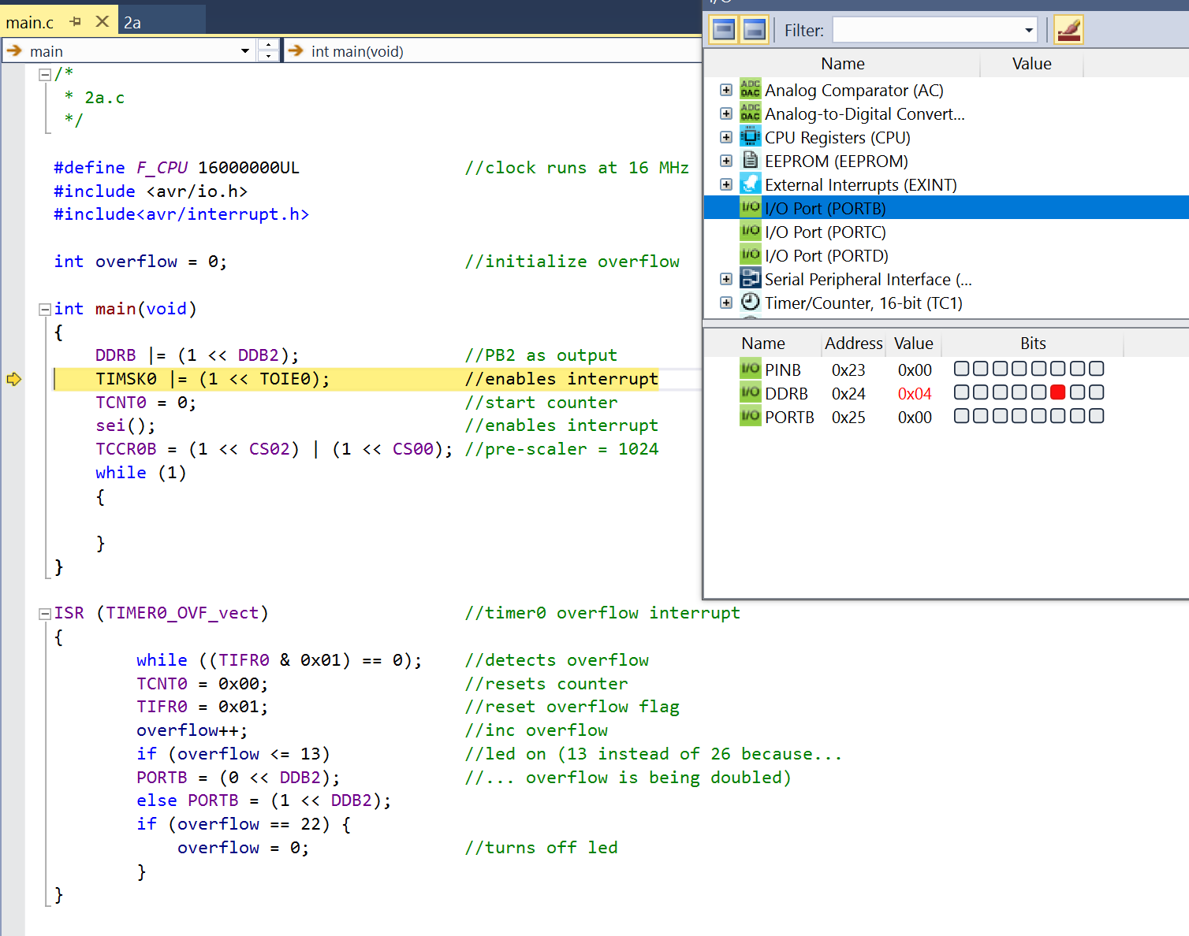

**2B**

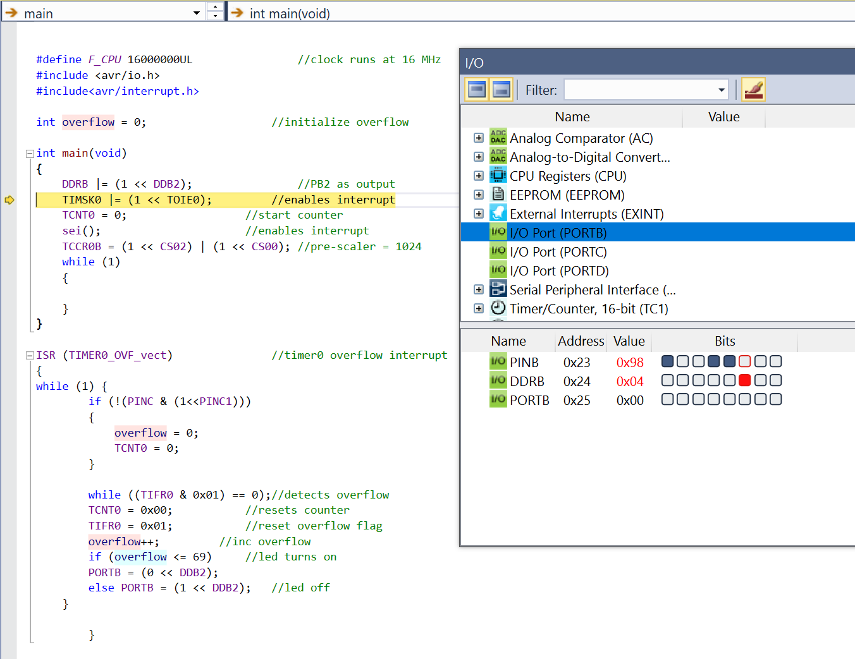

**3A**

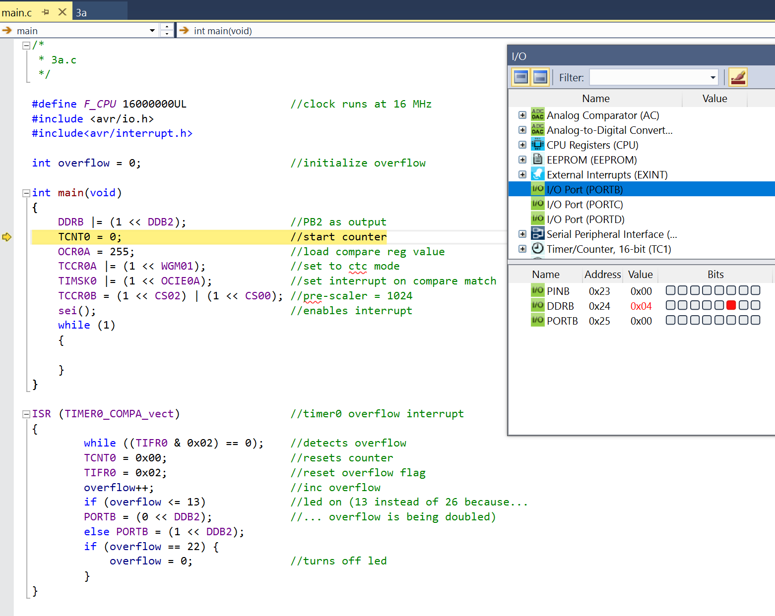

**3B**

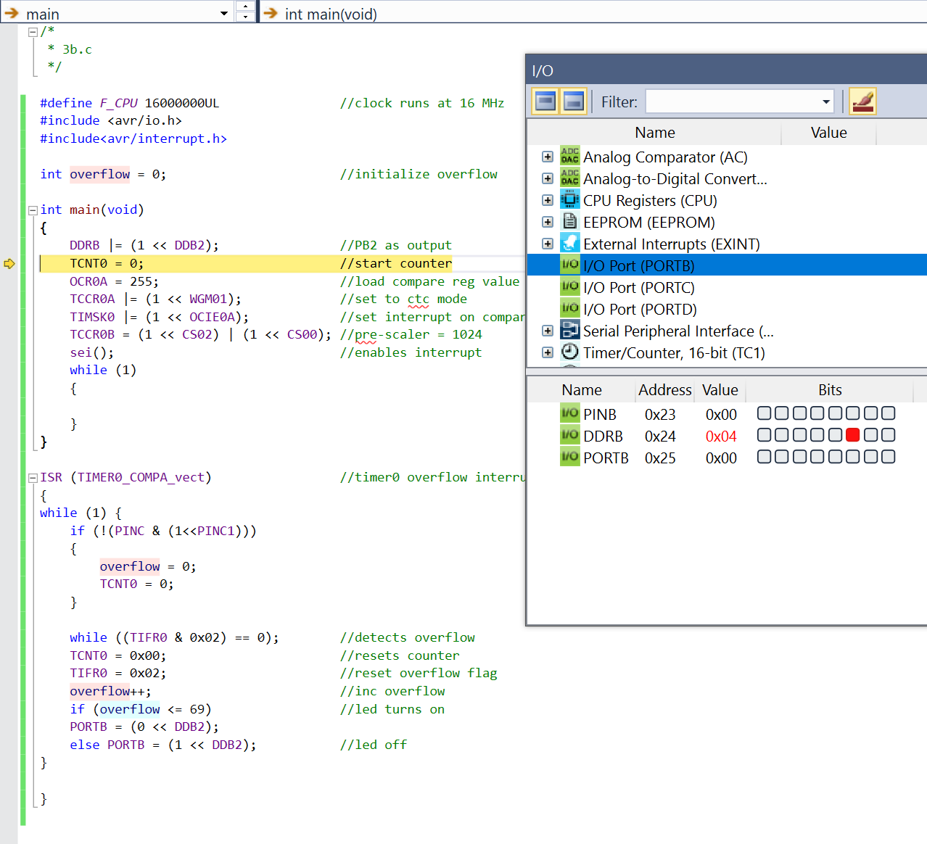

1. **SCREENSHOT OF EACH DEMO (BOARD SETUP)**

**The board set up is the same for all exercises**

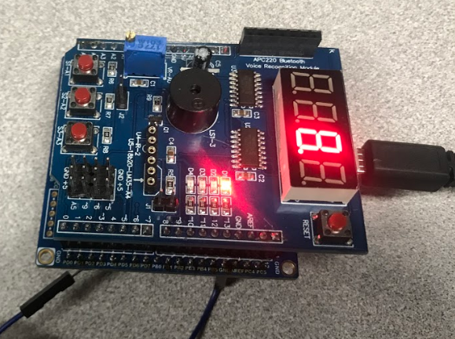

1. **VIDEO LINKS OF EACH DEMO**

**1A**

[**https://youtu.be/7cCjv1m9Di4**](https://youtu.be/7cCjv1m9Di4)

**1B**

[**https://youtu.be/z2lXkrFeqw0**](https://youtu.be/z2lXkrFeqw0)

**2A**

[**https://youtu.be/m-iaM6LmcC8**](https://youtu.be/m-iaM6LmcC8)

**2B**

[**https://youtu.be/j0gw1afVVrg**](https://youtu.be/j0gw1afVVrg)

**3A**

[**https://youtu.be/hrxYflyjL0o**](https://youtu.be/hrxYflyjL0o)

**3B**

[**https://youtu.be/MIzcfgecc1g**](https://youtu.be/MIzcfgecc1g)

1. **GITHUB LINK OF THIS DA**

<https://github.com/acexhp/submission_da.git>

**Student Academic Misconduct Policy**

<http://studentconduct.unlv.edu/misconduct/policy.html>

“This assignment submission is my own, original work”.

Allis Hierholzer