CPE301 – SPRING 2019

Design Assignment 4A

Student Name: Allis Hierholzer

Student #: 2000160356

Student Email: hierholz@unlv.nevada.edu

Primary Github address: https://github.com/acexhp/submission_da.git

Directory: Repository/cpe301/DesignAssignment/DA4A

Task:

The goal of the assignment is to modify the above codes to do the following:

1. Write an AVR C program to control the speed of the DC Motor using a potentiometer connected to PC0. Use an interrupt on a button (PC1/2/3) to stop and start the motor at each click. The minimum speed of the motor should be 0 when pot is minimum and maximum should be 95% of PWM value.

Submission:

The following are required for successful completion of the design assignment:

a. AVR C code that has been compiled and working.

b. The C code should be well documented with explanation of every instruction.

c. A word document that contains the flow chart of the assembly code along with the snapshots of the schematics, components connected on the breadboard and screenshots.

1. **COMPONENTS LIST**

* Breadboard
* Power Supply
* Wires
* USB Cables
* ATMEGA328P XPLAINED MINI
* ATMEL STUDIO 7.0
* Multifunction Shield
* TB6612FNG Driver IC for DC Motor
* DC Motor

1. **INITIAL/MODIFIED/DEVELOPED CODE OF TASK 1/A**

/*

* DA4A.c

*/

#define *F_CPU* 16000000UL //clock runs at 16 MHz

#include <avr/io.h>

#include <util/delay.h>

#include <avr/interrupt.h>

#include <stdio.h>

#define MTR_1 5

#define SWITCH (PINC&(1<<3)) // switch on PINC3

int DCMotor=0; //variable for on/off motor

int main(void)

{

PORTC |=(1<<2); //pull-up resistor

OCR0A = 200; //setting top = 200, frequency

//sets timer/counter control register, mode 7, fast PWM and prescaler is 256

TCCR0A |= (1<<COM0A1)|(0<<COM0A0)|(1<<COM0B1)|(0<<COM0B0)|(1<<WGM01)|(1<<WGM00);

TCCR0B |= (1<<WGM02)|(1<<CS02)|(0<<CS01)|(0<<CS00);

while (1)

{

//Checks if the button is pressed while motor is off

while (!DCMotor)

{

if(!SWITCH)

{

*_delay_ms*(100);

ADCSRA |= ((1<<ADEN)|(1<<ADSC)|(0<<ADPS2)|(0<<ADPS1)|(1<<ADPS0));

ADMUX |= (1<<REFS0);

{

OCR0B = ADC; //value being read from potentiometer,

sets duty cycle

DDRD = 0xFF; //output

PORTD = 0x20; //sets PD5 HIGH

DCMotor=1; //setting motor to 1 to get out of

while loop

}

}

}

//Checks if the button is pressed while motor is on

while (DCMotor)

{

if(!SWITCH)

{

*_delay_ms*(100);

// Turns off the motor and let it run CW

PORTD &= ~(1<<5);

DDRD = 0;

DCMotor=0;

}

}

}

}

1. **SCHEMATICS**

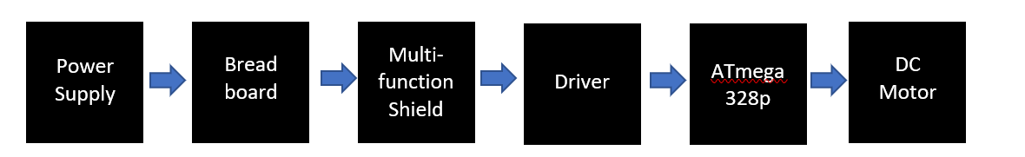

1. **SCREENSHOTS OF EACH TASK OUTPUT (ATMEL STUDIO OUTPUT)**

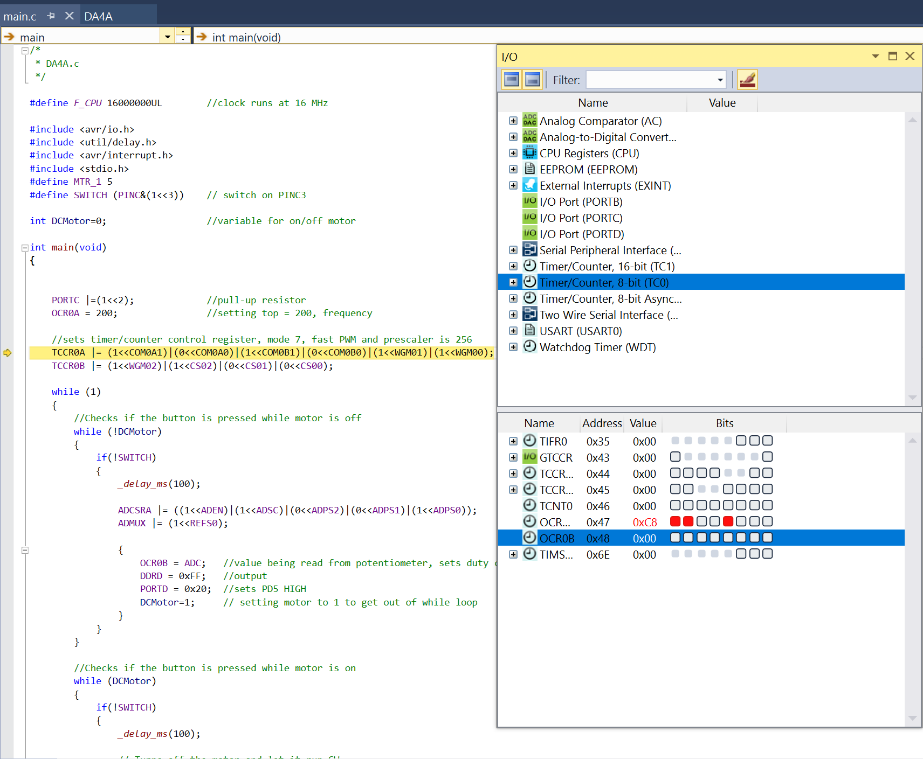

1. **SCREENSHOT OF EACH DEMO (BOARD SETUP)**

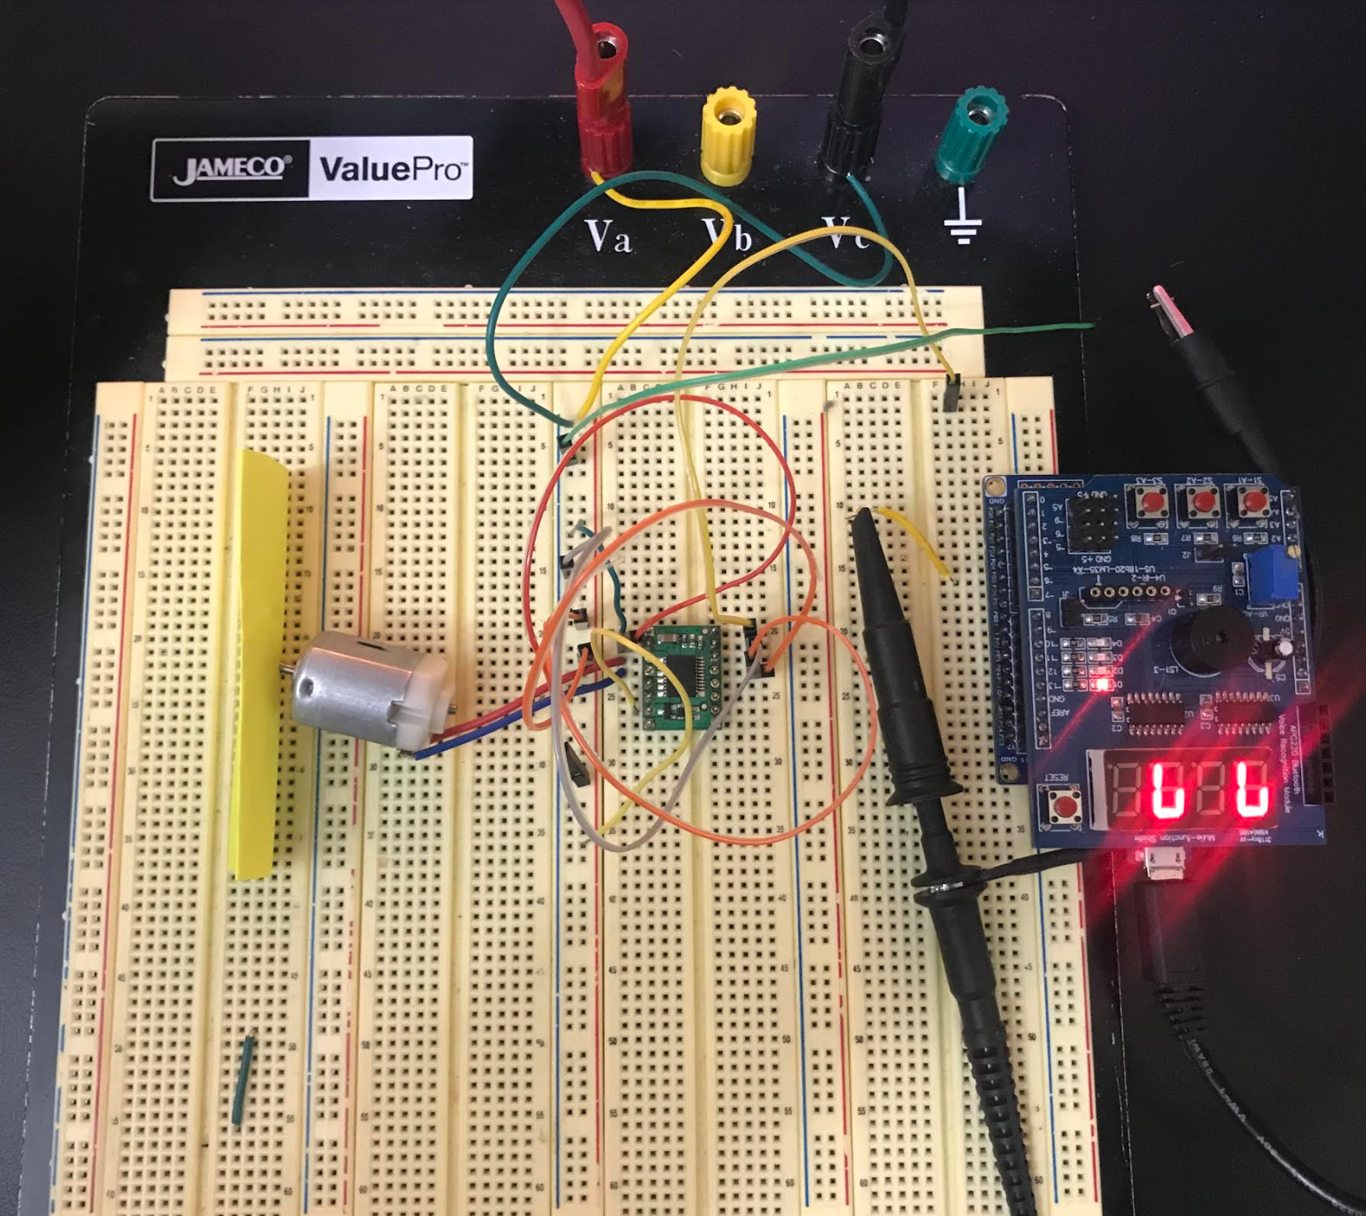

1. **VIDEO LINKS OF EACH DEMO**

<https://youtu.be/2Bzs6oS3j8g>

1. **GITHUB LINK OF THIS DA**

<https://github.com/acexhp/submission_da.git>

**Student Academic Misconduct Policy**

<http://studentconduct.unlv.edu/misconduct/policy.html>

“This assignment submission is my own, original work”.

Allis Hierholzer