Break the resume into components
Search and label/separate resumes into components:

Preprocessing Proposal:
The first thing we do to the input, one user resume, is convert it from a PDF file extension, to plain text. We want to break the resume text into several components: “Name,” “Location,” “Summary,” “Skills/Projects,” “Work Experience,” and “Education.”
Converting the entire document into a semantic vector is quicker in the short term, but more difficult to analyze the patterns we need later. So, we have several sets of artificial weights and biases for each category. A window, or kernel is run over the text, the window size is a line and embeds each line as a semantic vector using the sentence_transformers Python module, and checks for embedded key words. For example, for education a key word may be: “university,” “degree,” or “academic”. The idea here is that we may update the key words and weights as more users use the application, and use the weights as a filter to find the components we need.
In addition, there is an introduced bias, when the program hits a keyword, the lines around it are given a higher weight for the previous keyword, which decreases in strength as we venture further from the key word hit. As we iterate through the text, separating the windows into different sets, we embed each window as a vector, to compare with our dataset later.
We use the ‘re’ Python module to create string patterns to search for, specifically looking for addresses, and dates. When we come across a potential address we use the ‘Geopy’ module to check if the line is a valid address, if it is, that becomes are current location, and the place where we wish to search for potential employers.

The program asks the user to enter their name, which is used as a locater, as most modern resume formats have the owner’s name along with their contact information at the top of the resume:

Here a new window is created, with a high weight on the information surrounding the name, so an address or job position title, is weighted heavier here. We use a separate dataset for job positions, that we can embed, and then use cosine similarity to find the closest match within the ‘name’ window.
With the resume organized by cosine similarity, we can now pass that information to the data-scraping agent, which searches linkedIn for the user’s job title, and location.
We then organize the linkedIn job posting in the same manner as the resume, and match the components together, finding the similarity between components, then taking the micro-average, between the job posting and the resume components. Then we use UMap to find the top two components with the highest variance, and plot them on a scatter plot, so the user can visualize how likely a job offer is for them.
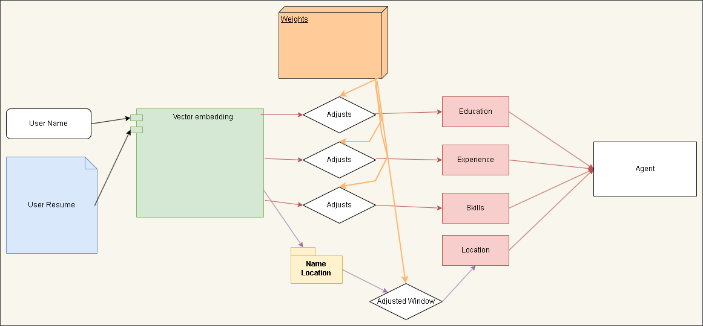
Potential Example Output:
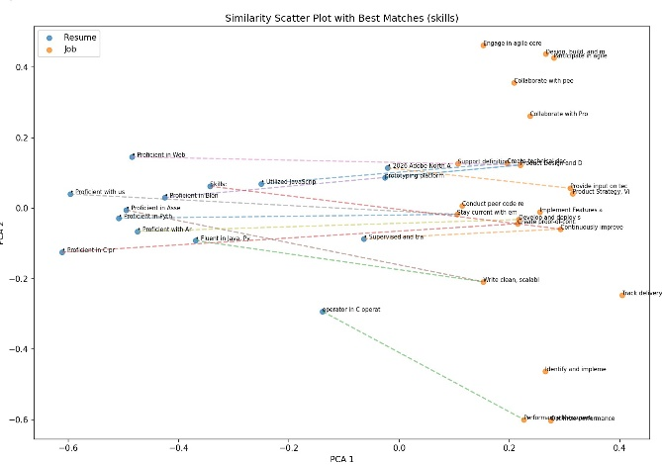

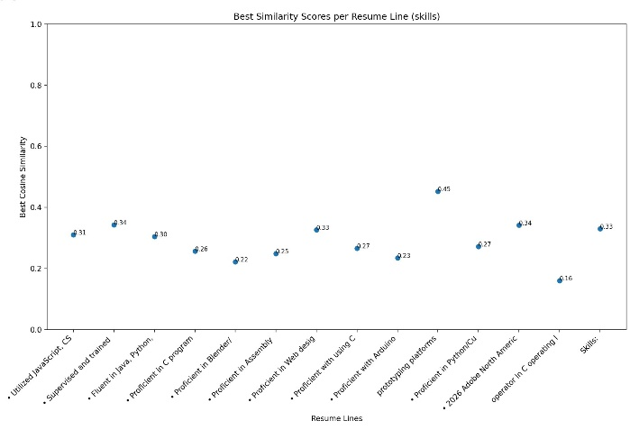
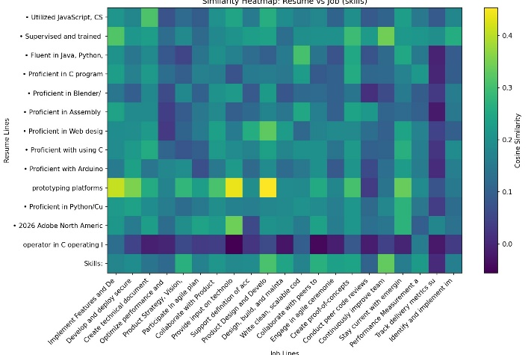
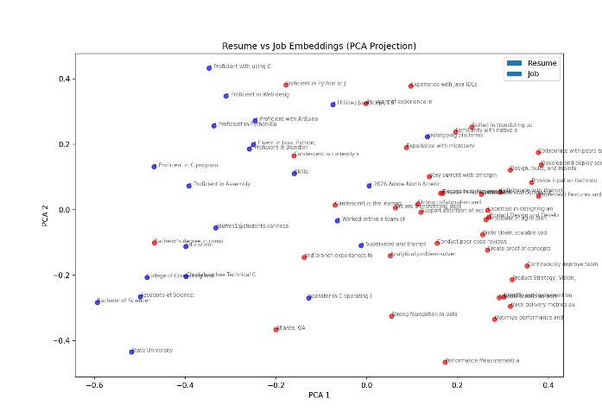
Example of a good heatmap:
