**Spirit Airlines Customer Service Analysis: A Study on Airlines Business Analytics and its**

**Applications to Improve Customer Satisfaction**

Nisha Chapagain

Mathew English

Ana C Faria

Eliza Sapkota

University of Tampa

ITM 615: Data Mining for Businesses

J.B. Kim, Ph.D.

December 5th, 2022

**Table of Contents**

**SECTION 1. Executive Summary**3

**SECTION 2. Spirit Airlines**4

Company Background 4

Company Product 5

Current Business Analytics Maturity 5

**SECTION 3. Business Analytics Problem**6

**SECTION 4. Business Analytics Solution**8

Logistic Regression Model. Identification of Customer Preferences. 10

Cluster Analysis Model. Identification of Loyalty Program Attributes. 13

**SECTION 5. Implementation**16

Logistic Regression Model Result Recommendations. 16

Cluster Analysis Model Result Recommendations. 17

**SECTION 6. Summary & Conclusion**18

**REFERENCES.**18

# **SECTION 1. Executive Summary**

Spirit Airlines has been at the forefront of low cost traveling in the massive airlines market. Yet, in recent years, their successful low cost business strategy has started to be questioned based on the customer service performance. Many travelers have come forward to even name the airline as one of the worst ones in the market, which has cost Spirit Airlines their reputation, and given other low cost competitors the advantage to attract new customers. In the following report, we discuss the findings of our analysis into their customer satisfaction, what the company can do in order to improve their performance in customer service, and attract new customers, as well as welcoming back past customers.

For this analysis, we created a logistic regression model to first understand what their customer pool values in customer service. With the results, we found evidence of customers being generally unsatisfied with the current loyalty program. On one hand, we found that customers usually value convenience focused customer services, that is services that make the experience easier, rather than services that add to their experience. On the other hand, this analysis showed great evidence that shows that Spirit Airlines should focus on a younger customer pool, who is most likely to have lower expectations on what their experience traveling with Spirit Airlines will look like.

Given the resulting evidence found from the logistic model, we chose to find more information regarding the customer loyalty program, and how it can be improved. For this, we conducted a cluster analysis to understand Spirit Airlines customer pool based on their age, distance traveled, if they traveled in business class or economy class, if they traveled for business or pleasure, and whether they are part of a loyalty program or not. We found compelling evidence that the loyalty program holder can be divided into two groups. One defined by older travelers that are traveling long distances for business and seeking comfort and younger tourists that travel short distances.

In the last section of our results, we explain what Spirit airlines can do with the information gathered from our business analysis, and what are some of the next steps they should follow in order to improve their customer services in the future. Given how the organization seems to be in the first stages of being competitive with their business analytics capabilities, we also provided recommendations regarding data handling. Data analytics is capable of providing a lot of useful information for the organization, yet it must be used with discretion as to not alienate prospective and current customers. Finally, we also include in our report what some things the organization should do in order to improve their business analytics capabilities moving forward.

# **SECTION 2. Spirit Airlines Company Overview**

## **Company Background**

Over 8 million passengers fly around the world every day on average, and over 2 billion fly within the United States. Everyone wants affordable flights, plush seats, and on-time departures. Spirit Airlines is an airline that takes pleasure in offering meager prices to consumers and works hard to be the most cost-effective airline compared to its rivals. (Yeo, 2012). With a few exceptions, their company strategy mostly complies with the competitive scope's dimensions.

According to their website, "Spirit Airlines was founded in 1964 as a Clippert Trucking Company." (Spirit, 2022). Twenty years later, the business started offering charter flights and vacation packages to entertainment locations within the United States, mostly from the Midwest to Atlantic City, New Jersey, under the name Charter One. By 1992, Charter One changed its name to Spirit Airlines and began offering scheduled service that promoted inexpensive rates. Some have referred to this tactic as "bottom feeding" because it is characterized by frequent additional fees and subpar customer care.

The airline expanded routes from the Midwest and Northeast to Florida, which helped it to develop, but it suffered with low and inconsistent earnings since it had not completely embraced one of Porter's three generic competitive strategies: cost leadership, distinctiveness, or focus (Porter, 1998). Due to Spirit’s lack of a competitive edge, it suffered significant losses from 2004 to 2006 that put the airline in danger of failing. Spirit introduced new management and established a business strategy in 2006 that was entirely centered on offering the lowest prices to a very specific market niche for air travel. The ultra-low-cost strategy has been astonishingly effective, according to a review of current financial and operational data. Spirit had the highest growth in the United States in 2012, with revenue passenger miles increasing by 30.6% and available seat miles decreasing by 27.5%, bringing its load factor to 84.8%. (Hegeman, 2013). Additionally, Spirit had the second-highest profitability among all major U.S. earners in 2012, with revenues declining by 3%. Since then, the company has expanded its services beyond coast to coast and transformed into a low-cost and ultra-low-cost airline. However, like many of its competitors, Spirit has faced harsh financial struggles in the past few years. In 2021, they had to cancel millions of flights as they faced weather issues, staff shortages, and technology issues (Forbes, 2021). The airline reported a net loss of $473 million in 2021, according to the Wall Street Journal (WSJ, 2022). This is the second year that Spirit Airlines has reported a net loss after the 2020 Covid-19 pandemic. This led to Jet Blue’s agreement to acquire Spirit Airlines in February 2022 for $3.8 billion. Still, the acquisition is under investigation by regulators. If approved, it would leave only one discount carrier in the market, Frontier Airlines (CNBC, 2022).

**Company Organizational Structure**

Currently Spirit Airlines is led by CEO & President Ted Christie III. The executive team is divided into seven positions. Matthew Klein oversees Marketing, Pricing & Revenue Management, Network Planning & Scheduling, and Commercial & Operational Analytics as the Chief Commercial Officer & Senior Vice President. Robert Schroeter oversees Advertising, Brand, Communications, Pricing and Revenue Management, Omnichannel Commerce, and Guest Care as Senior Vice President & Chief Marketing Officer. Rocky Wiggins leads as Senior Vice President and Chief Information officer since 2016, and has prior experience working as CIO in other smaller local airlines such as Sun Country Airlines and AirTran Airways. Scott Haralson leads as a Senior Vice President & Chief Financial Officer. John Bendoratitis has served as the Executive Vice President & Chief Operating Officer since December 2017. Thomas Canfield is General Counsel & Secretary at Spirit Airlines. Finally, Linde Grindle oversees the Human Resource Department as Chief Human Resources Officer at Spirit (Spirit Airlines Website, 2022). Spirit has 9,823 employees across the country with an 18.7% turnover rate.

## **Company Product**

Spirit Airlines has continued to diversify throughout the twenty-first century. As it aimed to extend its network outside of the US, it started with the adoption of Spanish-language customer assistance services. The turn of 2000, also brought about changes to Spirit's fleet; it has now switched from McDonnell Douglas planes to Airbus A320 series aircraft. In addition, they also made significant changes to their brand. In 2014, Spirit introduced their distinctive yellow carriers, which remain one of the most distinctive in the US since then (USA Today, 2014).

Looking at services, they solely indicate the price of transporting clients to their location, free of any additional fees. Every client has frill control, which gives them the freedom to select the services they want to add to the base fare without considering the preferences of other customers (Spirit Airlines 10K, 2015).

The Spirit airline sector manages a variety of commercial processes at once, including customer service, luggage handling, flight scheduling, and general administration of operations. As a result, through a variety of systems (such as frequent flyer programs and central reservation systems), airlines gather and retain enormous amounts of heterogeneous data. By providing individually customized communication, they use the information to better understand their customers and thereby improve their customer service, which results in higher sales. To examine aviation safety data and improve internal airline safety analyses, spirit airlines make use of data warehouse techniques (Revels, 2013).

## **Current Business Analytics Maturity**

As a massive airline with billions of flights per day, and a massive operation, they have been working with SAP S/4HANA public cloud since 2019. That year they transitioned from SAP legacy ECC software. (ComputerWorld, 2019). They faced several issues during this integration as it initially faced issues integrating OpenText for invoicing and Z-Options, the Excel plug-in. They currently have a business analytics team that, according to their 2020 filings, are still working on the ERP integration (Spirit Airlines Inc 10-K, 2020).

***DELTA Model***

The DELTA model provides the five main components that encompass a successful business analytics program. With the limited data we were provided we concluded the following to be the results for Spirit Airlines:

* Data: Stage 3. As they are finalizing their ERP System integration, we concluded that they must have their data readily organized in a centralized ERP warehouse.
* Enterprise: Early Stage 4. As earlier discussed, Spirit Airlines has been in the process of integrating a new ERP system. In addition, they are known not to have a reliable way to book flights or even interline agreements to be able to accommodate passengers in the case of cancellations or delays. (CNBC, 2021)
* Leadership: Stage 4. They have a Chief Information Officer that should be overseeing Business Analytics and Software integrations efforts in their business.
* Targets: Stage 3. As they are finalizing their ERP integration, we can assume that there is a set of analytics goals recognized by the organization. Yet, given their recent business struggles, it may also be true that there may be conflicting levels of priority in their business model.
* Analysts: Stage 5. According to a recent interview with the company's CIO, the analytics team has been working on developing technology that is useful for both the company as well as customer use (Profile Magazine, 2020).

Overall, it can be determined that Spirit Airlines is highly motivated to keep improving its business analytics capabilities and see the value in analytics. Yet, their somewhat archaic business analytics structure in addition to their struggles in EPR integration, we concluded that they must be around Stage 3 in their Business Maturity.

# **SECTION 3. Business Analytics Problem**

In order to be able to identify the most important business problems in Spirit Airlines, we conducted a SWOT Analysis to understand Spirit Airlines' business operations and the areas of weaknesses that could be improved using business analytics tools.

***Strengths***

* Brand recognition across their operating region.
* Cost leadership in the airline market. Only one price competitor in the market, Frontier.
* Ongoing development in an integrated infrastructure that helps enhance operational efficiency.

***Weaknesses***

* Although Spirit Airlines is one of the leading organizations in the industry, they are facing challenges in moving to other product segments outside of its core business.
* A high employee turnover ratio and lack of organizational commitment can increase recruitment costs and reduce organizational productivity.
* Not efficient in product demand forecasting leading to a higher rate of missed opportunities in comparison to its competitors.
* Customer service has been detrimental to the brand, in 2018, it was branded as the worst airline in America by Business Insider (Business Insider, 2018)

***Opportunities***

* The new advanced technology allows Spirit airlines to practice differentiated pricing strategies in the market. This will attract new customers and maintain loyal customers with great service.
* The changing needs, tastes, and preferences of the customer might be an opportunity for the business organization if they have **good market knowledge.**
* The growing popularity of low-fare airline travel, in addition to the popularity of traveling after COVID-19 restrictions, were lifted.

***Threats***

* The increase in the number of airlines in the industry created intense competition which has put pressure not only on profitability but also on overall sales.
* Lack of supply of innovative products.
* An increase in the price of fuel is a threat to low-cost operations.

Spirit’s main focus or main business process can be dwindled down to being a low-cost air carrier. They’ve accomplished this by being innovative in their cost management. They were the first air carrier to charge customers for checked baggage (Ghitis, 2015). While this may seem shrewd and could be considered a petty cost, it does allow customers to pay for what they actually need. A customer may not need overhead space as he or she is only going away for 1 night. While other air carriers include checked baggage fees in their airfare prices, Spirit gives customers the option. Additionally, Spirit’s target customer is a price-sensitive customer, so this business practice fits what their customer wants.

Spirit’s operating strategy of being a low-cost air carrier has been proven successful. They have the highest operating margin of any air carrier and by a large margin. Part of this success comes from their purchases of new planes. Having new planes allows them to have less maintenance. On top of that, Spirit also has a quick turnaround on flights, allowing them to spread their fixed costs more efficiently. Another reason for their low-cost success is the similarity between their fleet. They operate Airbus planes A319, A320, and A321. Operating within the same family of planes allows the crew to gain familiarity, and ergo cuts costs for additional training and maintenance. Lastly, Spirit has more seats in its airplanes than its competitors. They accomplish this by having less legroom and no reclining option for their seats.

The main issue that Spirit finds itself in is its customer service. Due to the low-cost nature of their business processes, there is bound to be some hiccups along the way. In 2013, they were the first air carrier to be rated a two-star carrier. This rating followed a five-year stretch where Spirit led the industry in the number of complaints filed to the Department of Transportation (Rollert, 2015). This is very concerning, especially considering that major airlines travel a lot more often than Spirit. Between 2009 and 2013, Spirit was three times more likely to receive a complaint from one of its customers than any other airline. The poor customer service perhaps reached its apex when, in 2014, a poll showed that a small margin of respondents preferred to ride on a plane filled with snakes than a plane with Spirit (Rollert, 2015). Perhaps a bit hyperbolic, however, this poll shows the negative effect of its business process. Obviously trying to operate at as low of a cost as possible, you’re bound to have issues. Spirit has seemingly made a tradeoff between a higher quality product and services and low costs and poor customer service performance.

As far as possibilities, we have previously mentioned Spirit Airlines' recent ERP integration, as well as information technology improvement as told by the company’s Chief information officer. Still, recognizing that one of their most important areas to improve is customer service, there may be business analytic tools that would help improve customer service management. According to a marketing research conducted by Harvard Business School professor Dr. Roger Hallowell in 1996 concluded that even though there is no clear relationship between customer satisfaction, customer loyalty and profitability, there is a causal relationship between customer satisfaction and customer loyalty. In addition, this research also shows evidence of a strong relationship between customer loyalty and profitability (Hallowell, 1996). Hence, we propose that since customer loyalty is related to profitability, we could find a way to improve customer loyalty/retention through higher customer satisfaction reviews and therefore improve profitability and brand reputation. Given their cost-effective strategy, it seems that there are some areas of customer service they could improve on. That is, they could work on recognizing what changes they should make in their cost-effective strategy to improve their customer ratings, and brand without sacrificing their operating margin.

For our report, we will be conducting a logistic regression analysis to be able to define what are the key variables that are statistically significant as to predict whether a customer is “satisfied” or “unsatisfied” with their experience. As we previously mentioned, customer satisfaction is related to customer loyalty. Therefore, we would first like to establish what areas of customer service are elemental to customers categorizing their experience as either satisfactory or unsatisfactory. On the other hand, this model will help guide the business into investing in customer service areas that are found to have a greater impact on the customer’s satisfaction result.

As previously mentioned, research shows that there is a relationship between customer satisfaction and customer loyalty. Therefore, we will be studying the attributes of different groups within our data set that help the business build an effective customer loyalty program. In order to do this, we will conduct a cluster analysis to help us differentiate what are some of the patterns on different customer groups, and based on their attributes, and characteristics build an effective marketing plan that will be easily accessible for the demographic, as well as guide the business as to what this demographics are attracted to.

# **SECTION 4. Business Analytics Solution**

In the following section, we will provide the results of our analysis, as well as a description of the model chosen. We will also illustrate the goodness of fit and how this model is relevant given the data that we were supplied. For the development of these analyses, we will be using a customer satisfaction dataset retrieved from Keggle.com.

Table 1 shown below describes the variables that we worked with for our analysis and were provided by the company. We assume that as the company expands their data analytics efforts, they will be able to retrieve more demographic attributes that will help the model be even more robust, and effective.

**Table 1.**

|  |  |  |
| --- | --- | --- |
| **Variable** | **Description** | **Data Type** |
| Column1 | Data ID control | Typeless |
| id | Customer Identification number | Typeless |
| Male? | (1) if customer is male, (0) if the customer is female | Flag |
| LoyalCustomer? | (1) if customer is currently part of loyalty program, (0) if the customer is not part of loyalty program | Flag |
| Age | Customer age (ranges from 7 to 85). | Continuous |
| BusinessTravel? | (1) if customer is traveling for business, (0) if the customer is traveling for pleasure | Flag |
| Economy? | (1) if customer is traveling in economy class, (0) if the customer is in business class (1st row, extra room) | Flag |
| FlightDistance | Miles traveled by customer | Continuous |
| Inflightwifiservice | Customer Satisfaction Rating (from 1-5) of Inflight Wifi Service | Continuous |
| FlightTimeConvenient | Customer Satisfaction Rating (from 1-5) of Scheduled flight time convenience | Continuous |
| EaseOnlineBooking | Customer Satisfaction Rating (from 1-5) of Ease of booking flight online | Continuous |
| GateLocation | Customer Satisfaction Rating (from 1-5) of the location of the gate | Continuous |
| FoodDrink | Customer Satisfaction Rating (from 1-5) of foods and drinks provided In-flight | Continuous |
| OnlineBoarding | Customer Satisfaction Rating (from 1-5) of online check in for boarding | Continuous |
| SeatComfort | Customer Satisfaction Rating (from 1-5) of seat comfort | Continuous |
| InflightEntertainment | Customer Satisfaction Rating (from 1-5) of inflight entertainment provided | Continuous |
| OnBoardService | Customer Satisfaction Rating (from 1-5) of overall service during boarding of airplane | Continuous |
| LegRoom | Customer Satisfaction Rating (from 1-5) of legroom on plane | Continuous |
| BaggageHandling | Customer Satisfaction Rating (from 1-5) of baggage handling service | Continuous |
| CheckinService | Customer Satisfaction Rating (from 1-5) of the in person check in service | Continuous |
| InflightService | Customer Satisfaction Rating (from 1-5) of overall services during the flight | Continuous |
| Cleanliness | Customer Satisfaction Rating (from 1-5) of aircraft overall cleanliness | Continuous |
| DepartureDelay Min | Departure delay in minutes | Continuous |
| ArrivalDelayMin | Arrival delay in minutes | Continuous |
| Satisfied? | (1) if customer is overall satisfied with experience, (0) if customer is neutral unsatisfied with experience | Continuous |

## **Logistic Regression Model. Identification of Customer Preferences.**

For our first model, we created a logistic regression model that defines the key customer service attributes that are significant as to predict whether the overall experience satisfied the customer based on their expectations or not.

***Methodology & Results***

During the construction of the logistic regression model we found that DepartureDelay and ArrivalDelay exhibited multicollinearity issues that could hinder the accuracy of the model. This is most likely due to how both variables may be overstating the fact that if the traveler’s flight was delayed by 1 minute, then it arrived at its final destination at least 1 minute later than initially estimated.

On the other hand, we found that GateLocation, FoodDrink and DepartureDelayMin were all statistically insignificant to the model. Therefore, GateLocation and FoodDrink were excluded from the model. On the other hand, DepartureDelayMin and ArrivalDelayMin had multicollinearity issues as we have reason to believe that a departure delay will cause an arrival delay. Therefore, we determined it would be beneficial if we excluded ArrivalDelayMin, instead of DepartureDelayMin.

The regression model created using all of the data points described in Table 1 (with the exception of Column1 & ID) and excluding the variables deemed statistically insignificant, resulted in the following output shown in Table 2.

**Table 2.**

|  |  |  |  |  |  |
| --- | --- | --- | --- | --- | --- |
| Variable | Beta | S.E. | df | Sig. | Exp(B) |
| Male?(1) | -0.134 | 0.045 | 1 | 0.003 | 0.875 |
| LoyalCustomer?(1) | -2.012 | 0.064 | 1 | <.001 | 0.134 |
| Age | -0.008 | 0.002 | 1 | <.001 | 0.992 |
| BusinessTravel?(1) | -2.77 | 0.066 | 1 | 0 | 0.063 |
| Economy?(1) | 0.436 | 0.052 | 1 | <.001 | 1.546 |
| Inflightwifiservice | 0.46 | 0.026 | 1 | <.001 | 1.584 |
| FlightTimeConvenient | -0.215 | 0.017 | 1 | <.001 | 0.807 |
| EaseOnlineBooking | -0.175 | 0.025 | 1 | <.001 | 0.84 |
| OnlineBoarding | 0.533 | 0.021 | 1 | <.001 | 1.704 |
| SeatComfort | 0.068 | 0.024 | 1 | 0.004 | 1.071 |
| OnBoardService | 0.288 | 0.022 | 1 | <.001 | 1.334 |
| LegRoom | 0.205 | 0.019 | 1 | <.001 | 1.228 |
| BaggageHandling | 0.118 | 0.025 | 1 | <.001 | 1.125 |
| CheckinService | 0.302 | 0.019 | 1 | <.001 | 1.352 |
| InflightService | 0.165 | 0.026 | 1 | <.001 | 1.179 |
| Cleanliness | 0.221 | 0.023 | 1 | <.001 | 1.247 |
| DepartureDelay Min | -0.005 | 0.001 | 1 | <.001 | 0.995 |
| Constant | -4.85 | 0.148 | 1 | <.001 | 0.008 |

Based on this results we can determine the probability that a customer will be satisfied with their experience using the following equation:

**Equation 1.**

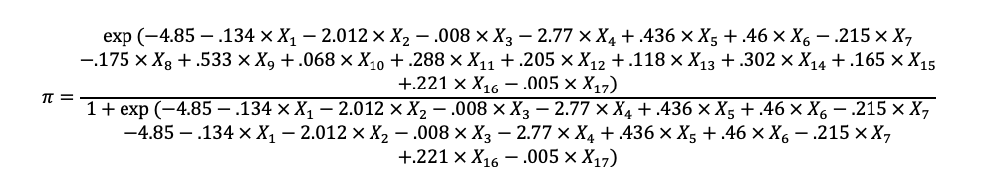

Where,

* X_1=Male?(1),
* X_2=LoyalCustomer?(1),
* X_3=Age,
* X_4=BusinessTravel?(1),
* X_5=Economy?(1),
* X_6=Inflightwifiservice,
* X_7=FlightTimeConvenient,
* X_8=EaseOnlineBooking,
* X_9=OnlineBoarding,
* X_10=SeatComfort,
* X_11=OnBoardService,
* X_12=LegRoom,
* X_13=BaggageHandling,
* X_14=CheckinService,
* X_15=InflightService,
* X_16=Cleanliness,
* X_17=DepartureDelay Min,

This results yield the following conclusions:

* Probability of customers being satisfied increases if they are traveling in economy class.
* Probability of the customer being satisfied decreases if the customer is male, is a loyal customer, and the reason for traveling is business.
* Probability of the customer being satisfied decreases as the customer's age increases.
* Probability of customer satisfaction increases with higher ratings on In-flight services, Online Boarding Experience, Seat Comfort, Boarding Services, Leg room, Baggage Handling, Check In Services, Inflight services, and cleanliness.
* Probability of customers being satisfied decreases as the departure delay increases.
* Probability of customer being satisfied decreases as Flight Time convenience and Ease of Online Booking rating increases.

Since the probability that a customer is satisfied decreases if the customer is in the loyalty program, it can be interpreted that the customer is not satisfied with the benefits provided through the program. In addition, with a coefficient value of (-2.012), loyalty program customers have one of the highest impacts on the model. This infers that loyalty program customers are more likely to be disappointed with the services given that their expectations of better customer service are probably higher.

Furthermore, we also found that the reason for traveling is one of the greatest predictors of whether the customer is satisfied or not, as shown in Chart 1.

**Exhibit 1.**

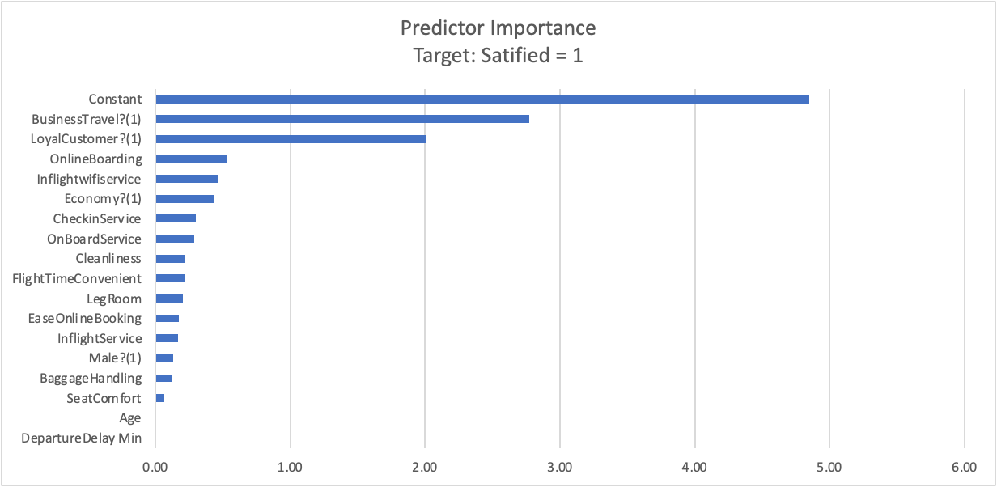

This also infers that business travelers are more likely to be unsatisfied with services rather than customers traveling for personal reasons. This opens the opportunity of focusing on targeting tourists who seek convenience rather than executives who seek comfort for a short trip. In addition, the variable with the second highest impact in the model is online boarding check-in services which increases the probability that the customer will be satisfied by 0.533 if the rating increases 1 unit. Which leads us to believe that Spirit Airlines should seek to optimize their online check in operation capabilities to attract more customers. Finally, another key variable that most impacts the probability that the customer will be satisfied with their experience is InFlightWifiService rating response, which increases the probability that the customer will be satisfied by 0.46 units if the rating increases 1 unit. This can be observed as an opportunity to improve the wifi service provided in-flight in order to attract more customers.

***Model Accuracy Analysis***

In order to test the accuracy of the logistics model we conducted a sensitivity analysis based on the results shown in chart 2, shown below.

**Exhibit 2.**

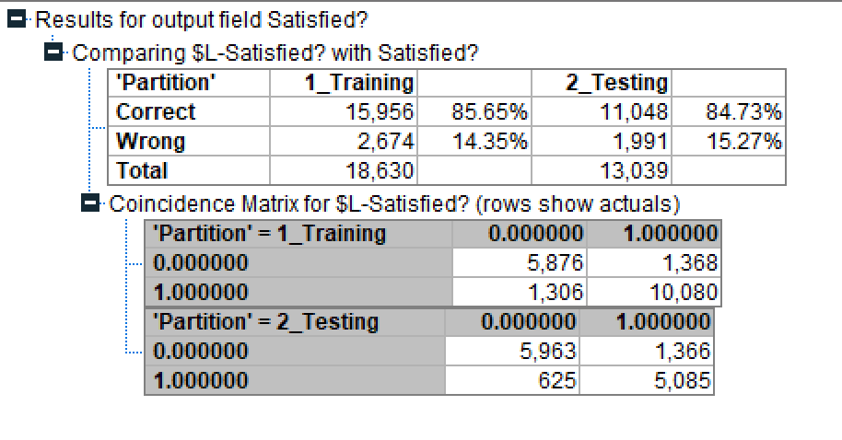

Chart 2 shows that the model has an accuracy rate of 84.73%. Furthermore, if we conduct a sensitivity analysis with the values in the coincidence matrix, we can conclude that it describes 88.06% of predicted satisfied outcomes. On the other hand, the logistic regression results show that the model has a Nagelkerke R Square of 64.2%, which means that the model explains more than half of the variability in the data.

## **Cluster Analysis Model. Identification of Loyalty Program Attributes.**

For our second model, we created a cluster analysis model that identifies different customer groups that could be captured given the data provided. This model will help Spirit Airlines adapt their marketing strategies based on the demographic or characteristics that traveler groups have in common.

***Methodology & Results***

For the development of this model we decided to measure the parameters observed in Table 3 from our dataset to study if we could identify certain customer groups.

**Table 3.**

|  |
| --- |
| Variable |
| LoyalCustomer? |
| Age |
| BusinessTravel? |
| Economy? |
| FlightDistance |

These variables were selected as they are the variables provided that describe specific attributes from the pool of customers in the study. On the other hand, we discovered through our study that including other variables that describe the experience instead of characteristics of the traveler, the validity of the model is hindered. The cluster analysis findings are described in Table 4.

**Table 4.**

|  |  |  |  |
| --- | --- | --- | --- |
| **Attribute** | **Cluster 1\*** | **Cluster 2\*** | **Cluster 3\*** |
| **LoyalCustomer?** | **1** | **0** | **1** |
| **FlightDistance** | **795.515** | **708.416** | **1799.883** |
| **Economy?** | **1** | **1** | **0** |
| **BusinessTravel?** | **0** | **1** | **1** |
| **Age** | **38.942** | **34.782** | **43.271** |

Where, LoyalCustomer? = 1, means that the customer is part of the loyalty program and LoyalCustomer? = 0, means that the customer is not part of the loyalty program. Economy? = 1, means that the customer is flying in economy class and Economy? = 0, means that the customer is flying business class. Finally, BusinessTravel? = 1, means that the customer’s trip is for business reasons and BusinessTravel? = 0, means that the customer is traveling for pleasure.

The resulting analysis places Spirit Airline’s customer pool in three distinct groups. We can observe that in cluster 1, customers are older millennials (average age of 39) part of the loyalty program, flying around 796 miles in economy class, for personal reasons. Cluster 2 is described by younger millennials (average age of 35), not part of the loyalty program, flying around 708 miles in business class for business reasons. The final cluster is defined by generation X travelers (average age of 43) who are part of the loyalty program, traveling 1800 miles in business class for business reasons.

From the results we can observe two distinct groups of customers who are part of the loyalty program cluster 1, and cluster 3. The chart provided below describes their differences based on the variables analyzed for this model.

**Exhibit 3.**

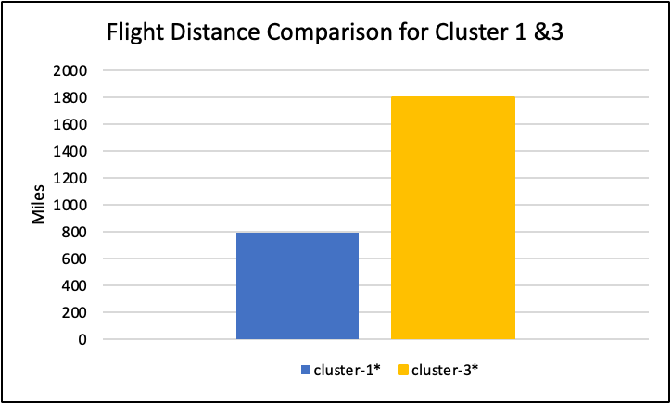

**Exhibit 4.**

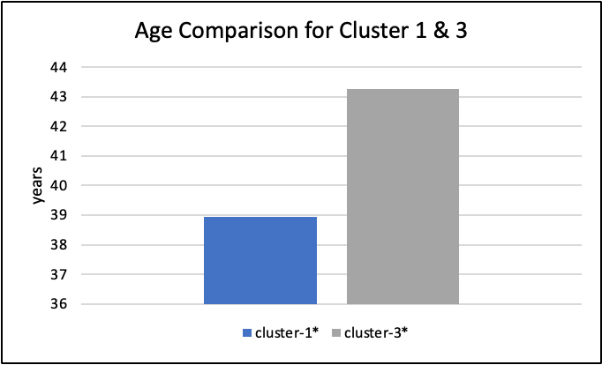

Cluster 1 describes loyal customers with the intention of traveling at a lower cost for tourism. On the other hand, cluster 3 describes loyal customers with the intentions of traveling comfortably for business.

***Model Accuracy Analysis***

When developing the cluster analysis, SPSS derived three possible models described in Exhibit 5. We decided to use the Two Step Cluster Analysis model as it had the highest silhouette score of 0.512. Since the silhouette score is greater than 0.5 we can conclude that the model has good evidence of the reality of the clusters in the data.

**Exhibit 5.**

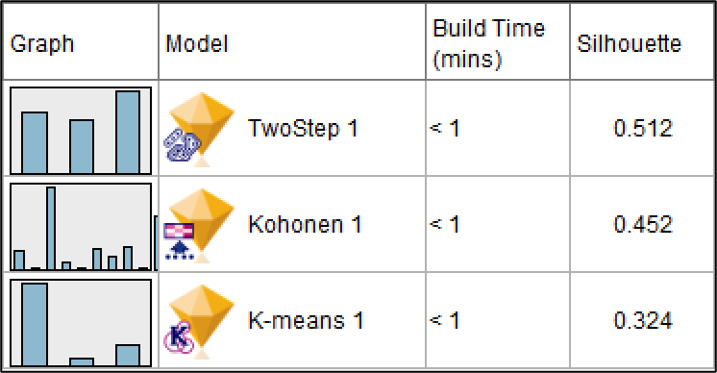

# **SECTION 5. Implementation**

In the following section, we will be describing the possible application for the results described in section 4.

## ***Logistic Regression Model Result Recommendations.***

As we previously mentioned, the logistic regression model provides the customer services that contribute to the overall satisfaction of Spirit Airlines customer base. For instance, we defined the reason for traveling as an important predictor of whether the customer is more likely to be satisfied or not. Spirit Airlines should focus their investments into customer services that greatly impact the probability that the customer will be satisfied with their experience traveling with them. Given the results, the customers choose Spirit Airlines for convenience and not for comfort. For instance, Exhibit 1 shows that the services that are of more impact are those that result in a more efficient traveling experience rather than a comfortable one. Variables such as online boarding services, check in service and in-flight wifi have more weight into the probability that a customer is satisfied with their experience than factors such as seat comfortability, leg room, and in-flight services. In fact, we can even argue that this may be the reason as to why services such as in-flight food and drinks seem to be statistically insignificant for the model.

Another key implementation of these results is how it is important that Spirit Airlines manages expectations. As previously mentioned, there seems to be a higher probability that the customer will be unsatisfied with their experience if they are part of the loyalty program. According to Edward Demming’s Total Quality Theory Principles, eliminating slogans, and targets towards their customers is highly beneficial for the quality perception as it levels expectations (ASQ, 2022). Therefore, it can be concluded that it seems like Spirit Airlines is not delivering what customers expect of their loyalty program. For that reason, we recommend that Spirit Airlines uses the information provided by the logistic regression model to enhance their loyalty program to favor services that optimize the convenience and efficiency in their experience, as opposed to comfortability focused services.

Finally, we can conclude that the results of this model further helps us understand that Spirit Airlines consumers' satisfaction can be alleviated by investment in technology that makes their flight easy, as opposed to full of benefits, which supports the low cost strategy Spirit Airlines currently uses.

## ***Cluster Analysis Model Result Recommendations.***

As we previously mentioned, one great application of this model is creating targeted loyalty programs based on the characteristics of the different clusters. Cluster 1, resulted in young loyalty program customers interested in inexpensive traveling experiences to destinations closer to their homes. While Cluster 3, resulted in older professionals interested in traveling comfortably. With this information, we recommend that Spirit Airlines should develop two different Loyalty Programs, one targeted towards business professionals and one targeted to young adventurers. Given how cluster 3 is older than cluster 1, we can also use effective marketing tools that attract younger audiences for the traveling focused loyalty program, while using more traditional marketing tools to target the comfort focused loyalty program. On the other hand, providing targeted loyalty programs can improve the probabilities of loyal customers being satisfied with their experience. As we previously mentioned, one key observation we found in the logistic regression model is that loyal customers are more likely to be unsatisfied with their experience. With the information provided by the cluster analysis model, Spirit Airlines could improve their loyalty customer programs and consequently, improve the probabilities that their loyal customers are satisfied with their future trips.

On the other hand, given the results of this analysis we believe it would be of great benefit if Spirit Airlines started gathering more data that describes the demographics of their customer base in order to improve this model. This would also help Spirit Airlines find more clusters within their customer pool to improve their marketing strategies and effectively reach potential new customers that fit the cluster criteria.

Finally, we would recommend that even though we encourage the organization to improve and expand their data analytics, we do advise the organization that the information gathered from the consumers is to be used with discretion. Our research finds that creating focused marketing plans may lead to unwarranted accusations that may hinder the reputations of the organization. As mentioned in an LinkedIn article by Damian Fernandez-Lamela, marketing data should be used with discretion, always keeping in mind the customers sensitivity towards their information being used to target them (Fernandez-Lamela, 2014).

# **SECTION 6. Summary & Conclusion**

For this project we identified a major business process issue that has been impacting Spirit Airlines reputation in the last couple of years. Utilizing predictive modeling, through a logistic regression model, we were able to identify insight on Spirit Airlines consumer base preferences. In addition, the model provided important insight regarding the current effectiveness of their loyalty program. We determined that currently loyalty program consumers' expectations are not being met, and henceforth they were identified as a group of consumers more likely to be unsatisfied with their experience with Spirit Airlines. On the other hand, through an unsupervised modeling analysis we were able to discover how Spirit Airlines can improve their loyalty program strategy. We found two distinctive clusters among the loyalty program consumers. Hence, we recommended that Spirit Airlines should create a loyalty program with a focus on their consumers preferences, specifically targeting young adventurers and older professionals.

Our project also provided some recommendations into gathering data to be able to identify more clusters among the consumer pool to create targeted marketing strategies to attract even more customers. Yet, we also advised against using the findings as to alarm the consumer base on the data that is being gathered.

With this project we were able to identify specific ways in which Spirit Airlines can use data analytics to improve one major issue in their business which is customer service satisfaction, without generating higher expenses that could hinder their current low cost business strategy. We understand that Spirit Airlines has become a profitable organization as a consequence of their low cost strategy, and has become a competitive organization given this strategy. With these business analytics tools, we were able to take an approach where Spirit Airlines does not have to make a huge investment to improve their overall customer services, but focus on finding impactful customer service areas that can be improved in a cost effective manner, and result in happier travelers and higher profit margins.

# 

# **REFERENCES.**

Apps Run The World. (n.d.). *Spirit Airlines, Inc. selects SAP S/4HANA cloud for ERP financial*. Apps Run The World. Retrieved October 23, 2022, from <https://www.appsruntheworld.com/customers-database/purchases/view/spirit-airlines-inc-united-states-selects-sap-s-4hana-cloud-for-erp-financial>

Elian, J. (2013). *Spirit Airlines: Achieving Competitive Advantage Through Ultra Low Costs* . Embry-Riddle Aeronautical University . Retrieved October 23, 2022, from <https://commons.erau.edu/cgi/viewcontent.cgi?article=1602&context=jaaer>

Rosenstein, D. E. (2013). *The changing low-cost airline model: An analysis of spirit airlines*. Purdue University. Retrieved October 23, 2022, from <https://docs.lib.purdue.edu/cgi/viewcontent.cgi?article=1018&context=atgrads>

Spirit Airlines. (2022). *Who we are*. Spirit AFA-CWA. Retrieved October 23, 2022, from <https://spiritafa.org/who-we-are#:~:text=Spirit%20Airlines%20was%20founded%20in,Rhode%20Island%2C%20to%20Atlantic%20City>

Carey, S. (2019, May 16). *Lessons learned from an s/4hana public cloud migration by spirit airlines*. Computerworld. Retrieved October 23, 2022, from <https://www.computerworld.com/article/3428070/lessons-learned-from-an-s-4hana-public-cloud-migration-by-spirit-airlines.html>

Josephs, L. (2021, August 6). *'we couldn't get in front of it.' spirit airlines CEO explains what caused the carrier's Meltdown*. CNBC. Retrieved October 23, 2022, from <https://www.cnbc.com/2021/08/06/spirit-airlines-ceo-on-what-caused-the-carriers-meltdown.html>

Loria, K. (2021, September 30). *Rocky Wiggins drives growth through innovation*. Profile Magazine. Retrieved October 23, 2022, from <https://profilemagazine.com/2020/rocky-wiggins-spirit-airlines/>

Picoult, J. (2021, August 9). *Why spirit's recent troubles may haunt the airline for a long time to come*. Forbes. Retrieved October 23, 2022, from <https://www.forbes.com/sites/jonpicoult/2021/08/09/why-spirits-recent-troubles-may-haunt-the-airline-for-a-long-time-to-come/?sh=71eb3a681a1b>

Wall Street Journal(2022). *Save | spirit airlines inc.. annual income statement - WSJ*. The Wall Street Journal. Retrieved October 23, 2022, from <https://www.wsj.com/market-data/quotes/SAVE/financials/annual/income-statement>

Josephs, L. (2022, July 29). *JetBlue to buy spirit for $3.8 billion in push to become the fifth-largest US Carrier*. CNBC. Retrieved October 23, 2022, from <https://www.cnbc.com/2022/07/28/jetblue-airways-reaches-deal-to-buy-spirit-airlines.html>

Mutzabaugh, B. (2014, September 17). *Spirit picks flamboyant yellow as U.S. airlines repaint planes*. USA Today. Retrieved October 23, 2022, from <https://www.usatoday.com/story/todayinthesky/2014/09/16/spirit-picks-flamboyant-yellow-as-us-airlines-repaint-planes/15711597/>

Renfro, K. (2018, July 3). *I finally caved and flew on the 'worst airline in America' - here's what it was like*. Business Insider. Retrieved October 23, 2022, from <https://www.businessinsider.com/spirit-airlines-flight-review-food-photos-2018-6#a-brief-search-online-will-reveal-just-how-controversial-spirit-airlines-really-is-3>

D, J. (2018, June 10). *Passenger satisfaction*. Kaggle. Retrieved October 23, 2022, from <https://www.kaggle.com/datasets/johndddddd/customer-satisfaction>

Ghitis, S. (2015, December 8). *Spirit Airlines and the success of the ultra-low cost carrier*. Harvard - Technology and Operations Management. Retrieved October 23, 2022, from <https://d3.harvard.edu/platform-rctom/submission/spirit-airlines-and-the-success-of-the-ultra-low-cost-carrier/>

Rollert, John Paul. (2015, June 17). *Why Spirit Airlines is So Terrible.* Chicago Booth. Retrieved October 22, 2023, from https://www.chicagobooth.edu/review/why-spirit-airlines-is-so-terrible

Spirit Airlines, Inc. (2015). Form 10-K. Retrieved October 22, 2022, from <https://www.annualreports.com/HostedData/AnnualReportArchive/s/NASDAQ_SAVE_2020.pdf>

Spirit Airlines, Inc. (2020). Form 10-K. Retrieved October 22, 2022, from <https://www.sec.gov/Archives/edgar/data/1498710/000149871016000205/save-20151231x10k.htm>

Revels, M. (2013, August 28). *Data Mining and Data Warehousing in the Airline Industry*. Retrieved October 23, 2022, from <https://papers.ssrn.com/sol3/papers.cfm?abstract_id=2519737>

Hallowell, Roger. (1996, October 1) “The Relationships of Customer Satisfaction, Customer Loyalty, and Profitability: An Empirical Study.” *International Journal of Service Industry Management*, MCB UP Ltd, Retrieved November 20, 2022, from <https://www.emerald.com/insight/content/doi/10.1108/09564239610129931/full/html>.

ASQ (2022). “W. Edwards Deming's 14 Points for Total Quality Management.” *ASQ*, Retrieved on December 1,2022, from <https://asq.org/quality-resources/total-quality-management/deming-points>.

Fernandez-Lamela, Damian (2018, 13 Aug). “Lessons from Target's Pregnancy Prediction PR FIASCO.” *LinkedIn*, Retrieved on 1 December 2022, from, <https://www.linkedin.com/pulse/20140616204813-2554671-lessons-from-target-s-pregnancy-prediction-pr-fiasco/>.